HW2

Tiancheng Liu

2022-09-29

Table of Contents

## Question 1

### a

dbinom(15, 30, 0.5)

## [1] 0.1444644

The probability that exactly half of the rolls are even numbers is 0.144.

### b

1-pbinom(20, 30, 0.5)

## [1] 0.02138697

The probability that more than 20 of the rolls are even numbers is 0.0214.

### c

pbinom(4, 30, 1/3)

## [1] 0.01222972

The probability that less than 5 of the rolls are greater than 4 is 0.0122.

## Question 2

### a

ppois(40, 30) - ppois(19, 30)

## [1] 0.945817

The probability that the server gets pinged between 20 and 40 times in a particular second is 0.946.

### b

sec <- 365 * 24 * 60 * 60  
sec

## [1] 31536000

There are 31536000 seconds in a year.

### c

max(rpois(sec, 30))

## [1] 67

The maximum number of pings in a single second over the course of a year is around 66.

### d

qpois(0.99, 30)

## [1] 43

43 should be a good rate, as it is the 99 percent threshood.

## Question 3

### a

t <- seq(0, 5, by=0.1)  
  
prob3 <- dunif(t, 0, 5)  
  
plot(t, prob3)

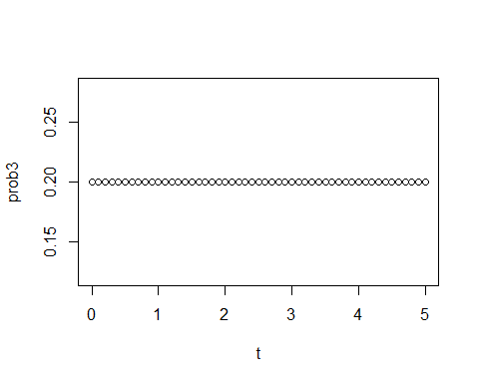

The density function are as shown.

### b

punif(1, 0, 5)

## [1] 0.2

The probability that the bus is more than 1 minutes late is 0.2.

### c

(1-punif(4, 0, 5))/(1-punif(3, 0, 5))

## [1] 0.5

The conditional probability that the bus is more than 4 minutes late, given that it is already 3 minutes late is 0.5.

## Question 4

### a

1 - pnorm(60, 50, 5)

## [1] 0.02275013

step <- seq(0, 100, by=0.01)  
prob4 <- dnorm(step, 50, 5)  
plot(step, prob4)  
abline(v = 60)  
polygon(c(step[step>=60], max(step), 60), c(prob4[step>=60],0,0), col="red")

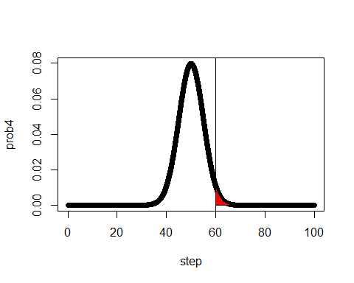

The probability that it is more than 60 cm in length is 0.0227.

### b

qnorm(0.1, 50, 5)

## [1] 43.59224

plot(step, prob4)  
polygon(c(step[step<=43],43, 40), c(prob4[step<=43],0,0), col="red")

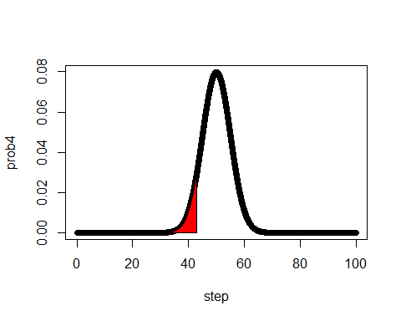

The length is 43.59.

### c

qnorm(0.3, 50, 5)

## [1] 47.378

plot(step, prob4)  
polygon(c(step[step>=47],47, 47), c(prob4[step>=47],0,0), col="red")

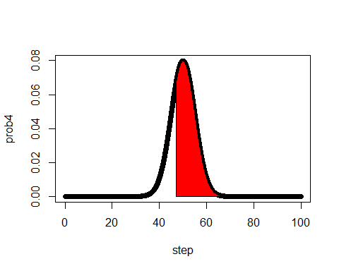

The length is 47.38.

## Question 5

### a

pnorm(90, 80, 10) - pnorm(70, 80, 10)

## [1] 0.6826895

### b

pnorm(100, 80, 10) - pnorm(60, 80, 10)

## [1] 0.9544997

### c

pnorm(110, 80, 10) - pnorm(50, 80, 10)

## [1] 0.9973002

### d

for (i in 1:3){  
 print(pnorm(0 + i * 1, 0, 1) - pnorm(0 - i * 1, 0, 1))  
}

## [1] 0.6826895  
## [1] 0.9544997  
## [1] 0.9973002

## Question 6

### a

pnorm(1.9, 2, 0.05)

## [1] 0.02275013

2.27 percent of nails are less than 1.9 inches in length.

### b

1 - pnorm(2.1, 2, 0.05)

## [1] 0.02275013

2.27 percent of nails are longer than 2.1 inches in length.

### c

qnorm(0.8, 2, 0.05)

## [1] 2.042081

Exactly 20% of the nails are longer than 2.04.

### d

qnorm(0.2, 2, 0.05)

## [1] 1.957919

Exactly 20% of the nails are shorter than 1.958.

## Question 7

### a

sim <- rpois(10000, 20)  
hist(sim)

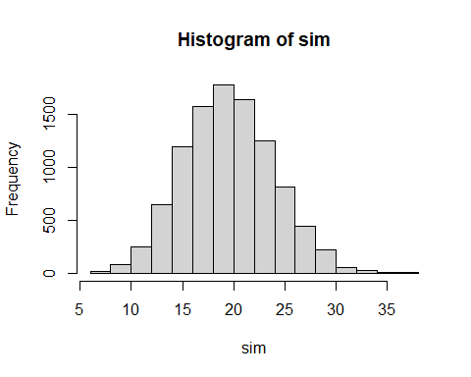

### b

simb <- c()  
for (i in sim){  
 simb <- append(simb, rbinom(1, i, 0.08))  
}  
  
hist(simb)

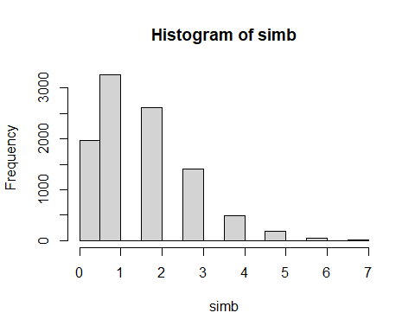

### c

simc <- c()  
for (i in simb){  
 simc <- append(simc, sum(rexp(i, 1/10000000)))  
}  
hist(simc)

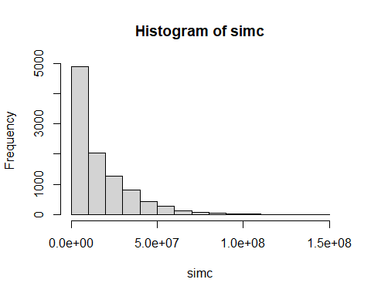

### d

mean((simc - 26000000) > 0)

## [1] 0.2234

About 22.76 percent of the simulation makes a profit.

### e

sim_RD <- rpois(10000, 24)  
rt_RD <- c()  
for(i in sim_RD){  
 rt_RD <- append(rt_RD, rbinom(1, i, 0.08))  
}  
rev_RD <- c()  
for(j in rt_RD){  
 rev_RD <- append(rev_RD, sum(rexp(j, 1/10000000)))  
}  
mean(rev_RD)

## [1] 19163167

rev_market <- c()  
for (k in simb){  
 rev_market <- append(rev_market, sum(rexp(k, 1/12000000)))  
}  
mean(rev_market)

## [1] 19237686

With different runs the result are different, sometimes one is higher sometimes the other one is higher. But most of the time marketing revenue is higher, Thus I conclude that spend money on marketing will yield higher revenue.