ICA5

Tiancheng Liu

2022-09-20

Table of Contents

## Question 1

### a

dpois(3,15/4)

## [1] 0.2066989

### b

1-ppois(11,15)

## [1] 0.8152482

### c

qpois(c(0.5,0.9),2.5)

## [1] 2 5

### d

rpois(10,30)

## [1] 27 40 32 30 30 36 26 26 27 32

### e

x <- 1:20  
y <- dpois(x,5)  
plot(x,y)

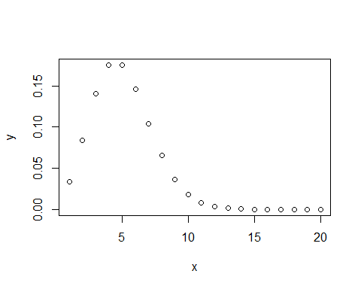

## Question 2

### a

pnbinom(10,5,0.4)

## [1] 0.7827223

### b

1-pnbinom(24,5,0.4)

## [1] 0.002201528

### c

mean(rnbinom(100,5,0.4))

## [1] 7.39

### d

hist(rnbinom(100,5,0.4))

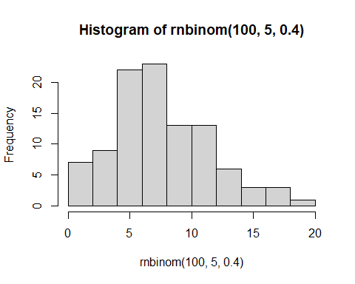

x <- 1:25  
y <- dnbinom(x,5,0.4)  
plot(x,y)

