ICA9

2022-10-03

Table of Contents

## Question 1

man <- (-20)*0.35 + 40*0.35 + 100*0.3  
pur <- 10*0.35 + 45*0.35 + 70*0.3  
  
man

## [1] 37

pur

## [1] 40.25

We can see that purchase has high expected profit.

## Question 2

### a

set high demand probability as p

man <- -20*0.35 + 40*(1-0.35-p) + 100*p man <- 60*p + 19 pur <- 10*0.35 + 45*(1-0.35-p) + 70*p pur <- 25*p + 32.75

### b

x = runif(100,0,0.65)  
plot(x = x, y = 60*x + 19, type = "l")  
lines(x = x, y = 25*x + 32.75)

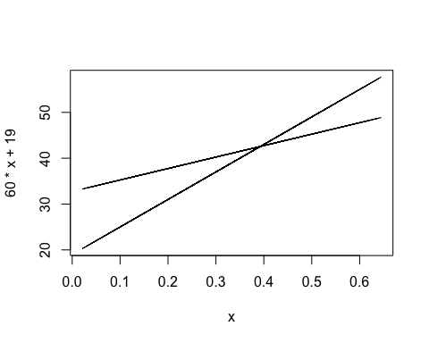  
### c

60*p + 19 = 25*p + 32.75 p = 0.393

Thus when high demand has probability of 0.393 the expected value will be equal.

## Question 3

### a

a = 0.3 * 5000000  
b = 1 * (1000000+5000000)/2  
c = 3200000  
a

## [1] 1500000

b

## [1] 3e+06

c

## [1] 3200000

The product c has the highest expected value.

### b

pa = 0.3  
samp = sample(1000000:5000000, 1000000,replace = T)  
pb = (length(samp[samp > 4000000]))/1000000  
c_sim = rexp(1000000,1/3200000)  
pc = length(c_sim[c_sim>4000000])/1000000  
pa

## [1] 0.3

pb

## [1] 0.24953

pc

## [1] 0.285187

Thus product a is most likely to achieve 4000000 revenue.