PENETRATION TESTING REPORT
FOOTPRINTING & RECONNAISSANCE PHASE
W2-PM1 | CYBERSECURITY | NETWORKWALKS

REPORT DETAIL | INFORMATION
Pentester Name | Umer Shahid
Program / Batch | B082 – Networkwalks
Report Date | 10 November 2026
Module Completed | W2-PM1 – Footprinting & Reconnaissance with Multiple Kali Tools
Client / Target | networkwalks.com
Testing Environment | Kali Linux
Permission | Conducted under the authorization guidance provided by the  Networkwalks program
Phase Covered | Phase 1 – Reconnaissance & Footprinting

WEEK 02 • INTERNSHIP PROJECT

1. Liability Disclaimer
The activities documented in this report were performed for educational and research purposes as part of the Networkwalks cybersecurity internship. Testing was limited to the assigned target and the reconnaissance activities described in the practical. The work was conducted under the authorization guidance communicated by the program. No exploitation, unauthorized access, privilege escalation, denial-of-service activity, brute-force testing, or modification/deletion of data was performed.
Cybersecurity tools and techniques must only be used on systems for which appropriate authorization has been obtained. The author is responsible for ensuring that any future testing remains within the approved scope and applicable laws.

2. Introduction
This report documents the Week 2, Project Module 1 activity of the Networkwalks cybersecurity internship. The practical focused on footprinting and reconnaissance of the networkwalks.com domain using six Kali Linux tools: WHOIS, WhatWeb, Nslookup, Curl, WAFW00F and DNSRecon.
The purpose of the activity was to collect and analyze publicly available information about the target domain, its web technologies, HTTP response headers, Web Application Firewall and DNS infrastructure. Each tool provided a different perspective on the target. The commands, observed findings and their security relevance are documented in the following sections.
The report covers W2-PM1 only. It does not claim completion of the separate Zenmap/local-network scanning module shown in the sample report.

3. Tools Used
Tool | Purpose
Kali Linux | Operating system used to perform the reconnaissance activities.
WHOIS | Retrieve publicly available domain registration details, registrar information and name-server entries.
WhatWeb | Identify publicly observable website technologies, server details and content-management-system information.
Nslookup | Resolve the domain name to its IP address using DNS.
Curl (-I) | Retrieve HTTP response headers from the website.
WAFW00F | Detect and fingerprint a Web Application Firewall.
DNSRecon | Enumerate DNS information such as SOA, NS, A, MX, TXT and SRV records.

4. Activities Performed

4.1 Footprinting & Reconnaissance
Reconnaissance was performed against networkwalks.com using six Kali Linux tools. The tools were used to gather domain registration, web technology, DNS resolution, HTTP header, WAF and DNS record information.
4.1.1 WHOIS – Domain Registration Enumeration Command executed:
whois networkwalks.com > task1-whois.txt
Key observations:
- Domain name: NETWORKWALKS.COM.
- Registrar: GoDaddy.com, LLC.
- Creation date: 06 November 2019; last updated: 12 November 2025.
- Registry expiry date: 06 November 2027.
- The registry section listed NS6135.HOSTGATOR.COM and NS6136.HOSTGATOR.COM.
- The registrar WHOIS section also displayed NS29.DOMAINCONTROL.COM and NS30.DOMAINCONTROL.COM.
- DNSSEC was reported as unsigned.
- Registrant information was privacy-protected through Domains By Proxy, LLC / Registration Private.
Security relevance: WHOIS information provides publicly available registration and infrastructure details. The privacy service limits direct exposure of registrant contact information. The different name-server entries appear in separate sections of the WHOIS output and should not be assumed to represent the same active authoritative configuration without further verification.
4.1.2 WhatWeb – Website Technology Fingerprinting Command executed:
whatweb networkwalks.com > task2-whatweb.txt
Key observations:
- The HTTP version of the site returned 301 Moved Permanently and redirected to HTTPS.
- The HTTPS site returned 200 OK.
- Web server identified: Apache.
- Content management system identified: WordPress 7.1.4.
- WordPress Download Manager identified: 3.3.76.
- jQuery version identified: 3.7.1; Bootstrap was reported by WhatWeb as 7.1.4.
- Google Tag Manager and the page title “Networkwalks Academy” were detected. ● The website resolved to IP address 192.232.216.135.
Security relevance: Technology fingerprinting can help a security reviewer understand the website's software stack. Publicly identifiable product and version information may help an attacker narrow research to relevant software advisories, but the detection alone does not prove that any component is vulnerable.
4.1.3 Nslookup – DNS Resolution Command executed:
nslookup networkwalks.com > task3-nslookup.txt
Key observations:
- DNS resolver used: 1.1.1.1 (Cloudflare).
- The resolver returned the IPv4 address 192.232.216.135 for networkwalks.com.
- The response was labelled “Non-authoritative answer.”
Security relevance: DNS resolution links a domain name to its network address. A non-authoritative answer means the response was supplied by the recursive resolver rather than directly by an authoritative name server; it does not mean the answer is invalid.
4.1.4 Curl – HTTP Response Header Analysis Command executed:
curl -I https://networkwalks.com > task4-curl.txt
Key observations:
- The server returned HTTP/2 200, indicating a successful response.
- The Server header identified Apache.
- The Link header exposed the WordPress REST API endpoint at /wp-json/.
- The response included the cookie name __wpdm_client with Secure and HttpOnly attributes.
- The Referrer-Policy header was no-referrer-when-downgrade.
- The response included x-endurance-cache-level: 0 and x-nginx-cache: WordPress headers. ● The content type was text/html; charset=UTF-8.
Security relevance: HTTP headers provide information about server behavior, application technology and browser-facing security controls. The cookie value itself is not reproduced in this report because session-related values should not be unnecessarily exposed. The presence of the /wp-json/ link indicates a WordPress REST API reference, not by itself a vulnerability.
4.1.5 WAFW00F – Web Application Firewall Detection Command executed:
wafw00f networkwalks.com
Key observations:
- WAFW00F version: 2.3.1.
- Target checked: https://networkwalks.com.
- Detected WAF: ModSecurity (SpiderLabs).
- Number of requests reported by the tool: 2.
Security relevance: The result indicates that WAFW00F fingerprinted ModSecurity (SpiderLabs) in front of the website. A WAF can inspect and filter web requests. Detection does not establish whether the WAF is correctly configured or whether it blocks every malicious request.
4.1.6 DNSRecon – DNS Enumeration Command executed:
dnsrecon -d networkwalks.com > task6-dnsrecon.txt 2>&1
Key observations:
- DNSRecon version: 1.6.3.
- SOA record: ns6135.hostgator.com (50.87.144.87).
- NS records: ns6136.hostgator.com (192.232.216.131) and ns6135.hostgator.com (50.87.144.87).
- A record: networkwalks.com resolved to 192.232.216.135.
- MX record: mail.networkwalks.com resolved to 192.232.216.135.
- TXT records included a Google site-verification value and an SPF policy.
- The SPF record began with v=spf1 and included +a, +mx, an IPv4 address, websitewelcome.com and ~all.
- SRV records were returned for _autodiscover._tcp.networkwalks.com, pointing to cPanel email discovery hosts on port 443.
- The tool reported BIND version 9.16.23-RH for the two name-server IPs.
- The DNSSEC query returned “No answer”; the earlier WHOIS result also reported DNSSEC as unsigned.
- DNSRecon completed enumeration and displayed “8 Records Found.”
Security relevance: DNS records reveal information about domain hosting, mail routing and service configuration. The SPF record provides information about the domain's email-sending policy. Software-version disclosure can assist technology fingerprinting. These observations are informational and do not independently confirm a security weakness.

5. Summary of Key Findings
Area | Observed result
Domain registration | GoDaddy.com, LLC; domain created 06 Nov 2019; expiry 06 Nov 2027; DNSSEC unsigned.
Web technologies | Apache; WordPress 7.1.4; WordPress Download Manager 3.3.76; jQuery 3.7.1.
Domain IP | 192.232.216.135, consistently observed through WhatWeb, Nslookup and DNSRecon.
HTTP response | HTTP/2 200; Apache; WordPress REST API link /wp-json/.
WAF | ModSecurity (SpiderLabs) identified by WAFW00F.
DNS infrastructure | HostGator name servers, mail record, TXT/SPF records and email autodiscovery SRV records.

6. Risk Analysis / Impact
The following table identifies potential information-exposure considerations based on the reconnaissance observations. These are not confirmed vulnerabilities and no exploitation or vulnerability validation was performed.
# | Observation | Potential impact | Indicative level
1 | Web technologies and versions were identified by WhatWeb. | May help an attacker identify relevant software and research known weaknesses. | Medium
2 | The domain resolved to 192.232.216.135. | Reveals the public IP address associated with the web service. | Low
3 | HTTP headers exposed server and WordPress-related information. | May assist technology fingerprinting and further reconnaissance. | Low
4 | WAFW00F identified  ModSecurity (SpiderLabs). | Reveals information about the website's defensive technology. | Low
5 | DNSRecon identified name-server, mail, TXT, SPF and SRV records. | Helps build a broader picture of domain and email infrastructure. | Medium
6 | DNSRecon reported BIND version 9.16.23-RH. | Version disclosure may help guide further security research. | Low

Risk levels are indicative assessments of information exposure only. A software version, IP address, DNS record or WAF fingerprint does not by itself demonstrate that a system is vulnerable. Further authorized assessment and validation would be required to determine actual risk.

7. Recommendations
- Review publicly exposed technology information and limit unnecessary version disclosure where practical.
- Keep the CMS, plugins, web server and supporting components updated in accordance with vendor security advisories.
- Review HTTP response headers and apply appropriate browser-facing security policies.
- Review DNS records periodically and remove records that are no longer required.
- Maintain and monitor the ModSecurity WAF, and review its rules and logs as part of normal security operations.
- Review the SPF policy and other email-domain configurations to ensure they reflect the organization's current mail infrastructure.
- Review DNS server configuration and software lifecycle, including whether version information should be disclosed.
- Perform any further testing only with appropriate authorization and within the approved scope.

8. Conclusion
During Week 2 of the Networkwalks cybersecurity internship, I completed the W2-PM1 practical covering footprinting and reconnaissance using six Kali Linux tools. WHOIS provided domain registration information;
WhatWeb identified publicly observable website technologies; Nslookup resolved the domain to its IP address; Curl displayed HTTP response headers; WAFW00F identified ModSecurity (SpiderLabs); and DNSRecon collected DNS infrastructure information.
The practical helped me understand how different reconnaissance tools collect complementary information about a target. It also demonstrated the importance of recording exact commands, preserving tool output and interpreting findings carefully. The information gathered can support later authorized security assessment, but the findings in this report should be treated as observations rather than confirmed vulnerabilities.
All activities documented here were limited to the assigned footprinting and reconnaissance tasks. No exploitation, unauthorized access or disruptive testing was performed.

9. Evidence Collected
Insert the corresponding terminal screenshots in the spaces below. The screenshots should show the command and its result clearly. Keep the matching text output files with the final submission.

Evidence 1: WHOIS – Domain Registration Enumeration



Evidence 2: WhatWeb – Website Technology Fingerprinting
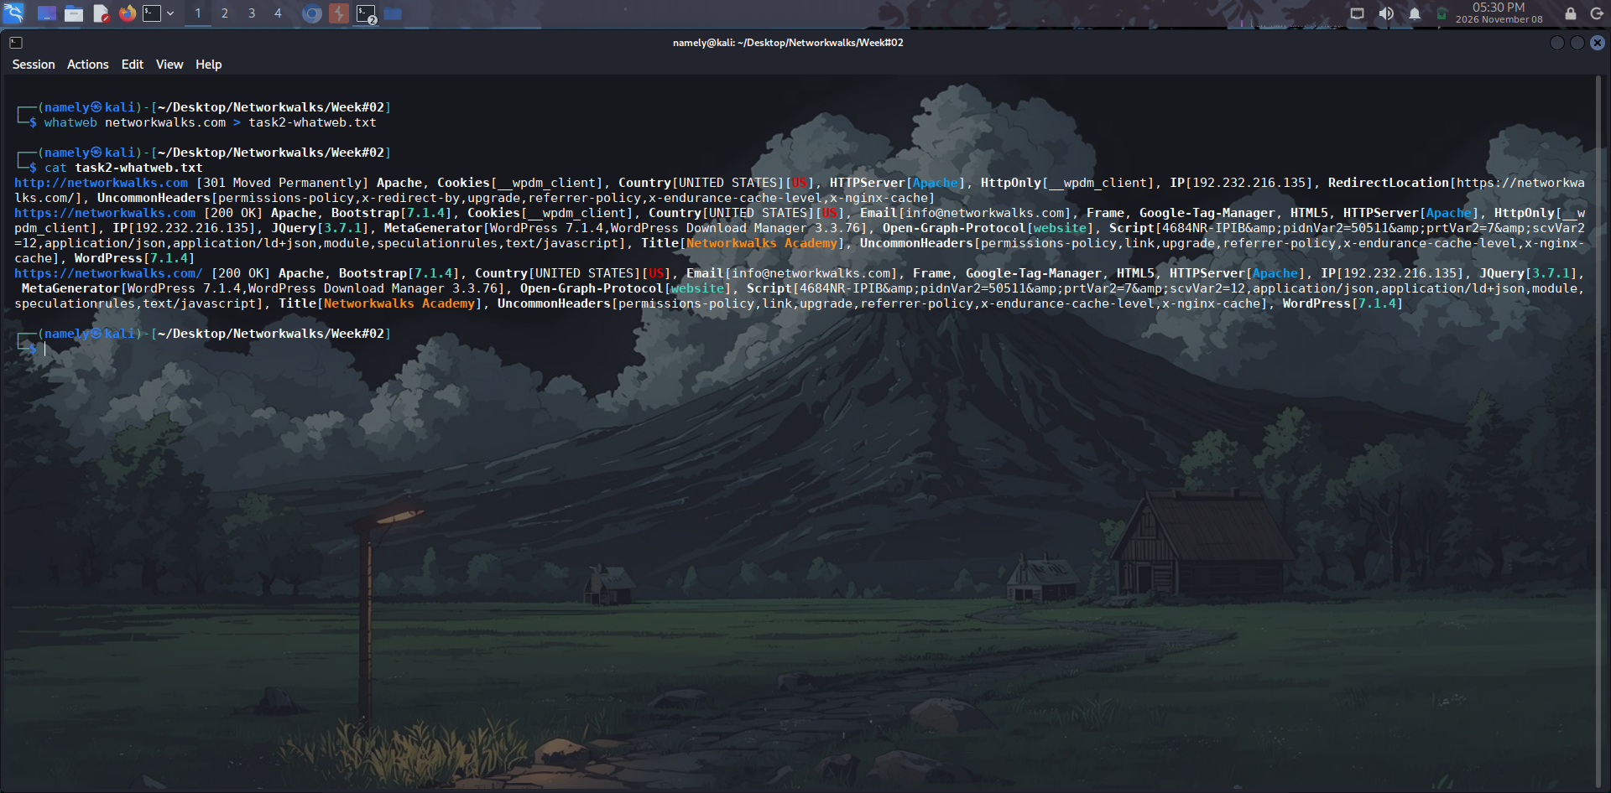

Evidence 3: Nslookup – DNS Resolution

Evidence 4: Curl – HTTP Response Header Analysis
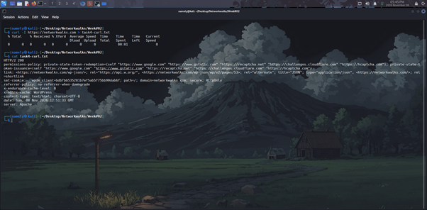

Evidence 5: WAFW00F – WAF Detection


Evidence 6: DNSRecon – DNS Enumeration
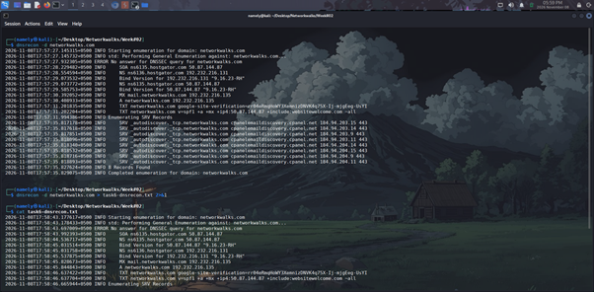
— END OF REPORT —

