📑 Smoking Health Risk Analysis Report Documentation
Name: Douzi Narmeen Khanam
Date: 25-02-2026

1. Project Overview
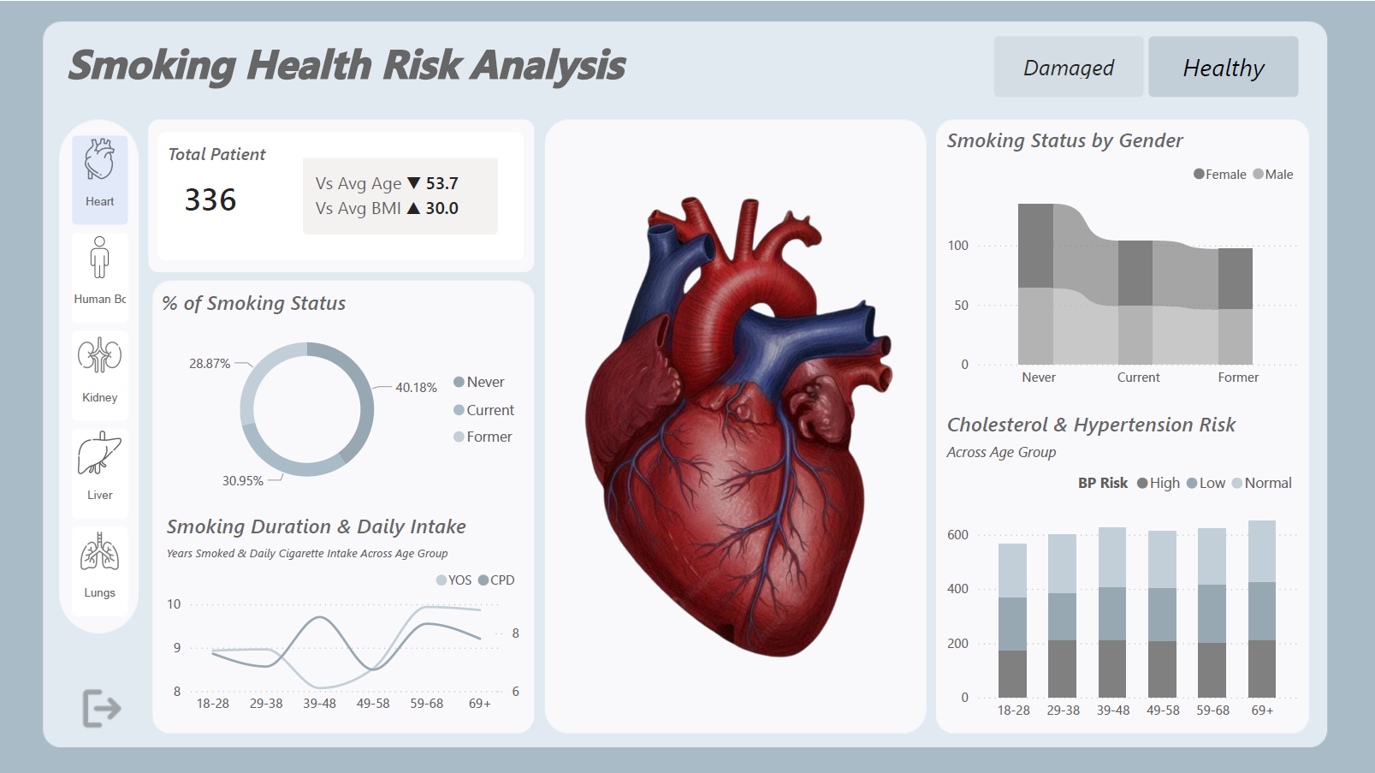
The objective of this report is to analyze the physiological and demographic risks associated with different smoking statuses (Never, Current, and Former). It utilizes patient data to visualize correlations between smoking duration, daily intake, and the health of vital organs such as the heart, liver, kidneys, and lungs.
2. Data Source & Assets
- Dataset: Provided in the video description of the tutorial by Isaac Emmanuel.
- Assets: All visual assets, including anatomical 3D renders (Heart, Liver, Kidney, Lungs) and background UI elements, were sourced from the project assets folder included in the video description.

3. Technical Stack
- Power BI Desktop: Used for report authoring and data visualization.
- Power Query: Employed for data cleaning and transforming raw patient records.
- DAX (Data Analysis Expressions): Used to create measures for Average Age, Average BMI, and risk percentages across age groups.

4. Key Report Components & Features
🩺 Patient Demographics & KPI Cards
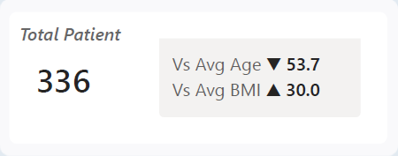
The report tracks key patient metrics to provide context for the health data:
- Total Patient Count: Dynamic count based on filtered views (e.g., 336 patients in the primary view).
- Vs Average Age: Benchmarks the current selection against the global average age (approx. 53–57 years).
- Vs Average BMI: Tracks body mass index, indicating an average BMI of approximately 30.0 (Obese/Overweight threshold).
🚬 Smoking Status Analysis
- Smoking Status Distribution: A donut chart breaks down the patient population into Never Smoked (approx. 40.18%), Current Smokers (approx. 30.95%), and Former Smokers (approx. 28.87%).
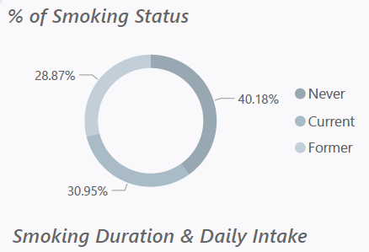
- Gender Analysis (Ribbon Chart): Visualizes the flow of smoking habits between Male and Female patients across all categories.
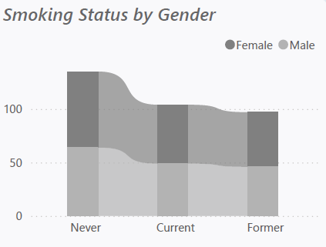
- Smoking Duration & Intake: A line chart tracks Years Smoked (YOS) vs. Cigarettes Per Day (CPD) across age groups (18–69+), identifying peak usage years.
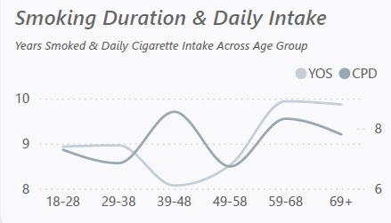
📉 Clinical Risk Assessment
- Organ Health Status: High-quality anatomical visuals indicate whether an organ is Healthy or Damaged based on user selection.
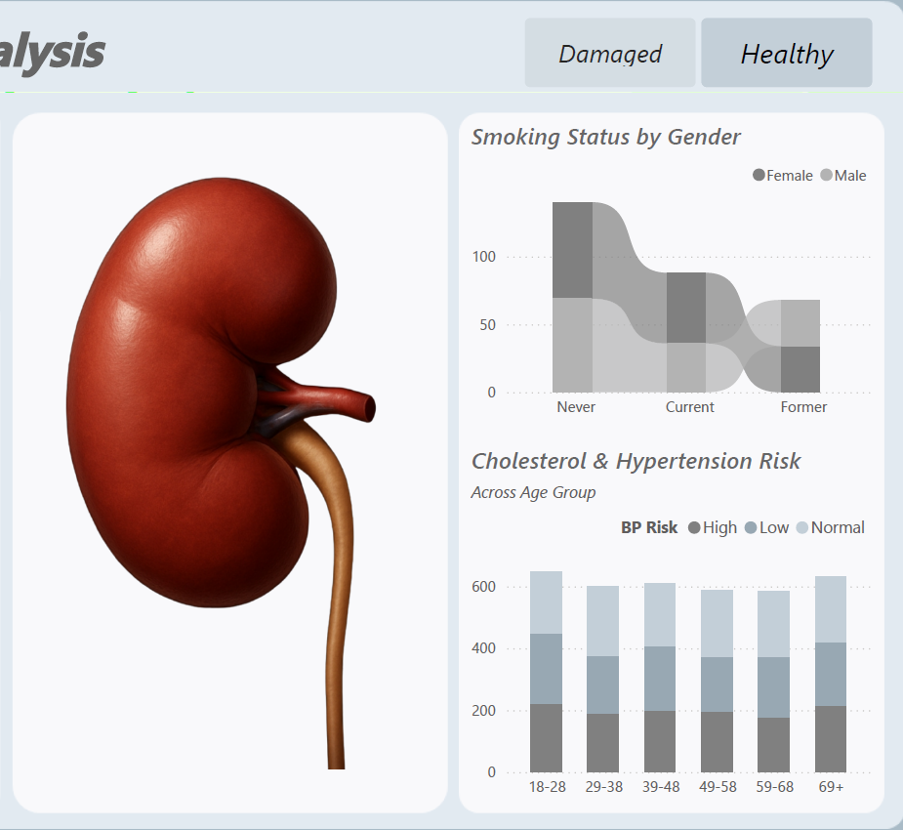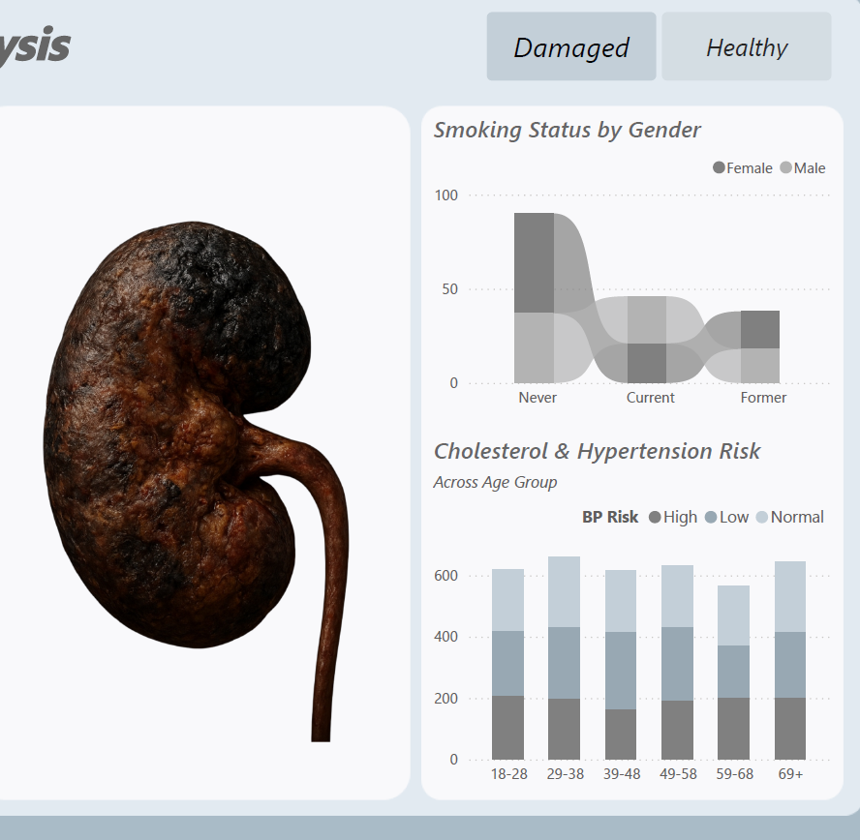
- Cholesterol & Hypertension Risk: A stacked bar chart analyzes Blood Pressure (BP) risks (High, Low, Normal) across various age groups.
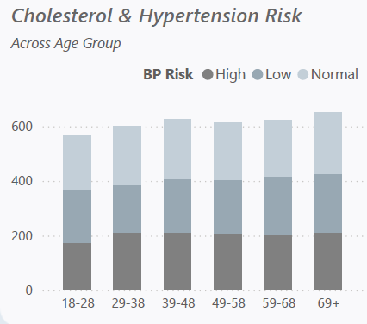

5. Visual Summary of Findings
- Age Correlation: Older age groups (59–68 and 69+) show a higher prevalence of Former Smokers and higher BP risk.
- Organ Impact: The report demonstrates a visual correlation between high "Cigarettes Per Day" and damaged organ indicators.
- BMI Risk: The average BMI remains consistently high (▲ 30.0) across the patient dataset, suggesting a combined risk factor with smoking.

