1. Game engines
   1. Types of engines
      1. Unreal engine
      2. Unity
   2. Loop
   3. [Unreal Engine architecture](https://docs.unrealengine.com/4.27/en-US/ProgrammingAndScripting/ProgrammingWithCPP/UnrealArchitecture/)
      1. Concept of Uclass, Actors, Pawn, Character using UML
2. Basics of skeleton animations
   1. Pose
   2. Mesh
   3. Transform
   4. Tree structure
3. Unreal engine Animation system
   1. Difference between Animation and Gameplay
   2. Creating UML of classes dependent on anim and character
   3. Animation framework
   4. Run Time(AnimInstance)
   5. Data(Sequence, Composite and montages)
4. Unreal engine AnimGraph
   1. UAnimGraphNode_Base
   2. FAnimNode_Base

AnimInstance is the runtime animation class that maintains runtime data & plays shit

* This is the parent class of the animation blueprint

UAnimationAsset is the classes that contain the actual data and also calculates bones & curves

* UAnimSequence
* UAnimComposite
* UAnimMontage

Two classes for each Anim Node; separated for optimization b/c node construction is expensive

**UAnimGraphNode_Base**: Anim Graph Node that’s shown in editor

* Only exist in editor

**FAnimNode_Base**: Anim Behavior node that is run time

* Initialize: Called whenever need to initialize/reinitialize (e.g. changing mesh instance)
* Update: Called to update current state (such as advancing playtime or updating blend weights)
* Takes FAnimationUpdateContext that knows the delta time for the update & the current nodes blend weight
* Might be where we hook in to do the forward time projection intersection
* Evaluate/EvaluateComponentSpace: Generates a ‘pose’ i.e. list of bone transforms
* FAnimationRuntime has lots of good functions to look at and utility/helper functions

We have lots of locomotion examples, but usually you use AnimGraph from Animation Blueprint. Animation Blueprint consists of two graph. One is AnimGraph and second is EventGraph. What are the differences? Animation Graph is the one running animation system and outputs bone transform, where as Event Graph runs BEFORE Animation Graph and update inputs using awesome blueprint system.

Because AnimGraph works with bone transforms, it is expensive and a bit complicated. But basically when you have character with random states such as running or flying or crouch, it is easy to use Anim Graph.

When do I use AnimMontages?

AnimMontages are a special asset that can be used for one-time event. Like swing or melee attacks or special event triggered animation. It provides different slots or different sections that you can control based on your gameplay.

AnimMontage plays inside of AnimGraph. It doesn't play alone. You have to create AnimGraph with a proper slot that AnimMontage can play on. You can have multiple slots for them to blend.

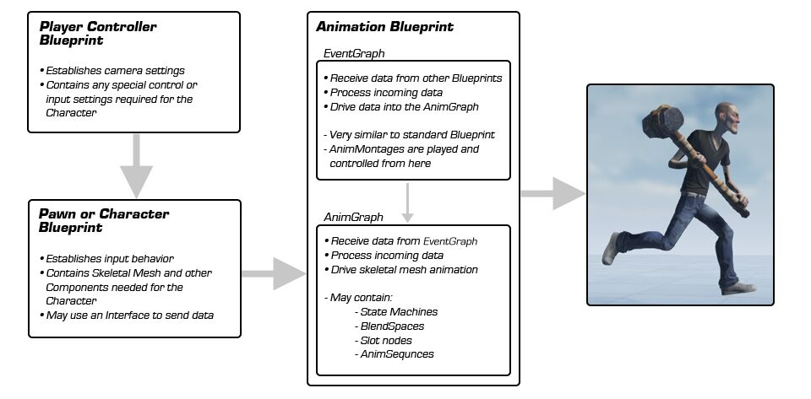

References

1. <https://ikrima.dev/ue4guide/gameplay-programming/animation-subsystem/animation-subsystem/>
2. <https://iluvanimation.blogspot.com/2017/02/what-do-i-do-when-this-happens.html>
3. <https://docs.unrealengine.com/4.27/en-US/AnimatingObjects/SkeletalMeshAnimation/Overview/>
4. <https://app.creately.com/diagram/fZknuArLuyk/view>
5. <https://unrealcommunity.wiki/basic-class-structure-0b7kv9n1>
6. <https://www.reddit.com/r/unrealengine/comments/gye6r7/thats_a_diagram_of_basic_classes_in_the_engine/>
7. here
8. <https://docs.unrealengine.com/4.27/en-US/API/Runtime/CoreUObject/UObject/UObject/>
9. <https://docs.unrealengine.com/4.27/en-US/AnimatingObjects/SkeletalMeshAnimation/AnimBlueprints/>
10. <https://docs.unrealengine.com/4.27/en-US/AnimatingObjects/SkeletalMeshAnimation/AnimBlueprints/AnimGraph/>