HOME

Moshie Zongo Development Organization is own by the Chiefs, Immam, Pastors and Opinion leaders of moshie zongo on behalf of the people of Moshie Zongo.

**Profile of Management of the Organization.**

**Manager**

Name: Yusif Abubakari

CEO Park Teletech Africa

CEO LOLC Ghana Limited

CEO BD Advisors Consult Limited.

Director Jins Savings and Loans

Education: MBA Strategic Management and Consulting, Chartered Banker (CIB), Chartered Financial and Investment Analyst (Cifia-GH),

BA Economics (UG)

**Deputy Manager**

Muniru Mohammed Salifu Esq

Credit Collections and Recovery Officer- Standard Chartered Bank

Barrister , Moomin & Botta Solicitors-Kumasi

BL, Ghana School of Law,

LLB KNUST,

BSC Admin KNUST.

**Secretery**

Name: Nuhu Ibrahim Zeba

Previous role: Former Headteacher of Ashanti Pride Educational Complex(APEC)

Current role: Educational Consultant

Grade: Principal Superintendent - A Teacher in Ghana Education Service(GES)

Qualification: B. Ed (Basic Education)

Institution: University of Education, Winneba.

**Accountant**

Awal Mohammed

Educationist

Economist Tutor Ibadul Rahment SHS.

BSC. Development Studies -UDS, Dip in Education UEW.

PRO

Kwame Nsia

Lands Commission Officer

GFA referee

**ABOUT**

**Moshie Zongo Development Organization (MZDO)** is company limited by guarantee incorporated on 5th May, 2023 by the chiefs, religious and opinion leaders of Moshie Zongo.

-**structure**

The highest decision-making body of the organization is the General Assembly made up of a meeting of the general members the community together with officers of the origination.

The second highest decision-making organization is the Executing Council which is made up of the Chiefs, Religious and Opinion leaders of the community.

The third decision making body is the Management Committee which seeks to the day-to-day operations of the organization.

The last decision-making body of the organization is the functional executives or zonal representatives who represent the various divisions of the community.

**-Formation**

The Chiefs, religious and opinion leaders of the community, realizing the need to provide support to the residents in the community, came together to establish an organization which will source funds to provide scholarships, apprentice support and projects to aid in the development of the community.

- **ownership**

It is owned by the Chiefs, religious leaders on behalf of the people of Moshie Zongo

- **sources of funds**

1. Donations by major mosques where Jumah prayers are held,
2. Donations by religious leaders from a fraction of contributions received at ever program,
3. Donations from volunteer donors
4. Donations from residents abroad
5. Revenue from properties owned by the community
6. Contributions from businesses and merchants in the community
7. Revenue from income generating businesses engaged in by the organisation

**-Accountability**

-Publication of revenue and expenses every 3months, 6months and 1year on our website, social media pages, mosques and churches in the community,

-Holding of annual general meetings.

-Holding of elections to appoint leaders

**PROGRAMES**

-***scholarship***

We have partnerships with educational institutions in the community to provide scholarships to brilliant but needy students in the community. Partner schools includes Premier Nurses’ Training College and Naz Earlychildhood Development Centre.

-***employment***

We provide employment through our income generating ventures.

We also train graduates in the community on how to be marketable in the job market.

-***apprenticeships support***

Through our partnership with dressmakers association, hairdressers associations and shoe makers associations, we are provide support to would be apprentice buy providing them the necessary tools and payment for expenses. We also provide support in terms of allowance to apprentice so they can focus on their training.

After graduation from their apprentice, we also support them with seed capital to put up their own shop.

-***health support & screening***

We also provide regular health screening to residents of the community and provide assistance in payment of medical bills for residents

-***development projects***

We acknowledge the government bears the larger responsibility in providing development projects. To contribute our quota in making life easy for our people, we also provide(directly and indirectly through other agencies) development in access to clean drinking water to our people, provision of furniture and other supports to public schools in the community.

-***community engagement***

As our civil duty and also to make our people informed about national issues, regular community engagement are held to sensitize the community about current issues in the country.

- ***incoming programs/projects***

Projects in the pipeline is to provide a clean water in an area where clean water is scarce in the community.

**UPDATE**

-**News** (about Moshie Zongo), this is the section we will be posting news about moshie zongo

-***announcements –*** at this section, we shall be posting any announcement we want to make. Find some recent announcement below;

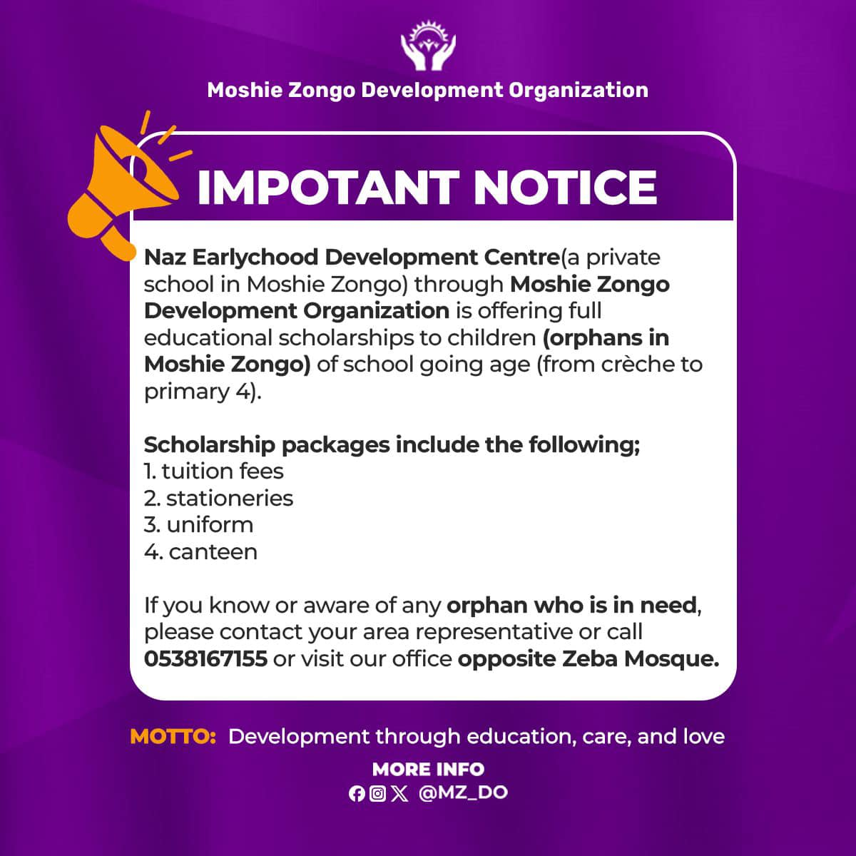

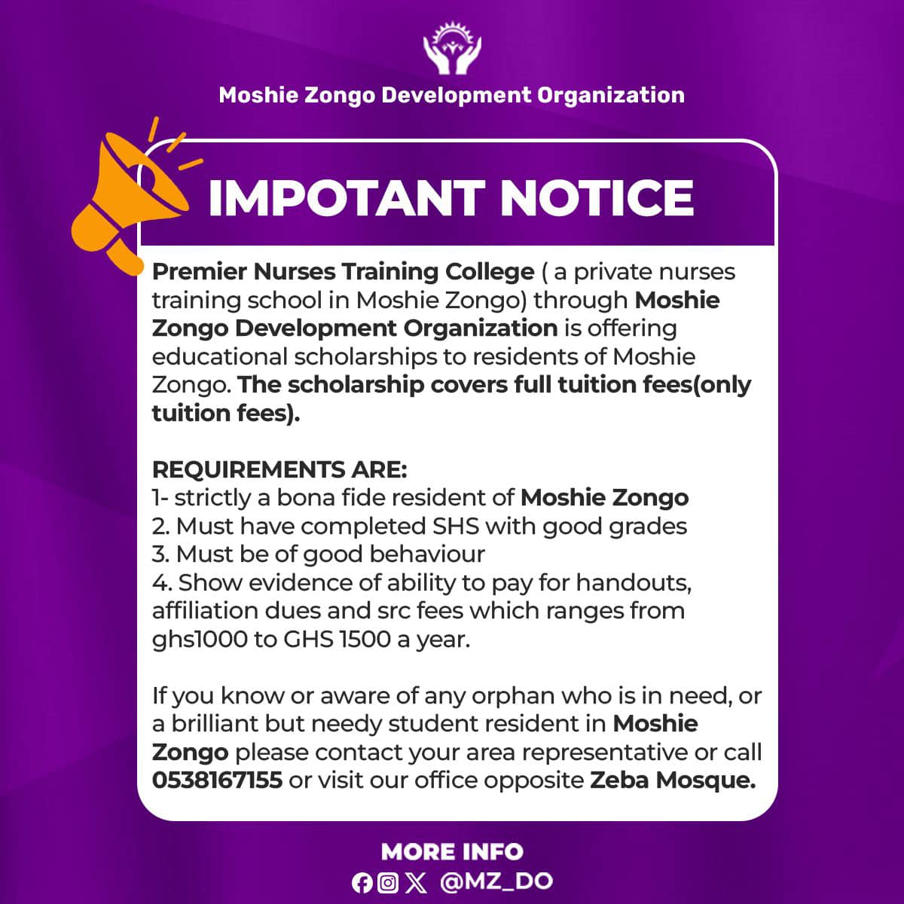

-**past activities**

**Health walk during the launching(**pictures to be provided). At this section, we shall post pictures and videos of past activities. Find some pictures below;

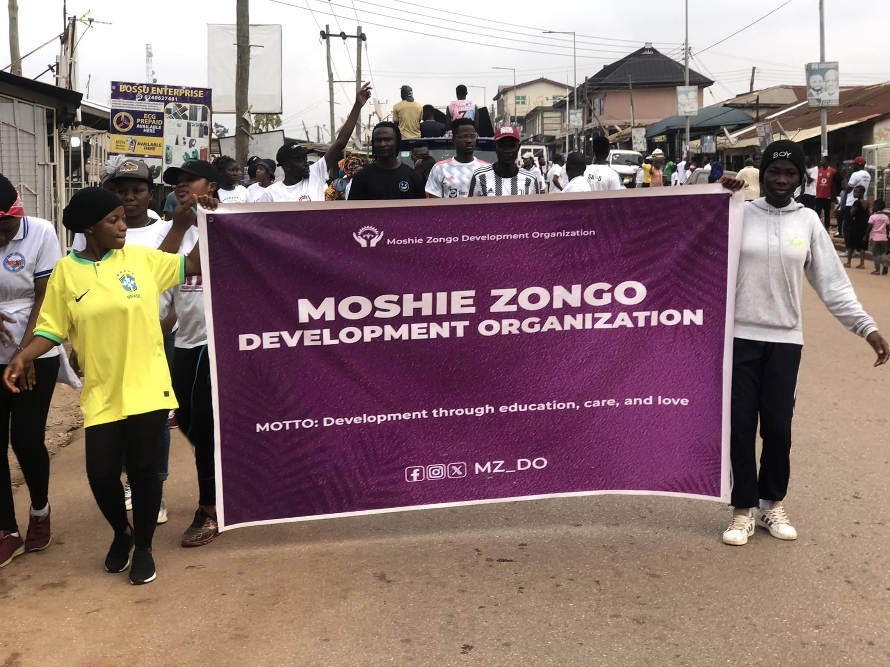

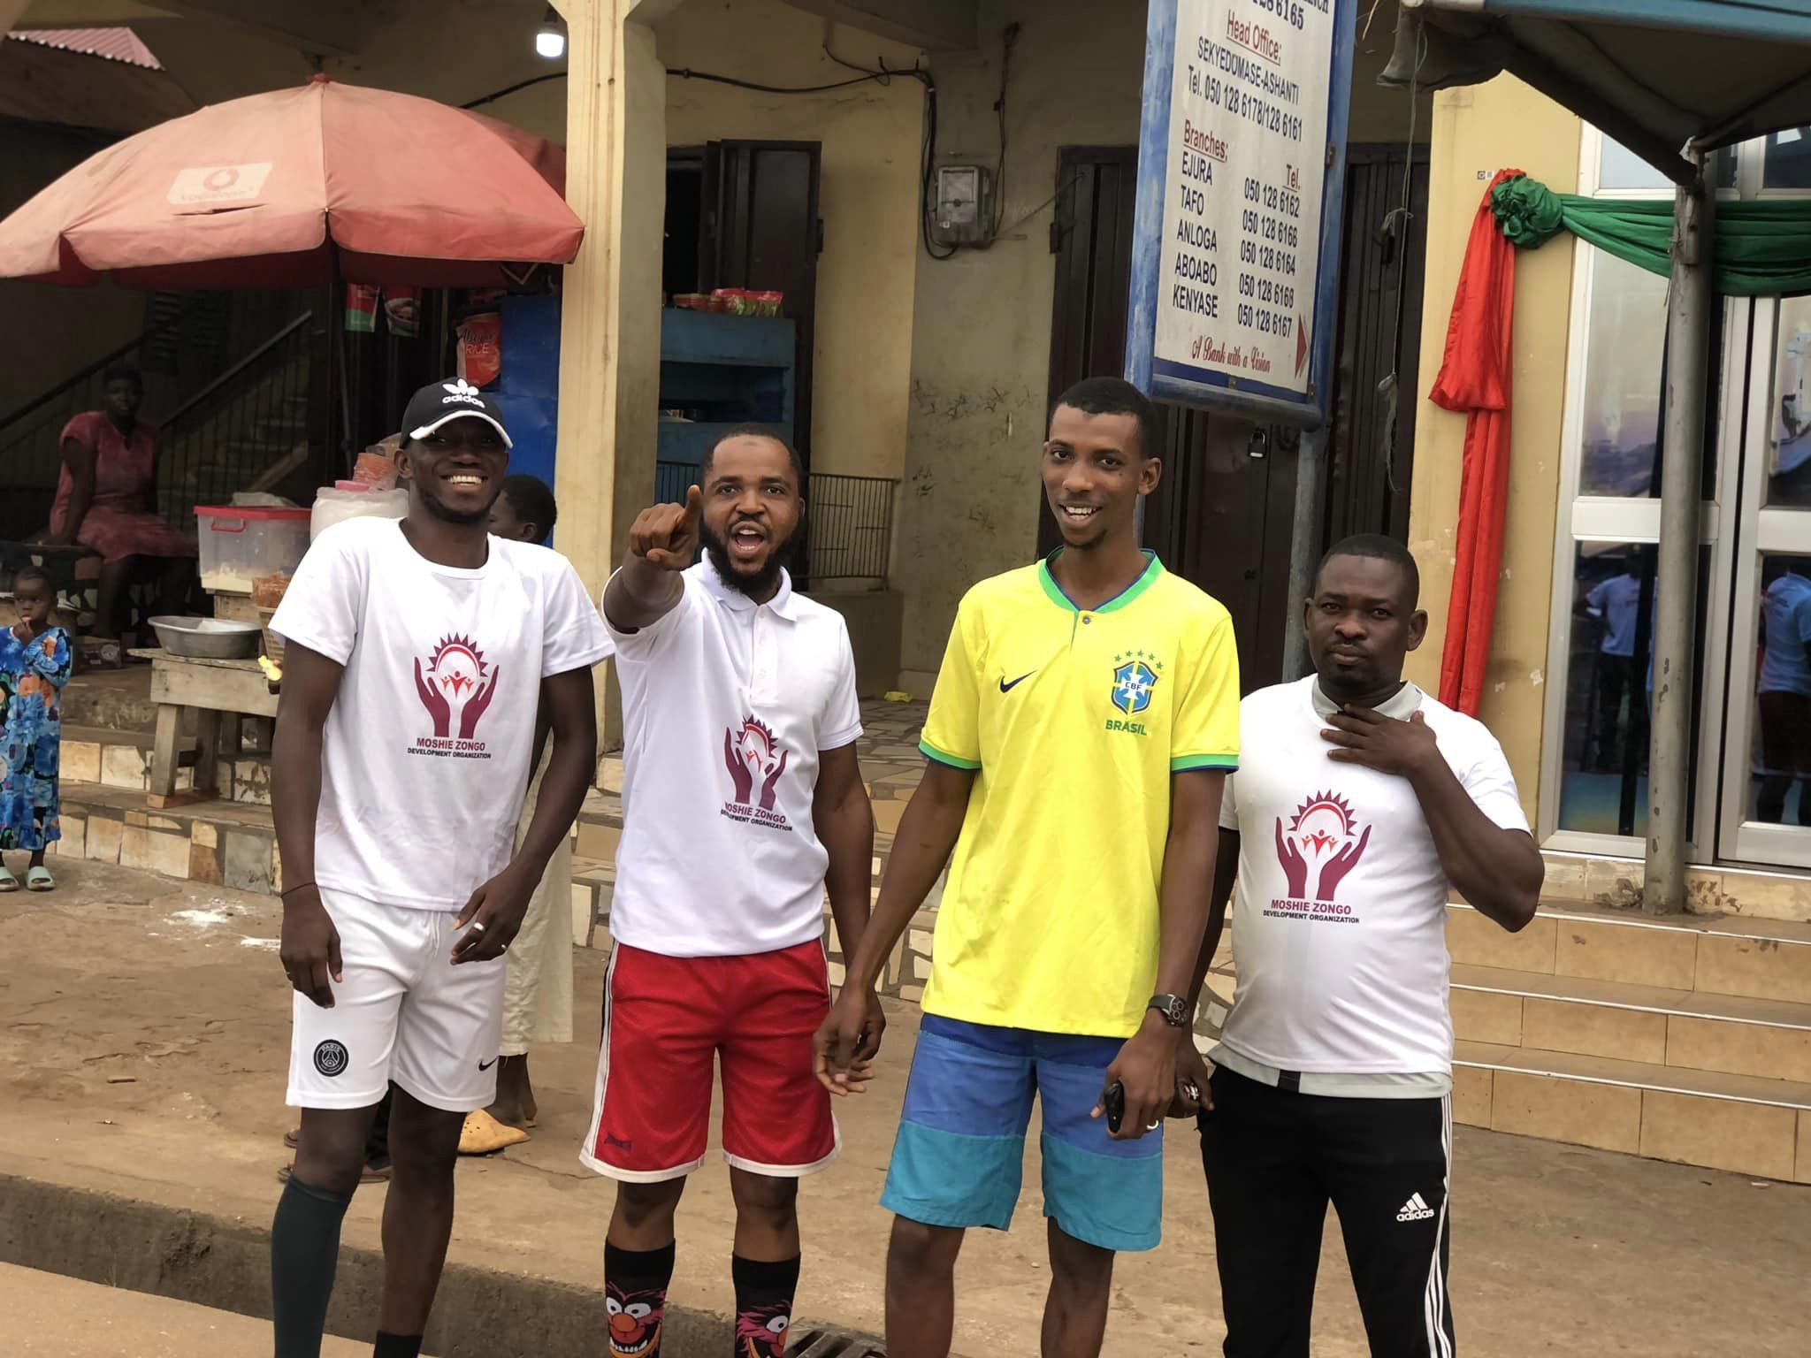

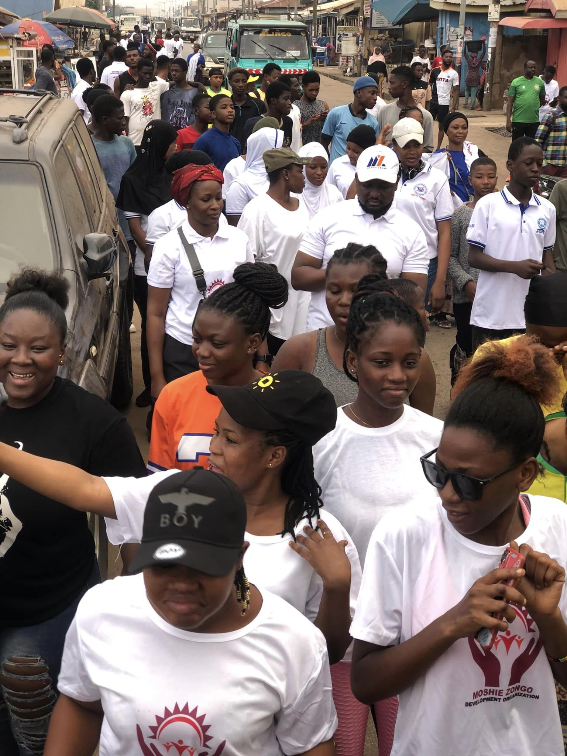

**Health screening during the launching (pictures to be provided)**

**Soccer Galla(pictures to be provided)**

**Quiz competitiong**

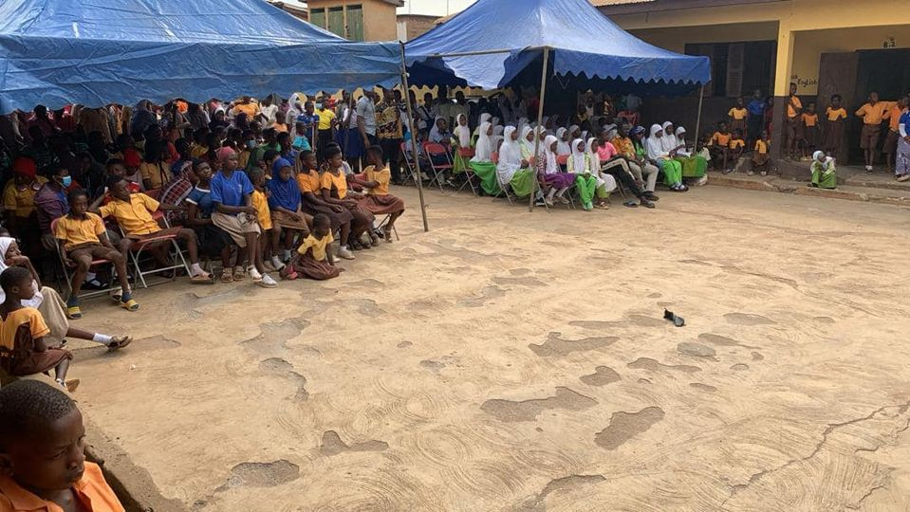

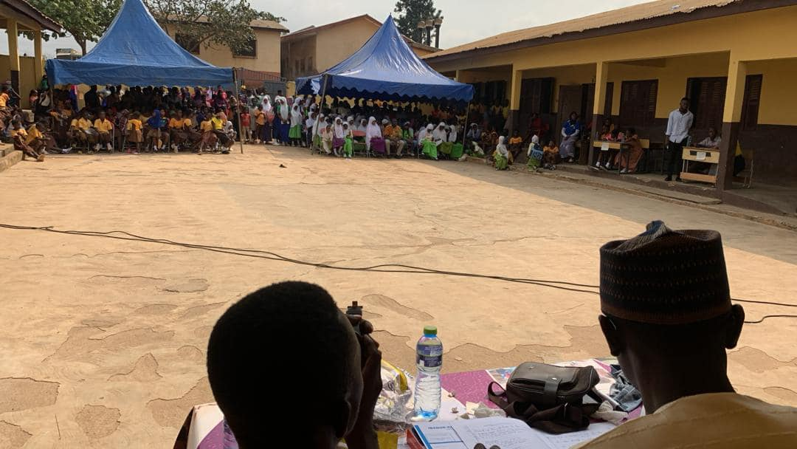

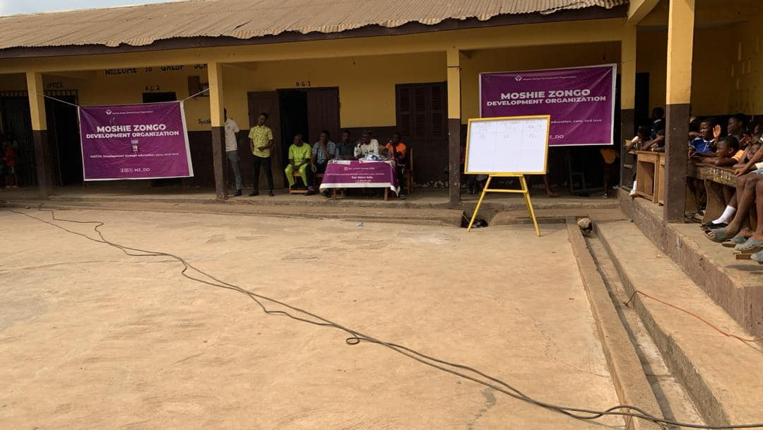

**Durba( pictures to be provided)**

**Artiste night( pictures to be provided)**

**6th March Celebration**

**CONTACT**

picture and directions to our office,

**GPS Address** AK-047-1691 Opposie zeba mosque

**Google map location of office-**

**Contact numbers-** 233 538167155

***email address,***

***social media address***