**QUICK GUIDE FOR APPLICANT AND ADMINISTRATOR**

1. **ADMINISTRATOR(Steps)**

* **Click administrator link to login**

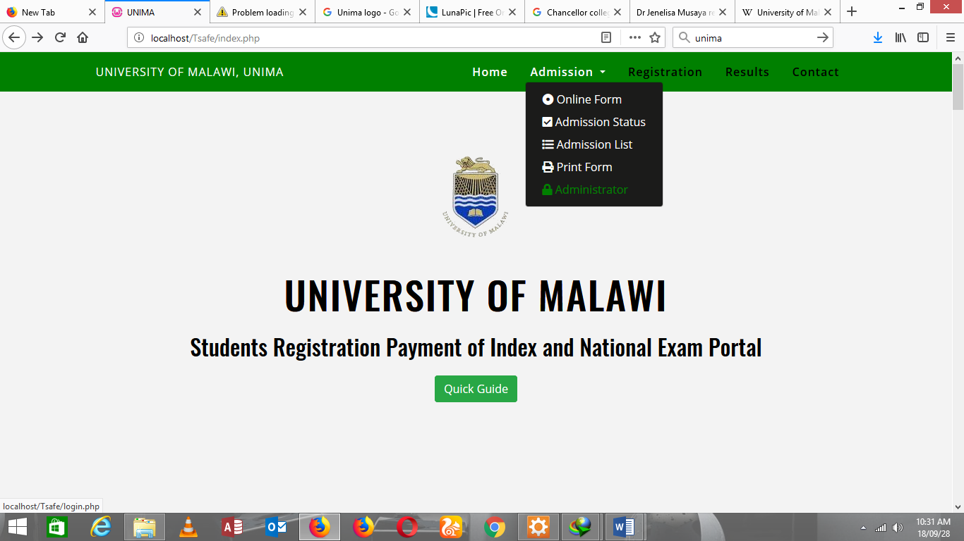

* **Administrator panel below**

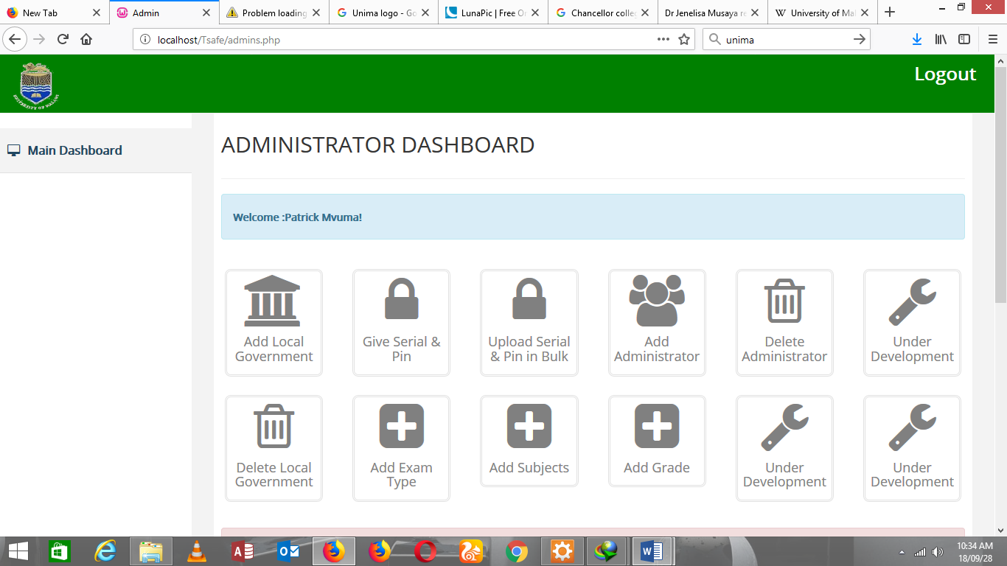

* **1ST Add Local governments to their respective state**
* **2nd Add Subjects**
* **3rd Add Grade**
* **Now you can start creating Pin and Serial numbers for applicants.**

1. **APPLICANT(Steps)**

* **Ask for Pin and Serial number from administrator**
* **Login using the link**

