Quantitative Techniques – Assignment I: Analysis of E-Commerce Customer Purchase and Sales Data

1. Introduction
This report analyses a set of customer purchase records collected from an online retail (e-commerce) store. The purpose of this report is to apply the statistical concepts covered in the Quantitative Techniques module to a real business dataset, and to show how simple descriptive statistics can support practical business decisions. The report is divided into three parts: Part A describes the data and the variables used, including their type and level of measurement; Part B presents the data using frequency tables and charts; and Part C analyses the data using measures of central tendency, dispersion, correlation and regression, along with a short discussion of what the results mean for the business.

2. Part A – Data Collection and Description
The dataset was obtained from the digital checkout / transaction records of an online store that sells products under three categories: Electronics, Furniture and Office Supplies. Each row in the dataset represents one completed purchase transaction. A total of 50 transactions (data points) were used for this assignment, which were extracted directly from the company's sales system, so no separate questionnaire was needed. The dataset records information such as the product purchased, quantity, unit price, total price, delivery time, payment method used and the customer's review rating for the transaction.
Six variables were selected for this assignment, covering both qualitative (categorical) and quantitative (numerical) data, as required by the assignment guidelines. These are summarised below:
Variable | Type of Data | Level of Measurement | Description
Product Category | Qualitative (Categorical) | Nominal | Electronics, Furniture or Office Supplies. Categories have no natural order.
Review Rating | Qualitative (Categorical) | Ordinal | Customer satisfaction rating from 1 (Poor) to 5 (Excellent). Has a meaningful order.
Delivery Days | Quantitative (Discrete) | Ratio | Number of days taken to deliver the order. Whole numbers only.
Quantity | Quantitative (Discrete) | Ratio | Number of units bought in the transaction. Whole numbers only.
Unit Price (Rs.) | Quantitative (Continuous) | Ratio | Price per unit of the product. Can take any decimal value.
Total Price (Rs.) | Quantitative (Continuous) | Ratio | Total amount paid for the transaction (Quantity × Unit Price).

All four numerical variables are measured on a ratio scale because they have a true zero point and equal intervals (for example, a delivery time of 0 days means no delay, and Rs. 0 means no spending). Product Category is nominal because the categories are simply labels with no order. Review Rating is ordinal because the numbers 1 to 5 represent an order of preference, but the gap between each rating is not necessarily equal.

3. Part B – Data Presentation

3.1 Presentation of Categorical Data
The table and chart below show how the 50 purchases are distributed across the three product categories.
Category | Frequency | Percentage (%)
Electronics | 14 | 28
Furniture | 16 | 32
Office Supplies | 20 | 40
Total | 50 | 100
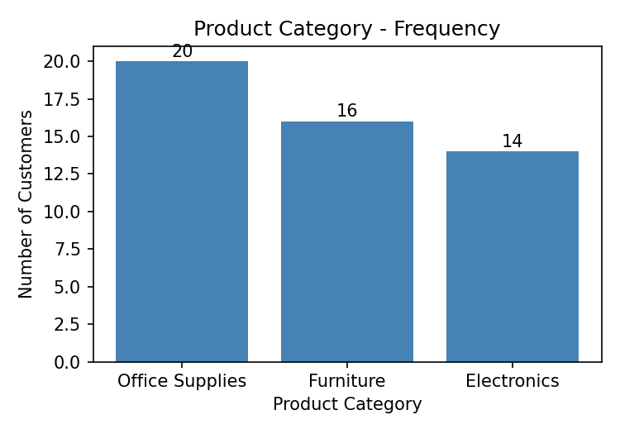
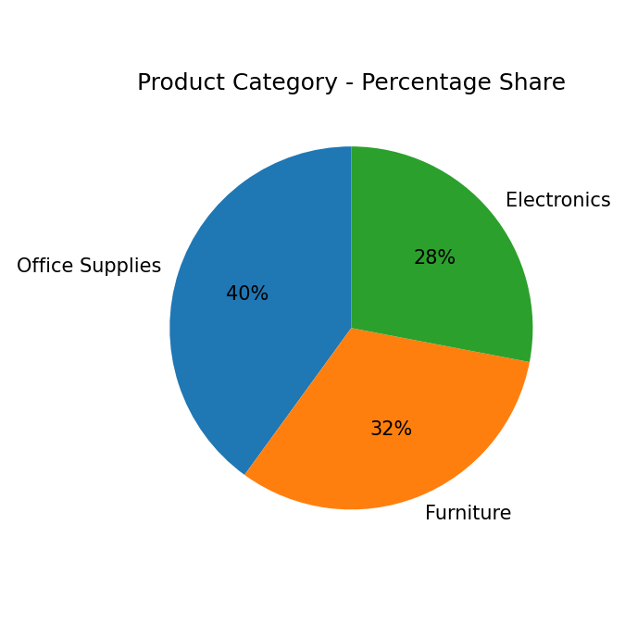
Figure 1: Product Category distribution
Office Supplies is the most frequently purchased category (40% of transactions), followed by Furniture (32%) and Electronics (28%). No category dominates completely, so customer purchases are fairly spread across all three product lines, with a slight lean towards Office Supplies.
The next table and chart show customer review ratings, which range from 1 (Poor) to 5 (Excellent).
Rating | Frequency | Percentage (%)
1 | 11 | 22
2 | 10 | 20
3 | 8 | 16
4 | 10 | 20
5 | 11 | 22
Total | 50 | 100
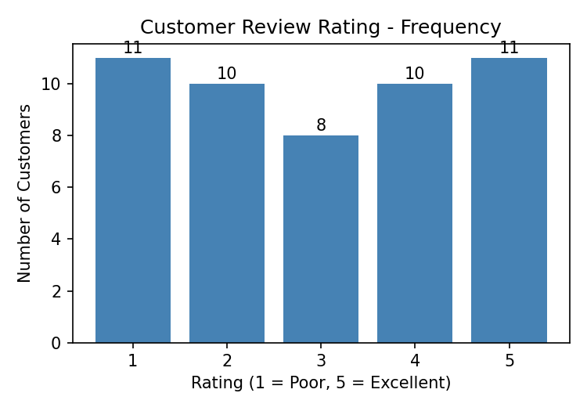
Figure 2: Distribution of customer review ratings
The ratings are almost evenly spread between poor and excellent (22% gave a rating of 1, and 22% gave a rating of 5), with a slightly lower share choosing the middle rating of 3 (16%). This suggests customer opinions are quite mixed, with almost as many unhappy customers as happy ones, rather than most customers sitting in the middle.

3.2 Presentation of Numerical Data
Delivery Days is a discrete variable that only takes the values 3, 4 or 5, so the frequency table below is built directly from these values.
Delivery Days | 3 | 4 | 5
Frequency | 16 | 20 | 14
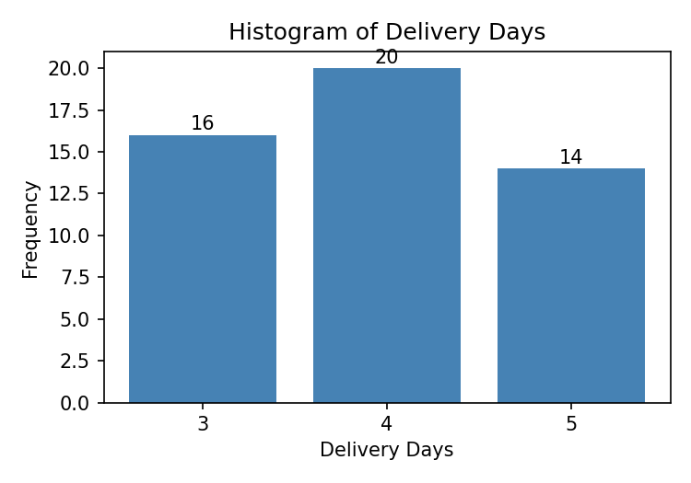
Figure 3: Histogram of Delivery Days
Most orders (20 out of 50) are delivered in 4 days, and the distribution is fairly balanced around this middle value, with slightly more 3-day deliveries (16) than 5-day deliveries (14). This tells us that delivery performance is quite consistent, without any extreme delays.
Quantity purchased is also a discrete variable, so its frequency distribution is built directly from the individual values (1 to 8 units).
Quantity | 1 | 2 | 3 | 4 | 5 | 6 | 7 | 8
Frequency | 3 | 11 | 9 | 4 | 5 | 2 | 6 | 10
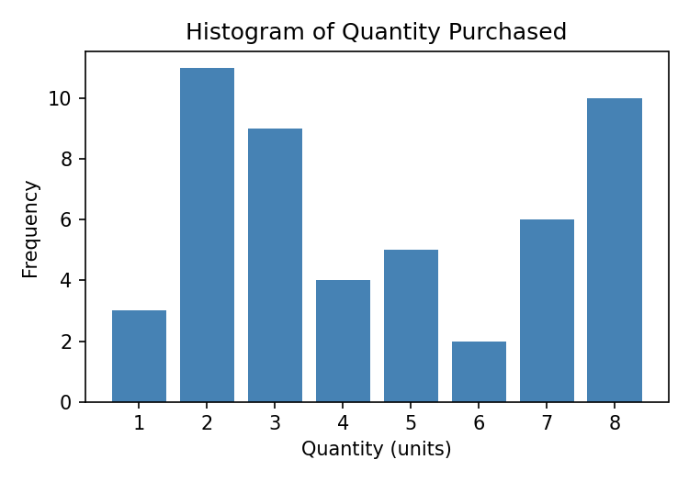
Figure 4: Histogram of Quantity purchased
The histogram of Quantity does not show a single smooth peak; it has two high points, at 2 units and at 8 units. This means customers tend to either buy a small amount (around 2 units) or a large amount close to the maximum (8 units), with fewer customers buying a middle amount like 6 units.
Unit Price is a continuous variable, so it was grouped into class intervals of width Rs. 100 to build its frequency distribution and histogram.
Unit Price (Rs.) | Frequency
0 – 100 | 4
100 – 200 | 10
200 – 300 | 11
300 – 400 | 3
400 – 500 | 7
500 – 600 | 7
600 – 700 | 3
700 – 800 | 5
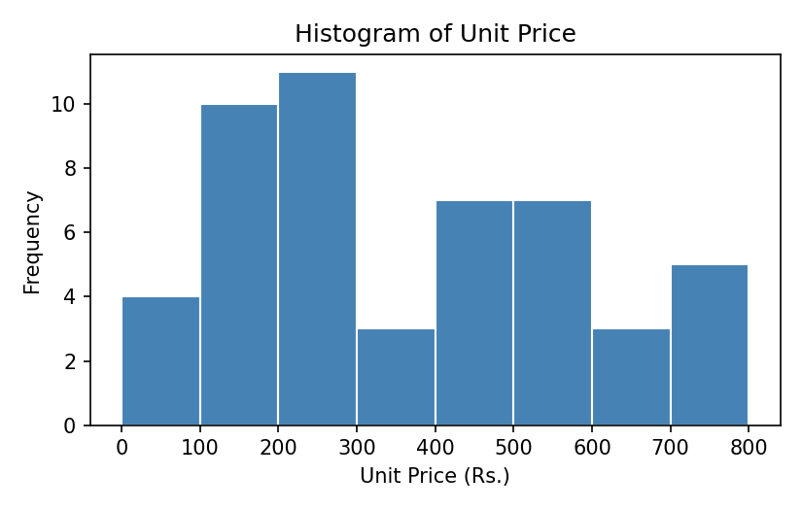
Figure 5: Histogram of Unit Price
Unit Price is more spread out than the other numerical variables, with two noticeable peaks: one in the Rs. 100–300 range (products such as office supplies and small accessories) and a smaller one in the Rs. 400–600 range (higher-value electronics and furniture items). This reflects the fact that the store sells a mix of low-cost and higher-cost products rather than items clustered around one price point.
Total Price is a continuous variable, so it was grouped into class intervals of width Rs. 700 to build the frequency distribution and histogram.
Total Price (Rs.) | Frequency
0 – 700 | 16
700 – 1400 | 9
1400 – 2100 | 10
2100 – 2800 | 7
2800 – 3500 | 3
3500 – 4200 | 1
4200 – 4900 | 2
4900 – 5600 | 2
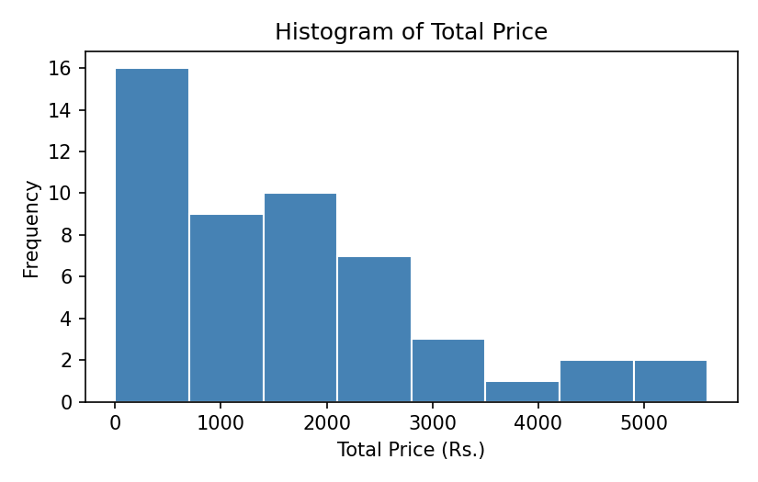
Figure 6: Histogram of Total Price
The histogram of Total Price is right-skewed (positively skewed). Most transactions (about half of them) are on the lower end, below Rs. 1400, and the frequency drops off as the total price increases, with only a few large transactions above Rs. 4200. This is a common pattern in sales data, where most purchases are small to medium, but a few large orders pull the average upward.

4. Part C – Data Analysis

4.1 Measures of Central Tendency
Quantity (discrete) and Total Price (continuous) were selected for this section, as required by the assignment.
Measure | Quantity (units) | Total Price (Rs.)
Mean | 4.54 | 1,585.14
Median | 4.00 | 1,374.46
Mode | 2 | No repeated value (grouped modal class: Rs. 0–700)
For Quantity, the mean (4.54) and median (4.00) are close to each other, so the average and the middle value roughly agree, and the mode of 2 shows that buying 2 units is the single most common transaction size. For Total Price, the mean (Rs. 1,585.14) is noticeably higher than the median (Rs. 1,374.46). This gap confirms what the histogram already showed: a few high-value transactions are pulling the mean upward, so the median is a more realistic 'typical' value for Total Price than the mean. Because Total Price is continuous, most individual values do not repeat, so instead of a single mode value, the modal class (Rs. 0–700) from the frequency table is used, which agrees with the histogram.

4.2 Measures of Dispersion
Measure | Quantity (units) | Total Price (Rs.)
Range | 7 | 4,904.76
Variance (sample) | 5.97 | 1,623,931.94
Standard Deviation | 2.44 | 1,274.34
Coefficient of Variation | 53.81% | 80.39%
The Coefficient of Variation (CV) allows the two variables to be compared fairly, even though they are measured in different units. Total Price has a much higher CV (80.39%) than Quantity (53.81%), which means Total Price varies more relative to its own average. In practical terms, customers are somewhat inconsistent in how many units they buy, but they are even more inconsistent in how much money they spend per transaction. This fits with the earlier observation that a small number of large purchases are driving up both the mean and the spread of Total Price.

4.3 Correlation and Regression Analysis
Quantity purchased (X) and Total Price (Y) were chosen for correlation and regression, since it is reasonable to expect that buying more units should be associated with paying more overall.
Statistic | Value
Correlation coefficient (r) | 0.574
Coefficient of determination (R²) | 0.329
Regression equation | Total Price = 226.39 + 299.29 × Quantity
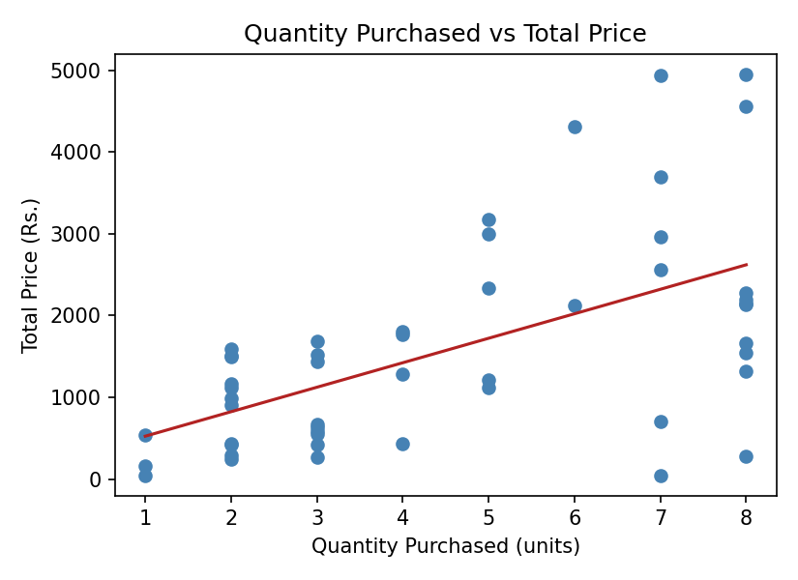
Figure 7: Scatter plot of Quantity vs Total Price with regression line
The correlation coefficient of r = 0.574 shows a moderate positive relationship between Quantity and Total Price: as the number of units purchased increases, the total amount spent also tends to increase, but the relationship is not very strong or perfectly consistent. This is expected, because Total Price also depends on Unit Price, which varies a lot between products (for example, a laptop costs far more per unit than a chair), so quantity alone does not fully determine total spending. The R² value of 0.329 means that only about 33% of the variation in Total Price can be explained by Quantity; the remaining 67% is explained by other factors such as the price of the product bought.
The regression equation, Total Price = 226.39 + 299.29 × Quantity, can be used to estimate a customer's total spending from the quantity they buy. The slope of 299.29 means that, on average, each extra unit purchased is associated with an increase of about Rs. 299.29 in total spending. The intercept of 226.39 is the estimated starting spend even before quantity is added into the model; it does not have a very meaningful real-world interpretation here since a purchase of zero quantity would not actually occur. As an example, for a customer buying 5 units, the predicted total price would be 226.39 + (299.29 × 5) = Rs. 1,722.84.

5. Conclusion and Business Insights
This analysis of 50 e-commerce transactions shows a few useful patterns for the business. First, Office Supplies is the leading product category by number of transactions, so the store may want to keep good stock levels for this category, while Electronics, despite generating higher revenue per unit, is bought slightly less often. Second, customer satisfaction is divided, with as many customers giving low ratings as high ratings, which suggests the business should look into what is causing dissatisfaction for a large share of customers; the fairly consistent delivery times found in this dataset (mostly 3 to 5 days) suggest that delivery speed alone may not fully explain the mixed ratings, so other factors such as product quality or pricing may also be involved. Third, spending behaviour is uneven: most transactions are of low to medium value, but a small number of large transactions pull the average spending up, so these high-value customers could be worth targeting with loyalty offers. Fourth, unit prices are spread across a wide range, showing that the store carries both budget and premium items, which may call for different marketing approaches for each price segment. Finally, while buying more units is moderately linked to higher total spending, it is not the main driver of revenue on its own, since unit price differences between products play a bigger role. Overall, this assignment shows how basic descriptive statistics, frequency distributions, and simple regression can already provide useful insight into customer purchase behaviour from raw transaction data.

