| **[Планета](https://ru.wikipedia.org/wiki/%D0%9F%D0%BB%D0%B0%D0%BD%D0%B5%D1%82%D0%B0" \o "Планета)(**[**карликовая планета**](https://ru.wikipedia.org/wiki/%D0%9A%D0%B0%D1%80%D0%BB%D0%B8%D0%BA%D0%BE%D0%B2%D0%B0%D1%8F_%D0%BF%D0%BB%D0%B0%D0%BD%D0%B5%D1%82%D0%B0)**)** | **Диаметр, относи­тельно** | **Масса, относи­тельно** | **Орбиталь­ный радиус,**[**а. е.**](https://ru.wikipedia.org/wiki/%D0%90%D1%81%D1%82%D1%80%D0%BE%D0%BD%D0%BE%D0%BC%D0%B8%D1%87%D0%B5%D1%81%D0%BA%D0%B0%D1%8F_%D0%B5%D0%B4%D0%B8%D0%BD%D0%B8%D1%86%D0%B0) | [**Период обращения**](https://ru.wikipedia.org/wiki/%D0%A1%D0%B8%D0%B4%D0%B5%D1%80%D0%B8%D1%87%D0%B5%D1%81%D0%BA%D0%B8%D0%B9_%D0%BF%D0%B5%D1%80%D0%B8%D0%BE%D0%B4)**, земных лет** | [**Сутки**](https://ru.wikipedia.org/wiki/%D0%A1%D1%83%D1%82%D0%BA%D0%B8)**, относи­тельно** | **Плотность, кг/м³** | [**Спутники**](https://ru.wikipedia.org/wiki/%D0%A1%D0%BF%D1%83%D1%82%D0%BD%D0%B8%D0%BA_(%D0%BA%D0%BE%D1%81%D0%BC%D0%BE%D1%81)) |
| --- | --- | --- | --- | --- | --- | --- | --- |
|  |  |  |  |  |  |  |  |
| [Меркурий](https://ru.wikipedia.org/wiki/%D0%9C%D0%B5%D1%80%D0%BA%D1%83%D1%80%D0%B8%D0%B9) | 0,382 | 0,055 | 0,38 | 0,241 | 58,6 | 5427 | [0](https://ru.wikipedia.org/wiki/%D0%A1%D0%BF%D1%83%D1%82%D0%BD%D0%B8%D0%BA%D0%B8_%D0%9C%D0%B5%D1%80%D0%BA%D1%83%D1%80%D0%B8%D1%8F) |
| [Венера](https://ru.wikipedia.org/wiki/%D0%92%D0%B5%D0%BD%D0%B5%D1%80%D0%B0) | 0,949 | 0,815 | 0,72 | 0,615 | 243[[129]](https://ru.wikipedia.org/wiki/%D0%A1%D0%BE%D0%BB%D0%BD%D0%B5%D1%87%D0%BD%D0%B0%D1%8F_%D1%81%D0%B8%D1%81%D1%82%D0%B5%D0%BC%D0%B0#cite_note-negative-129) | 5243 | [0](https://ru.wikipedia.org/wiki/%D0%A1%D0%BF%D1%83%D1%82%D0%BD%D0%B8%D0%BA%D0%B8_%D0%92%D0%B5%D0%BD%D0%B5%D1%80%D1%8B) |
| [Земля](https://ru.wikipedia.org/wiki/%D0%97%D0%B5%D0%BC%D0%BB%D1%8F)[[130]](https://ru.wikipedia.org/wiki/%D0%A1%D0%BE%D0%BB%D0%BD%D0%B5%D1%87%D0%BD%D0%B0%D1%8F_%D1%81%D0%B8%D1%81%D1%82%D0%B5%D0%BC%D0%B0#cite_note-130) | 1,0 | 1,0 | 1,0 | 1,0 | 1,0 | 5515 | [1](https://ru.wikipedia.org/wiki/%D0%9B%D1%83%D0%BD%D0%B0) |
| [Марс](https://ru.wikipedia.org/wiki/%D0%9C%D0%B0%D1%80%D1%81) | 0,53 | 0,107 | 1,52 | 1,88 | 1,03 | 3933 | [2](https://ru.wikipedia.org/wiki/%D0%A1%D0%BF%D1%83%D1%82%D0%BD%D0%B8%D0%BA%D0%B8_%D0%9C%D0%B0%D1%80%D1%81%D0%B0) |
| [Церера](https://ru.wikipedia.org/wiki/%D0%A6%D0%B5%D1%80%D0%B5%D1%80%D0%B0) | 0,074 | 0,00015 | 2,76 | 4,6 | 0,378 | 2161 | 0 |
| [Юпитер](https://ru.wikipedia.org/wiki/%D0%AE%D0%BF%D0%B8%D1%82%D0%B5%D1%80) | 11,2 | 318 | 5,20 | 11,86 | 0,414 | 1326 | [67](https://ru.wikipedia.org/wiki/%D0%A1%D0%BF%D1%83%D1%82%D0%BD%D0%B8%D0%BA%D0%B8_%D0%AE%D0%BF%D0%B8%D1%82%D0%B5%D1%80%D0%B0) |
| [Сатурн](https://ru.wikipedia.org/wiki/%D0%A1%D0%B0%D1%82%D1%83%D1%80%D0%BD) | 9,41 | 95 | 9,54 | 29,46 | 0,426 | 687 | [62](https://ru.wikipedia.org/wiki/%D0%A1%D0%BF%D1%83%D1%82%D0%BD%D0%B8%D0%BA%D0%B8_%D0%A1%D0%B0%D1%82%D1%83%D1%80%D0%BD%D0%B0) |
| [Уран](https://ru.wikipedia.org/wiki/%D0%A3%D1%80%D0%B0%D0%BD_(%D0%BF%D0%BB%D0%B0%D0%BD%D0%B5%D1%82%D0%B0)) | 3,98 | 14,6 | 19,22 | 84,01 | 0,718[[129]](https://ru.wikipedia.org/wiki/%D0%A1%D0%BE%D0%BB%D0%BD%D0%B5%D1%87%D0%BD%D0%B0%D1%8F_%D1%81%D0%B8%D1%81%D1%82%D0%B5%D0%BC%D0%B0#cite_note-negative-129) | 1270 | [27](https://ru.wikipedia.org/wiki/%D0%A1%D0%BF%D1%83%D1%82%D0%BD%D0%B8%D0%BA%D0%B8_%D0%A3%D1%80%D0%B0%D0%BD%D0%B0) |
| [Нептун](https://ru.wikipedia.org/wiki/%D0%9D%D0%B5%D0%BF%D1%82%D1%83%D0%BD) | 3,81 | 17,2 | 30,06 | 164,79 | 0,671 | 1638 | [14](https://ru.wikipedia.org/wiki/%D0%A1%D0%BF%D1%83%D1%82%D0%BD%D0%B8%D0%BA%D0%B8_%D0%9D%D0%B5%D0%BF%D1%82%D1%83%D0%BD%D0%B0) |
| [Плутон](https://ru.wikipedia.org/wiki/%D0%9F%D0%BB%D1%83%D1%82%D0%BE%D0%BD) | 0,186 | 0,0022 | 39,2[[131]](https://ru.wikipedia.org/wiki/%D0%A1%D0%BE%D0%BB%D0%BD%D0%B5%D1%87%D0%BD%D0%B0%D1%8F_%D1%81%D0%B8%D1%81%D1%82%D0%B5%D0%BC%D0%B0#cite_note-semimajor-131) | 248,09 | 6,387[[129]](https://ru.wikipedia.org/wiki/%D0%A1%D0%BE%D0%BB%D0%BD%D0%B5%D1%87%D0%BD%D0%B0%D1%8F_%D1%81%D0%B8%D1%81%D1%82%D0%B5%D0%BC%D0%B0#cite_note-negative-129) | 1860 | [5](https://ru.wikipedia.org/wiki/%D0%A1%D0%BF%D1%83%D1%82%D0%BD%D0%B8%D0%BA%D0%B8_%D0%9F%D0%BB%D1%83%D1%82%D0%BE%D0%BD%D0%B0) |
| [Хаумеа](https://ru.wikipedia.org/wiki/%D0%A5%D0%B0%D1%83%D0%BC%D0%B5%D0%B0) | ~0,11 [[132]](https://ru.wikipedia.org/wiki/%D0%A1%D0%BE%D0%BB%D0%BD%D0%B5%D1%87%D0%BD%D0%B0%D1%8F_%D1%81%D0%B8%D1%81%D1%82%D0%B5%D0%BC%D0%B0#cite_note-132) | 0,00066 | 43[[131]](https://ru.wikipedia.org/wiki/%D0%A1%D0%BE%D0%BB%D0%BD%D0%B5%D1%87%D0%BD%D0%B0%D1%8F_%D1%81%D0%B8%D1%81%D1%82%D0%B5%D0%BC%D0%B0#cite_note-semimajor-131) | 281,1 | 0,163 | ~2600 | [2](https://ru.wikipedia.org/wiki/%D0%A1%D0%BF%D1%83%D1%82%D0%BD%D0%B8%D0%BA%D0%B8_%D0%A5%D0%B0%D1%83%D0%BC%D0%B5%D0%B0) |
| [Макемаке](https://ru.wikipedia.org/wiki/%D0%9C%D0%B0%D0%BA%D0%B5%D0%BC%D0%B0%D0%BA%D0%B5) | 0,116 | ~0,0005 [[133]](https://ru.wikipedia.org/wiki/%D0%A1%D0%BE%D0%BB%D0%BD%D0%B5%D1%87%D0%BD%D0%B0%D1%8F_%D1%81%D0%B8%D1%81%D1%82%D0%B5%D0%BC%D0%B0#cite_note-133) | 45,4[[131]](https://ru.wikipedia.org/wiki/%D0%A1%D0%BE%D0%BB%D0%BD%D0%B5%D1%87%D0%BD%D0%B0%D1%8F_%D1%81%D0%B8%D1%81%D1%82%D0%B5%D0%BC%D0%B0#cite_note-semimajor-131) | 306,28 | 0,324 | ~1700 [[134]](https://ru.wikipedia.org/wiki/%D0%A1%D0%BE%D0%BB%D0%BD%D0%B5%D1%87%D0%BD%D0%B0%D1%8F_%D1%81%D0%B8%D1%81%D1%82%D0%B5%D0%BC%D0%B0#cite_note-134) | [1](https://ru.wikipedia.org/wiki/S/2015_(136472)_1) |
| [Эрида](https://ru.wikipedia.org/wiki/%D0%AD%D1%80%D0%B8%D0%B4%D0%B0) | 0,182 | 0,0028 | 67,8[[131]](https://ru.wikipedia.org/wiki/%D0%A1%D0%BE%D0%BB%D0%BD%D0%B5%D1%87%D0%BD%D0%B0%D1%8F_%D1%81%D0%B8%D1%81%D1%82%D0%B5%D0%BC%D0%B0#cite_note-semimajor-131) | 558,04 | 1,1 | 2520 | [1](https://ru.wikipedia.org/wiki/%D0%94%D0%B8%D1%81%D0%BD%D0%BE%D0%BC%D0%B8%D1%8F_(%D1%81%D0%BF%D1%83%D1%82%D0%BD%D0%B8%D0%BA)) |

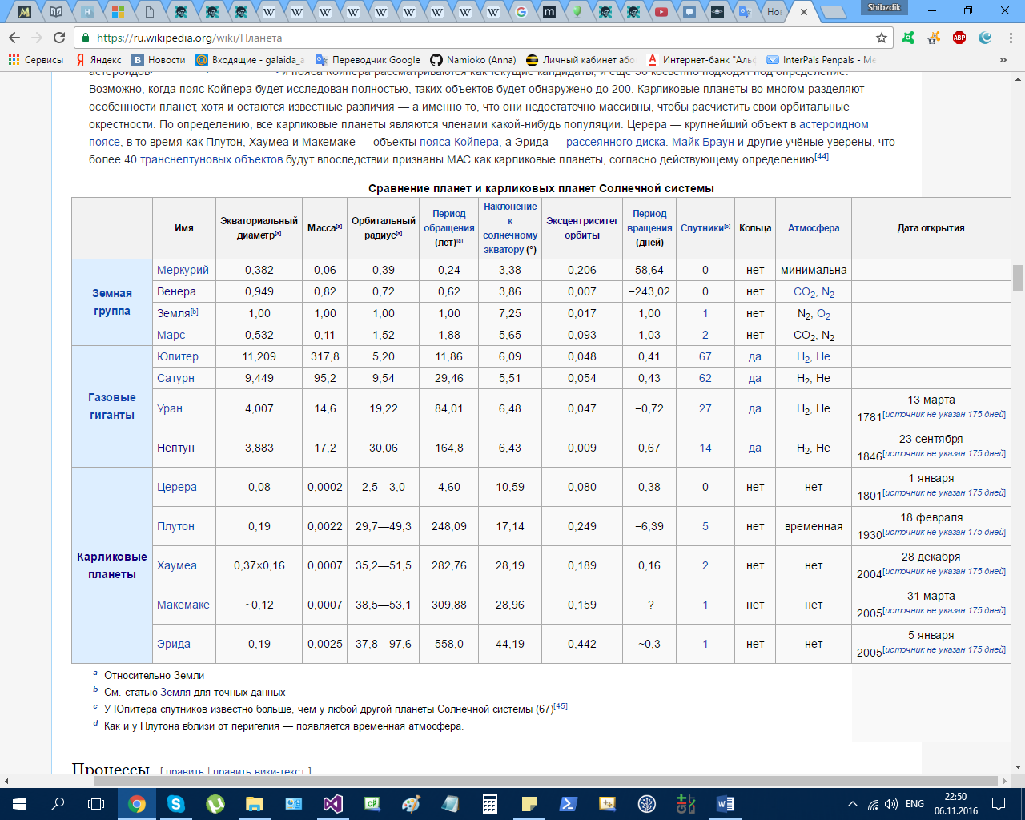

Орбитальный радиус – большая полуось (a)