NLP Project – 1 Report
Nijat Jafarov, Namig Planov

Introduction & Motivation
In this project, we introduce a custom corpus of Azerbaijani folktales collected from Wikisource and accompanied by a detailed datasheet to ensure transparency and reproducibility. Folktales were selected due to their public-domain status, narrative richness, and use of formal literary Azerbaijani, making them well-suited for linguistic analysis and educational use. Using this corpus, we systematically examine and compare multiple tokenization approaches, including word-level, character-level, and subword-based methods.
The goal of this work is twofold: first, to provide a clean and well-documented Azerbaijani text dataset that can be reused for NLP education and research; and second, to empirically analyze how different tokenization strategies affect token statistics and segmentation behavior in a morphologically rich, low-resource language setting. Through this study, we aim to highlight both the strengths and limitations of common tokenization techniques when applied to Azerbaijani text.

Related Background
Tokenization is a fundamental preprocessing step in Natural Language Processing, responsible for converting raw text into discrete units that can be processed by machine learning models. Early NLP systems commonly relied on word-level tokenization, typically using whitespace and punctuation as delimiters. While simple and interpretable, word-based approaches suffer from vocabulary sparsity and poor generalization in morphologically rich languages.
To address these limitations, character-level tokenization was introduced, representing text as sequences of individual characters. This approach eliminates out-of-vocabulary issues but significantly increases sequence length and often loses semantic structure. As a result, character-level methods are generally less efficient for higher-level language modeling tasks.
Subword-based tokenization methods have become the dominant approach in modern NLP systems. Techniques such as Byte-Pair Encoding (BPE) and Unigram Language Models aim to balance vocabulary size and representational power by segmenting words into frequently occurring subword units. These methods are particularly effective for languages with rich morphology, as they allow shared representations across related word forms.
SentencePiece is a widely used, language-independent tokenization framework that learns subword units directly from raw text without relying on whitespace-based preprocessing. Similarly, transformer-based models such as BERT employ WordPiece tokenization to manage rare and unseen words through subword decomposition.
Despite extensive research on tokenization in high-resource languages, relatively little work has focused on systematic analysis of tokenization behavior for Azerbaijani. This project builds on existing tokenization techniques and evaluates their applicability to a low-resource, morphologically rich language using a custom, well-documented corpus.

Dataset Description
The dataset introduced in this project consists of a collection of Azerbaijani folktales gathered from Wikisource, an online repository of public-domain literary texts. Folktales were selected due to their cultural significance, narrative richness, and use of formal literary Azerbaijani, making them suitable for linguistic analysis and educational NLP experiments.
All texts in the corpus are in standard Azerbaijani and are provided in plain text format. Each document corresponds to a single folktale and includes basic metadata such as the title and source reference. The dataset does not contain any personal or sensitive information and does not relate to identifiable individuals.
A comprehensive datasheet was created following established best practices for dataset documentation. The datasheet describes the motivation for dataset creation, data sources, collection and preprocessing steps, intended use cases, ethical considerations, and licensing information. This documentation ensures transparency, reproducibility, and responsible reuse of the dataset.

Methodology

4.1 Tokenization and Normalization (Task 1)
This stage performs text normalization and word-level tokenization. OCR artifacts and line-break hyphenation are corrected by removing hyphens followed by whitespace to prevent artificial word splits.
Tokenization is based on a regular expression tailored to the Azerbaijani alphabet, ensuring correct handling of language-specific characters (ə, ğ, ş, ç, ö, ü). All tokens are lowercased for consistency.
The output includes a token list, a set of unique word types, and a frequency dictionary, forming the basis for subsequent tasks.

4.2 Vocabulary Growth and Heaps’ Law (Task 2)
Vocabulary growth is analyzed by tracking cumulative token (N) and type (V) counts. Heaps’ Law is applied to model this relationship, with parameters estimated via logarithmic transformation and linear regression.
This analysis highlights the lexical richness of Azerbaijani and allows comparison with vocabulary growth patterns in other languages.

4.3 Byte Pair Encoding (BPE) Tokenization (Task 3)
To address large vocabulary size, Byte Pair Encoding is applied. Words are initially split into characters with an end-of-word marker, and frequent character pairs are iteratively merged.
After a fixed number of merges, the learned subword units are used to tokenize the corpus, effectively capturing frequent morphemes while reducing vocabulary size.

4.4 Sentence Segmentation (Task 4)
Sentence segmentation uses rule-based regular expressions adapted to Azerbaijani narrative texts. The method accounts for abbreviations, dialogue markers, and punctuation inconsistencies, minimizing incorrect splits.
Non-linguistic and empty segments are removed from the final sentence list.

4.5 Spell Checking with Standard Levenshtein Distance (Task 5)
A dictionary-based spell checker is implemented using Levenshtein distance. Insertions, deletions, and substitutions are modeled with dynamic programming, with substitutions assigned higher cost.
Edit sequences are extracted to explain correction decisions.

4.6 Weighted Levenshtein Distance (Additional Task)
A character-level confusion matrix is constructed using observed substitution frequencies. Candidate words are efficiently filtered via bigram indexing.
Weighted substitution costs derived from error statistics are integrated into the Levenshtein algorithm, improving correction accuracy.
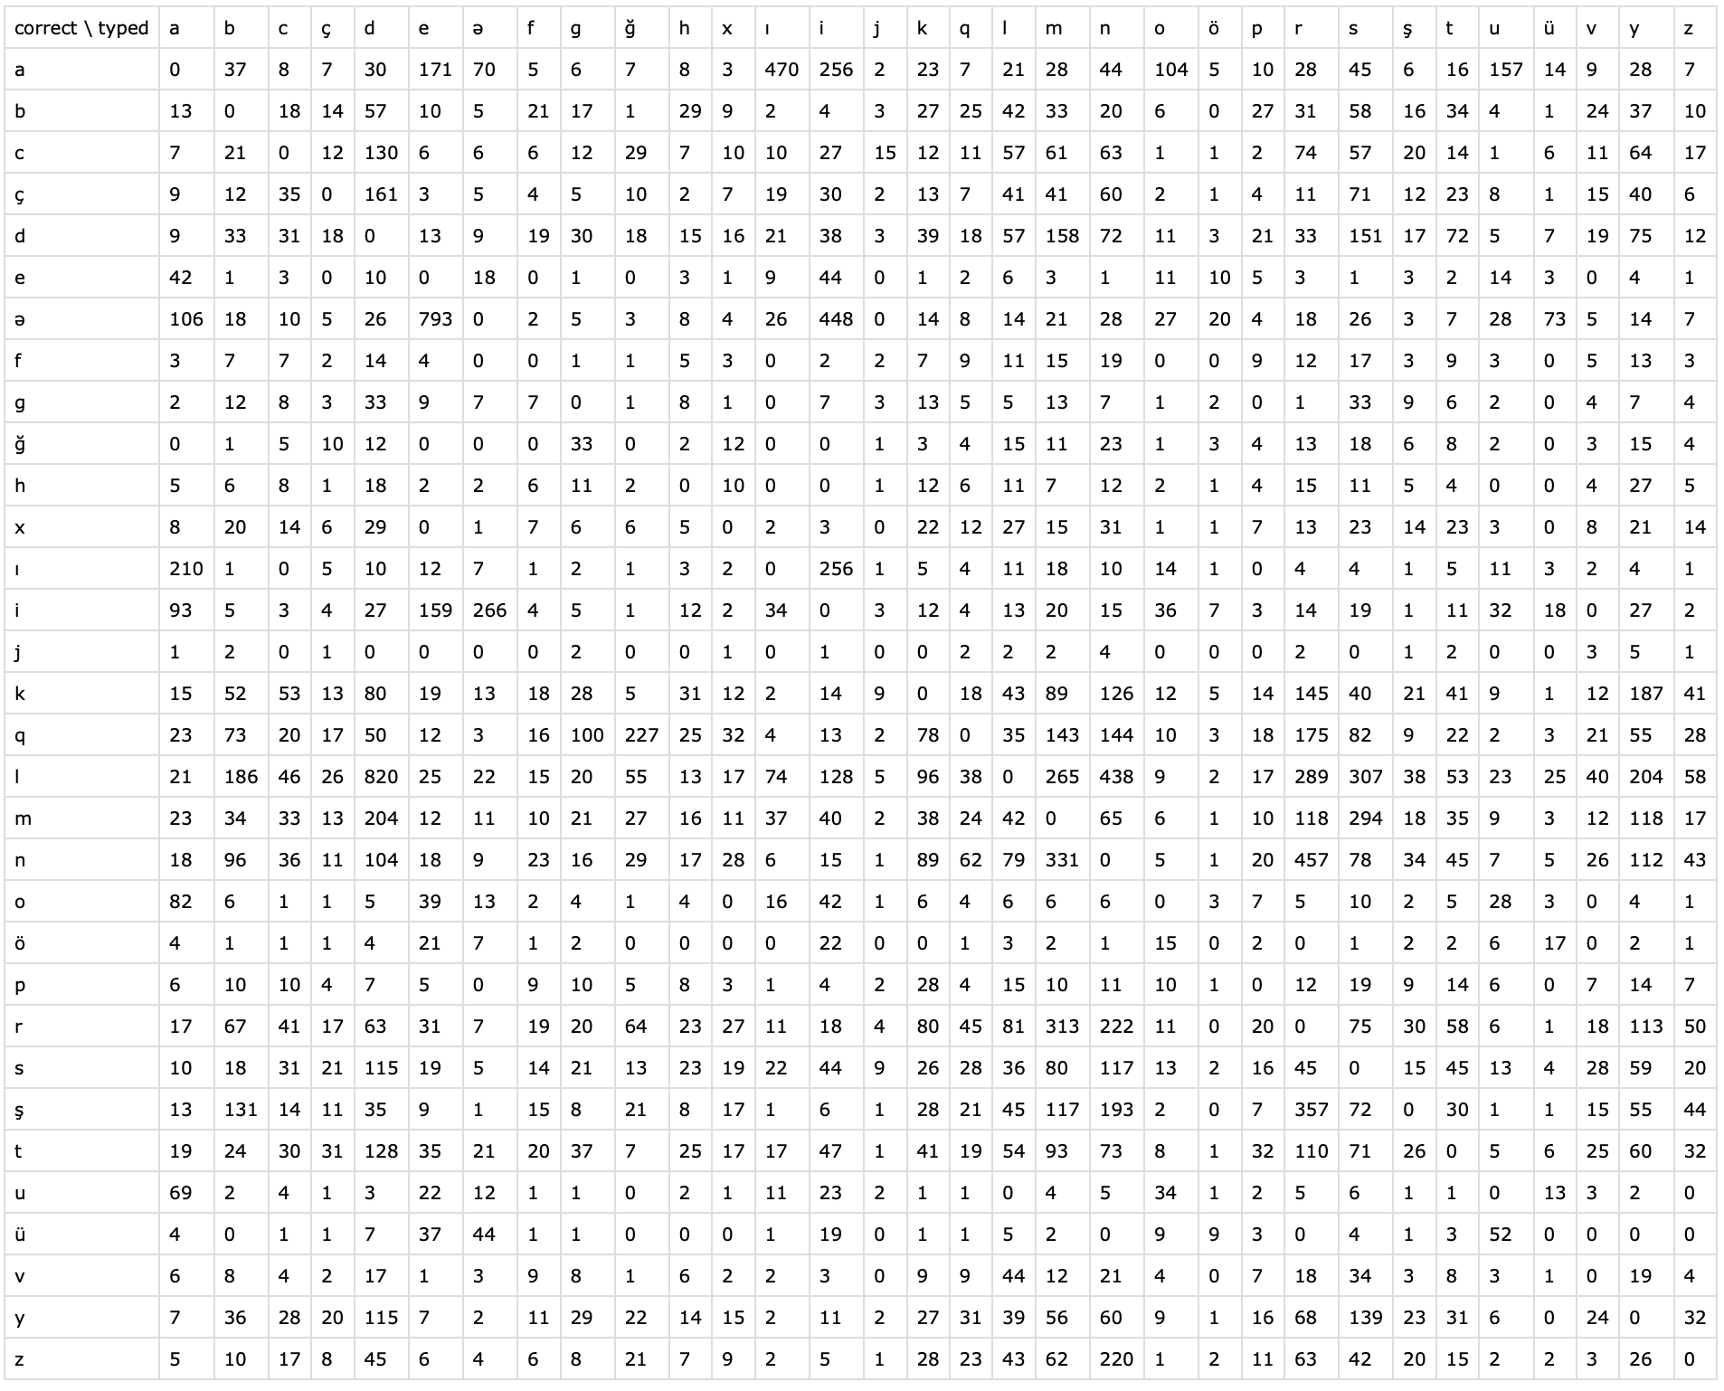
Figure 1: Confusion Matrix

Experiments & Results

5.1 Tokenization Results
The tokenizer produces clean and linguistically valid tokens, preserving Azerbaijani characters and correcting OCR-induced splits. The frequency distribution shows a typical long-tailed pattern.

5.2 Heaps’ Law Results
The estimated parameters confirm sublinear vocabulary growth. The relatively high β reflects the morphological richness of Azerbaijani.

5.3 BPE Tokenization Results
After 1000 merge operations, BPE significantly reduces vocabulary size while preserving meaningful stems and affixes, demonstrating effective subword modeling.

5.4 Sentence Segmentation Results
Manual evaluation shows accurate segmentation, especially in dialogue-heavy narrative texts.

5.5 Standard Levenshtein Results
The standard spell checker corrects many common errors but struggles to distinguish equally distant candidates.

5.6 Weighted Levenshtein Results
The weighted model consistently outperforms the standard approach by favoring linguistically plausible corrections, demonstrating the benefit of incorporating empirical error statistics.

Error Analysis & Discussion
When we prepared the confusion matrix, we used a dataset of noisy Azerbaijani tweets, and for checking correctness, we used an Azerbaijani dictionary. Initially, we tried to check each noisy token against the dictionary directly. However, this approach was very time-consuming. To improve efficiency, we incorporated bigrams. We converted each token into 2-character subtokens and searched for the correct version of the noisy word by identifying dictionary words that contained the most matching bigrams. This method, however, did not perform well. Although it accounted for substitutions based on similarity, from a human perspective, it was often clear that the word written by the user was unlikely to correspond to the version suggested by the program.

Team Contributions
All team members contributed equally to the conception, development, implementation, and documentation of the project. Responsibilities were divided to ensure efficient collaboration, but each member actively participated in discussions related to the theoretical background, experimental design, and interpretation of results.
Nijat Jafarov was primarily responsible for the data-related components of the project. This included collecting Azerbaijani folktales from Wikisource, cleaning and organizing the corpus, and creating a comprehensive datasheet documenting the dataset’s motivation, collection process, ethical considerations, and licensing. He also prepared the presentation slides.
Namig Planov focused mainly on the technical and experimental aspects of the project. This included researching relevant tokenization algorithms, implementing the tokenization methods in code, and conducting the experimental evaluations. Namig analyzed token statistics, compared different approaches, and contributed to the interpretation of experimental results.
Both members jointly reviewed the full report, discussed error analysis and limitations, and are equally prepared to answer questions related to the project’s theoretical foundations, implementation details, and experimental findings.

Limitations & Future Work
Despite its usefulness, the dataset and experiments in this project have several limitations:
- Domain limitation: The corpus consists exclusively of traditional folktales, which may not represent conversational, modern, or social media Azerbaijani.
- Dataset size: While sufficient for tokenization experiments, the dataset is relatively small for training large language models.
- Single preprocessing approach: Minimal preprocessing was applied to preserve linguistic structure; advanced normalization or morphological analysis was not included.
- Limited downstream evaluation: Tokenization methods were analyzed primarily through token statistics; their impact on downstream NLP tasks was not assessed.
Future work could address these limitations:
- Expanding the corpus to include other text domains (news, social media, literature) for broader applicability.
- Exploring morphology-aware tokenization methods and hybrid approaches for morphologically rich languages.
- Evaluating tokenization strategies on downstream NLP tasks such as language modeling, text classification, or named entity recognition.
- Developing Azerbaijani-specific NLP tools, including stemmers, lemmatizers, and spell-checkers, to enhance preprocessing pipelines.

- References

https://arxiv.org/pdf/1508.07909
https://arxiv.org/pdf/1804.10959
https://arxiv.org/pdf/1808.06226
https://arxiv.org/pdf/1803.09010

