**Features List**

After downloading the App

1. If mobile number already exists in the database(server), login using phone number and check credentials using OTP.
2. Else, User will be asked to register using phone number(verified with OTP) and provide the following details
   * Name #
   * Password ( to change the details)
   * Address
   * Email id
   * Date of birth #
   * Blood group # {to be prepared for emergency}
   * Health details #
   * Trusted contact details (minimum 3 contacts) #

# - compulsory

* UI of App
  + Home screen
    - Emergency button
    - Track me live button
    - Danger map
  + Side tab
    - Account info(edit right for trusted contact details)
    - Swipe settings
    - Instructions (Demo for swipe settings and how our app functions)
    - precautions(optional)
    - Notifications(about the user/trusted contacts/disaster team)
    - Map for danger area
* How our app works
  + **No emergency**
  + By default(static) our app takes location every one hour.
  + Whenever movement is observed(change of location from 50m radius) take location every 5mins.
  + Whenever user enters danger zone increase frequency to 30 seconds.
  + The user also has an option to choose - Track me live (which will track his location every 30 sec)*this can be used when he assumes to be in danger.
    - After a specific time (say 15 min), the user will be asked whether they are safe or not. From there, he has three options
      * Keep watching me
      * I am safe (stop tracking)
      * Emergency (send notification to disaster management server)
  + **Emergency**
  + The user clicks on the emergency button triggering the timer lasting 3 seconds, the user has the option of cancelling the action within the given time in case of triggering it by mistake. By the end of the countdown, the location will be shared with the trusted contacts and with the disaster management team.
    - With location on and internet on{Get location using GPS, and send it to the server.}
    - With location on and internet off{ get location using gps and send it via SMS (SMS gateway ) to server
    - With location off and internet on{ ask them to switch it on/do automatically}
    - With location off and internet off
    - Without cellular network
    - Temporary solution (dial 112)00
    - Dependencies - if the government can provide us with a unique gvt number we can use without cellular network to send information.
  + An SMS including link to view location will be sent to all the trusted contacts.
  + If the trusted contacts is registered in the App then they will also be notified, can watch them.
  + The server gets location of user through SMS gateway/internet.
  + This information will be sent to the disaster management server through our server.
  + User gets a notification(additional option) to send a note(voice(internet connection)/text) which is optional.
    - This note will be sent as an SMS if text to trusted contacts.
    - The voice message will be sent only if the internet connection is available.
    - These notes will be sent to server and notified to disaster management team(for taking appropriate action).
  + If the User is safe he can go to the app and click on the ‘I am safe button’.
    - This will change the status of user from Active emergency to Action not taken.
    - The location tracking frequency decreases to default.
    - Then we will ask the User to enter the type of Emergency occurred/no emergency. (to update the category of emergency)
    - Flowchart

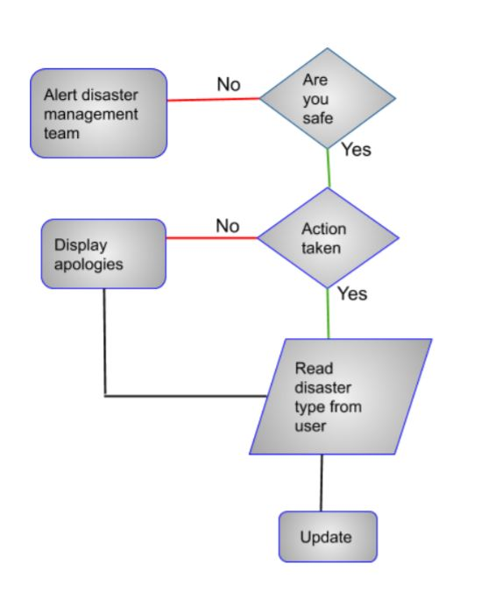

* + Else, we wait for the acknowledgement from the disaster management team.
    - If Acknowledgment provided
      * Update the condition of user to Action taken(green).
      * Send notification/SMS link to trusted contacts to confirm condition.(flowchart)
      * Update the type of problem.
    - If  not acknowledged within 12hrs
      * By default ‘Action not taken’.
    - If no reply after 24hrs
      * Update the condition to ‘action not taken’ until disaster any notification from disaster management team or trusted contacts.
  + Flowchart

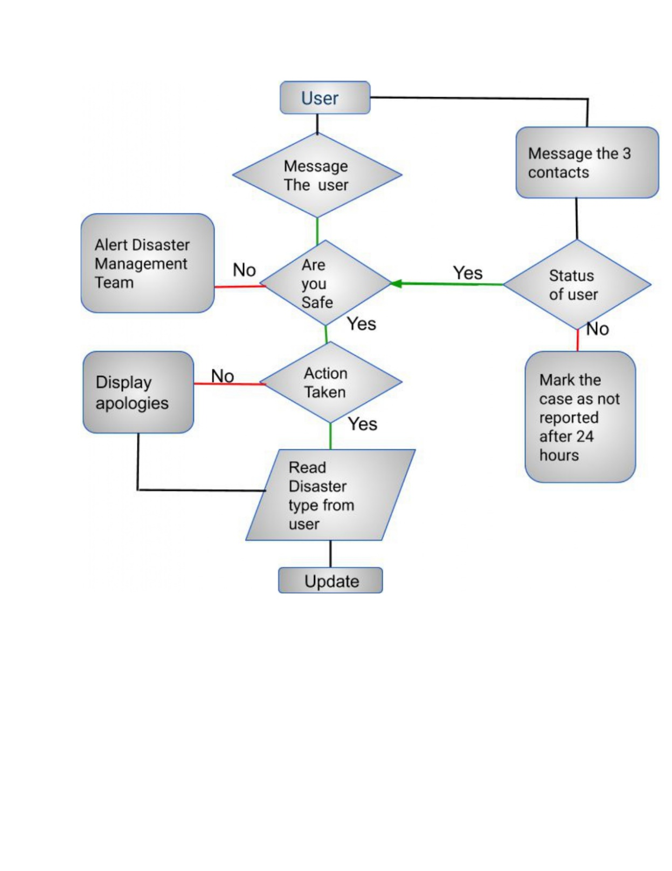

**Server side**

* We store information of
  + User details
  + User tracking
  + Emergency History
  + Connection to external server
  + Connection to trusted contacts
  + Emergency Category information
  + Emergency report
  + Danger zones
* Site

Different dashboards for the types of users(without login, login as user, login as administrator, login as disaster management member). The site will have the following options on the interface.

* + User Management
  + External Configuration
  + Emergency report
  + Performance report
  + Location tracking
  + Notifications
  + Status Check
  + Notify DMS
  + Acknowledgement
* For User:
  + - See information about himself and trusted contacts
    - See danger map
    - Fill in form of emergency report in any
  + For integrated server team
    - See information of emergencies reported
    - Fill in the details of emergency actions taken
  + Open through link in message
    - To report information about the concerned user/person.
    - To view map.

**Information enrichment:**

Dependencies: If the government can provide us with addition map with danger zones and location we can integrate into our map to show the zones and emergencies.

* Categorize reported emergencies into:
  + Can happen again in the same location?
    - Yes
    - No
  + Types of disaster:
    - Manmade/Natural disaster
    - Criminal
    - Accident
    - Health
  + Action taken/not taken

**Analytics**

Taking all the categories and 3rd party information of danger zones we can mark some regions as danger zone on a scale of 5.We can provide the information about the reported emergencies on the map.

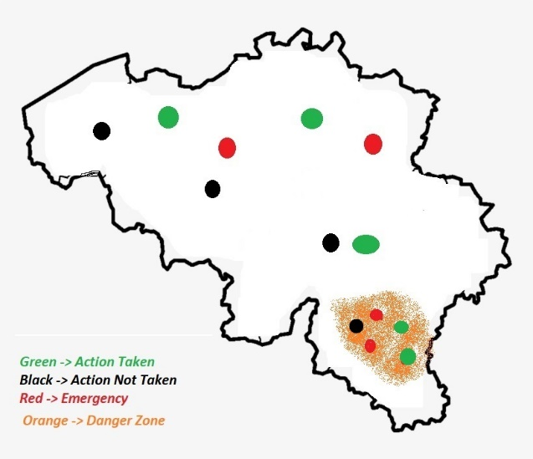

Technology Stack:

**APP:**

1. API: Rest API
2. Database: SQLite
3. Language: JavaScript
4. Platform: Ionic Framework
5. Operation System: Android, IOS

**SERVER:**

1. API: Rest API
2. Web Framework: Django
3. Language: Python
4. Database: PostgreSQL