Smart City Electronics Wiring Code Blueprint
Mapped build plan for the AI for a Better Future school exhibition model

Build Scope
This blueprint maps the electronics, wiring, source code, testing sequence, and safe construction plan for a 90 cm by 60 cm smart-city model. It uses one Arduino Uno-compatible board as the central controller and keeps every classroom circuit low-voltage.
The model demonstrates automation and sensing. It does not diagnose patients, control real traffic, identify people, or use household mains electricity.

System Architecture
Module | Electronics | Input | Output | Purpose
Healthcare | Analog temperature sensor such as LM35 or TMP36 | Temperature voltage on A1 | Serial value and optional status LED/OLED | Shows health monitoring as a sensor demonstration
Environment | LDR, 10 kOhm resistor, streetlight LEDs | Light divider on A0 | Street LEDs on D8 | Turns lights on when the model area is dark
Transportation | Red, yellow, green LEDs; ultrasonic sensor; button | D3/D4 distance, D10 request | Traffic LEDs on D5-D7 | Runs normal and emergency-priority demo sequences
Safety | PIR motion sensor, alert LED, optional active buzzer | Motion on D2 | LED on D9, buzzer on D11 | Shows movement-triggered alerting
Control center | Arduino Uno-compatible board and breadboard | All module signals | Serial Monitor readings | Centralizes wiring and code

Physical Blueprint
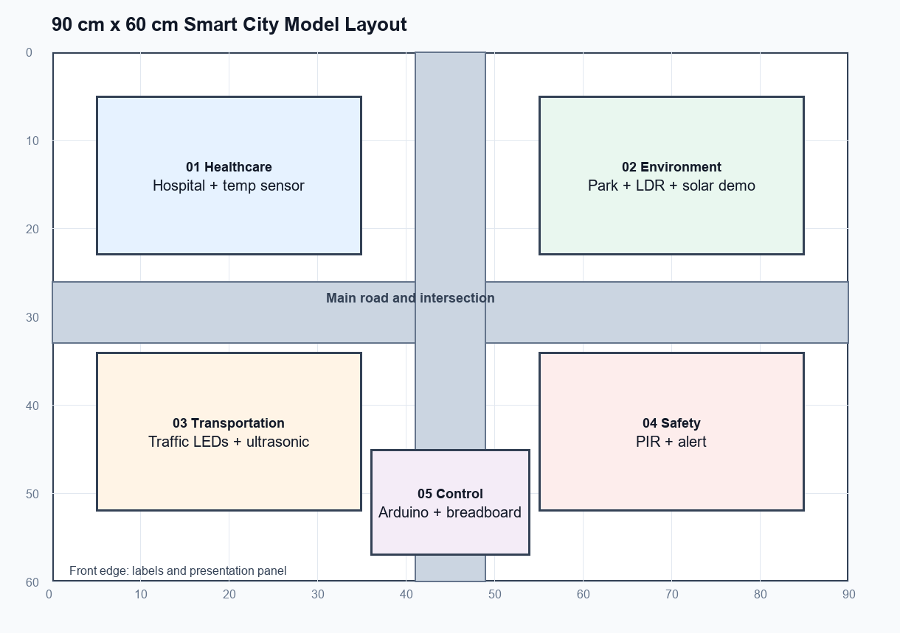
Zone | Position on base | Build notes
Healthcare | x 5-35 cm, y 5-23 cm | Hospital shell; sensor wires exit through the base.
Environment | x 55-85 cm, y 5-23 cm | Park, solar display, LDR exposed to room light.
Transportation | x 5-35 cm, y 34-52 cm | Road junction, traffic LEDs, ultrasonic sensor facing road.
Safety | x 55-85 cm, y 34-52 cm | Security building, PIR facing walkway.
Control center | x 36-54 cm, y 45-58 cm | Accessible Arduino, breadboard, USB port, and power switch.

Central Wiring Diagram
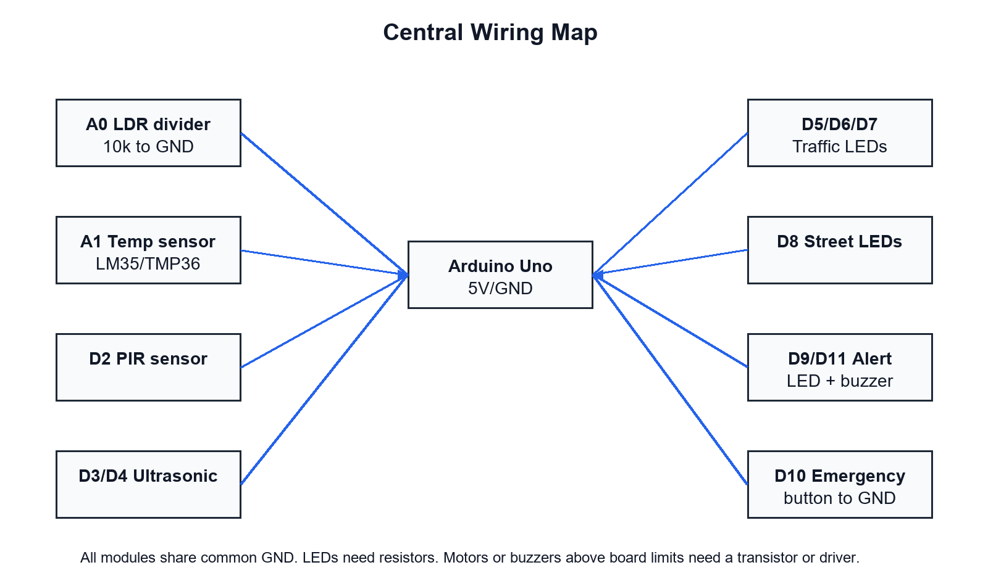

Final Pin Map
Arduino pin | Connected part | Wire path | Electrical rule
A0 | LDR divider midpoint | 5V -> LDR -> A0 -> 10 kOhm -> GND | If readings invert, swap LDR and resistor positions or invert code comparison.
A1 | Temperature signal | Sensor VCC to 5V, GND to GND, OUT to A1 | Use the formula matching the chosen sensor.
D2 | PIR OUT | PIR VCC to 5V, GND to GND, OUT to D2 | Allow warm-up time before judging false triggers.
D3 | Ultrasonic TRIG | D3 to TRIG | Digital output pulse.
D4 | Ultrasonic ECHO | ECHO to D4 | Check module voltage compatibility.
D5 | Red traffic LED | D5 -> 220 ohm -> LED anode, cathode to GND | Each LED needs its own resistor.
D6 | Yellow traffic LED | D6 -> 220 ohm -> LED anode, cathode to GND | Do not share one resistor across multiple LEDs.
D7 | Green traffic LED | D7 -> 220 ohm -> LED anode, cathode to GND | Keep wires color-coded.
D8 | Streetlight LEDs | D8 -> resistor(s) -> LEDs -> GND | For many LEDs, use a transistor driver.
D9 | Alert LED | D9 -> 220 ohm -> LED -> GND | Visual security alert.
D10 | Emergency button | D10 to one button leg; other leg to GND | Code uses INPUT_PULLUP.
D11 | Optional buzzer | D11 to buzzer driver/input | Use a transistor driver if current exceeds pin rating.
5V/GND | Power rails | Arduino 5V and GND to breadboard rails | All modules must share common GND.

Module Wiring Details

Environment Streetlight
Build the LDR as a voltage divider. Use Serial Monitor to record bright and dark values, then tune DARK_THRESHOLD in the code.

Traffic Junction
Place the red, yellow, and green LEDs beside the road. The button simulates an emergency vehicle request and temporarily keeps green on for the demo lane.

Safety Alert
Mount the PIR above the security building entrance. Keep scenery away from the lens and expect a short warm-up time after power-on.

Healthcare Temperature Demo
Use LM35 or TMP36-style wiring only after confirming the selected part pinout. Label the display as a temperature monitoring demonstration.

Electronics List
Part | Qty | Typical value or type | Needed for
Arduino Uno-compatible board | 1 | 5V logic | Central controller
Breadboard and jumpers | 1 set | Male-male and male-female | All wiring
LDR | 1 | Photoresistor | Automatic streetlight
Fixed resistor | 1 | 10 kOhm | LDR divider
LEDs | 8-12 | Red, yellow, green, white, alert color | Traffic, street, security
LED resistors | 8-12 | 220-330 ohm | Current limiting
PIR sensor | 1 | HC-SR501 or similar | Security
Ultrasonic sensor | 1 | HC-SR04 or compatible | Proximity
Temperature sensor | 1 | LM35 or TMP36 | Healthcare demo
Push button | 1 | Momentary | Emergency request
Active buzzer | 1 optional | 5V module preferred | Alert sound
NPN transistor and diode | as needed | 2N2222 plus flyback diode | Required for motor or high-current loads

Arduino Code
Save the companion sketch as SmartCity_Blueprint_Code.ino, or copy the code below into the Arduino IDE.
// Smart City Blueprint Demonstrator
// Board: Arduino Uno-compatible
// Purpose: classroom model for streetlight automation, traffic LEDs,
// PIR security alert, ultrasonic proximity, emergency-priority demo,
// and optional analog temperature reading.

const byte LDR_PIN = A0;
const byte TEMP_PIN = A1; // LM35/TMP36-style analog sensor demo
const byte PIR_PIN = 2;
const byte TRIG_PIN = 3;
const byte ECHO_PIN = 4;

const byte RED_LED = 5;
const byte YELLOW_LED = 6;
const byte GREEN_LED = 7;
const byte STREET_LED = 8;
const byte ALERT_LED = 9;
const byte EMERGENCY_BUTTON = 10; // Button to GND, uses INPUT_PULLUP
const byte BUZZER_PIN = 11; // Optional active buzzer through driver if needed

const int DARK_THRESHOLD = 450; // Calibrate using Serial Monitor
const int NEAR_DISTANCE_CM = 15; // Proximity demo threshold
const unsigned long NORMAL_STEP_MS = 3000;
const unsigned long EMERGENCY_GREEN_MS = 5000;
const unsigned long PULSE_TIMEOUT_US = 25000;

unsigned long lastTrafficChange = 0;
unsigned long emergencyStarted = 0;
byte trafficState = 0; // 0 red, 1 green, 2 yellow
bool emergencyMode = false;

void setTraffic(bool redOn, bool yellowOn, bool greenOn) {
digitalWrite(RED_LED, redOn ? HIGH : LOW);
digitalWrite(YELLOW_LED, yellowOn ? HIGH : LOW);
digitalWrite(GREEN_LED, greenOn ? HIGH : LOW);
}

float readDistanceCm() {
digitalWrite(TRIG_PIN, LOW);
delayMicroseconds(2);
digitalWrite(TRIG_PIN, HIGH);
delayMicroseconds(10);
digitalWrite(TRIG_PIN, LOW);

unsigned long duration = pulseIn(ECHO_PIN, HIGH, PULSE_TIMEOUT_US);
if (duration == 0) return -1.0;
return duration * 0.0343 / 2.0;
}

float readTemperatureC() {
int raw = analogRead(TEMP_PIN);
float volts = raw * (5.0 / 1023.0);
// LM35: 10 mV per degree C. For TMP36 use: (volts - 0.5) * 100.0
return volts * 100.0;
}

void runNormalTraffic() {
unsigned long now = millis();
if (now - lastTrafficChange >= NORMAL_STEP_MS) {
trafficState = (trafficState + 1) % 3;
lastTrafficChange = now;
}

if (trafficState == 0) setTraffic(true, false, false);
if (trafficState == 1) setTraffic(false, false, true);
if (trafficState == 2) setTraffic(false, true, false);
}

void runEmergencyTraffic() {
if (!emergencyMode) {
emergencyMode = true;
emergencyStarted = millis();
setTraffic(false, false, true);
}

if (millis() - emergencyStarted >= EMERGENCY_GREEN_MS) {
emergencyMode = false;
trafficState = 2;
lastTrafficChange = millis();
setTraffic(false, true, false);
}
}

void setup() {
pinMode(PIR_PIN, INPUT);
pinMode(TRIG_PIN, OUTPUT);
pinMode(ECHO_PIN, INPUT);
pinMode(EMERGENCY_BUTTON, INPUT_PULLUP);

pinMode(RED_LED, OUTPUT);
pinMode(YELLOW_LED, OUTPUT);
pinMode(GREEN_LED, OUTPUT);
pinMode(STREET_LED, OUTPUT);
pinMode(ALERT_LED, OUTPUT);
pinMode(BUZZER_PIN, OUTPUT);

Serial.begin(9600);
setTraffic(true, false, false);
lastTrafficChange = millis();
}

void loop() {
int lightValue = analogRead(LDR_PIN);
bool dark = lightValue < DARK_THRESHOLD; // Reverse if your divider is opposite.
digitalWrite(STREET_LED, dark ? HIGH : LOW);

bool motionDetected = digitalRead(PIR_PIN) == HIGH;
digitalWrite(ALERT_LED, motionDetected ? HIGH : LOW);
digitalWrite(BUZZER_PIN, motionDetected ? HIGH : LOW);

float distanceCm = readDistanceCm();
bool emergencyRequested = digitalRead(EMERGENCY_BUTTON) == LOW;

if (emergencyRequested || emergencyMode) runEmergencyTraffic();
else runNormalTraffic();

Serial.print("LDR=");
Serial.print(lightValue);
Serial.print(" Dark=");
Serial.print(dark ? "YES" : "NO");
Serial.print(" Motion=");
Serial.print(motionDetected ? "YES" : "NO");
Serial.print(" Distance_cm=");
if (distanceCm < 0) Serial.print("NO_ECHO");
else Serial.print(distanceCm, 1);
Serial.print(" Near=");
Serial.print((distanceCm > 0 && distanceCm <= NEAR_DISTANCE_CM) ? "YES" : "NO");
Serial.print(" Temp_C=");
Serial.println(readTemperatureC(), 1);

delay(100);
}

Build Order
- Mark the base layout and drill small wire holes before fixing buildings.
- Assemble one circuit at a time on the breadboard and test it with Serial Monitor.
- Install the controller in the control center with USB access still visible.
- Route sensor wires under the board and label both ends with pin numbers.
- Install LEDs after testing polarity and resistor placement.
- Secure wires with tape or clips only after all modules pass testing.
- Run the full demonstration at least five times before the exhibition.

Testing Checklist
Test | Expected result | Fix if it fails
Upload sketch | No compile or upload errors | Select correct board and port; use a data USB cable.
LDR bright/dark | Serial value changes clearly | Swap divider orientation or adjust threshold.
Streetlight | Turns on in low light | Check D8, resistor, LED polarity, and threshold.
PIR | Alert turns on with motion | Wait for warm-up; check D2 and module power.
Ultrasonic | Distance appears in Serial Monitor | Check TRIG/ECHO and point at a flat target.
Traffic LEDs | Red, green, yellow sequence repeats | Check D5-D7 and each LED resistor.
Emergency button | Green priority demo starts | Check button from D10 to GND.
Buzzer | Sounds only during motion | Use a driver if the buzzer draws too much current.

Safety Rules
- Use only USB or a regulated low-voltage supply.
- Never connect household mains electricity to the model.
- Never power motors directly from Arduino pins.
- Every LED branch needs current limiting.
- Disconnect power before rewiring.
- Keep bare wire ends separated and insulated.
- Label conceptual AI features separately from working automation features.

