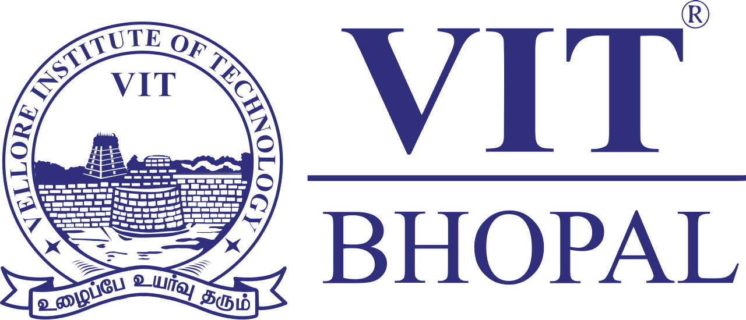

Digital Literacy Report
Name : Namit Magotra
Registration Number : 25MIB10013
Branch : Int.Mtech Bioinformatics And Artificial Intelligence
Year : 2025-2026
Course Code :
Date : 24th March 2026

Introduction
The project and the course focuses on developing digital literacy skills that are essential for students and adults in today’s technology driven world. As a student digital ambassador my goal was to understand and promote safe responsible and effective use of digital technology and tools. Through this project, I explored many aspect of digital literacy and digital world such as creating an effective infographic, building a profesional online portfolio , using coding and collboration platforms , practicing email etiquette in professional way and understanding what cybercrime is and prevntions to be taken.
Each of these tasks have helped me to gain practical experience and navigate digital world confidently and safely. This project enhanced my technical skills and ahelped me to build awreness and be aware of the harms of digital world and the scams involved in it. Overall, it prepared me to use digital technologies more effectively in both academic and real world situations.
Task-1: Infographic
For my first task, I created a digital litecy infographic using Canva. The infographic was designed as a singular slide that highlighted the key points of digital literacy in a simple manner. It included topics what digital literacy means , what are some useful tools for students, and safe internet practices to follow. I used pictures,captivating info and other stuff to make the content visually appealing and easy to understand at a glance and to capture the maximum amount of information.
The goal of the design was to ensure that students can quickly understand the key and important concepts related to using digital world effectively and responsibly. Canva made it easy to make a template , add colors , pictures and edit it with ease
One challenge I faced was selecting the right amount of content without making the infographic look too crowded. However, this helped me learn how to present information in a very concise yet beautiful manner. Overall, this task improved my creativity and ability to communicate ideas clearly through design.
Task-2: Digital Portfolio
For Task 2, I created and updated my profiles on GitHub, LinkedIn, and Kaggle to build a professional digital presence. On GitHub, I set up my profile README, which includes my name, branch, year, and a brief description of my learning goals. This platform will help me showcase my coding projects and track my progress over time.
On LinkedIn, I completed my education details, including my degree, institution, and expected graduation year. LinkedIn will help me connect with professionals, explore career opportunities, and build a professional network. On Kaggle, I created an account to explore datasets and improve my skills in data analysis and machine learning.
These platforms are important for students as they help in building a strong online portfolio. Over the next four years, I plan to actively use these platforms to share my work, learn new skills, and connect with others in my field. This task helped me understand the importance of maintaining a professional digital identity.
Task-3: Platforms
For Task 3, I explored both coding practice platforms and collaboration tools. I created an account on HackerRank and completed a beginner-level problem, which helped me understand basic problem-solving and coding logic. This platform is useful for improving programming skills and preparing for technical interviews.
In addition, I created a Google Form as a Digital Literacy Awareness Quiz with five questions, including multiple-choice and descriptive questions. I also viewed the responses in Google Sheets, which helped me understand how data can be collected and analyzed efficiently.
These tools are very useful for students as they support both learning and collaboration. HackerRank helps in building coding skills, while Google Forms and Sheets are useful for surveys, quizzes, and teamwork. This task gave me hands-on experience with practical tools that I can use throughout my academic journey. It also improved my understanding of how technology can be used for both individual learning and group activities.
Task-4: Email Etiquette
In Task 4, I learned about professional email communication and digital etiquette. I wrote two emails—one requesting an assignment extension from a professor and another expressing interest in an internship opportunity. This helped me understand the importance of maintaining a clear subject line, polite tone, proper structure, and formal sign-off.
I also created a checklist of do’s and don’ts for responsible social media use. One situation where poor communication can cause problems is when a student sends an informal or unclear email to a professor, which may be ignored or misunderstood. This can lead to missed opportunities or negative impressions. To avoid this, it is important to be clear, respectful, and professional in all digital communication. This task improved my awareness of how to communicate effectively online.
Task-5: Cybercrime
In Task 5, I explored cybercrime and learned about different online threats such as phishing and UPI fraud. What surprised me the most was how easily people can become victims of scams through simple actions like clicking on unknown links or sharing personal information.
I also created a prevention checklist that included practical tips to stay safe online, especially for students. One important habit I will change is being more cautious while sharing personal or financial information online. I will also make sure to verify sources before trusting any message or link. This task increased my awareness of online risks and taught me how to protect myself and others in the digital world.

