<PREDICTIVE ANALYSIS USING R> PROJECT REPORT
(Project Semester August-December 2024)

Analysis and Classification of Vertebral Column Dataset

Submitted by
Namita

Registration No 12214379

Programme and Section BTech CSE
Course Code .INT 234.

Under the Guidance of

Mr Anchal Kaundal (29612)

Discipline of CSE/IT

Lovely School of Computer Science

Lovely Professional University, Phagwara

CERTIFICATE

This is to certify that NAMITA bearing Registration no. 12214379 has completed INT 234> project titled, “.Analysis and Classification of Vertebral Column Dataset” under my guidance and supervision. To the best of my knowledge, the present work is the result of his/her original development, effort and study.

Signature and Name of the Supervisor
Designation of the Supervisor
School of COMPUTER SCIENCE
Lovely Professional University
Phagwara, Punjab.

Date: 17-11-2024

DECLARATION

I, .NAMITA, student of B Tech CSE under CSE/IT Discipline at, Lovely Professional University, Punjab, hereby declare that all the information furnished in this project report is based on my own intensive work and is genuine.

Date: 17-11-2024 Namita
Registration No.12214379 Name of the student

Project Introduction
The primary goal of this project is to classify and analyze vertebral column data using a variety of machine learning algorithms. The vertebral column, or spine, is a critical part of the human skeletal system, and abnormalities in its structure can lead to significant health issues such as herniated discs, spondylolisthesis, and lumbar lordosis. Accurate diagnosis is essential for effective treatment planning, and machine learning models can offer valuable insights by identifying patterns in the data that are not easily discernible through traditional diagnostic methods.
To achieve this goal, we employ various machine learning techniques, including:
- Artificial Neural Networks (ANN)
- Decision Trees
- Support Vector Machine (SVM)
- K-Means Clustering
These algorithms will help in identifying patterns within the dataset, classifying patients as having either a normal or abnormal vertebral condition, and ultimately determining which model performs the best based on specific evaluation metrics.

Motive of the Project
The main objectives of this project are:
- Automated Diagnosis: To develop a reliable classification system that can automatically diagnose vertebral column conditions based on given attributes.
- Model Comparison: To compare the performance of various machine learning models and identify the most effective algorithm for this specific classification problem.
- Data-Driven Insights: To derive insights from the data that may help in better understanding the contributing factors to vertebral abnormalities.
- Scalability: To lay the foundation for future improvements, enabling the integration of more advanced algorithms or neural network architectures for even better performance.
This project not only aims to classify the data but also to contribute to the medical field by providing a scalable and efficient diagnostic tool.

Scope of the Analysis
The project involves several key steps, which are outlined as follows:
- Data Preprocessing and Normalization:
  - Data cleaning and preprocessing are crucial steps to ensure the models receive high-quality inputs.
  - Normalization of features is performed using the min-max normalization technique, which scales the data to a range between 0 and 1. This step helps in improving the convergence of certain machine learning algorithms like neural networks and SVMs.
- Implementation of Machine Learning Models:
  - Artificial Neural Networks (ANN): A deep learning model inspired by the biological neural network in the human brain. It is used here to capture complex, non-linear relationships in the dataset.
  - Decision Trees: A non-parametric supervised learning method that is easy to interpret and can handle both numerical and categorical data. It works by recursively splitting the data based on feature values to create a tree-like model of decisions.
  - Support Vector Machine (SVM): A supervised learning algorithm that constructs a hyperplane or set of hyperplanes in a high-dimensional space to classify the data points effectively. It is particularly useful for binary classification problems.
  - K-Means Clustering: An unsupervised learning technique used for clustering the dataset into two groups (normal and abnormal). It helps in exploratory data analysis and can provide insights into the natural grouping of the data points.
- Model Evaluation and Comparison:
  - The models are evaluated using various metrics such as accuracy, precision, recall, and F1-score.
  - The results of these metrics will help in determining the best-performing model for the classification task.

Source of the Dataset
The dataset used in this analysis is publicly available and was originally collected for the purpose of diagnosing vertebral column conditions. It contains the following attributes related to pelvic and spinal characteristics:
- Pelvic Incidence
- Pelvic Tilt
- Lumbar Lordosis Angle
- Sacral Slope
- Pelvic Radius
- Grade of Spondylolisthesis
The target variable is a binary classification indicating whether the patient’s vertebral column is normal (0) or abnormal (1). The dataset is suitable for binary classification tasks and is a good fit for evaluating the performance of various machine learning algorithms.

ETL (Extract, Transform, Load) Process
The ETL process in this project involves the following steps:
- Extract:
  - The dataset is loaded into the R environment using the read.csv function. R is chosen for its powerful data manipulation and visualization capabilities.
- Transform:
  - Data cleaning is performed, where missing values and outliers are handled appropriately.
  - The target variable, which indicates the condition of the vertebral column, is converted into a binary format (0 for Normal, 1 for Abnormal).
  - Feature normalization is carried out using min-max normalization, which helps in scaling the features to a uniform range of [0, 1]. This step is especially important for algorithms that are sensitive to the scale of data, like neural networks and SVMs.
- Load:
  - The cleaned and transformed data is ready for modeling. It is split into training and testing datasets to evaluate the performance of different machine learning models.

Analysis on the Dataset
The analysis involves applying the following machine learning models:
- Artificial Neural Networks (ANN):
  - ANN is used to capture complex relationships in the data. It is designed with multiple layers, including an input layer, one or more hidden layers, and an output layer.
  - The model is trained using a backpropagation algorithm to minimize the error between the predicted and actual outcomes.
  - ANN is chosen for its ability to model non-linear and complex interactions between features.
- Decision Tree:
  - This algorithm is chosen for its interpretability and simplicity. It uses a tree-like structure where internal nodes represent feature conditions, and leaves represent the classification outcomes (normal or abnormal).
  - It helps in identifying the most important features contributing to the classification.
- Support Vector Machine (SVM):
  - SVM is applied for its effectiveness in binary classification problems. It finds the optimal hyperplane that maximizes the margin between the two classes.
  - The kernel trick is used to handle non-linearly separable data, allowing the SVM to perform better with complex datasets.
- K-Means Clustering:
  - K-Means is used as an unsupervised learning technique to explore the natural grouping in the data. It helps in understanding the underlying structure of the dataset and can provide initial insights before applying supervised learning models.

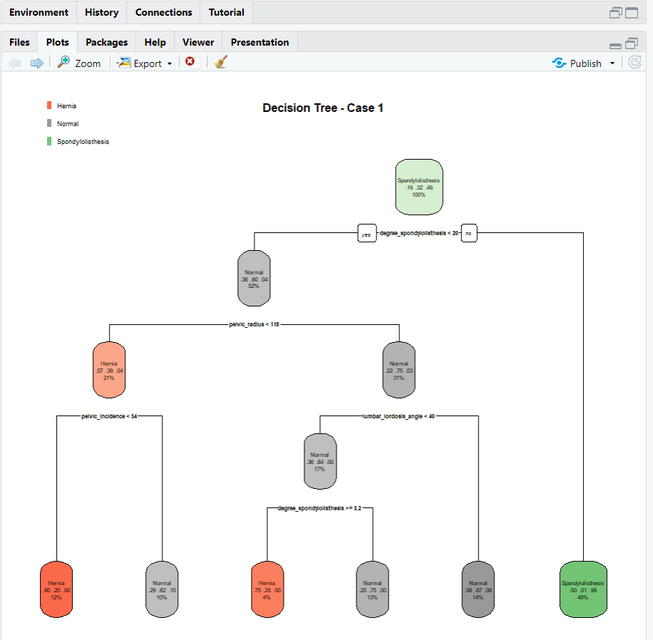

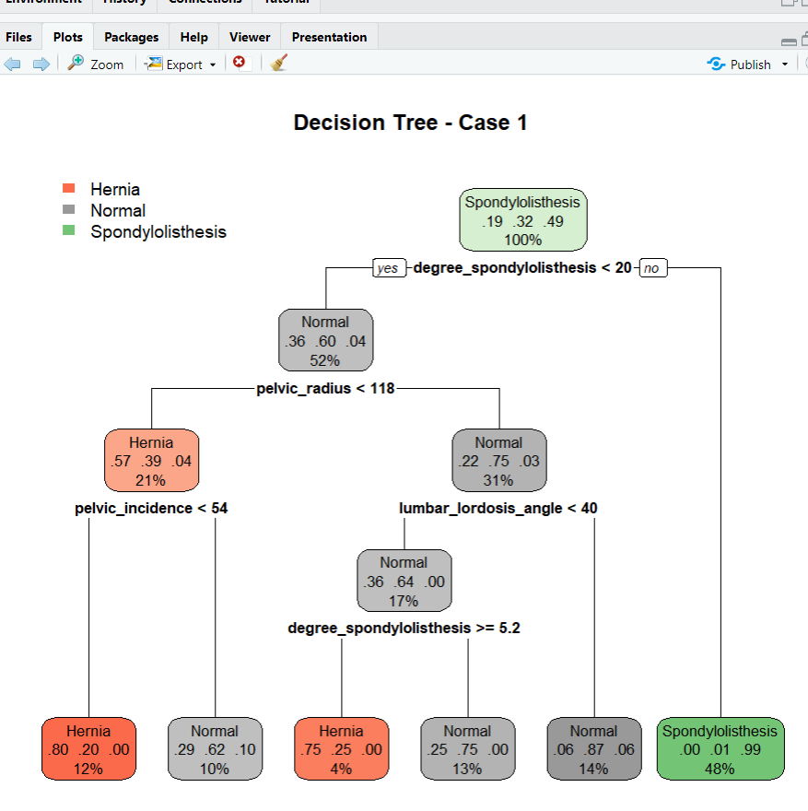

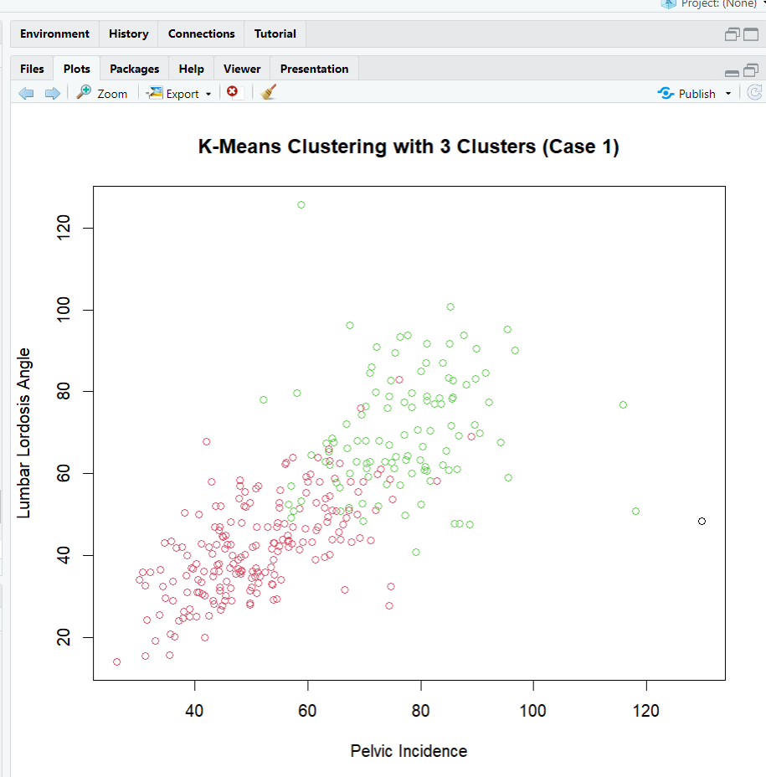

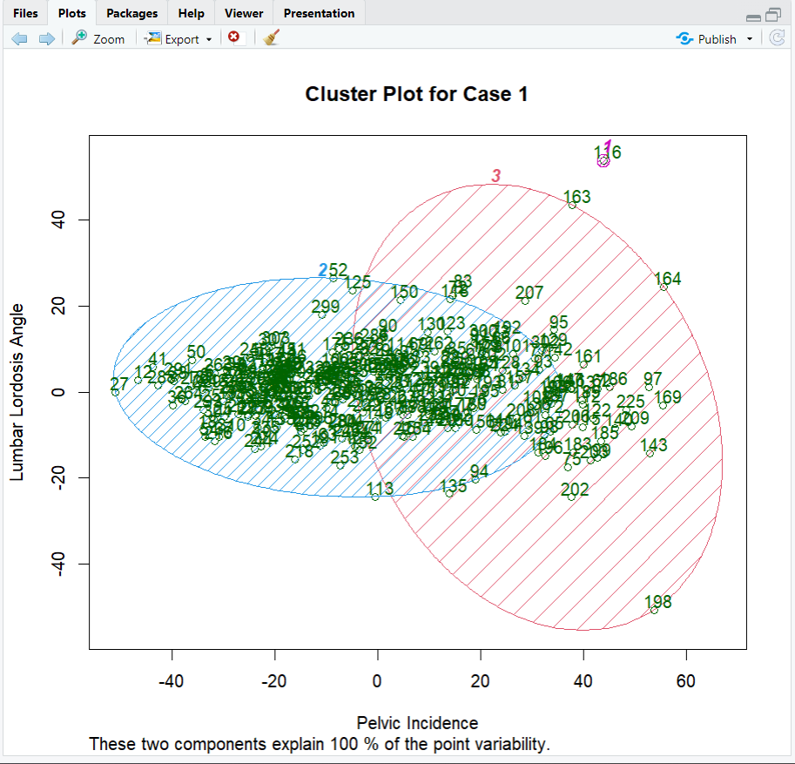

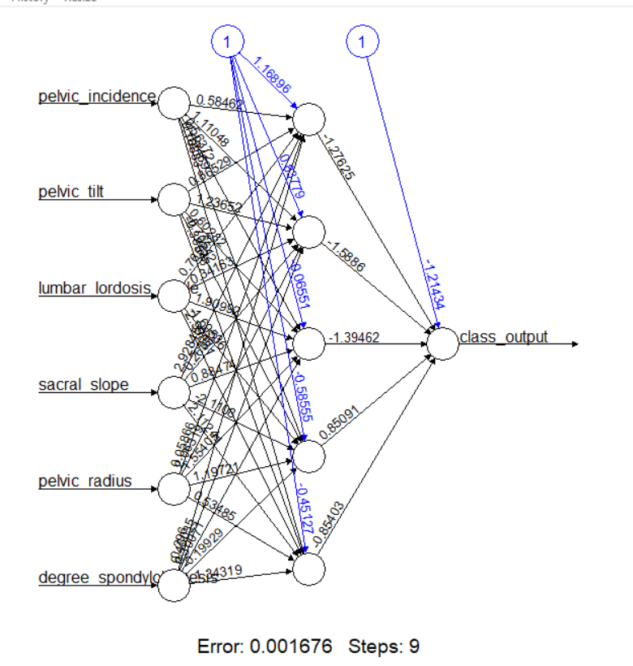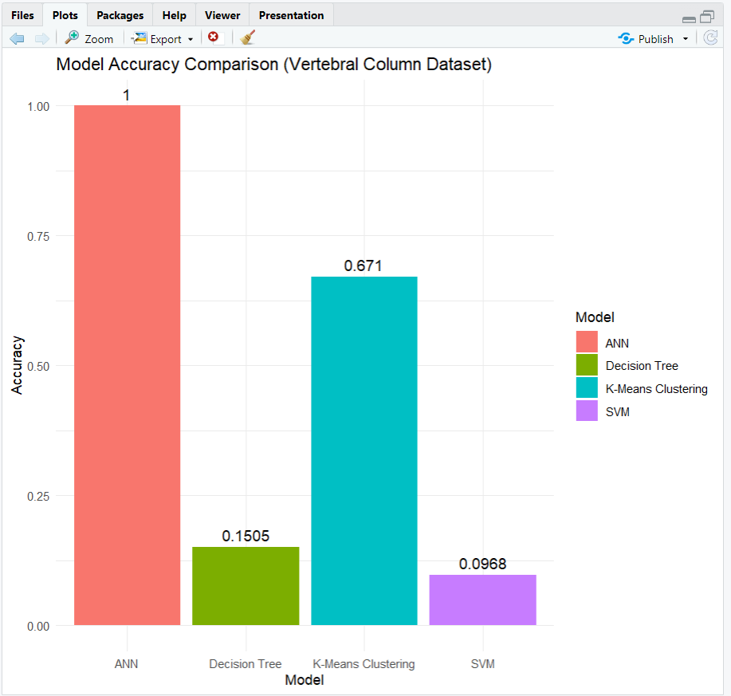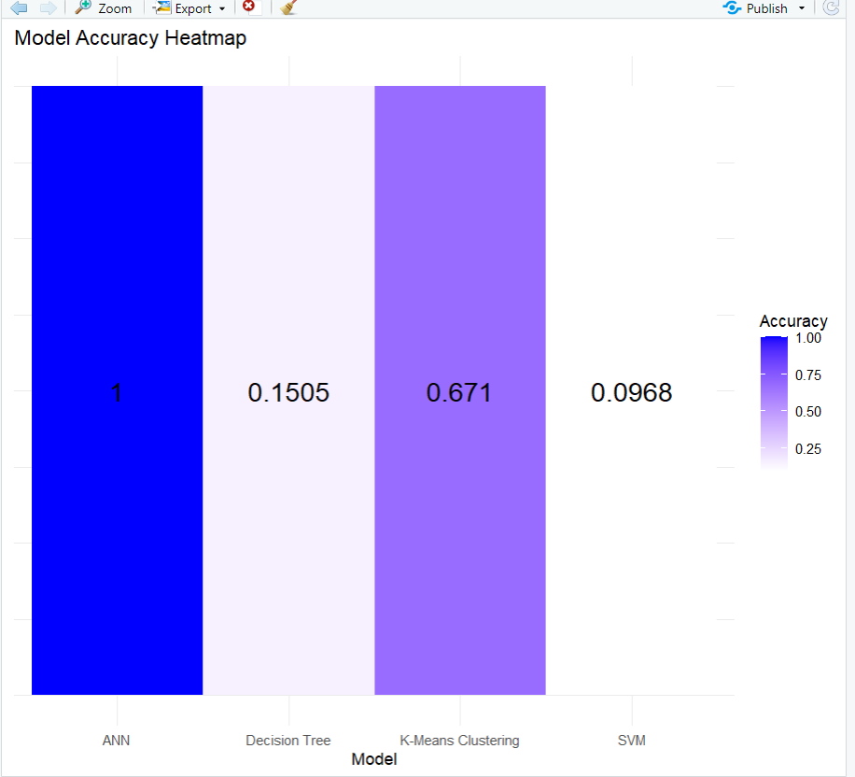

Future Scope
The future enhancements for this project could include:
- Advanced Neural Network Architectures:
  - Implementing Convolutional Neural Networks (CNN) to improve feature extraction and capture spatial relationships in the dataset.
  - Exploring other deep learning architectures like Recurrent Neural Networks (RNN) for potential improvements in capturing temporal dependencies if sequential data is available in future versions of the dataset.
- Ensemble Learning:
  - Utilizing ensemble methods like Gradient Boosting, Random Forest, and XGBoost to potentially improve the model’s performance by combining the strengths of multiple algorithms.
- Integration of Clinical Data:
  - Expanding the dataset to include additional clinical parameters like age, gender, and lifestyle factors, which could enhance the model's diagnostic capability.
- Deployment of Predictive Model:
  - Developing a web-based application or a software tool to make the model accessible to healthcare providers for real-time diagnosis.

