**AdventureWorks SQL Assignment**

**Namita Kiran Mahindrakar**

**--Problem 1**

select u.Name, t.inventorysum, sum(ASS.OrderQty) as ordersum

from [AdventureWorks2019].[Sales].[SalesOrderDetail] as ASS, (select AP.ProductID, AP.Name from [AdventureWorks2019].[Production].[Product] as AP) as u,

(select APP.ProductID, sum(APP.Quantity) as inventorysum from [AdventureWorks2019].[Production].[ProductInventory] as APP group by APP.ProductID) as t

where u.ProductID = ASS.ProductID and ASS.ProductID = t.ProductID

group by u.Name, t.inventorysum

order by ordersum DESC

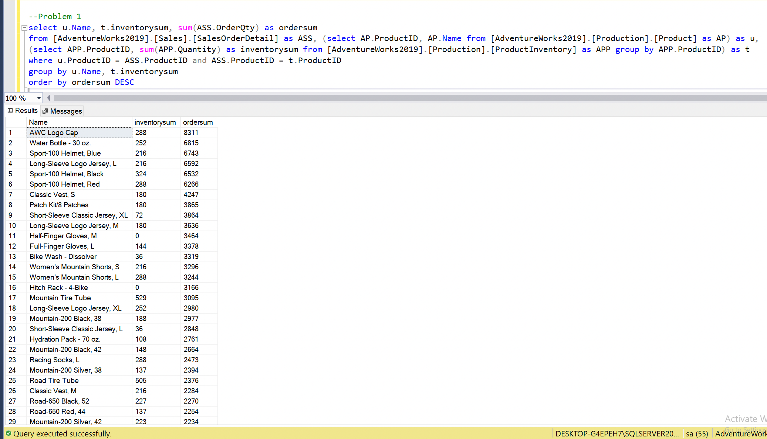

**--Problem 2**

select u.Name, t.inventorysum, sum(ASS.OrderQty) as ordersum into production_product_details

from [AdventureWorks2019].[Sales].[SalesOrderDetail] as ASS, (select distinct AP.ProductID, AP.Name from [AdventureWorks2019].[Production].[Product] as AP) as u,

(select APP.ProductID, sum(APP.Quantity) as inventorysum from [AdventureWorks2019].[Production].[ProductInventory] as APP group by APP.ProductID) as t

where u.ProductID = ASS.ProductID and ASS.ProductID = t.ProductID

group by u.Name, t.inventorysum

order by ordersum DESC

Select * from production_product_details

**--Problem 3**

select * from production_product

where inventorysum < 100

**--Problem 4**

select name from Production.Product

where ProductNumber like 'FR%'

select ProductID,

name,

SUBSTRING(name,1,3) as Prefix,

SUBSTRING(name, PATINDEX('% %',name)+1 , PATINDEX('%-%',name)-PATINDEX('% %', name)-1) as Type,

CASE

WHEN name like '%W%' then 'F'

ELSE 'M'

END as Gender,

SUBSTRING(name,len(name)-1,3) as Size,

SUBSTRING(name, PATINDEX('%-%',name)+1 , PATINDEX('%,%',name)- PATINDEX('%-%', name)-1) as Color

INTO Product_Number

from production.product

where ProductNumber like 'FR%';

select * from Product_Number;

