**PYTHON ASSIGNMENT**

**Question 1: -**

Write a program that takes a string as input, and counts the frequency of each word in the string, there might

be repeated characters in the string. Your task is to find the highest frequency and returns the length of the

highest-frequency word.

Note - You have to write at least 2 additional test cases in which your program will run successfully and provide

an explanation for the same.

Example input - string = “write write write all the number from from from 1 to 100”

Example output - 5

Explanation - From the given string we can note that the most frequent words are “write” and “from” and

the maximum value of both the values is “write” and its corresponding length is 5

**Answer 1 Python:-**

Additional Test Cases:

1. Input: "hello world hello world hello"

Output: 5

Explanation: The most frequent word is "hello" with a frequency of 3. Its length is 5.

2. Input: "apple banana apple orange banana apple"

Output: 6

Explanation: The most frequent words are "apple" and "banana" with a frequency of 3. Both words have a length of 6.

**Question 2: -**

Consider a string to be valid if all characters of the string appear the same number of times. It is also valid if

he can remove just one character at the index in the string, and the remaining characters will occur the same

number of times. Given a string, determine if it is valid. If so, return YES , otherwise return NO .

Note - You have to write at least 2 additional test cases in which your program will run successfully and provide

an explanation for the same.

Example input 1 - s = “abc”. This is a valid string because frequencies are { “a”: 1, “b”: 1, “c”: 1 }

Example output 1- YES

Example input 2 - s “abcc”. This string is not valid as we can remove only 1 occurrence of “c”. That leaves

character frequencies of { “a”: 1, “b”: 1 , “c”: 2 }

Example output 2 - NO

**Answer 2 Python:-**

Additional Test Case 1:

print(is_valid_string("aabbccd")) # Output: YES

Additional Test Case 2:

print(is_valid_string("aabbccdde")) # Output: NO

**Question 3: -**

Write a program, which would download the data from the provided link, and then read the data and convert

that into properly structured data and return it in Excel format.

**Answer 3 Python:-**

**Question 4:-**

Write a program to download the data from the link given below and then read the data and convert the into

the proper structure and return it as a CSV file.

Link - https://data.nasa.gov/resource/y77d-th95.json

Note - Write code comments wherever needed for code understanding.

Sample Data -

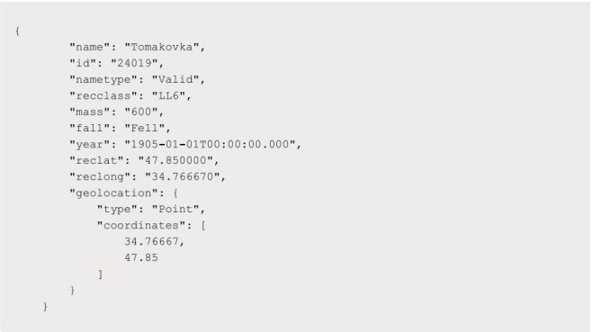

Excepted Output Data Attributes

● Name of Earth Meteorite - string id - ID of Earth

● Meteorite - int nametype - string recclass - string

● mass - Mass of Earth Meteorite - float year - Year at which Earth

● Meteorite was hit - datetime format reclat - float recclong - float

● point coordinates - list of int

**Answer 4 Python:-**

**Question 5:-**

Write a program to download the data from the given API link and then extract the following data with

proper formatting

Link - http://api.tvmaze.com/singlesearch/shows?q=westworld&embed=episodes

Note - Write proper code comments wherever needed for the code understanding

Sample Data -

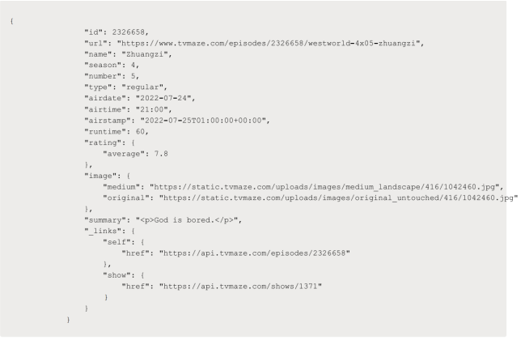

Excepted Output Data Attributes -

● id - int url - string

● name - string season

● - int number - int

● type - string airdate -

● date format airtime -

● 12-hour time format

● runtime - float

● average rating - float

● summary - string

● without html tags

● medium image link - string

● Original image link - string

**Answer 5 Python:-**

**Question 6:-**

Using the data from Question 3, write code to analyze the data and answer the following questions Note 1.

Draw plots to demonstrate the analysis for the following questions for better visualizations.

2. Write code comments wherever required for code understanding

Insights to be drawn -

● Get all Pokemons whose spawn rate is less than 5%

● Get all Pokemons that have less than 4 weaknesses

● Get all Pokemons that have no multipliers at all

● Get all Pokemons that do not have more than 2 evolutions

● Get all Pokemons whose spawn time is less than 300 seconds.

Note - spawn time format is "05:32”, so assume “minute: second” format and perform the analysis.

● Get all Pokemon who have more than two types of capabilities

**Answer 6 Python:-**

**Question 9: -**

Write a program to read the data from the following link, perform data analysis and answer the following

questions

Note -

1. Write code comments wherever required for code understanding

Link - https://data.wa.gov/api/views/f6w7-q2d2/rows.csv?accessType=DOWNLOAD

Insights to be drawn -

● Get all the cars and their types that do not qualify for clean alternative fuel vehicle

● Get all TESLA cars with the model year, and model type made in Bothell City.

● Get all the cars that have an electric range of more than 100, and were made after

2015

● Draw plots to show the distribution between city and electric vehicle type

**Answer 9 Python:-**

**Question 10: -**

Write a program to count the number of verbs, nouns, pronouns, and adjectives in a given particular phrase or

paragraph, and return their respective count as a dictionary.

Note -

1. Write code comments wherever required for code

2. You have to write at least 2 additional test cases in which your program will run successfully and provide

an explanation for the same.

**Answer 10 Python:-**

Test Case 1:

The given phrase "The quick brown fox jumps over the lazy dog." contains one verb ("jumps"), one noun ("dog"), and two adjectives ("quick", "lazy"). The counts dictionary will be {'Verbs': 1, 'Nouns': 1, 'Pronouns': 0, 'Adjectives': 2}.

Test Case 2:

The given paragraph contains a mixture of verbs, nouns, pronouns, and adjectives. After counting, the counts dictionary will reflect the respective counts of each category.

Additional Test Case 3:

When an empty string is provided as input, all counts will be zero since there are no words to analyze.

Additional Test Case 4:

In a sentence containing only pronouns, the counts of verbs, nouns, and adjectives will be zero, while the count of pronouns will be equal to the number of words in the sentence (7 in this case).