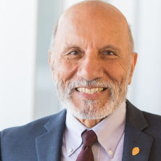
Advisory Council
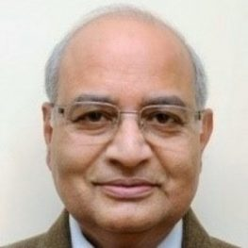
Prof. A. D. Amar, Ph.D. Prof. Sudhir K. Jain
Seton Hall University Former Vice Chancellor
USA Shri Mata Vaishno Devi University, Jammu, India
Former Head - DMS, IIT Delhi

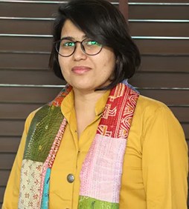
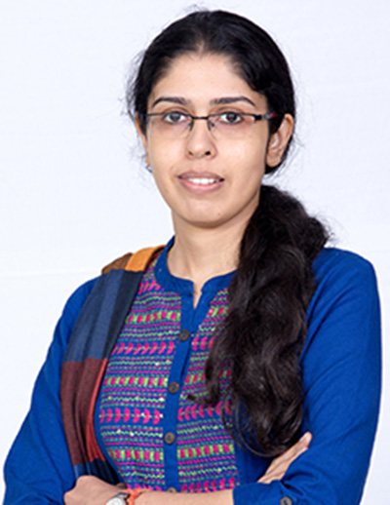

Prof. Garima Tiwari Prof. Suman Rani
National Law University, Delhi O.P. Jindal Global University, India
PhD - University of Camerino, Italy Fulbright Scholar – University of Notre Dame, USA

