Ex.no :6 Implemention of Ensemble Techniques (Bagging, Boosting, Random Forest, Stacking)and Handling Class Imbalance (SMOTE)
SCENARIO 1: (Bagging)
Problem Statement
Predict whether a patient has diabetes

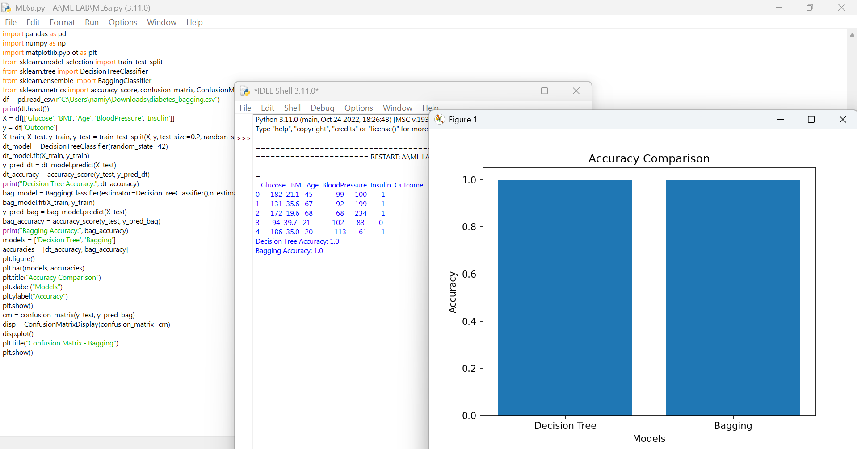

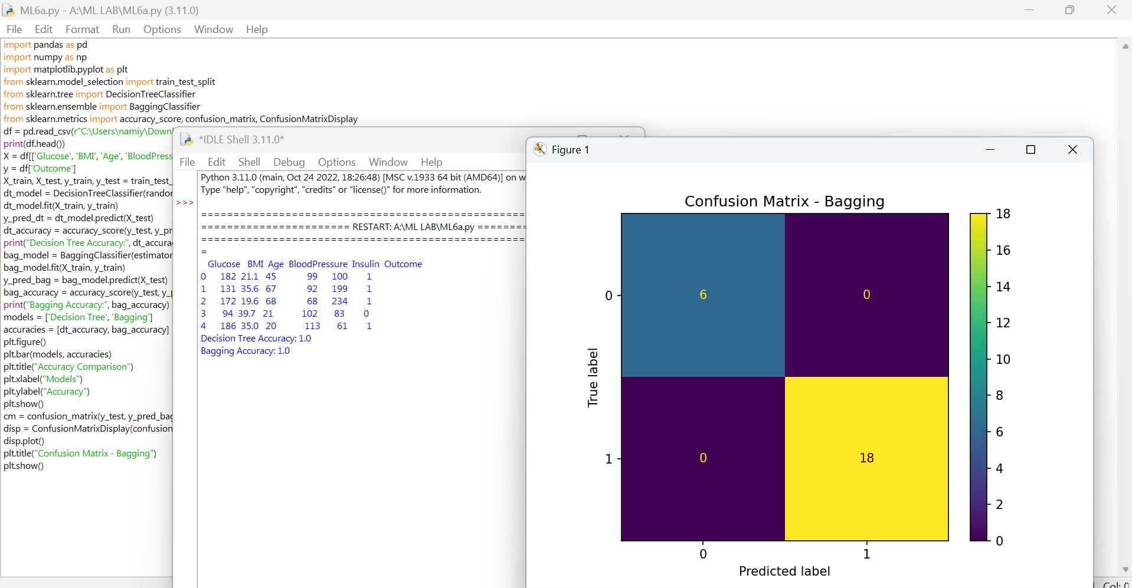
SCENARIO 2 - (Boosting-AdaBoost,Gradient Boosting)
Problem Statement
Predict whether a customer will churn.
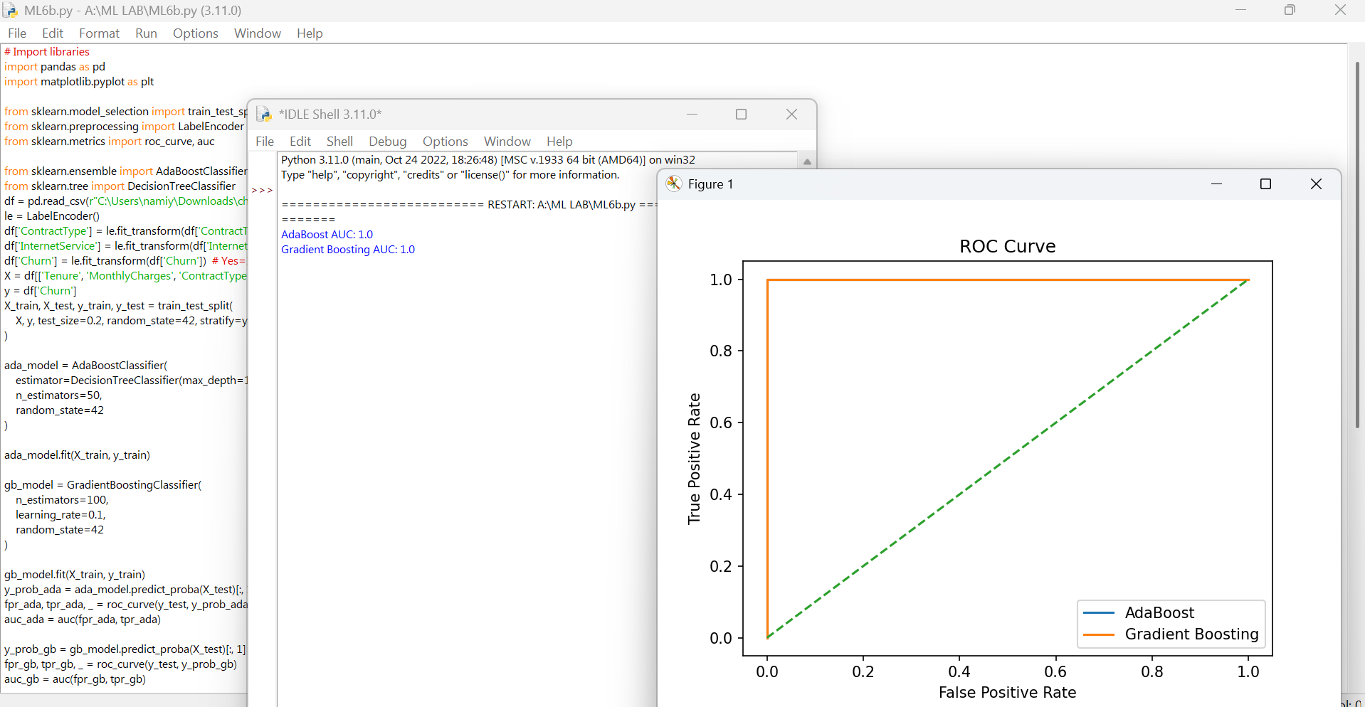

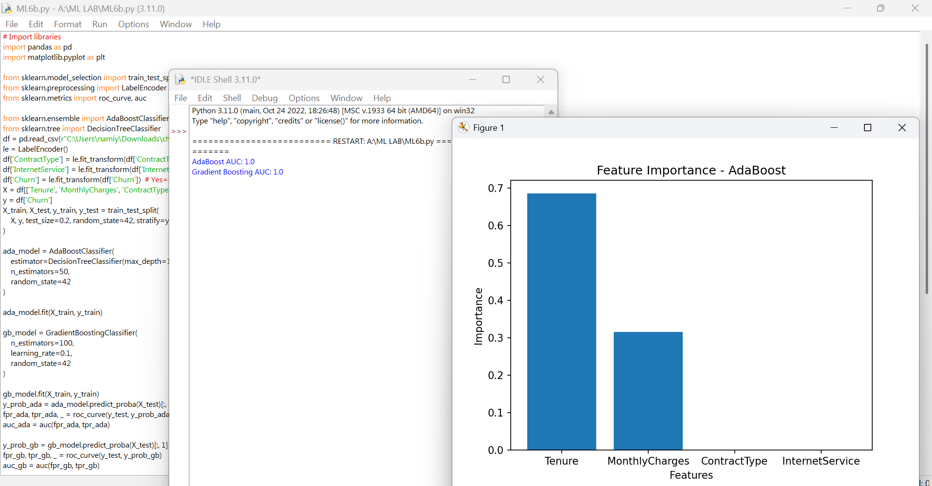

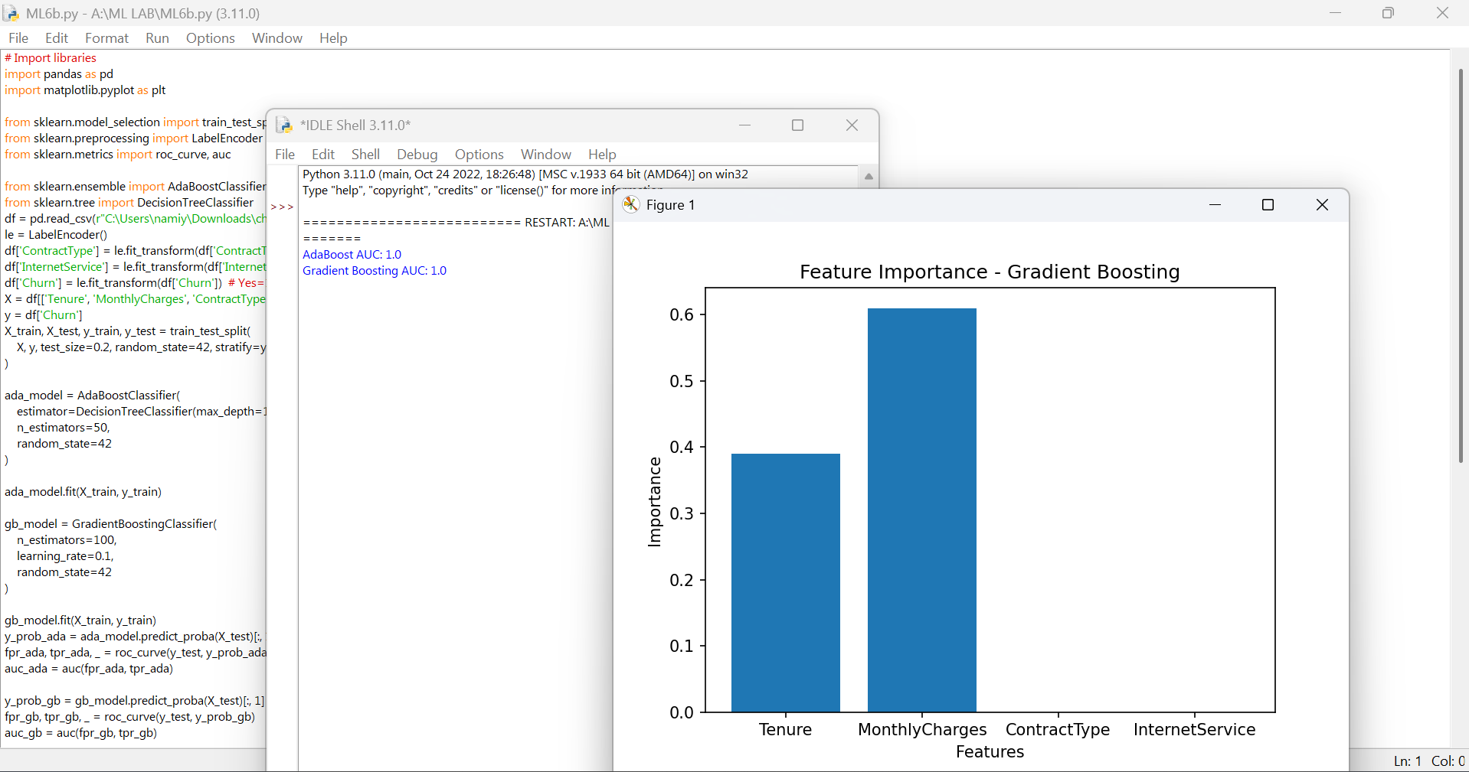

SCENARIO 3 – Random Forest
Problem Statement
Predict whether a person earns >50K salary.

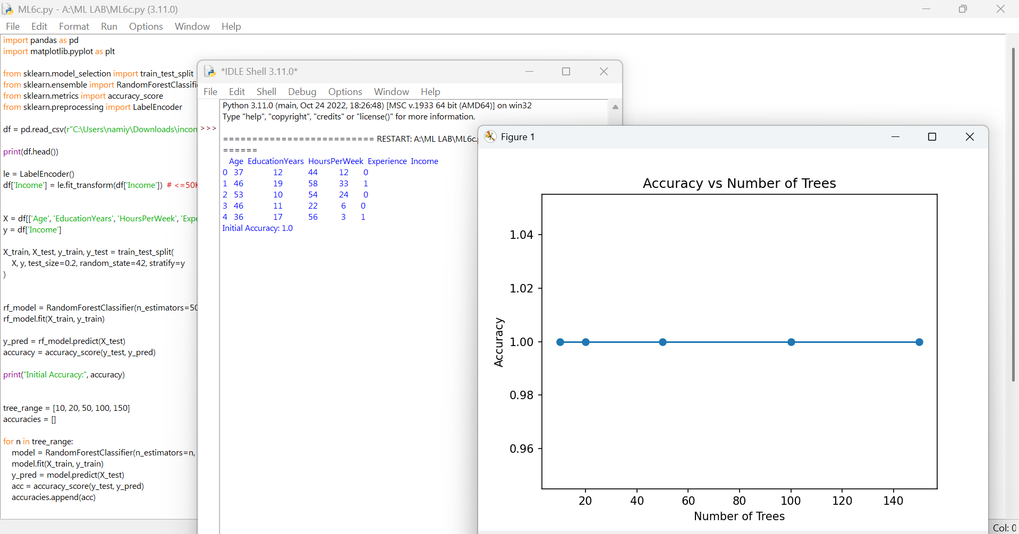

SCENARIO 4 – Stacking
Problem Statement
Predict heart disease presence.

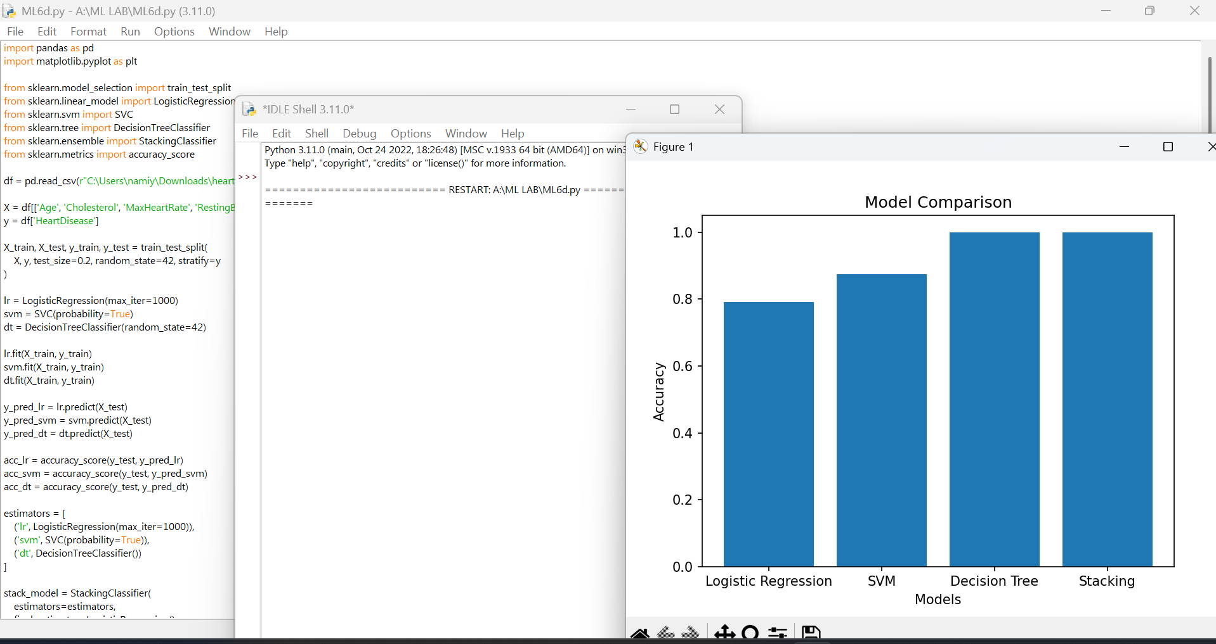

SCENARIO 5– SMOTE
Problem Statement
Detect fraudulent transactions.
