Ex.no :9 Recommendation Systems using Collaborative Filtering Techniques

SCENARIO 1 – USER-BASED COLLABORATIVE FILTERING
Problem Statement
Recommend movies to users based on similar users' preferences.
Dataset (Kaggle – Public)
MovieLens Dataset Dataset Link: https://www.kaggle.com/datasets/grouplens/movielens-100k

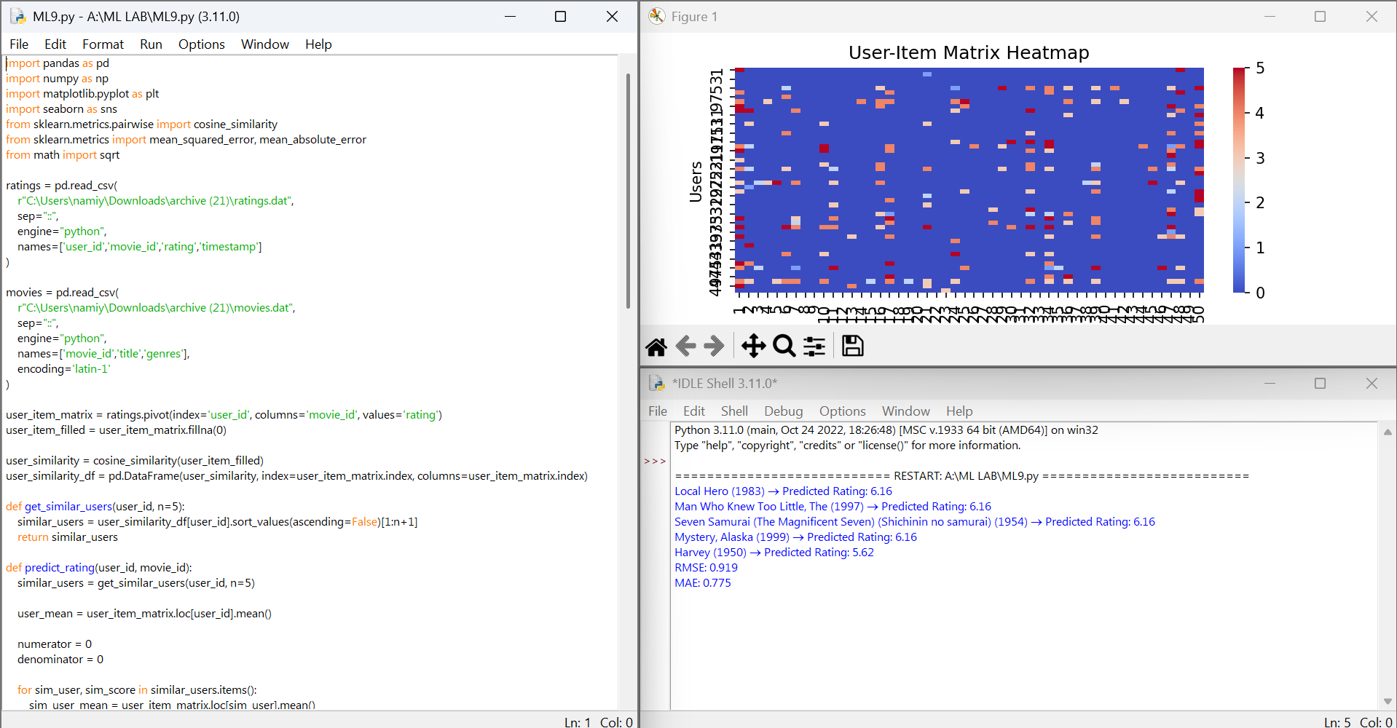



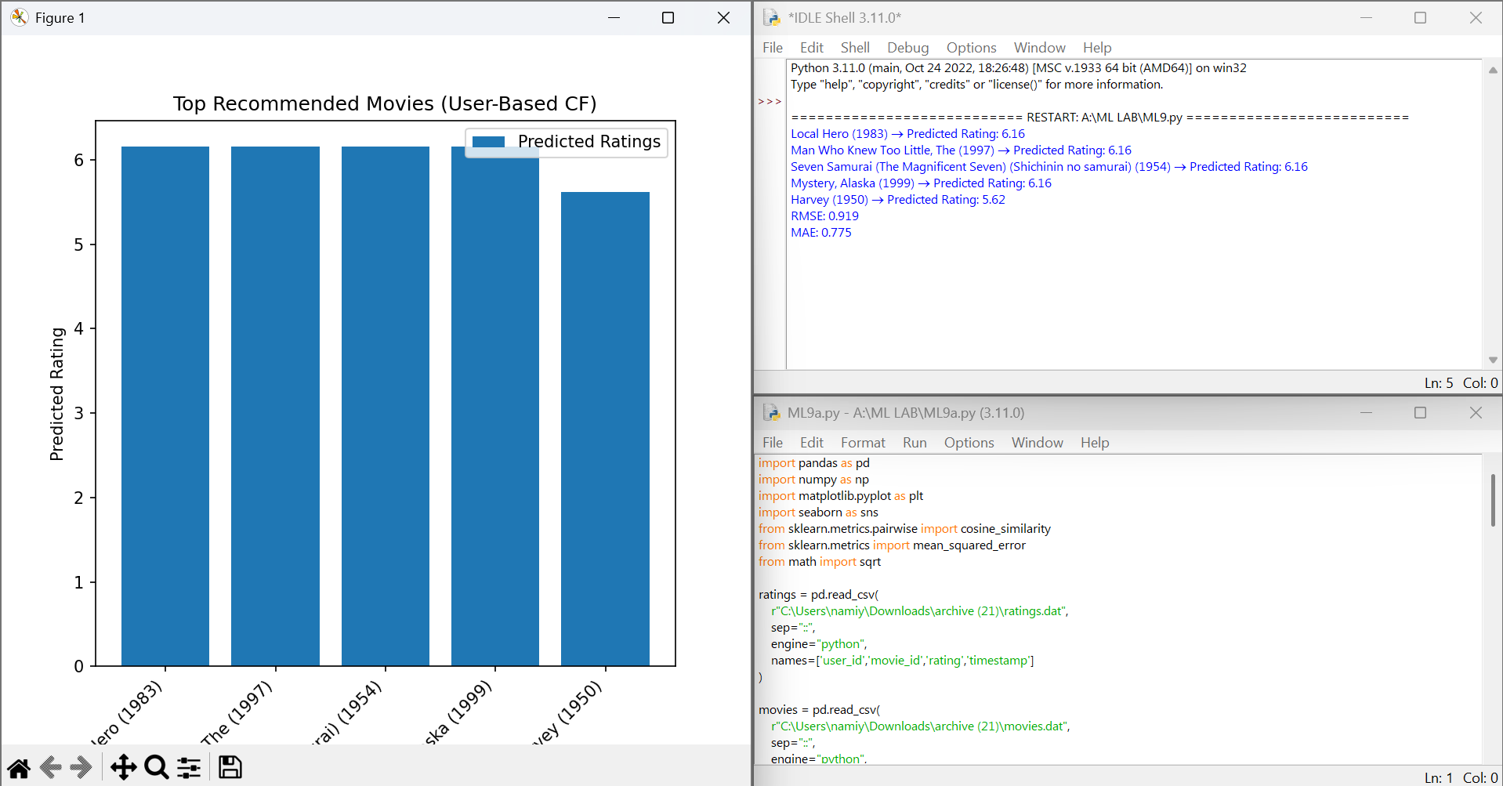

SCENARIO 2 – ITEM-BASED COLLABORATIVE FILTERING
Problem Statement
Recommend similar items (movies/products) based on user ratings.


