Ex.no : 01 Introduction to Python Libraries and
Dataset Preprocessing

SCENARIO 1: E-commerce Sales Data

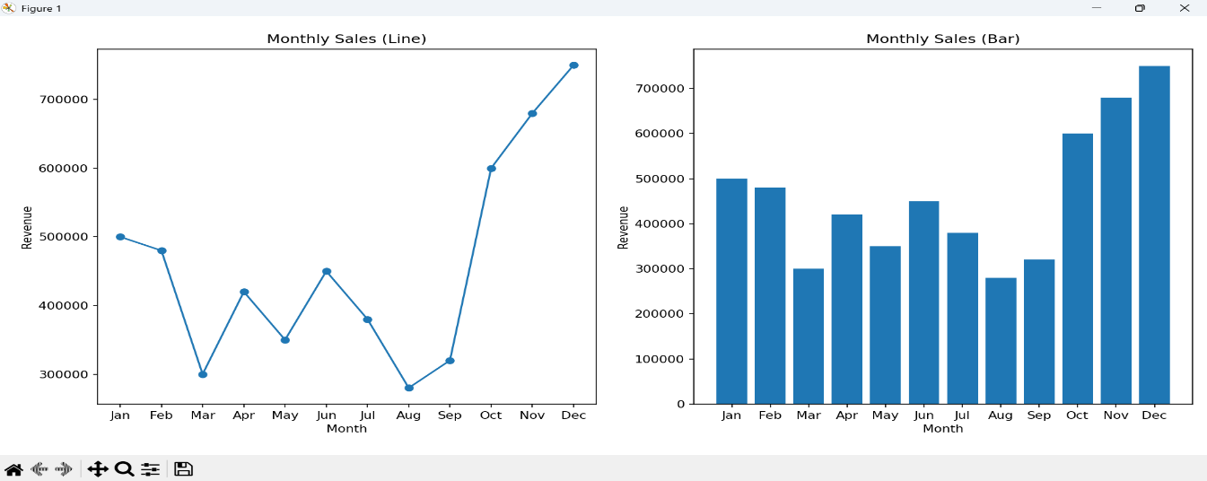

SCENARIO 2: Hospital Patient Records

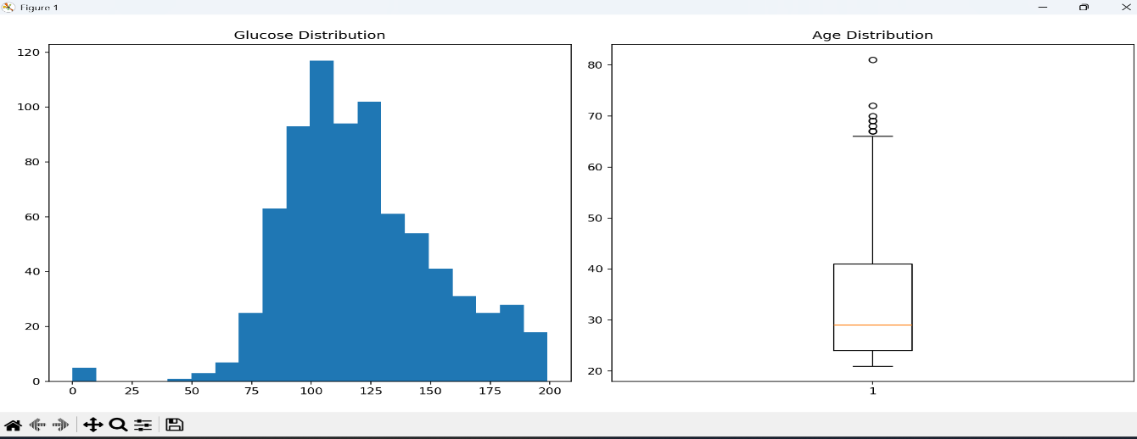

SCENARIO 3: Housing Dataset

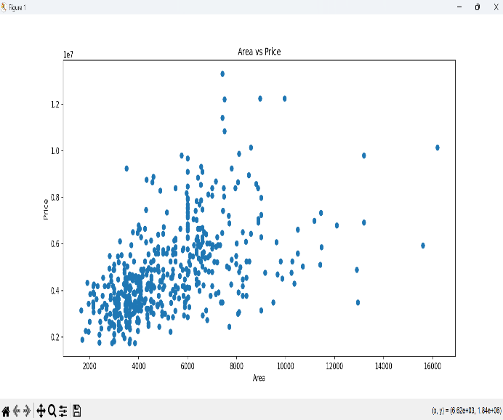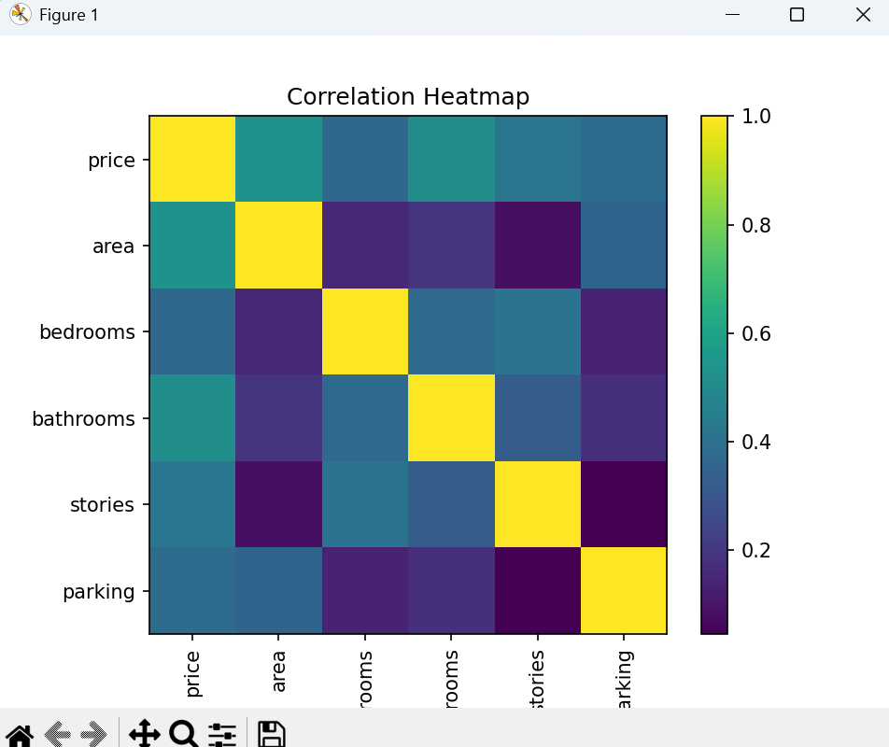

SCENARIO 4: Banking Customer Data

