Ex.no : 2 Regression and Optimization (Linear and Logistic regression)

SCENARIO 1: Predict ocean water temperature
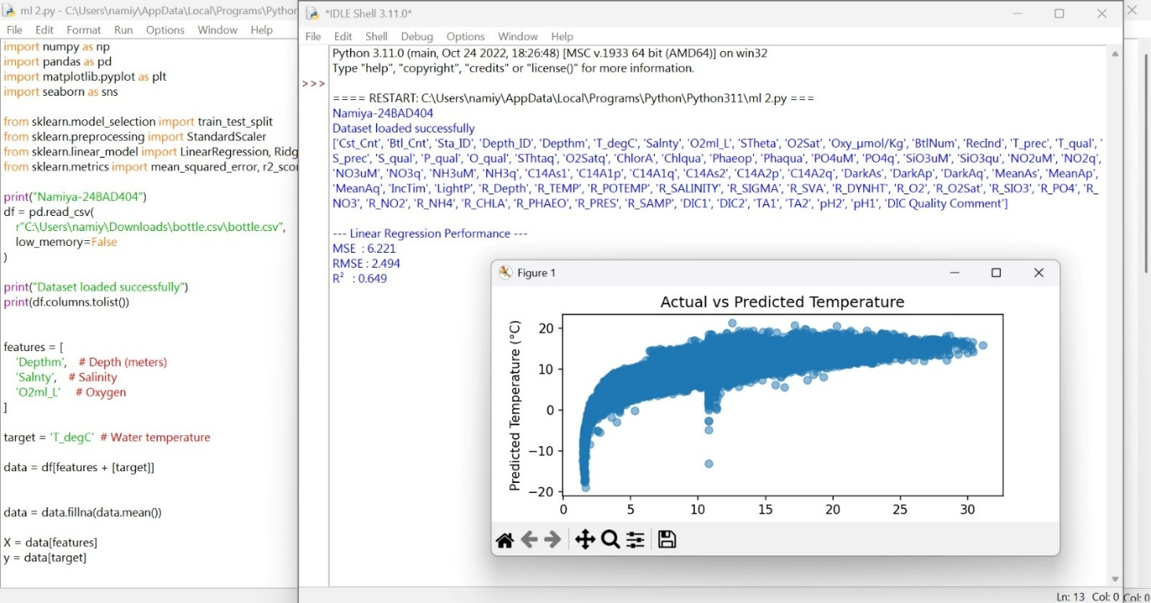

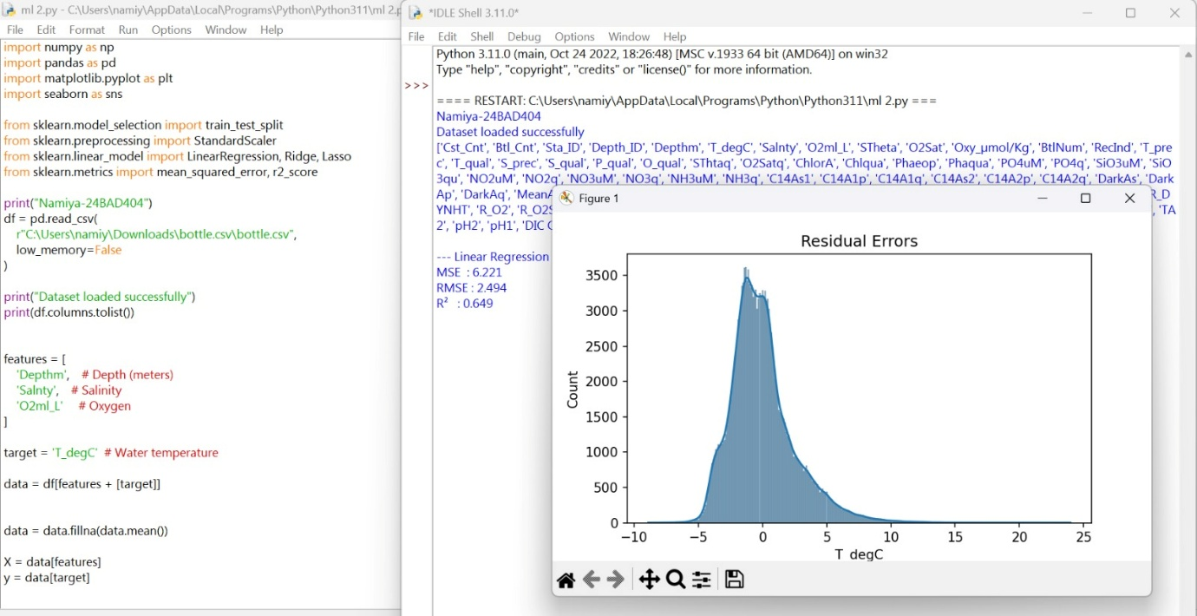

SCENARIO 2: whether LIC stock price will increase (1) or decrease (0) based on historical data.
