Ex.no :4Probabilistic Classification using Naïve Bayes (Gaussian & Multinomial Naïve Bayes
SCENARIO 1: MULTINOMIAL NAÏVE BAYES
Problem Statement
Classify SMS messages as Spam or Ham (Not Spam)..
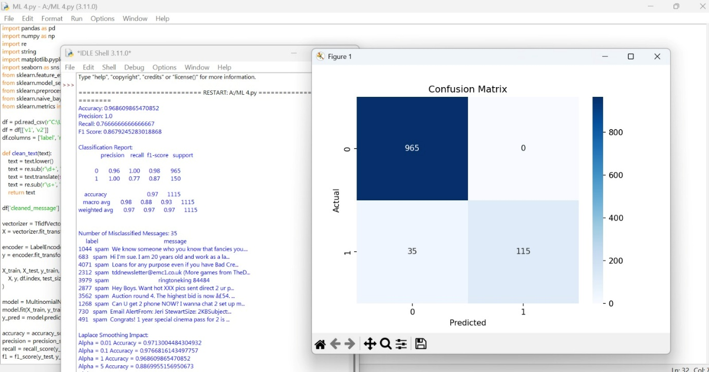

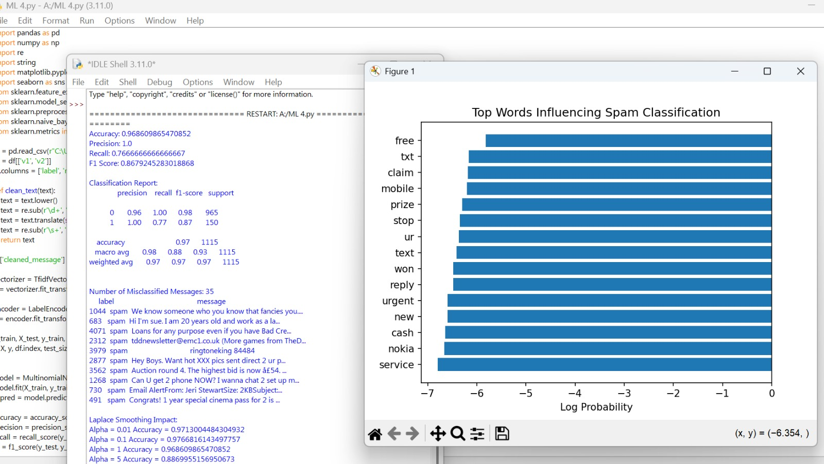

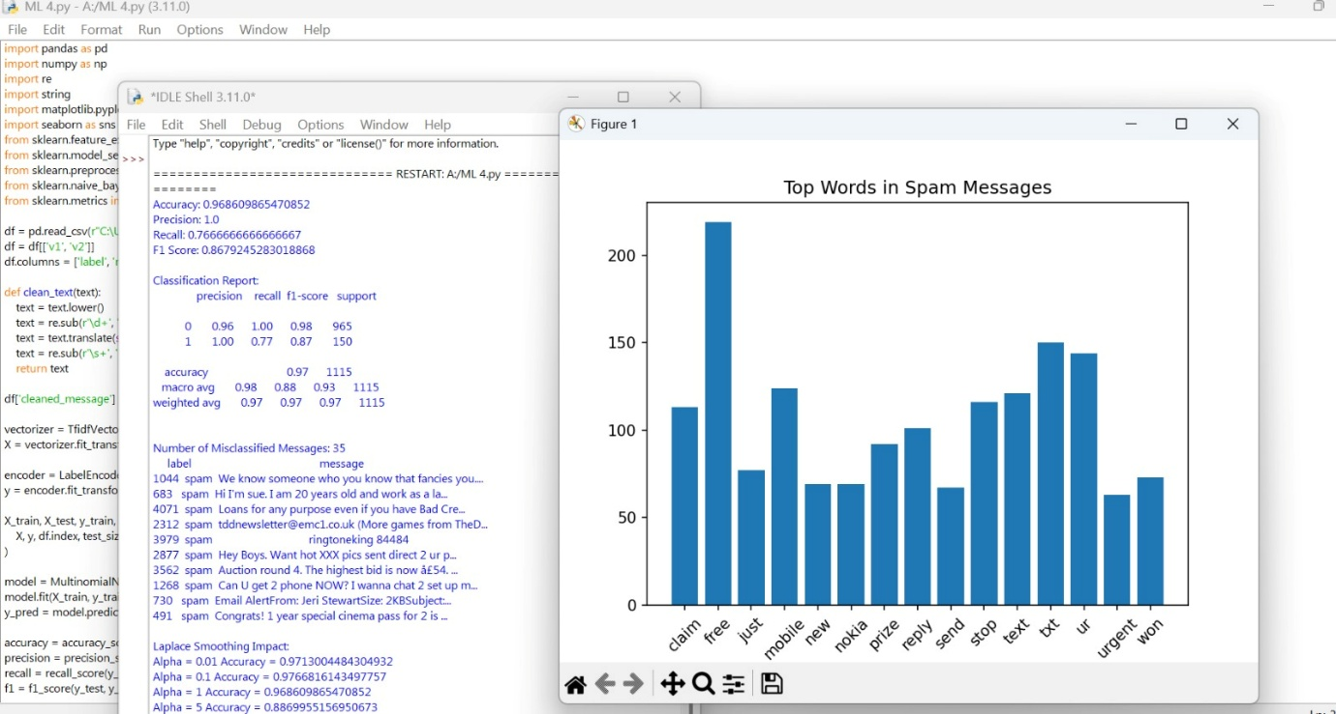

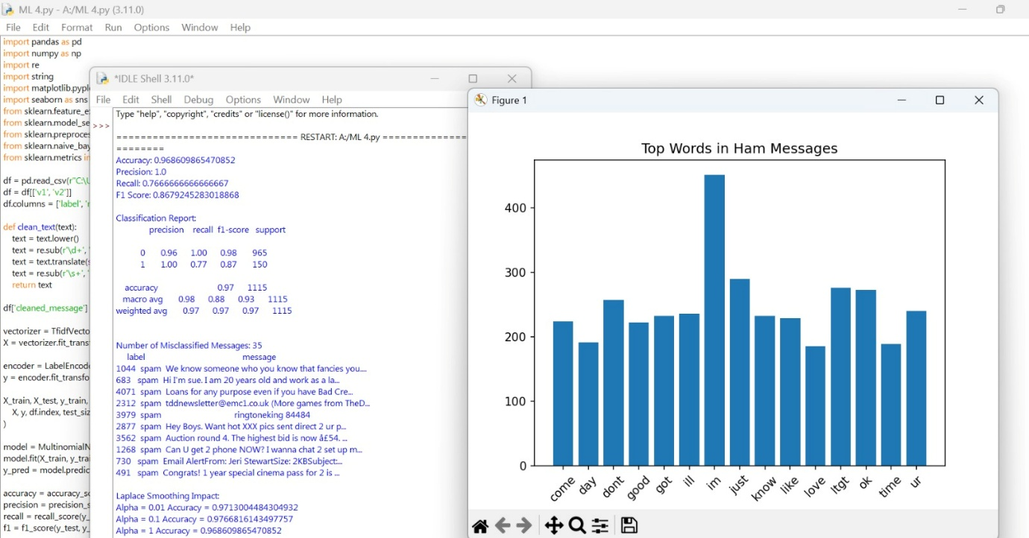

SCENARIO 2: GAUSSIAN NAÏVE BAYES
Problem Statement
Classify flower species based on physical measurements.
Dataset (Public / Standard Dataset)
Iris Dataset (sklearn)
