Ex.no :5 Classification using K-Nearest Neighbors (KNN) and Decision Tree

SCENARIO 1: K-NEAREST NEIGHBORS (KNN)
Problem Statement
Predict whether a tumor is benign or malignant based on medical measurements.
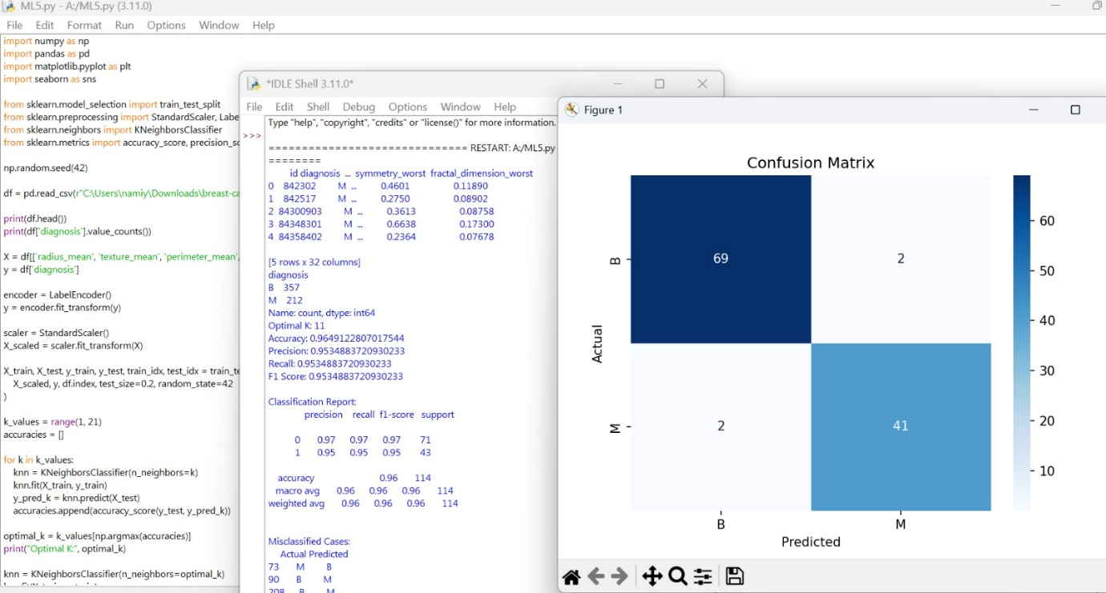

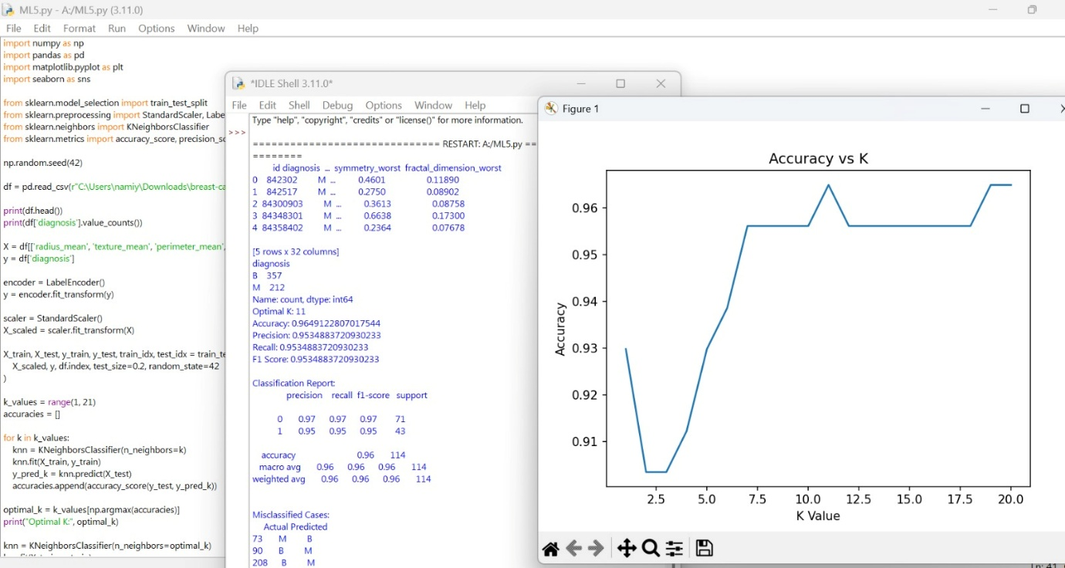
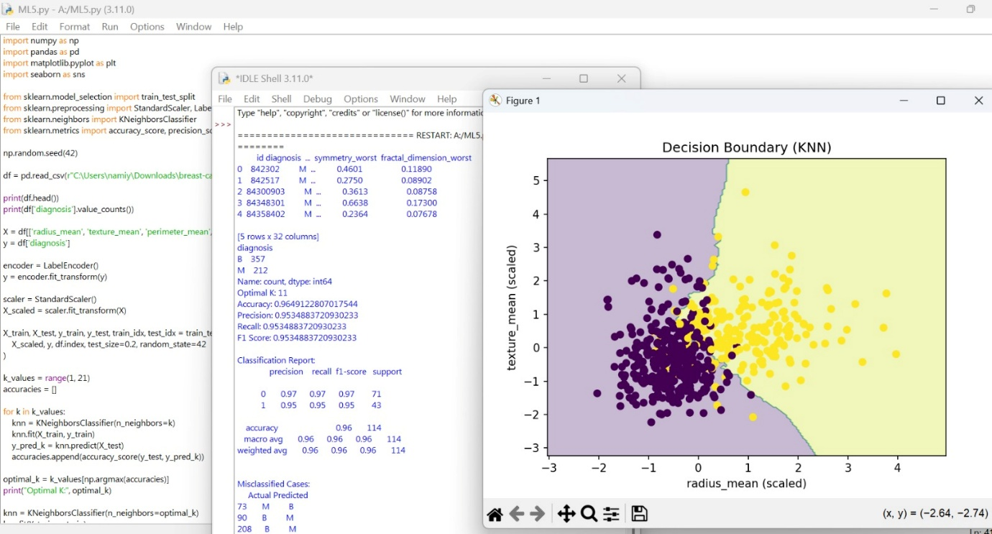

SCENARIO 2: DECISION TREE CLASSIFIER
Problem Statement
Predict whether a loan application should be approved or rejected.

