Ex.no : 8 Association Rule Learning (Apriori Algorithm) and Dimensionality Reduction (PCA)

SCENARIO 1: ASSOCIATION RULE MINING USING APRIORI ALGORITHM
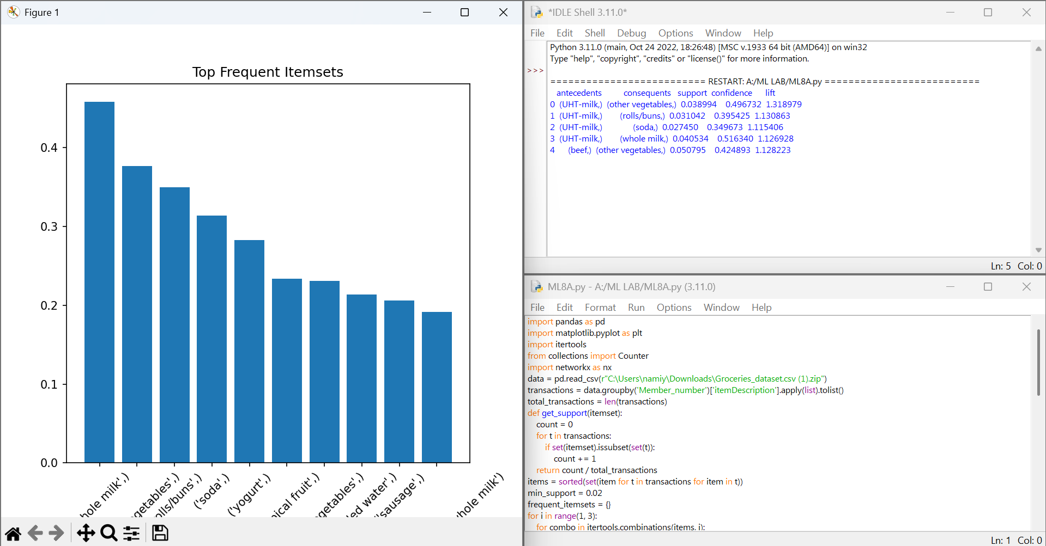

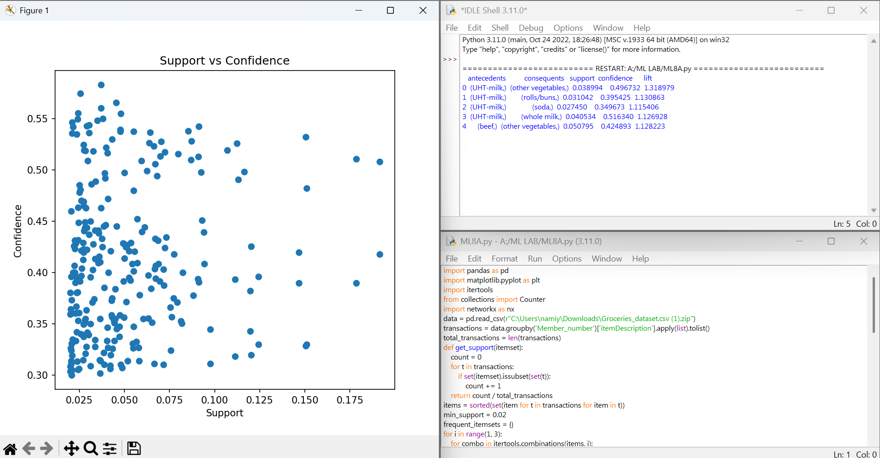

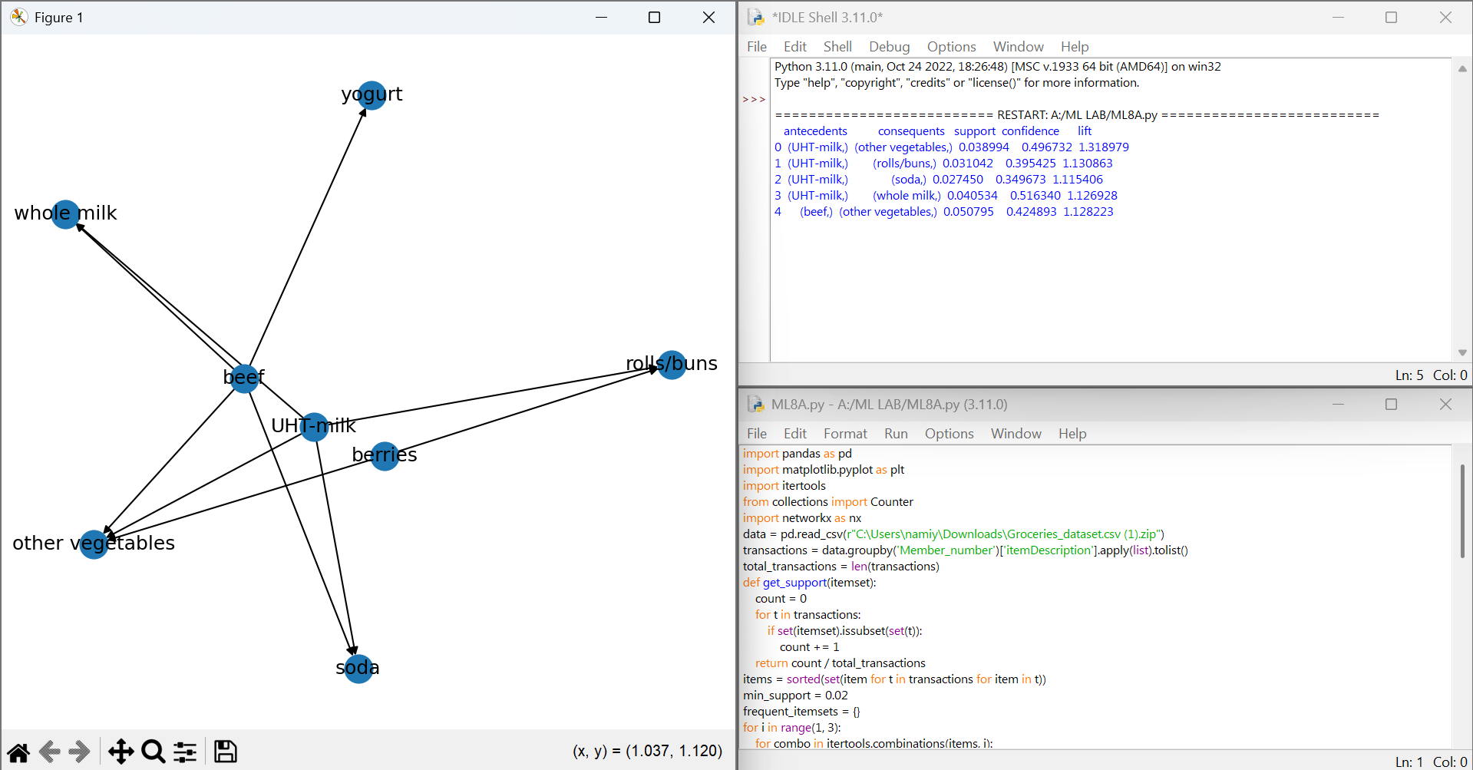

SCENARIO 2: DIMENSIONALITY REDUCTION USING PCA
