Selenium
Syllabus:
1. Introduction
2. Advantages of selenium
3. What are the components present in selenium
4. Selenium3 architecture
5. Selenium4 architecture
6. Locators
6.1 Name
6.2 ID
6.3 Class Name
6.4. Tag Name
6.5 Link Text
6.6 Partial Link Text
6.7 CSS Selector
6.8 Xpath
7. Search context methods
8. Web driver methods
9. HTML – Basics
10. Selenium4 related locators
11. Handling List Box
12. Handling Frames
13. Action class
14. Handling Windows
15. Synchronization
15.1 Implicit wait
15.2 Explicit wait
16. Handling popups
17. Auto IT
18. Test Ng
19. Advantages of Test Ng
20. ITestListener
21. Maven
22. Reports
22.1 TestNg Report
22.2 ReportNg Report
22.3 Extent Report
23. Data driving from Excel
24. Frame work
25. POM – Page object Model
26. Jenkins – CI (Continuous integration)
27. Interview Questions

Q: What is Automation?
Converting the manual process into the automation so that it saves lot of efforts and saves time and avoids repetitive works.
Q: What is Selenium?
Selenium is a free, open source, web application automation tool.
Q: Why it is named as Selenium?
Jason Huggins – Author/ Inventor of selenium
Mercury component poison - selenium
Email – You can cure mercury poisoning by taking selenium supplements.
History of selenium:
Jason Huggins – 2005 and he has given the name as “Selenium RC”
2008 – he moved to Google
Selenium RC – Paul Hammant – supported till 2009
Simon Stewart – “Web Driver” - 2010
Philpee Hanrigou – “Selenium Grid”
Thought Works acquired – “Selenium Web Driver”
Latest version available – 4.x.x

What are the components present in selenium?
Selenium Suite
- Selenium IDE (Integrated development environment) – Plugin present in chrome browser which helps in record and play back.
* Record and play back tool
* Chrome/Firefox plugin
* Java script-based framework
* SELENESE – is the program which is used to write the script
Disadvantage – Maintenance or modification of script is difficult
- Selenium RC (Remote control)
- It is not a record and play back tool
- Given chance to write the program and maintain on your own. (Java, PHP, Python, etc..)
- Execution possible in different browsers like chrome, firefox, safari, opera etc..

Disadvantage
- A server has to up end running while executing the program. Start and stop of server is required.
- Selenium WebDriver
- It is not a record and play back tool
- Given chance to write the program and maintain on your own. (Java, PHP, Python, etc..)
- Execution possible in different browsers like chrome, firefox, safari, opera etc..
- Execution of program in multiple platforms like mac, windows, linux..
- No need to start and stop the server, selenium webdriver will takes care of itself.
- Selenium Grid
* Selenium grid is used to run/execute the script in another slave machine.

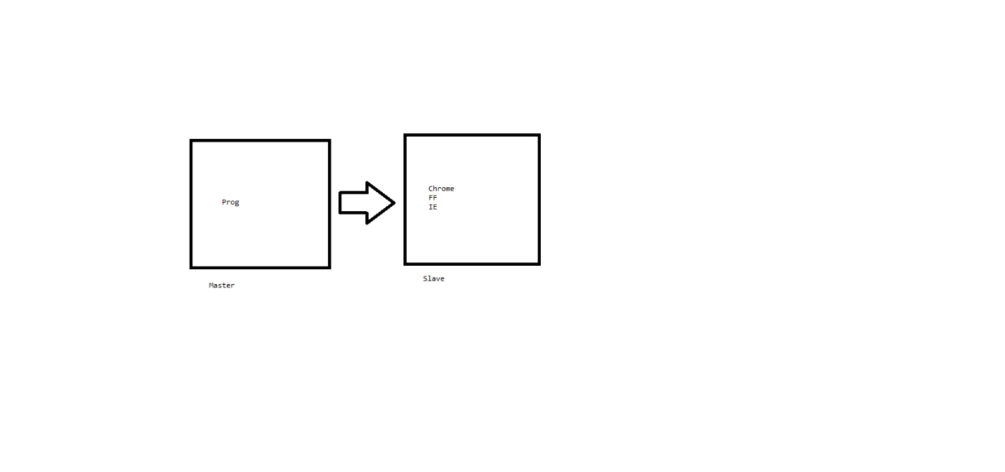
Selenium is a free, open source, web application automation tool.
Free – We don’t have to buy any license to work on selenium.
Open source - https://github.com/SeleniumHQ/selenium/tree/trunk
Entire source code is distributed freely so that if any modifications required in your company you can modify and utilize it.
web application automation tool – Any application which runs on browser engine is called as web application.
What are advantages of Selenium WebDriver?
1. Cross browser support – Chrome, Fire fox, IE, Safari, Opera etc..
2. Multi-platform – Windows, MAC, Linux, Ubuntu etc..
3. Multi Language support – Java, PHP, Python, Ruby, Java script, c#, Perl, Dart, Haskel, Object c etc..
4. Supports parallel execution.

Selenium 3 Architecture:
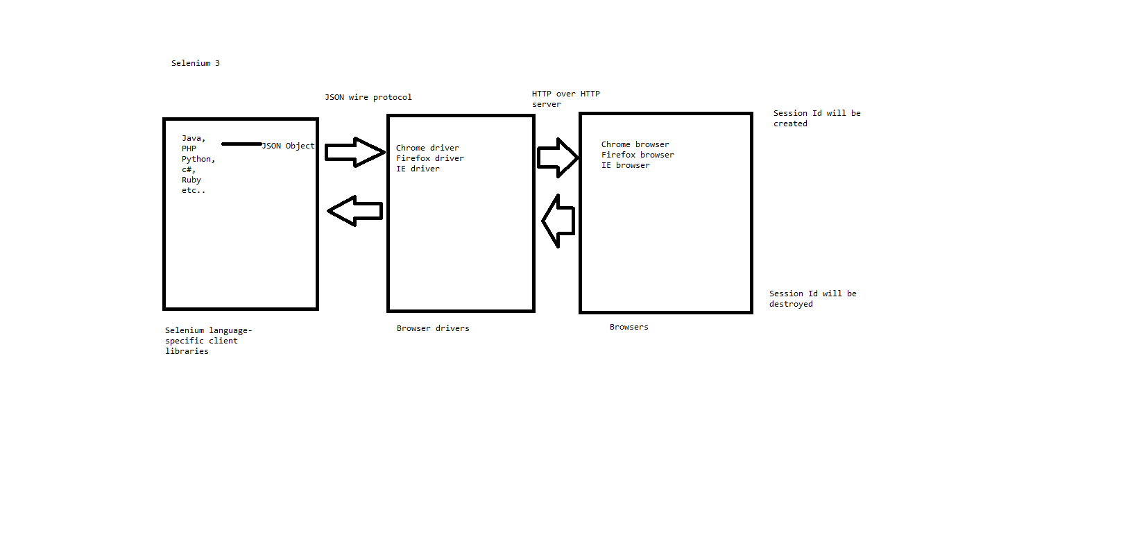
* In selenium3 we can write the program in multiple programming languages by using respective selenium language specific client libraries.
* These language specific client libraries are responsible for converting languages / programs into json objects.
* These json objects will be communicated to respective browser drivers via JSON wire protocol.
* These browser drivers are responsible for communicating to the respective browser.
* Once communication is established a session id will be generated.
* Once the program reaches to the end then session id will be destroyed and all the communications will be closed.

Selenium 4 Architecture:
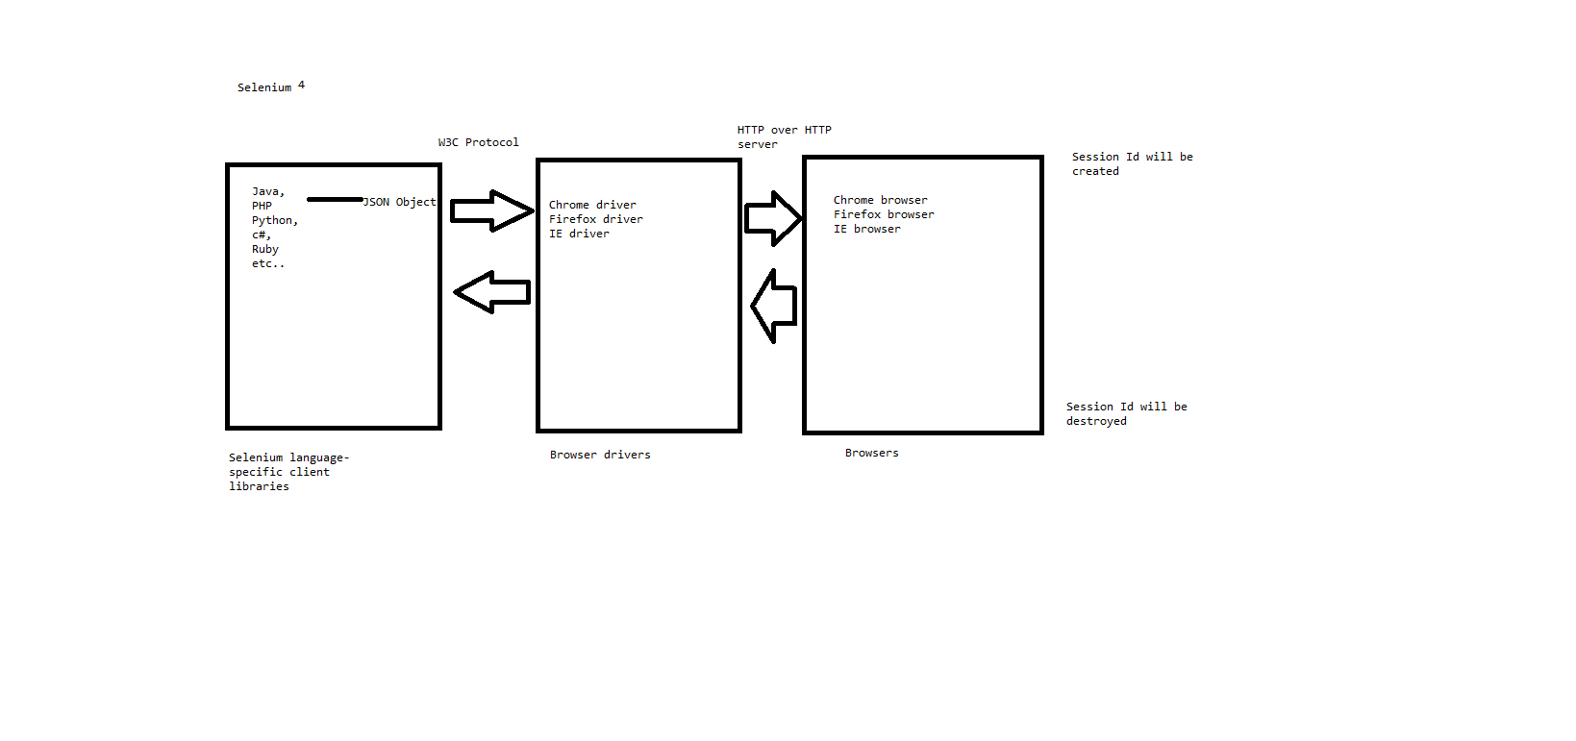
* In selenium4 we can write the program in multiple programming languages by using respective selenium language specific client libraries.
* These language specific client libraries are responsible for converting languages / programs into json objects.
* These json objects will be communicated to respective browser drivers via W3C protocol.
* These browser drivers are responsible for communicating to the respective browser.
* Once communication is established a session id will be generated.
* Once the program reaches to the end then session id will be destroyed and all the communications will be closed.
Note: * in selenium4 we don’t have to specify the browser driver explicitly while writing the program.
* In selenium4 we have new locators available.
Selenium-java architecture:
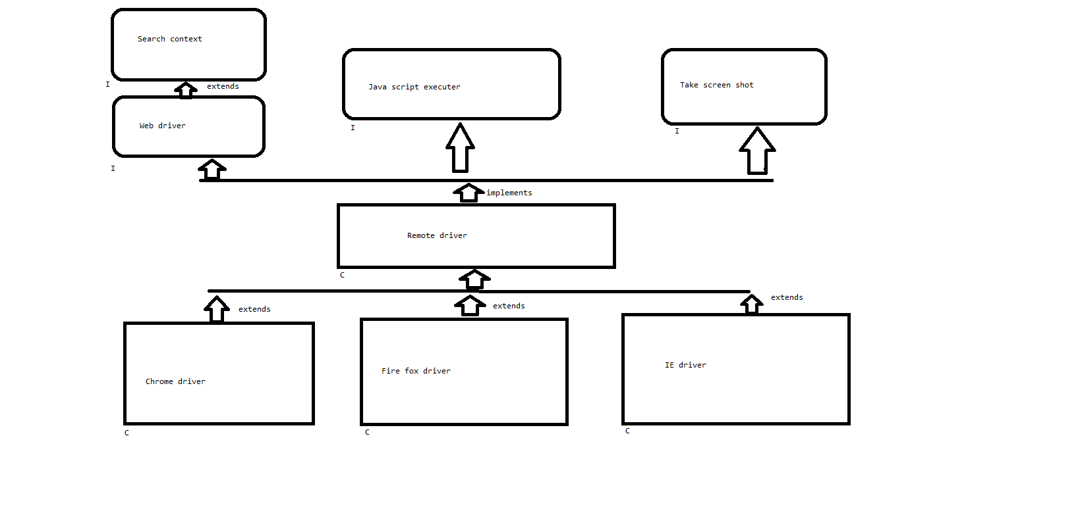
* Search context is the super the most interface present in the selenium-java which is extended by Web driver interface.
* This web driver interface is being implemented by Remote driver class along with other interfaces like Java script executer, take screen shot etc..
* All the browser driver classes like Chrome driver, Fire fox driver, IE driver etc.. are extended to Remote driver class.
Note: Abstract methods coming from Search context is extended to Web driver and overridden in Remote driver class like wise Java script executer, take screen shot abstract methods also overridden in Remote driver class.
Since browser driver classes are extended to remote driver class, all the overridden methods are easily accessible.
Git:
* Sign up/ create your own account - https://github.com/
* Click on New
* provide the repository name
* Make it as public for free. If private we need to pay some amount.
* click on create repository.
* Navigate to the place where your actual code is present in your system. (Right click on the project > Go to properties)
Eg: cd C:\Users\Admin\eclipse-workspace-java\SeleniumPractice
First time process
* git init
* git add .
* git commit -m "committing the code 24/09"
* git remote add origin https://github.com/Nammaqatraining/Selenium_22_Sep.git
* git branch -M main
* git push --set-upstream origin main
After modification of any file if you want to push the code
* git add .
* git commit -m "committing the code 24/09"
* git push
Note: Refer to link - https://github.com/Nammaqatraining/Selenium_22_Sep/tree/main
Steps for creating and accessing selenium jars:
1. Create a java project
2. Go to website - https://www.selenium.dev/downloads/
click on 4.35.0 (August 12, 2025)
3. Extract the downloaded .zip file
4. Copy all the jar files and paste it in 1 new folder eg: jars inside in your project.
5. Select all the jar files > right click > build path > add to build path
6. Refresh the project. You should see the jar files under Referenced libraries.
Note : org.openqa.selenium.SessionNotCreatedException we can expect this exception whenever the connection between your code to browser dint happened properly.
SearchContext (I) – Search context is the super most interface and it has only 2 abstract methods.
1. findElement()
2. findElements()
Note: If we upcast our browser driver object (chrome Driver/Firefox driver/Internet Explorer Driver) to the Search Context then we will be not able to access browser methods eg. get (). So, this is not a good idea to upcast browser driver object to Search Context interface.
WebDriver(I) – WebDriver interface is the core part in selenium and it has many browsers related abstract methods.
1. get(String url) – Enters the url in the opened browser window and it also waits until the page gets loaded successfully.
2. getCurrentUrl() – returns the String of url which is present in the opened browser window from automation.
3. getTitle() – returns the String of title which is present in the opened browser window from automation.
4. getPageSource() - returns the String of current page source (i.e HTML) which is present in the opened browser window from automation.
5. close() – it will close the current browser window opened by automation.
6. Quit() – it will close the multiple browser windows opened by automation.
7. getWindowHandle()
8. getWindowHandles()
9. switchTo()
10. navigate() – enters the url same as get(), it is also used for navigating back, forward, refresh the opened browser window from automation.
11. manage() – it will helps in minimizing, maximizing, setSize(required dimension) and setPosition(required position)
Note: * To set the required size of the browser window we need create the object of Dimension class and pass width and height as a parameter and pass this object reference to the setSize function.
* To set the required point of the browser window on the desktop we need create the object of Point class and pass x and y parameters and pass this object reference to the setPosition function.
Ref: day3 Prog2
Note: Since webdriver interface has many browser related abstract methods. It’s a good idea to upcast browser driver objects to WebDriver (I).
Q: How do you enter the url without using get()?
driver.navigate().to(URL);
Q: What is the difference between get() and navigate.to()?
-> get() – we can use get() method to enter the url and also it will wait until the page gets loaded completely.
-> navigate.to() – internally calls get() method and it has many functionalities like back, forward, refresh.
Q: What is WebDriver and provide some methods?
Q: What is Search Context and provide some methods?
Q: How do you set the dimension / customize the dimension of the browser window?
Q: How do you place the browser window in some position on the desktop?
Q: Give some difference between close() and quit()?
Q: Which method of web driver used to fetch the url from the browser window?
getCurrentUrl()
Q: How do you get the page source of the application?
getPageSource()
Q: How do you get the page title of the application?
getTitle()
HTML – Basics
Hyper Text Markup Language
* It is not case sensitive.
* While writing the html code we use pre-defined keywords within <> is called as tags.
* <keyword> -> start tag and </keyword> -> end/closing tag
To create the html page
* Create the package html
* right click > click on New > File > Provide the name as “Page1.html”
* If you’re not seeing suggestions then go to Help> Eclipse market place > Search (Wild Web Developer) > Click on Install (Accept the agreement) > Restart the eclipse once.
HTML page will be divided into 2 parts:
1. Head
2. Body
1. Head part usually consists of:
1.1 Title – Appears on the top/head of the page.
1.2 CSS (Cascading style sheet) - used by the designers to create look and feel of the browser
1.3 Java Script – Used by the developers for doing client-side validations.
* Stops the customer by providing the error messages and it will not carry the data to the server. (Saves some time).
