Selenium
Syllabus:
1. Introduction
2. Advantages of selenium
3. What are the components present in selenium
4. Selenium3 architecture
5. Selenium4 architecture
6. Locators
6.1 Name
6.2 ID
6.3 Class Name
6.4. Tag Name
6.5 Link Text
6.6 Partial Link Text
6.7 CSS Selector
6.8 Xpath
7. Search context methods
8. Web driver methods
9. HTML – Basics
10. Selenium4 related locators
11. Handling List Box
12. Handling Frames
13. Action class
14. Handling Windows
15. Synchronization
15.1 Implicit wait
15.2 Explicit wait
16. Handling popups
17. Auto IT
18. Test Ng
19. Advantages of Test Ng
20. ITestListener
21. Maven
22. Reports
22.1 TestNg Report
22.2 ReportNg Report
22.3 Extent Report
23. Data driving from Excel
24. Frame work
25. POM – Page object Model
26. Jenkins – CI (Continuous integration)
27. Interview Questions

Q: What is Automation?
Converting the manual process into the automation so that it saves lot of efforts and saves time and avoids repetitive works.
Q: What is Selenium?
Selenium is a free, open source, web application automation tool.
Q: Why it is named as Selenium?
Jason Huggins – Author/ Inventor of selenium
Mercury component poison - selenium
Email – You can cure mercury poisoning by taking selenium supplements.
History of selenium:
Jason Huggins – 2005 and he has given the name as “Selenium RC”
2008 – he moved to Google
Selenium RC – Paul Hammant – supported till 2009
Simon Stewart – “Web Driver” - 2010
Philpee Hanrigou – “Selenium Grid”
Thought Works acquired – “Selenium Web Driver”
Latest version available – 4.x.x

What are the components present in selenium?
Selenium Suite
- Selenium IDE (Integrated development environment) – Plugin present in chrome browser which helps in record and play back.
* Record and play back tool
* Chrome/Firefox plugin
* Java script-based framework
* SELENESE – is the program which is used to write the script
Disadvantage – Maintenance or modification of script is difficult
- Selenium RC (Remote control)
- It is not a record and play back tool
- Given chance to write the program and maintain on your own. (Java, PHP, Python, etc..)
- Execution possible in different browsers like chrome, firefox, safari, opera etc..

Disadvantage
- A server has to up end running while executing the program. Start and stop of server is required.
- Selenium WebDriver
- It is not a record and play back tool
- Given chance to write the program and maintain on your own. (Java, PHP, Python, etc..)
- Execution possible in different browsers like chrome, firefox, safari, opera etc..
- Execution of program in multiple platforms like mac, windows, linux..
- No need to start and stop the server, selenium webdriver will takes care of itself.
- Selenium Grid
* Selenium grid is used to run/execute the script in another slave machine.

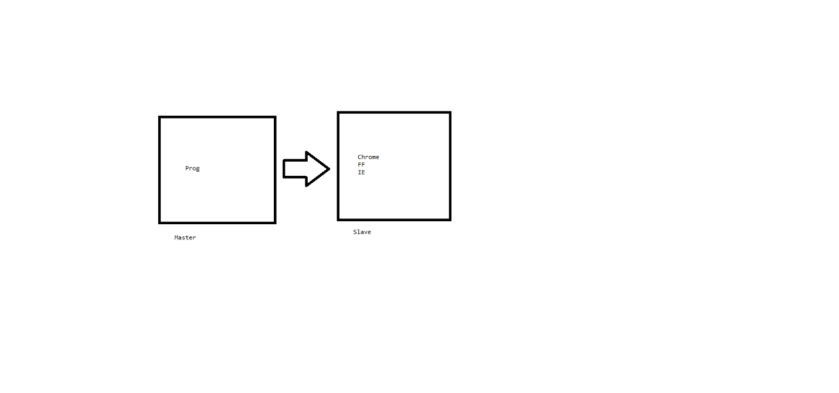
Selenium is a free, open source, web application automation tool.
Free – We don’t have to buy any license to work on selenium.
Open source - https://github.com/SeleniumHQ/selenium/tree/trunk
Entire source code is distributed freely so that if any modifications required in your company you can modify and utilize it.
web application automation tool – Any application which runs on browser engine is called as web application.
What are advantages of Selenium WebDriver?
1. Cross browser support – Chrome, Fire fox, IE, Safari, Opera etc..
2. Multi-platform – Windows, MAC, Linux, Ubuntu etc..
3. Multi Language support – Java, PHP, Python, Ruby, Java script, c#, Perl, Dart, Haskel, Object c etc..
4. Supports parallel execution.

Selenium 3 Architecture:
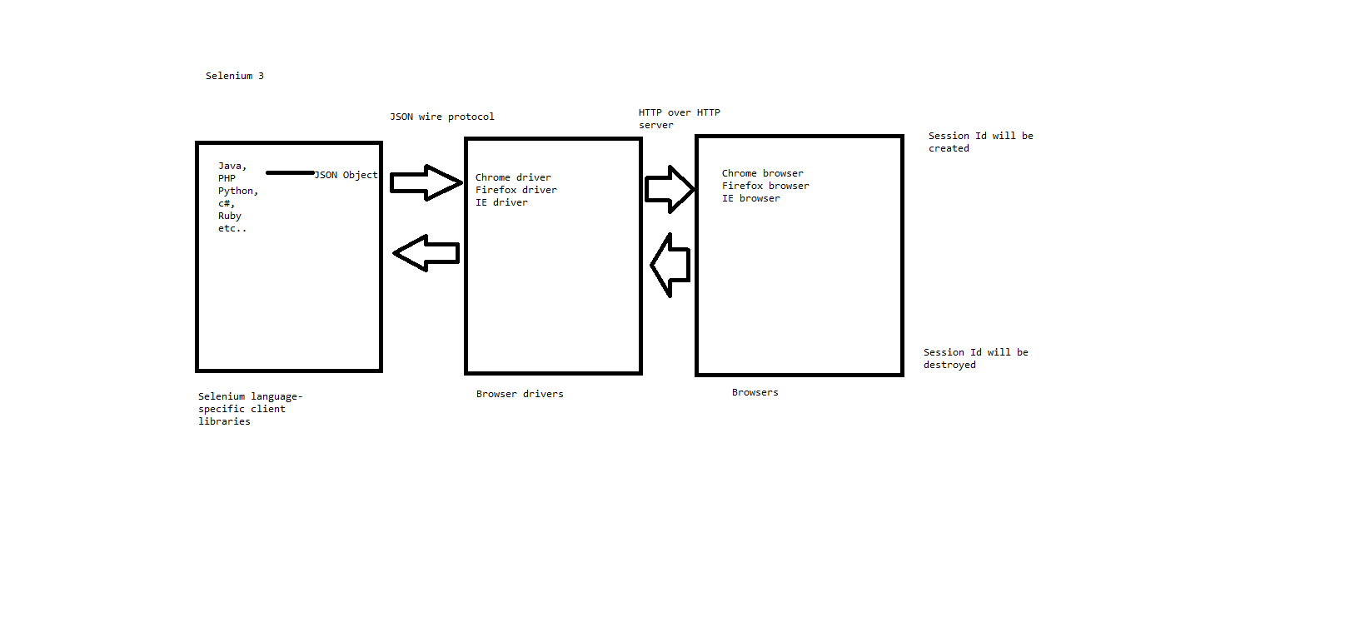
* In selenium3 we can write the program in multiple programming languages by using respective selenium language specific client libraries.
* These language specific client libraries are responsible for converting languages / programs into json objects.
* These json objects will be communicated to respective browser drivers via JSON wire protocol.
* These browser drivers are responsible for communicating to the respective browser.
* Once communication is established a session id will be generated.
* Once the program reaches to the end then session id will be destroyed and all the communications will be closed.

Selenium 4 Architecture:
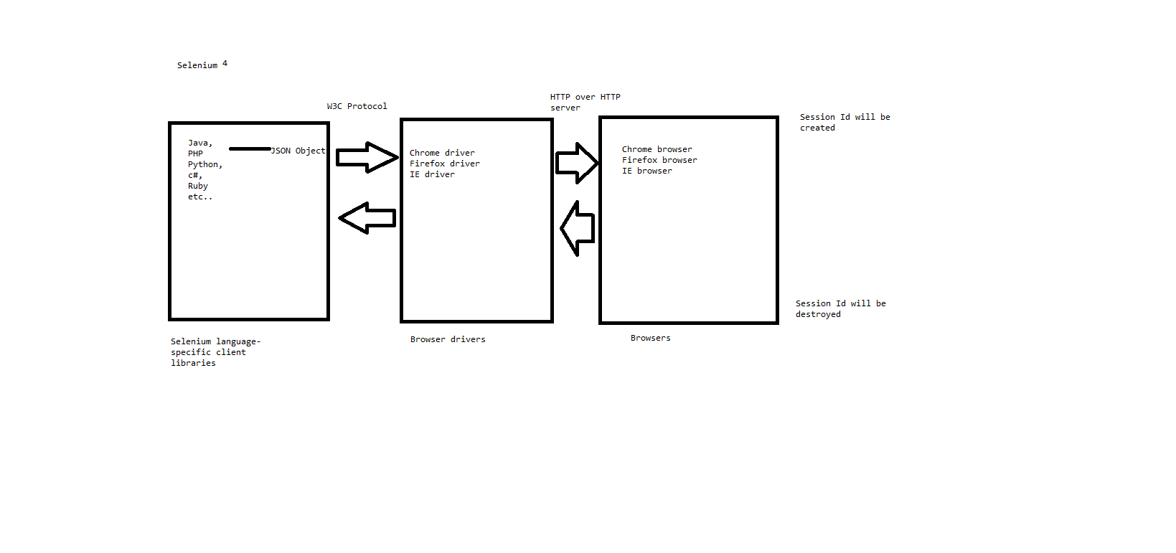
* In selenium4 we can write the program in multiple programming languages by using respective selenium language specific client libraries.
* These language specific client libraries are responsible for converting languages / programs into json objects.
* These json objects will be communicated to respective browser drivers via W3C protocol.
* These browser drivers are responsible for communicating to the respective browser.
* Once communication is established a session id will be generated.
* Once the program reaches to the end then session id will be destroyed and all the communications will be closed.
Note: * in selenium4 we don’t have to specify the browser driver explicitly while writing the program.
* In selenium4 we have new locators available.
Selenium-java architecture:
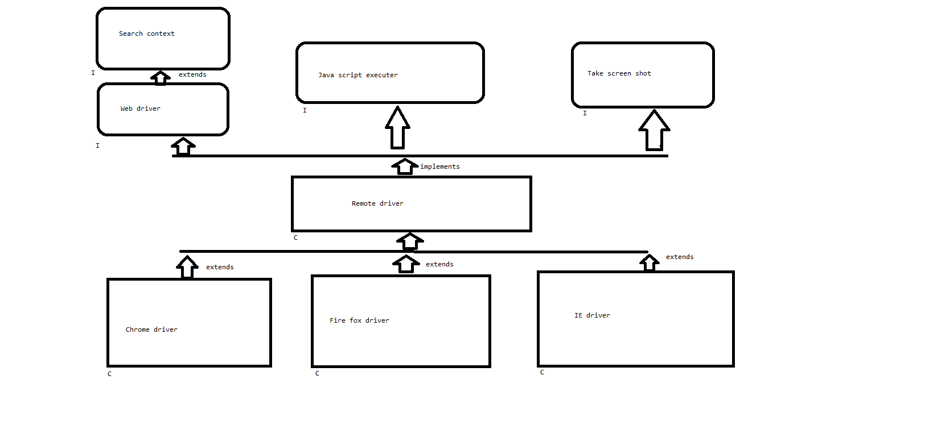
* Search context is the super the most interface present in the selenium-java which is extended by Web driver interface.
* This web driver interface is being implemented by Remote driver class along with other interfaces like Java script executer, take screen shot etc..
* All the browser driver classes like Chrome driver, Fire fox driver, IE driver etc.. are extended to Remote driver class.
Note: Abstract methods coming from Search context is extended to Web driver and overridden in Remote driver class like wise Java script executer, take screen shot abstract methods also overridden in Remote driver class.
Since browser driver classes are extended to remote driver class, all the overridden methods are easily accessible.
Git:
* Sign up/ create your own account - https://github.com/
* Click on New
* provide the repository name
* Make it as public for free. If private we need to pay some amount.
* click on create repository.
* Navigate to the place where your actual code is present in your system. (Right click on the project > Go to properties)
Eg: cd C:\Users\Admin\eclipse-workspace-java\SeleniumPractice
First time process
* git init
* git add .
* git commit -m "committing the code 24/09"
* git remote add origin https://github.com/Nammaqatraining/Selenium_22_Sep.git
* git branch -M main
* git push --set-upstream origin main
After modification of any file if you want to push the code
* git add .
* git commit -m "committing the code 24/09"
* git push
Note: Refer to link - https://github.com/Nammaqatraining/Selenium_22_Sep/tree/main
Steps for creating and accessing selenium jars:
1. Create a java project
2. Go to website - https://www.selenium.dev/downloads/
click on 4.35.0 (August 12, 2025)
3. Extract the downloaded .zip file
4. Copy all the jar files and paste it in 1 new folder eg: jars inside in your project.
5. Select all the jar files > right click > build path > add to build path
6. Refresh the project. You should see the jar files under Referenced libraries.
Note : org.openqa.selenium.SessionNotCreatedException we can expect this exception whenever the connection between your code to browser dint happened properly.
SearchContext (I) – Search context is the super most interface and it has only 2 abstract methods.
1. findElement()
2. findElements()
Note: If we upcast our browser driver object (chrome Driver/Firefox driver/Internet Explorer Driver) to the Search Context then we will be not able to access browser methods eg. get (). So, this is not a good idea to upcast browser driver object to Search Context interface.
WebDriver(I) – WebDriver interface is the core part in selenium and it has many browsers related abstract methods.
1. get(String url) – Enters the url in the opened browser window and it also waits until the page gets loaded successfully.
2. getCurrentUrl() – returns the String of url which is present in the opened browser window from automation.
3. getTitle() – returns the String of title which is present in the opened browser window from automation.
4. getPageSource() - returns the String of current page source (i.e HTML) which is present in the opened browser window from automation.
5. close() – it will close the current browser window opened by automation.
6. Quit() – it will close the multiple browser windows opened by automation.
7. getWindowHandle()
8. getWindowHandles()
9. switchTo()
10. navigate() – enters the url same as get(), it is also used for navigating back, forward, refresh the opened browser window from automation.
11. manage() – it will helps in minimizing, maximizing, setSize(required dimension) and setPosition(required position)
Note: * To set the required size of the browser window we need create the object of Dimension class and pass width and height as a parameter and pass this object reference to the setSize function.
* To set the required point of the browser window on the desktop we need create the object of Point class and pass x and y parameters and pass this object reference to the setPosition function.
Ref: day3 Prog2
Note: Since webdriver interface has many browser related abstract methods. It’s a good idea to upcast browser driver objects to WebDriver (I).
Q: How do you enter the url without using get()?
driver.navigate().to(URL);
Q: What is the difference between get() and navigate.to()?
-> get() – we can use get() method to enter the url and also it will wait until the page gets loaded completely.
-> navigate.to() – internally calls get() method and it has many functionalities like back, forward, refresh.
Q: What is WebDriver and provide some methods?
Q: What is Search Context and provide some methods?
Q: How do you set the dimension / customize the dimension of the browser window?
Q: How do you place the browser window in some position on the desktop?
Q: Give some difference between close() and quit()?
Q: Which method of web driver used to fetch the url from the browser window?
getCurrentUrl()
Q: How do you get the page source of the application?
getPageSource()
Q: How do you get the page title of the application?
getTitle()
HTML – Basics
Hyper Text Markup Language
* It is not case sensitive.
* While writing the html code we use pre-defined keywords within <> is called as tags.
* <keyword> -> start tag and </keyword> -> end/closing tag
To create the html page
* Create the package html
* right click > click on New > File > Provide the name as “Page1.html”
* If you’re not seeing suggestions then go to Help> Eclipse market place > Search (Wild Web Developer) > Click on Install (Accept the agreement) > Restart the eclipse once.
HTML page will be divided into 2 parts:
1. Head
2. Body
1. Head part usually consists of:
1.1 Title – Appears on the top/head of the page.
1.2 CSS (Cascading style sheet) - used by the designers to create look and feel of the browser
1.3 Java Script – Used by the developers for doing client-side validations.
* Stops the customer by providing the error messages and it will not carry the data to the server. (Saves some time).
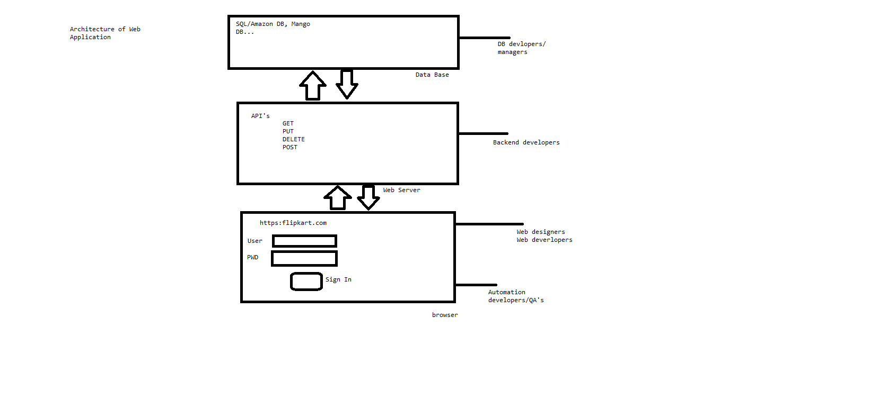
2. Body part usually consists of:
2.1 Text Box
2.2 Buttons
2.3 Radio Buttons
2.4 Check Box
2.5 Drop down list
2.6 Text area
2.7 Table
2.8 Lists
2.9 Links
2.10 Images
2.11 File browser
2.12 Headers
2.13 Paragraph
* To identify the element on the HTML page, we use html tag by the attributes and values of the element.

2.1 Text Box
<input type="text" name="userName" id="un" />
Keyword – input
Mandatory attributes - type="text"
Additional attributes - name="userName" id="un"
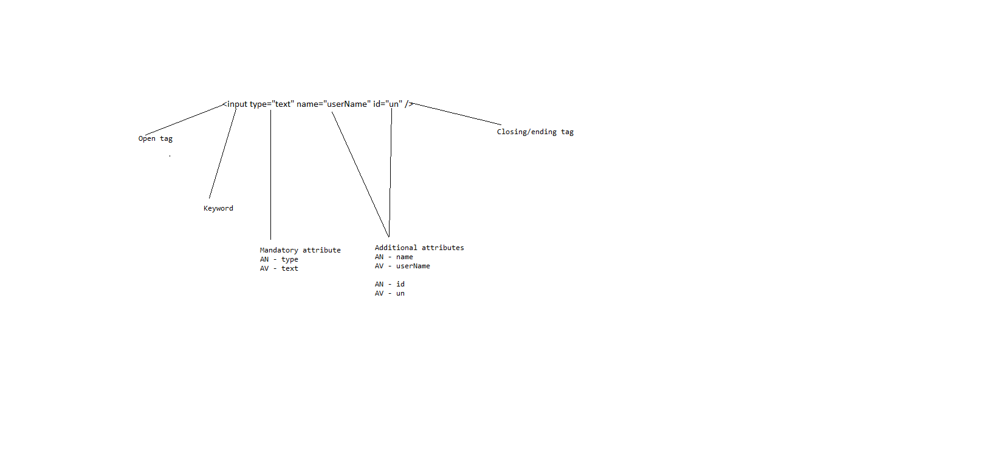
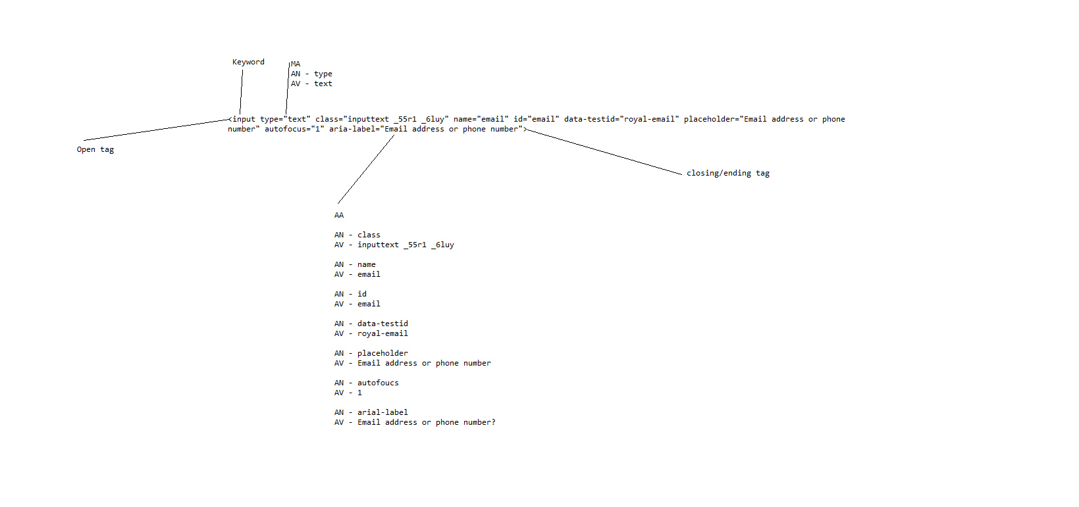
Note:
1. Anything which is present on the web page such as text box, buttons, radio buttons etc.. is called as Web Elements.
2. Any web element as the following component’s – tag, attribute, text.
3. Web element is created using HTML.
4. In HTML we use pre-defined words with angle brace (<>) they are called as tags/keywords, we end tag using Forword slash (/) is called as closing tag. But closing with (/) is not mandatory for all the html tags.
2.2 Buttons
<input type="button" value="Login" name="login" id="login">
2.3 Radio Buttons
MALE <input type="radio" name="male" id="male">
FEMALE<input type="radio" name="female" id="female">
2.4 Check Box
AadharCard : <input type="checkbox" id="aadharcard" name="aadharcard" class="input_checkBox">
PAN Card : <input type="checkbox" id="panCard" name="panCard"class="input_checkBox">

2.5 Drop down list
* There are 2 types of drop-down list present in the html
2.5.1. Single select drop down list
<select name="cities" id="cities_id">
<option value="1">Bangalore</option>
<option value="2">Hyderabad</option>
<option value="3">Chennai</option>
<option value="4">Vizag</option>
<option value="5">Pune</option>
<option value="6">mumbai</option>
</select>
2.5.2 Multi select drop down list
<select name="cities" id="cities_id" multiple="true">
<option value="1">Bangalore</option>
<option value="2">Hyderabad</option>
<option value="3">Chennai</option>
<option value="4">Vizag</option>
<option value="5">Pune</option>
<option value="6">mumbai</option>
</select>
2.6 Text area
<textarea height="100" width="100" name="feedback" id="feedback_id"></textarea>
2.7 Table
<table border="1">
<tr>
<th>SI No.</th><th>Student Name</th><th>Student Role Number</th>
</tr>
<tr>
<td>1</td><td>ABC</td><td>10001</td>
</tr>
<tr>
<td>2</td><td>CDE</td><td>10002</td>
</tr>
<tr>
<td>3</td><td>EFG</td><td>10003</td>
</tr>
</table>
2.8 Lists
* There are 2 types of lists present in the html
2.8.1 Ordered list
<ol name="countries" id="countries">
<li>India</li>
<li>China</li>
<li>USA</li>
<li>UK</li>
</ol>
2.8.2 Unordered list
<ul name="countries" id="countries">
<li>India</li>
<li>China</li>
<li>USA</li>
<li>UK</li>
</ul>
2.9 Links
<a href="https://en.wikipedia.org/wiki/Blog_award" name="Blog award" id="Blogaward_id">Blog award</a>
2.10 Images
<img src="IMG1.svg" title="image" name="image" id="image"/>
2.11 File browser
<input type="file" name="upload_resume" id="upload_id_resume"/>
2.12 Headers – varies between the font size and displays the text in bold letters.
<h1>India</h1>
<h2>India</h2>
<h3>India</h3>
<h4>India</h4>
<h5>India</h5>
<h6>India</h6>
2.13 Paragraph
<p>India is great</p>
Web Element | HTML Tag / Keywords | Mandatory attributes | Additional attributes
Text Box | input | type="text",type="password", type="email" ,type="number" | name/id/class name/place-holder..
Button | input | type="button" | name/id/class name/value..
Radio Button | input | type="radio" | name/id/class name..
Check Box | input | type="checkbox" | name/id/class name..
Single select dropdown | select,option | N/A | name/id/class name/value..
Multi select dropdown | select,option | multiple="true" | name/id/class name/value..
text area | textarea | height, width | name/id/class name..
table | table,tr,th,td | border="1" | name/id/class name..
ordered list | ol,li | N/A | name/id/class name..
unordered list | ul,li | N/A | name/id/class name..
Links | a | href | name/id/class name..
image | img | src | title/name/id/class name..
File browser | input | type="file" | name/id/class name..
headers | h1,h2,h3,h4,h5,h6 | N/A | N/A
Paragraph | p | N/A | N/A

6. Locators
* Locators are the static methods (any method which is having static keyword is called as static method and advantage of using static method is we can call the method directly by using class name. We don’t have to create the object for the class) present in “By” class.
* By class which is used to find elements in HTML page
* In selenium before performing the action such as clicking, typing .. we should find the element first.
* To find the element in the HTML page, we use locators.
* In selenium we have 8 type of locators present:
6.1 Name
6.2 ID
6.3 Class Name
6.4. Tag Name
6.5 Link Text
6.6 Partial Link Text
6.7 CSS Selector
6.8 Xpath

Note:
* All the above locators are static methods present in the By class.
* The above statements are used as arguments to findElement() and findElements() methods. i.e, By class with static methods can be passed as arguments to findElement() and findElements().
Eg: findElement(By.name())
* Return type of findElement() is WebElement (Interface).
* Return type of findElements() is List of WebElement(Interface). List<WebElement>.
WebElement interface has following abstract methods:
1. Click() – left mouse clicks
2. Submit() – left mouse clicks., internally calls click() method.
3. sendKeys(args) – typing text from the keyboard.
4. Clear() – clearing the text i.e using backspace/delete keys from the keyboard.
5. getTagName() – returns the tag name from the webelement.
6. getAttribute(args) – return the value of the attribute.
7. getText() – return the text from the WebElement.
8. isSelected() – return true/false
9. isEnabled() – return true/false
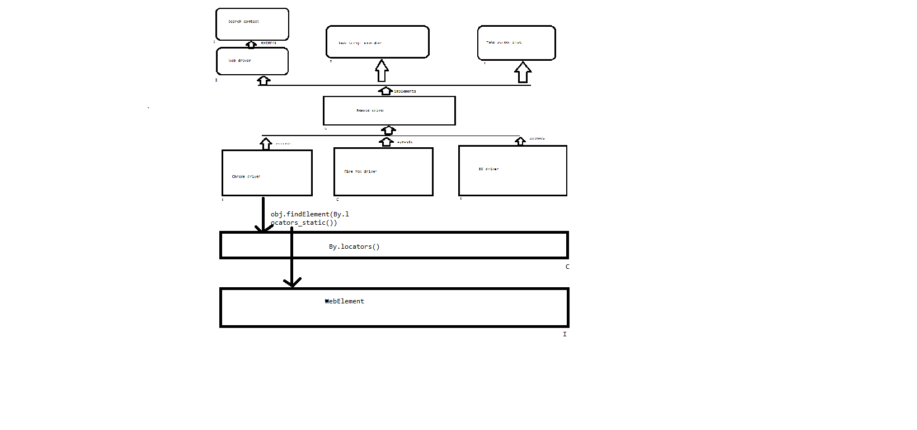
Eg:
<input type="text" value="submit" name="n1" id="i1" class="c1">
tagName – input
Attributes - type="text" value="submit" name="n1" id="i1" class="c1"
text – N/A
<a href="https://en.wikipedia.org/wiki/Blog_award" name="Blog award" id="Blogaward_id" class="Blogaward_class">Blog award</a>
tagName – a
Attributes - href="https://en.wikipedia.org/wiki/Blog_award" name="Blog award" id="Blogaward_id" class="Blogaward_class"
text – Blog award
***
Please follow the below rules while identifying the webelement:
1. Anything which is present after the < (open tag) is called as tagName (keywords).
2. Anything which is present after the tag Name is called as Attributes (Mandatory or Additional).
3. Anything which is present after the > (closing tag) is called as text.
Note: Any element which findElement is unable to identify on the webpage it will throw org.openqa.selenium.NoSuchElementException exception.
Eg:
<input type="text" value="submit" name="n1" id="i1" class="c1">
* For the above HTML tag, all types of locators (name,id,class-name,tagName) can be applied except link text and partial link text.
* Link text and partial link text is used to locate only the text present in the link.
* Partial link text is used to locate the link which is partially dynamic. (i.e some part of text might be keep changing.)
* Partial link can be applied whenever you’re seeing &nbsp; in the text.
* CSS and Xpath locators are not found because they are formulas.
Note: * If the specified locator is matching with more than one locator then findElement() returns the address of the first matching element.
* If the specified locator is not matching with any of the element in the page then findElement will throw NoSuchElementException exception.
CSS Selector:
* CSS selector stands for cascading style sheet.
* CSS selector is one of the locator and its expression is followed by the following formula.
* Anything which is present after the tagName is called as attributes. Can be mandatory or additional attributes can be used in CSS selector.
* text is not allowed in CSS selector (drawback).
* Backward traversing is not possible using CSS Selector (drawback).

***
CSS Selector
tagName[attributeName=’attributeValue’]
Eg:
<input type="button" value="submit" id="b1" class="c1" name="n1">
input[type='button']
input[value='submit']
input[id='b1']
input[class='c1']
input[name='n1']
Shortcuts applicable only for id and class name:
input[id='b1'] | input#b1 | #b1
input[class='c1'] | input.c1 | .c1
Formula for shortcuts:
tagName#idValue or #idValue
tagName.classValue or .classValue
Note: When ever we are passing wrong formula then findElement will throw InvalidSelectorException exception.
CSS selector with pre fix and suffix:
tagName[attributeName^=’starting text of attributevalue’] – starting with part of attribute value
tagName[attributeName$=’ending text of attributevalue’] - ending with part of attribute value
Eg:
a[href^='https']
a[name^='Bl']
a[name$='rd']
a[id$='id']
CSS selector with substring:
tagName[attributeName*=’part of the attributevalue’]
a[name*='aw']
a[id*='rd']
a[class*='wa']
CSS Selector Formula overall:
tagName[attributeName='attributeValue']
tagName#idValue or #idValue | shortcut
tagName.classValue or .classValue | shortcut
tagName[attribute^=’starting text of attributevalue’] | prefix
tagName[attribute$=’ending text of attributevalue’] | suffix
tagName[attributeName*=’part of the attributevalue’] | substring
CSS Traversing
* CSS will allow only forward traversing.
There are 2 types of traversing available for css:
1. Absolute css traversing.
2. Relative css traversing.
Absolute css traversing:
* Traversing from root tag (html).
* We use > symbol for traversing.
* To pass the index of the webelement we use the below formula.
tagName:nth-child(index)
Eg: html>body>input:nth-child(1)
Relative css traversing:
* Anywhere in the html tree.
* We use “ ” – space symbol for traversing
* To pass the index of the webelement we use the below formula.
tagName:nth-child(index)
Eg: html input:nth-child(1)
input:nth-child(1)
Note: * We need to use relative css path with index when we don’t see additional attributes in the html tag.
* When we have unique additional attributes its better to go with css path with attributes formula.
Absolute css traversing | >
Relative css traversing | - space
index | :nth-child(index)

Fb login page
1 | html
 | 1 | head
 | 1 | body
 |  | 1 | div
 |  |  | 1 | div
 |  |  |  | 1 | div
 |  |  |  |  | 1 | div
 |  |  |  |  |  | 1 | div
 |  |  |  |  |  |  | 1 | div
 |  |  |  |  |  |  | 2 | div
 |  |  |  |  |  |  |  | 1 | div
 |  |  |  |  |  |  |  |  | 1 | div
 |  |  |  |  |  |  |  |  |  | 1 | form
 |  |  |  |  |  |  |  |  |  |  | 1 | div
 |  |  |  |  |  |  |  |  |  |  |  | 1 | div
 |  |  |  |  |  |  |  |  |  |  |  |  | 1 | input
 |  |  |  |  |  |  |  |  |  |  |  | 2 | div
 |  |  |  |  |  |  |  |  |  |  |  |  | 1 | input
 |  |  |  |  |  |  |  |  | 2 | div
 |  |  |  | 2 | div
Fb create new account page
1 | html
 | 1 | head
 | 1 | body
 |  | 1 | div
 |  |  | 1 | div
 |  |  |  | 1 | div
 |  |  |  |  | 1 | div
 |  |  |  |  | 2 | div
 |  |  |  |  |  | 1 | div
 |  |  |  |  |  |  | 1 | div
 |  |  |  |  |  |  | 2 | div
 |  |  |  |  |  |  |  | 1 | div
 |  |  |  |  |  |  |  |  | 1 | div
 |  |  |  |  |  |  |  |  |  | 1 | div
 |  |  |  |  |  |  |  |  |  |  | 1 | div
 |  |  |  |  |  |  |  |  |  |  | 2 | div
 |  |  |  |  |  |  |  |  |  |  | 1 | form
 |  |  |  |  |  |  |  |  |  |  |  | 1 | div
 |  |  |  |  |  |  |  |  |  |  |  |  | 1 | div
 |  |  |  |  |  |  |  |  |  |  |  |  |  | 1 | div
 |  |  |  |  |  |  |  |  |  |  |  |  |  |  | 1 | div
 |  |  |  |  |  |  |  |  |  |  |  |  |  |  |  | 1 | div
 |  |  |  |  |  |  |  |  |  |  |  |  |  |  |  |  | 1 | div
 |  |  |  |  |  |  |  |  |  |  |  |  |  |  |  |  | 1 | input
 |  |  |  |  |  |  |  |  |  |  |  |  |  |  | 2 | div
 |  |  |  |  |  |  |  |  |  |  |  |  |  |  |  | 1 | div
 |  |  |  |  |  |  |  |  |  |  |  |  |  |  |  |  | 1 | div
 |  |  |  |  |  |  |  |  |  |  |  |  |  |  |  |  | 1 | input
 |  |  |  |  |  |  |  |  |  | 2 | div
 |  |  |  | 2 | div
 |  |  | 1 | span

Xpath
*Xpath is nothing but a path of an element in the HTML tree.
* Xpath is used to locate the element based on the XML path.
* XML stands for Extensible markup language and it is used to store, organize and transport arbitrary data.
* It stores the data in a key and value pair which is similar to the HTML tags.
* Both being mark up languages and since they fall under the same tree we can use xpath for finding the elements on the HTML page.
* The fundamentals behind locating elements using xpath is traversing between various elements.
There are 2 types of traversing available for xpath:
1. Absolute xpath traversing.
2. Relative xpath traversing.

Absolute xpath traversing | /
Relative xpath traversing | //
index | [index]
* While writing the xpath we use ‘/’ which represents the immediate child element.
* While writing the xpath we use ‘//’ which represents the any child element.
* ‘/’ means we are in the root element (HTML). It is used to create xpath with absolute path i.e xpath would be created to start selection from starting ‘/’ root node.
* ‘//’ any child(descendent). It is used to create xpath with relative path i.e xpath would be created to start selection from any where within the source tree.
Eg:
html>body>input:nth-child(1) - css
/html/body/input[1] - xpath
html input:nth-child(1) – css
//html//input[1] - xpath
input:nth-child(1) – css
//input[1] – xpath

