DATA ANALYTICS INTERNSHIP
ASSIGNMENT 2
Python, NumPy, Pandas, Data Analysis & Visualization
Name: Namokar Rajendra Patil
Course: Data Analytics Internship
Assignment No.: 2

Task 1 – Python Basics & NumPy Operations

1.1 Python Basics
i = 25
f = 3.14
s = "Data Analytics"
b = True
lst = [10, 20, 30]
tup = (1, 2, 3)
dct = {"name": "Aarav", "age": 28}
for value in [i, f, s, b, lst, tup, dct]:
print(value, type(value))
a, b_num = 10, 3
print("Add:", a+b_num); print("Sub:", a-b_num); print("Mul:", a*b_num)
print("Div:", a/b_num); print("Mod:", a%b_num); print("Power:", a**b_num); print("Floor div:", a//b_num)
print("Equal:", a==b_num); print("Greater:", a>b_num); print("Less:", a<b_num)
print("AND:", a>5 and b_num<5); print("OR:", a<5 or b_num<5)

1.2 NumPy Results
Shape: (12,) | Size: 12 | Dtype: int64
Sum: 2311 | Mean: 192.58 | Max: 275 | Min: 125 | Std: 47.3998
Indices > 200: [7, 8, 9, 10, 11]
Month-over-month growth: [13, 4, 13, 13, 12, 15, 15, 15, 15, 18, 17]
Reshaped 4 × 3 array:
[[125 138 142]
[155 168 180]
[195 210 225]
[240 258 275]]

Task 2 – Pandas: Data Loading, Cleaning & Merging
Customers and Purchases were loaded into customers_df and purchases_df. Missing age was filled with the mean and converted to integer; missing gender was replaced with 'Unknown'. The DataFrames were merged on cust_id using an inner join.
Merged DataFrame shape: (10, 9). The required head(), info(), missing-value checks and merged head are included in the Jupyter Notebook.

Task 3 – Filtering, Grouping, Aggregation & Visualization

3.1 Filtering
The notebook contains outputs for Mumbai purchases, purchases with amount > ₹5,000, and male customers who made any purchase.

3.2 Grouping & Aggregation
Total purchase amount per city
Bangalore: 34,699
Delhi: 8,499
Mumbai: 73,000
Pune: 2,150
Average purchase amount per gender
F: 2,833.00
M: 15,692.71
Number of purchases per customer
C01: 2
C02: 2
C03: 2
C05: 2
C06: 1
C07: 1
Top 3 customers by total spending
Aarav: 73,000
Chirag: 32,899
Bhavya: 8,000

3.3 Data Visualization
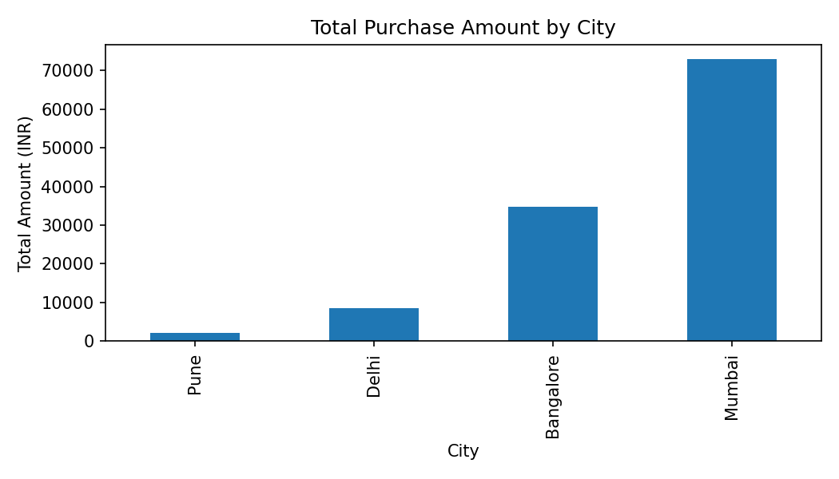
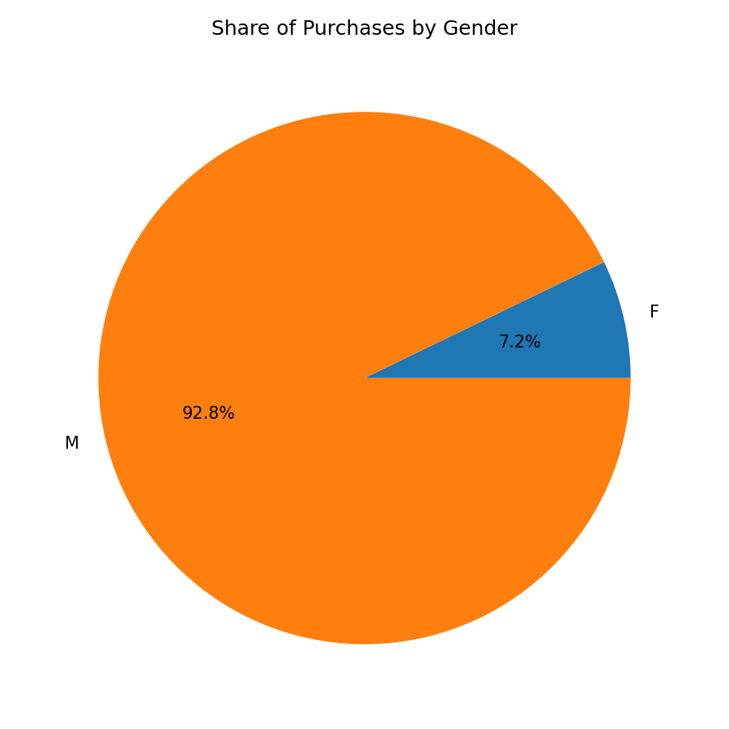
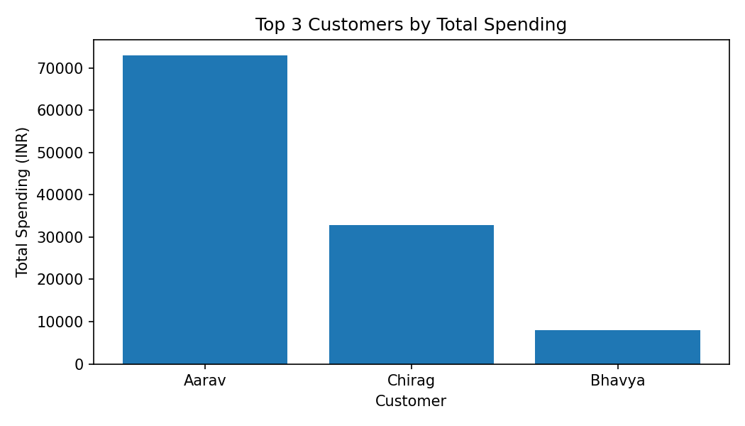
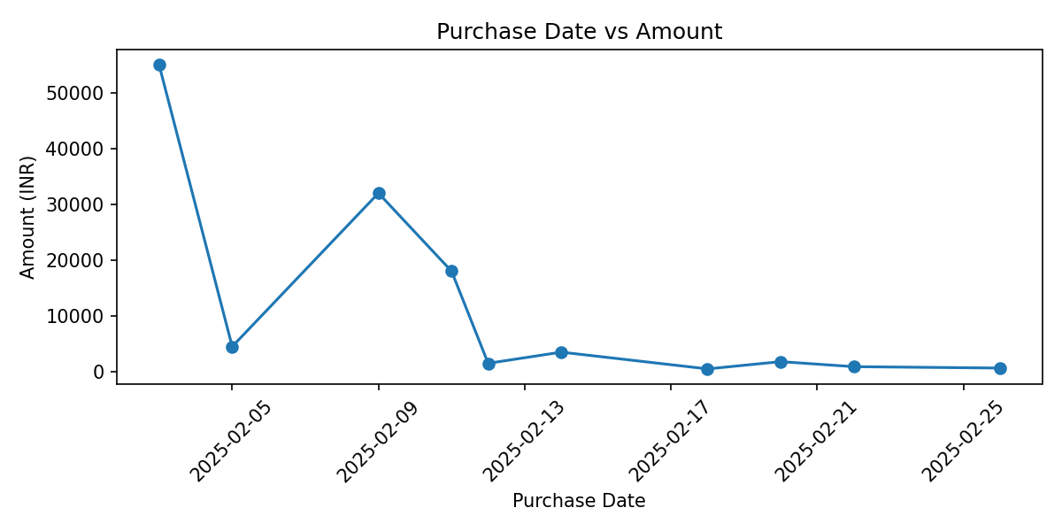

3.4 Data Analysis Summary
Mumbai generated the highest purchase revenue at ₹73,000, making it the strongest-performing city in the dataset. Aarav and Chirag were the most active customers by number of purchases, with two purchases each. Aarav was the top customer by total spending at ₹73,000, followed by Chirag at ₹32,899 and Bhavya at ₹8,000. The purchase pattern is concentrated in a few higher-value electronics purchases, especially the Laptop and Smartphone. Male customers recorded a higher average purchase amount than female customers in this sample. After cleaning, the missing gender value was replaced with Unknown and the missing age was filled using the mean age. Overall, the analysis shows that city, customer and product mix have a strong effect on total revenue.

Conclusion
The completed Jupyter Notebook contains the Python code, outputs, filtering/grouping analysis and all four required visualizations.

