**Task 2.**

1. Apply changes to the following app code to make GC curve have peaks that are more frequent.

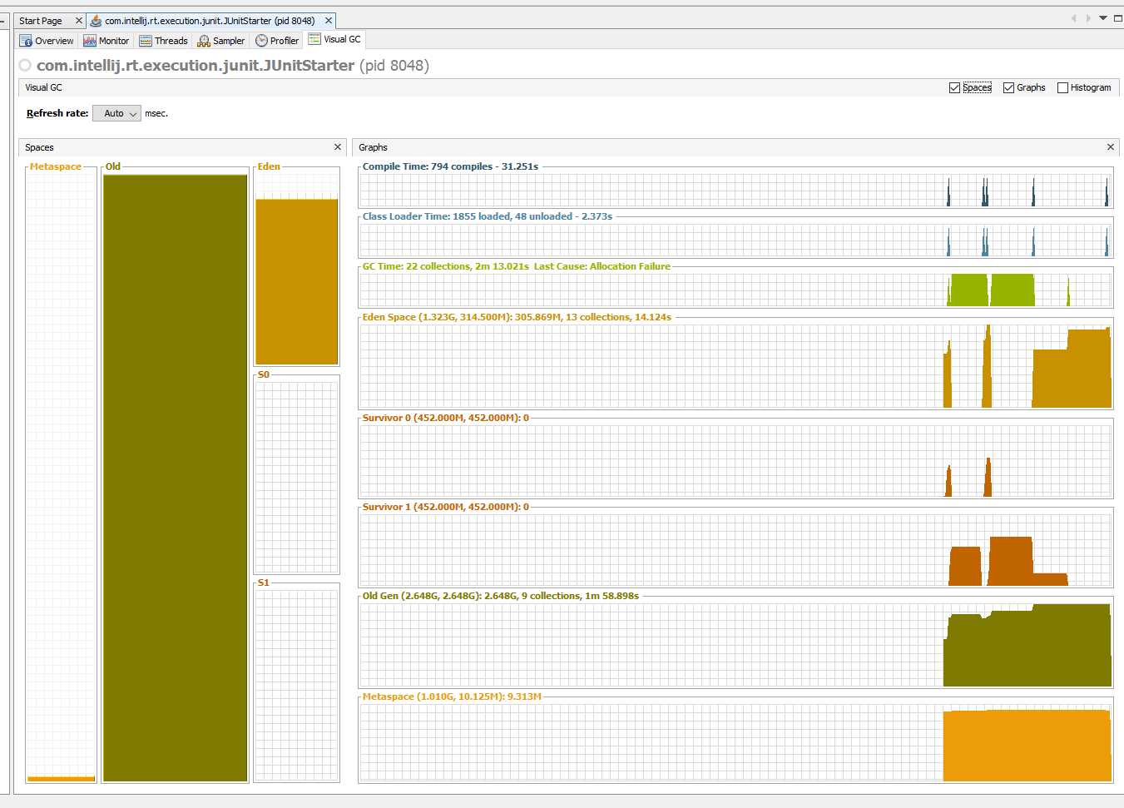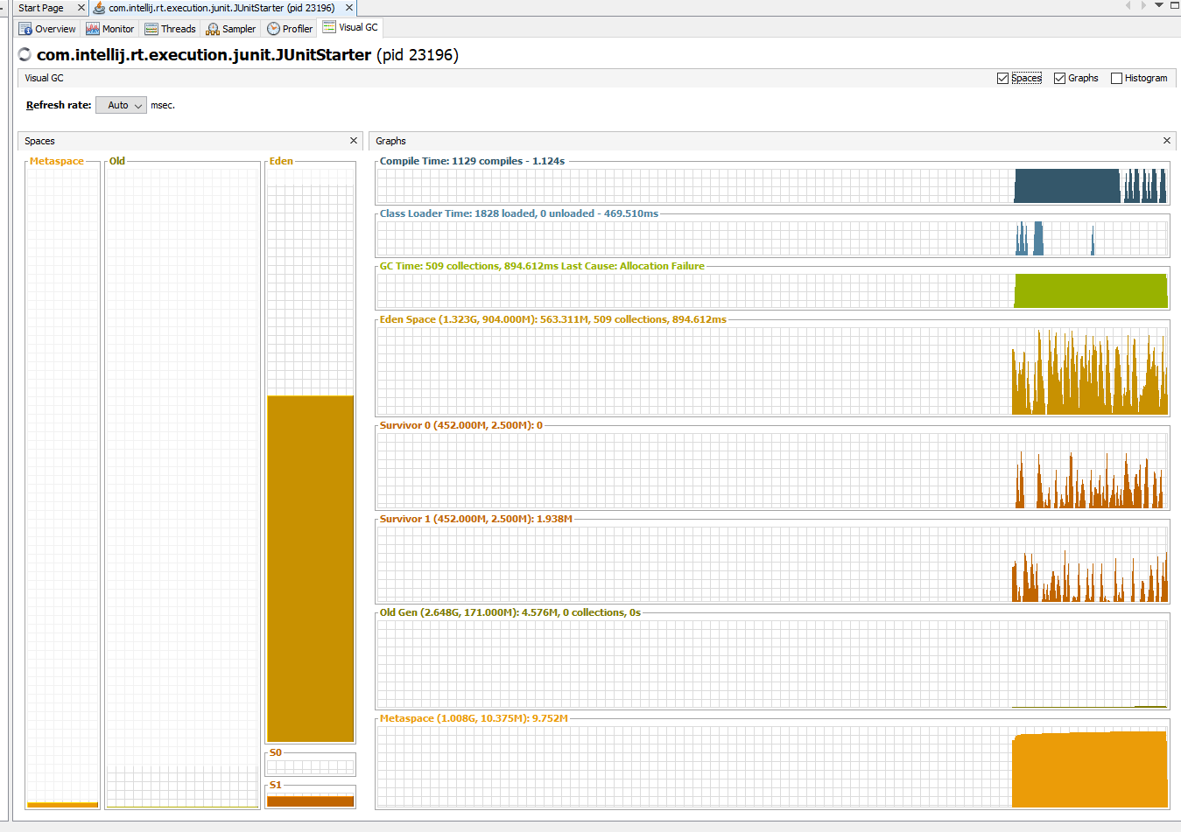

1. Tune GC settings via JVM flags (change GC, maybe) to make GC curve have peaks that are more frequent.

**-XX:+UseG1GC**

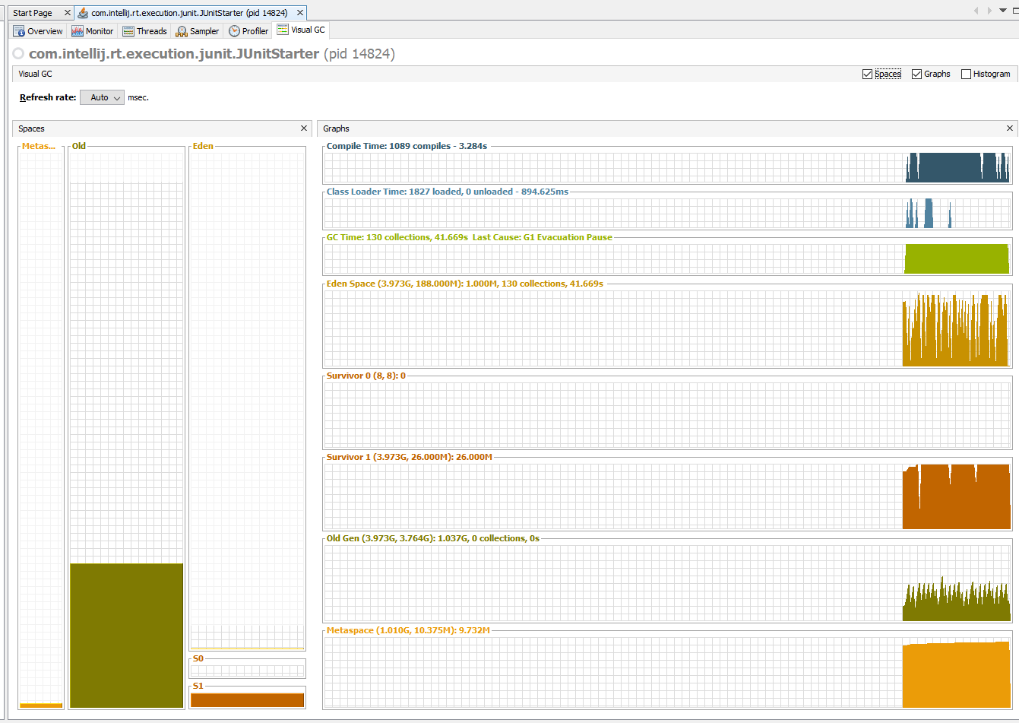

**-XX:+UseConcMarkSweepGC -XX:+UseParNewGC**

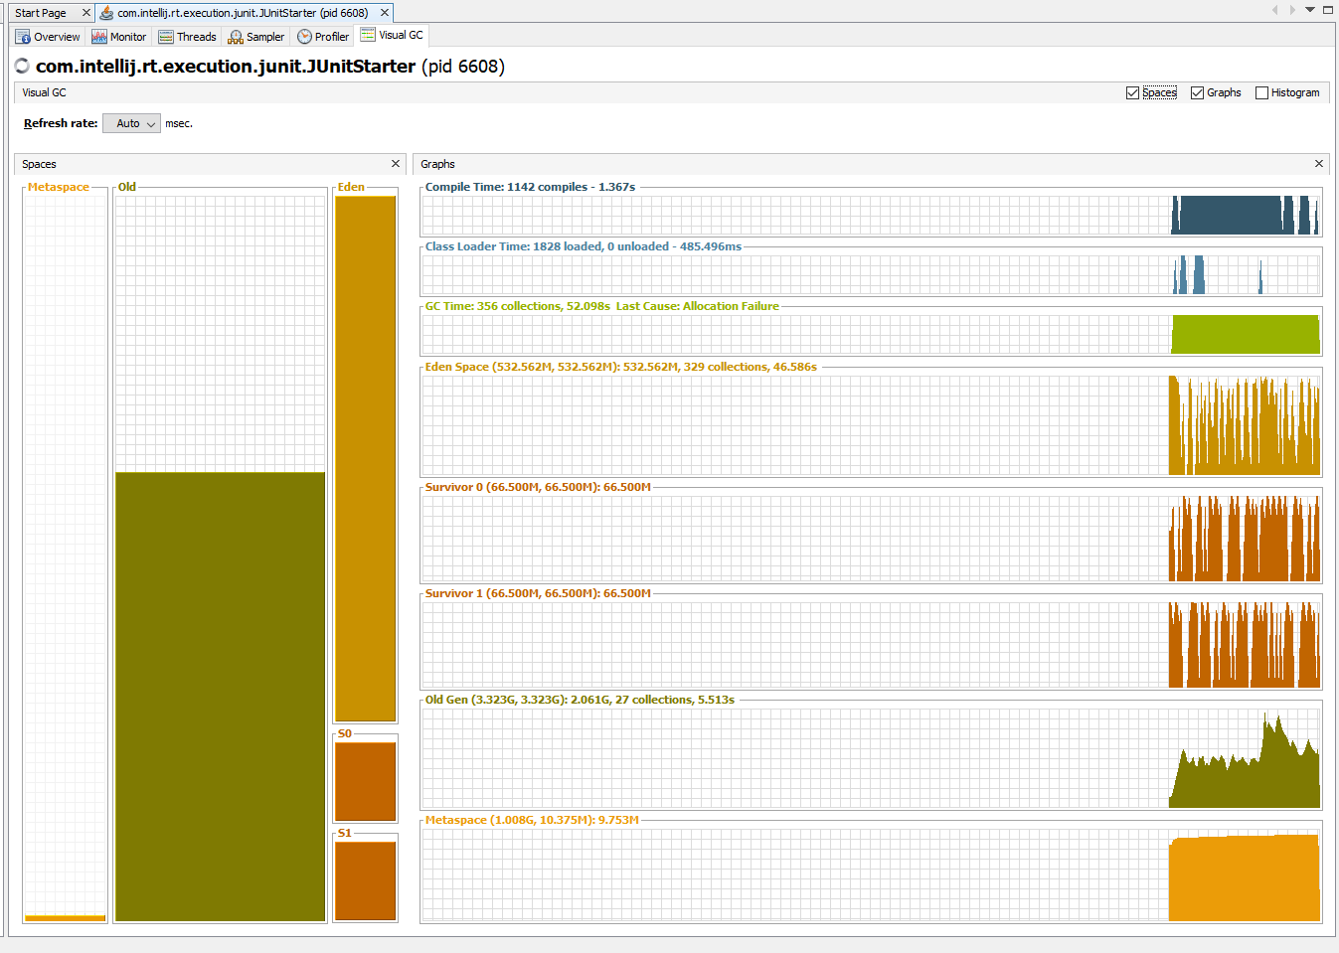

**-XX:+UseParallelGC -XX:+UseParallelOldGC -XX:+UseAdaptiveSizePolicy**

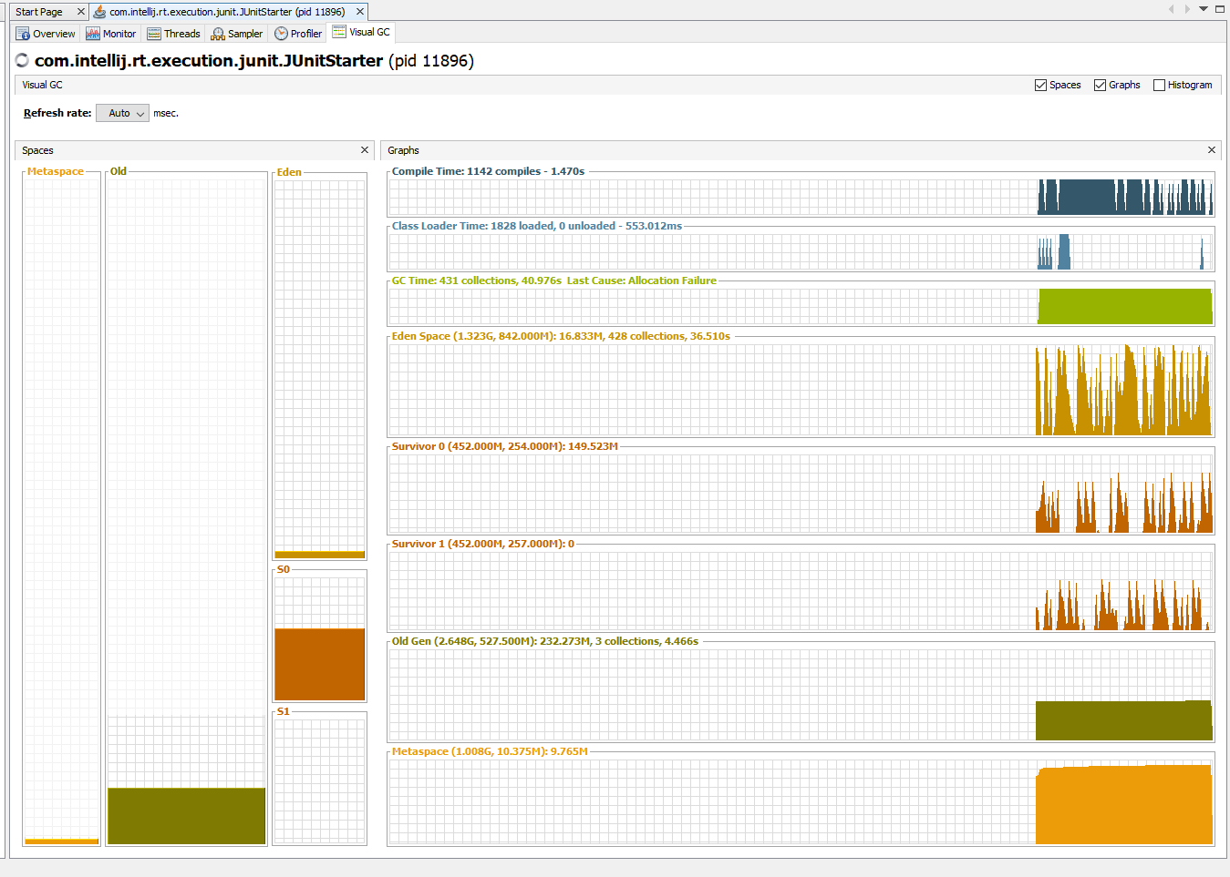

**-XX:+UseSerialGC**

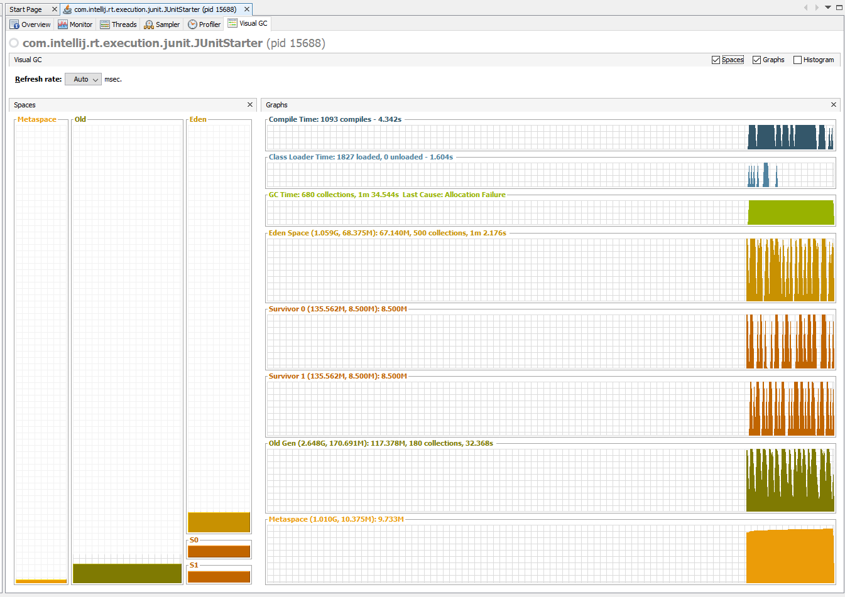

3) Tune Heap regions via JVM flags to make GC curve have peaks that are more frequent.

-XX:NewRatio=1 -XX:SurvivorRatio=3

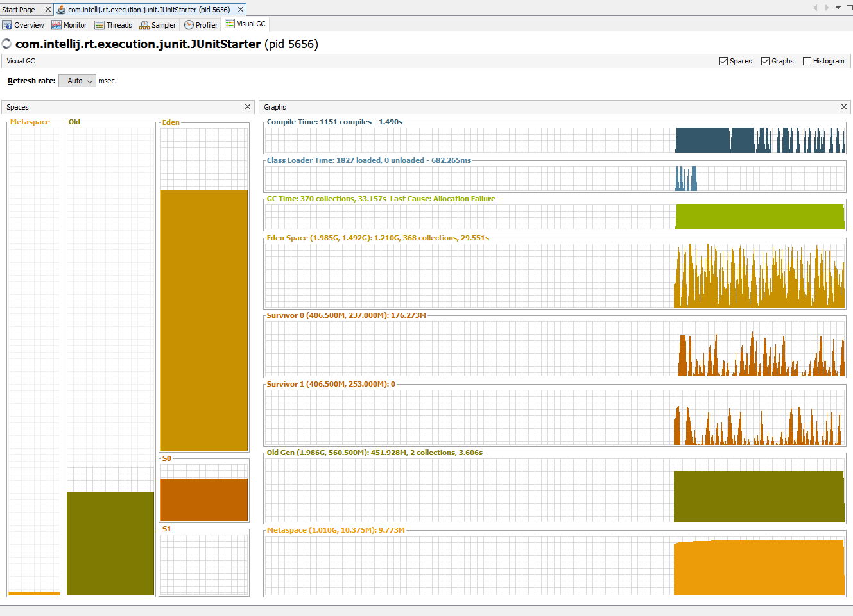

-XX:NewRatio=10 -XX:SurvivorRatio=3

