**Task 2.**

1. Apply changes to the following app code to make GC curve have peaks that are more frequent.

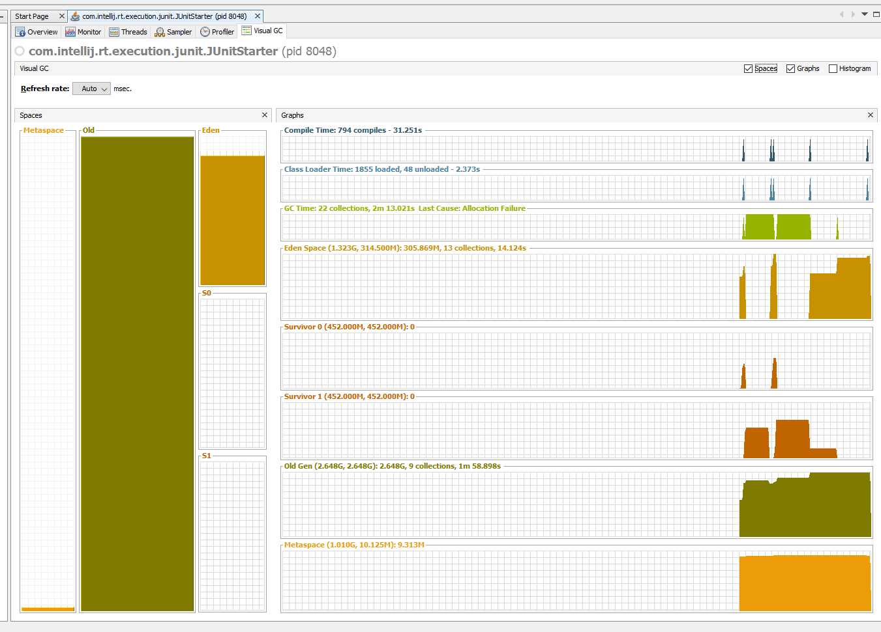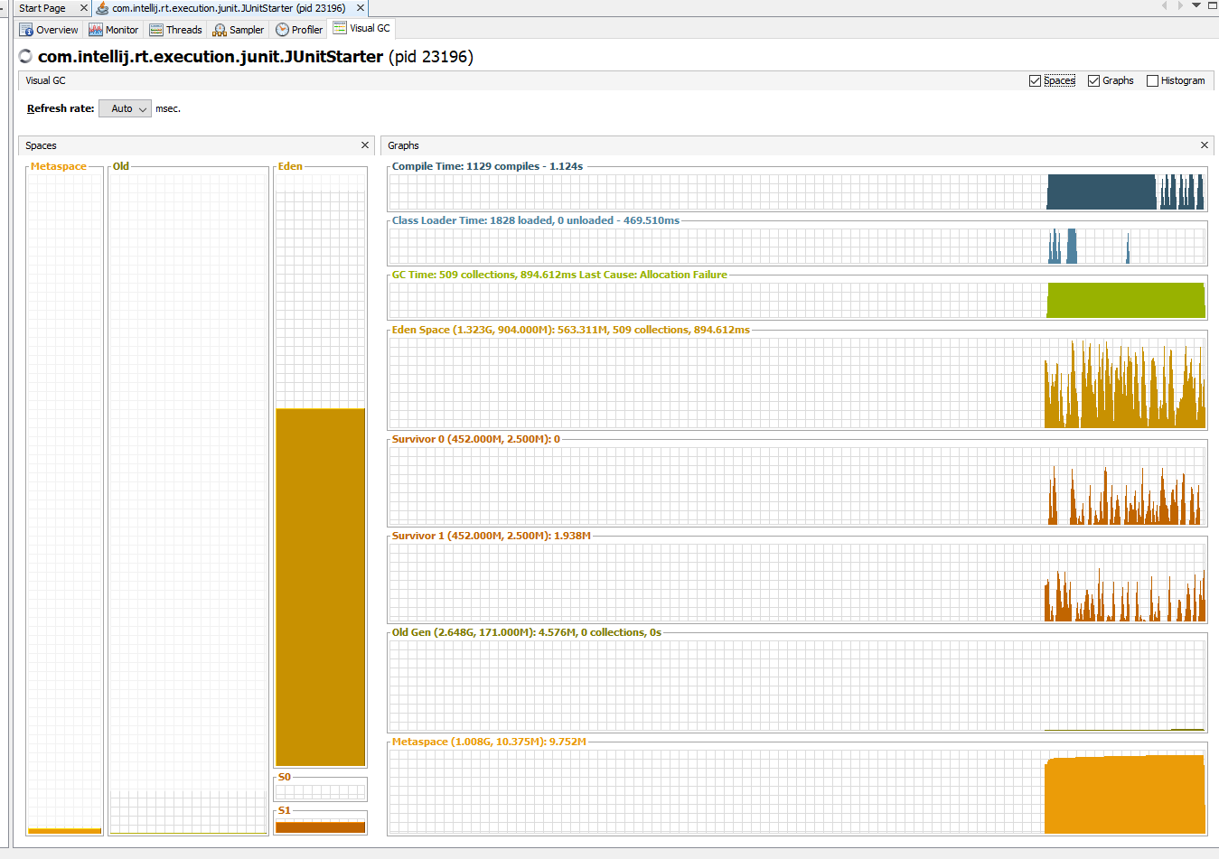

1. Tune GC settings via JVM flags (change GC, maybe) to make GC curve have peaks that are more frequent.

**-XX:+UseG1GC**

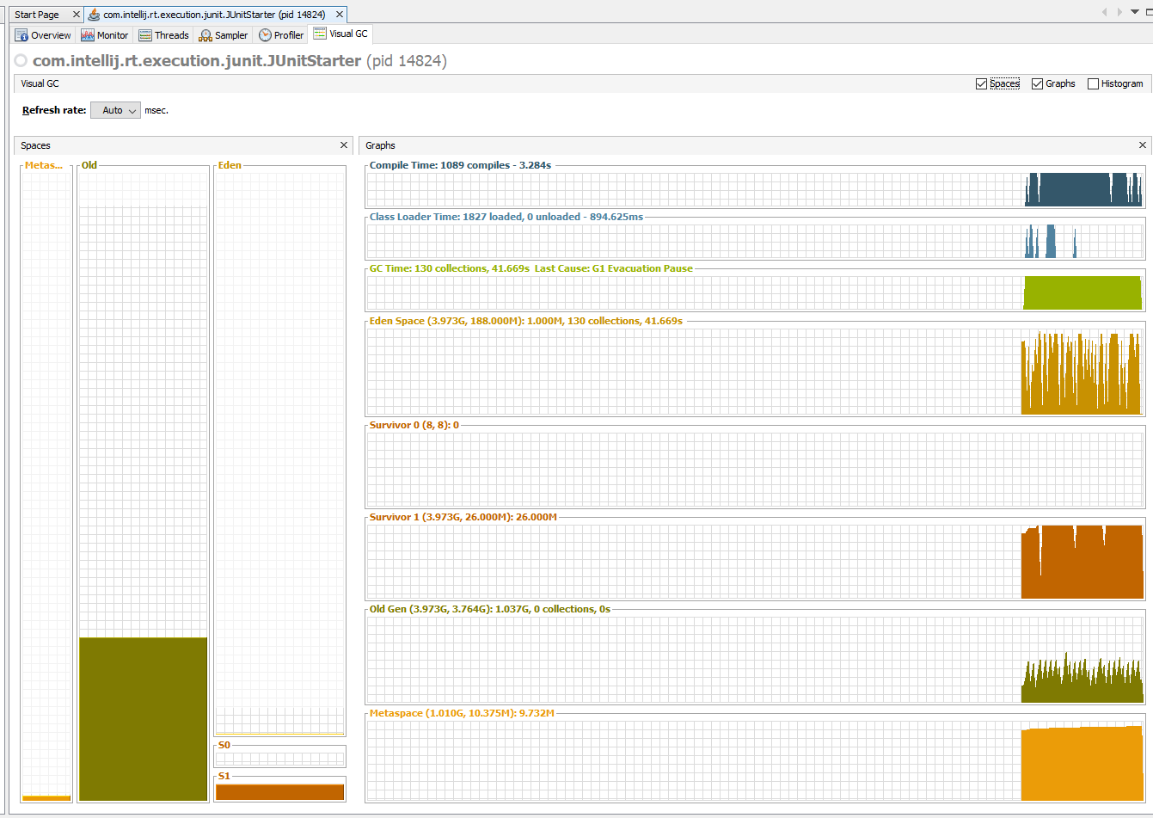

**-XX:+UseConcMarkSweepGC -XX:+UseParNewGC**

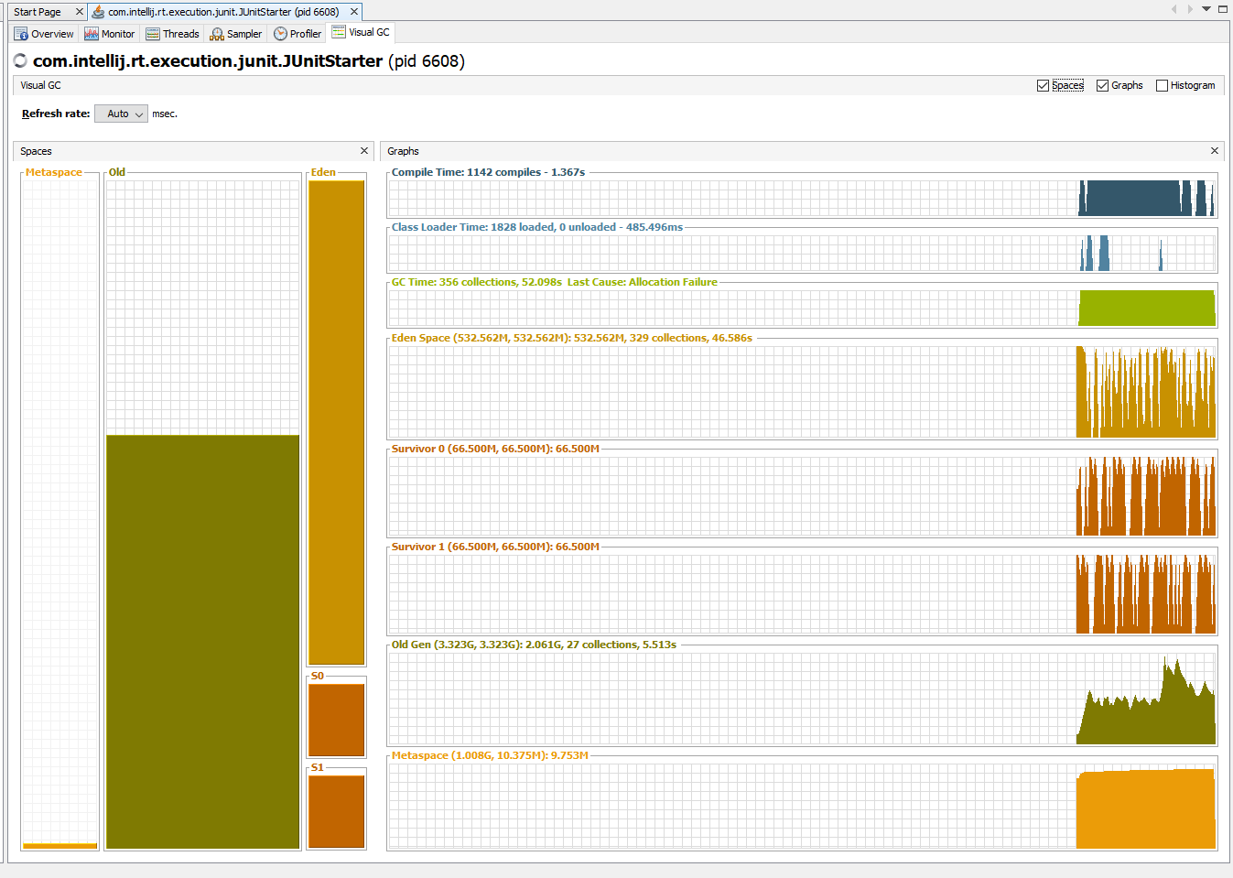

**-XX:+UseParallelGC -XX:+UseParallelOldGC -XX:+UseAdaptiveSizePolicy**

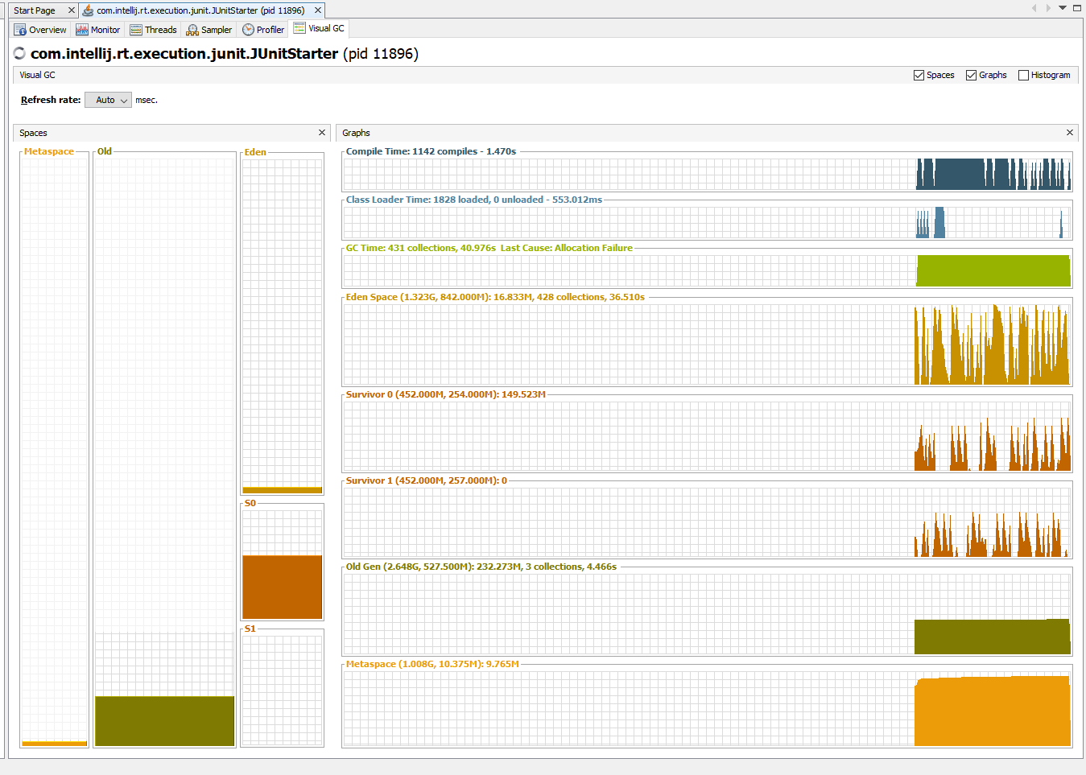

**-XX:+UseSerialGC**

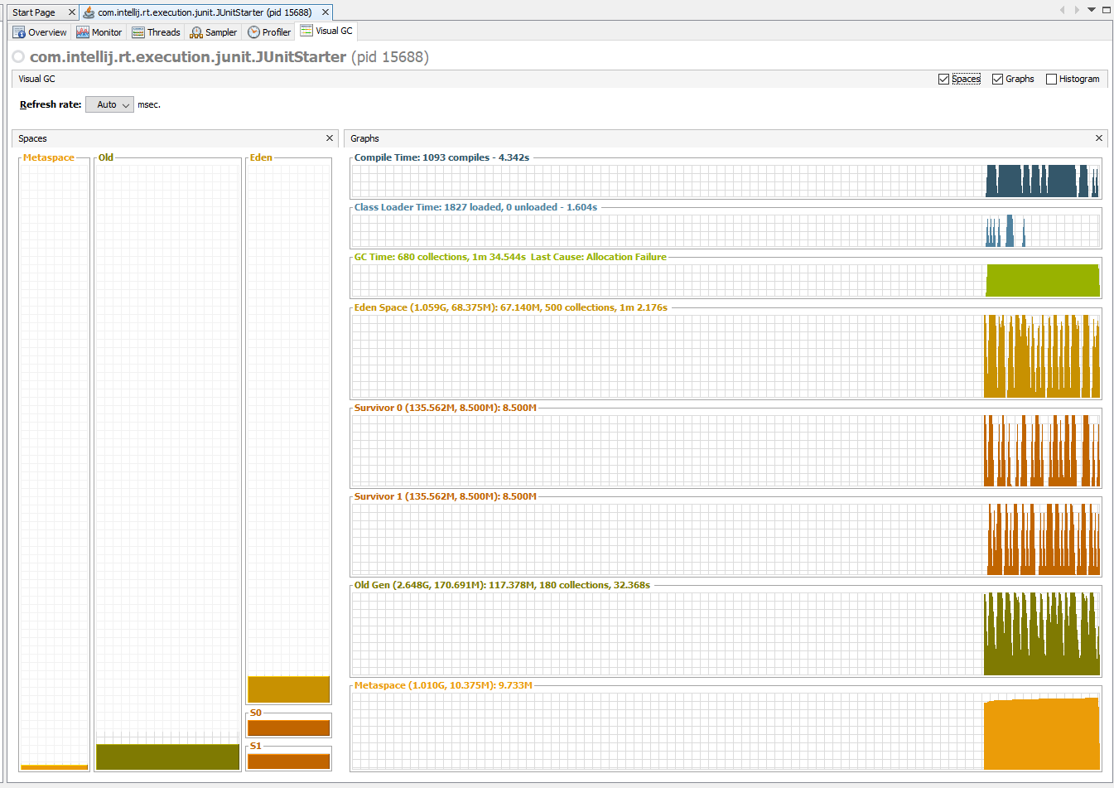

3) Tune Heap regions via JVM flags to make GC curve have peaks that are more frequent.

-XX:NewRatio=1 -XX:SurvivorRatio=3

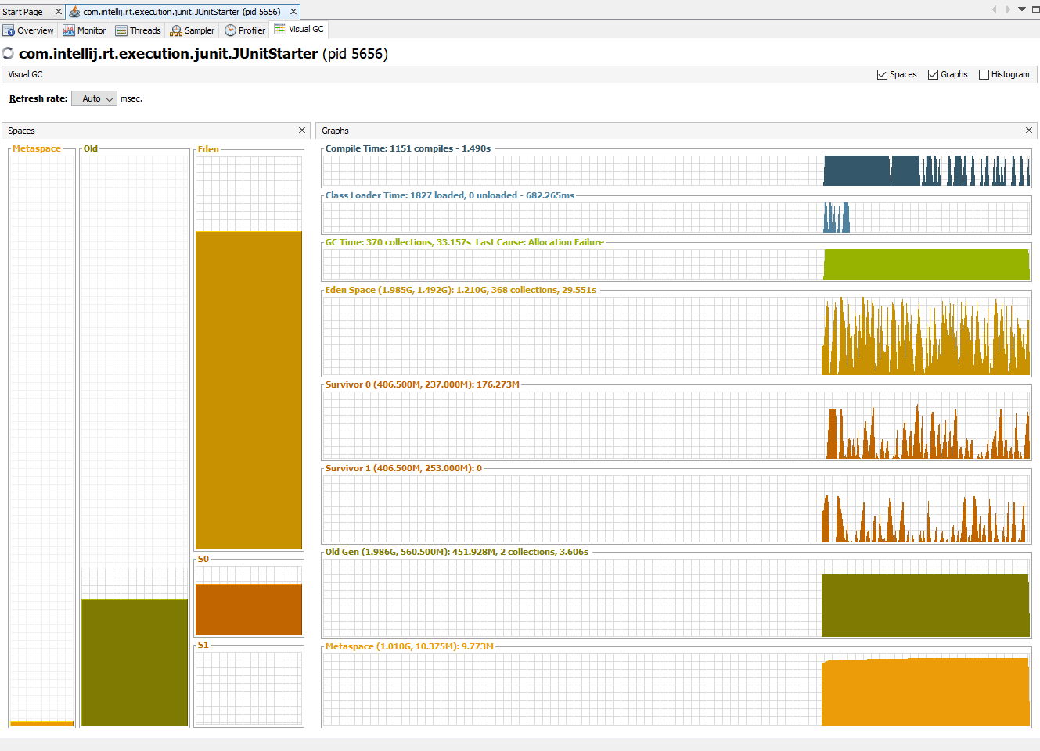

-XX:NewRatio=10 -XX:SurvivorRatio=3

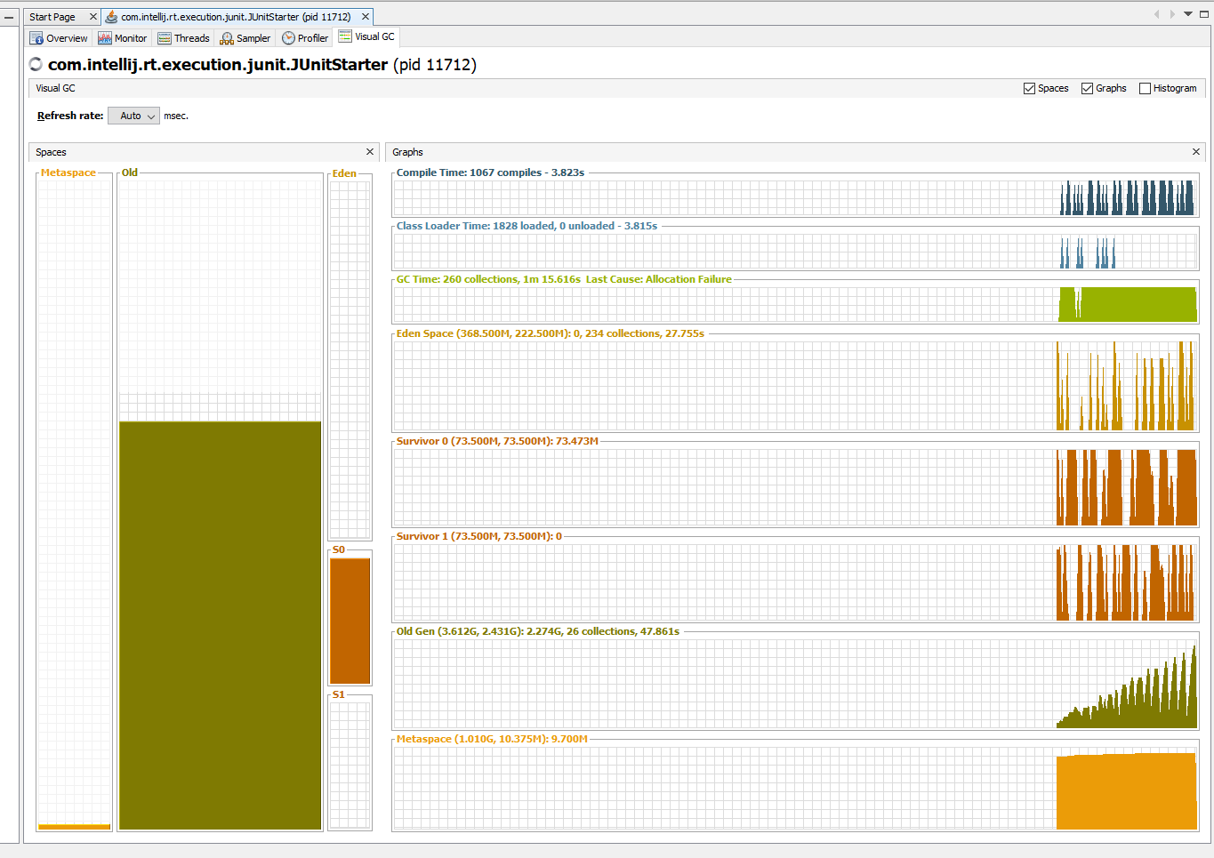

**Task 3.** Install MAT for eclipse. Review plugin features. Use one of apps from previous tasks and investigate leak suspects. Try to find other tools to detect memory leaks. Compare with MAT.

**Results with MAT:**

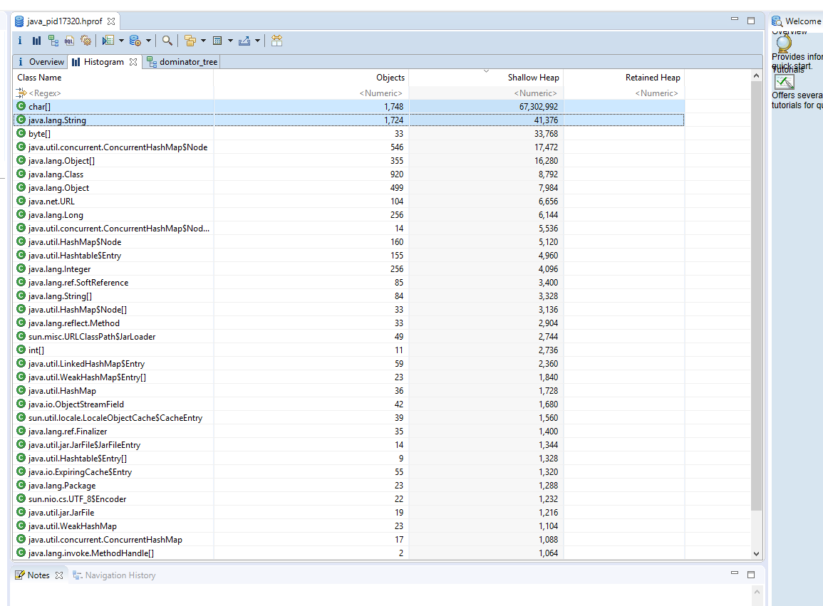

**Result with Heap Hero analyzer:**



**Task 4**

Create simple java application (for example text file parsing or something else) with at least two memory leaks and find them using Yourkit Profiler tool.

**Memory leaks:**

1. **Duplicate strings**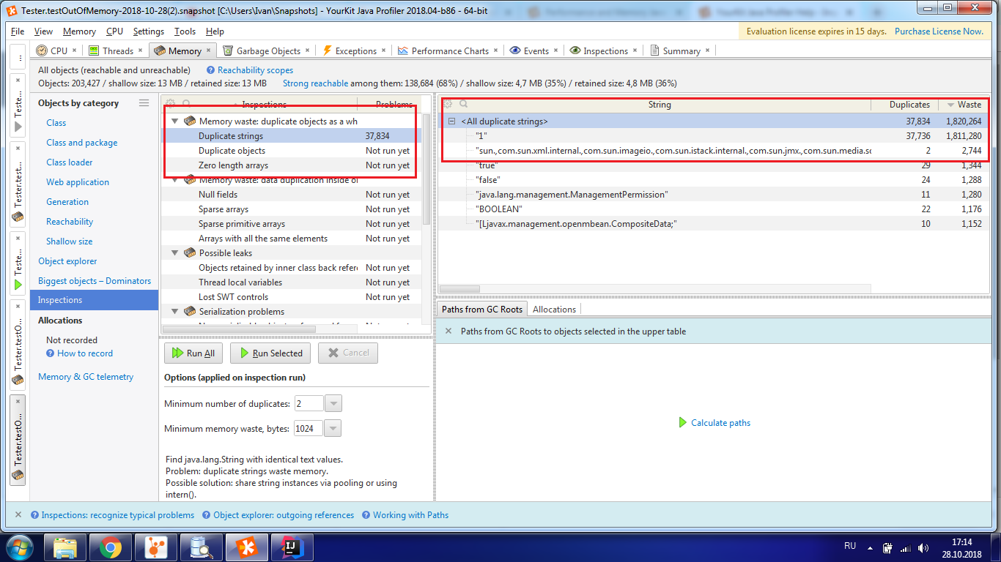
2. **Large collections:**

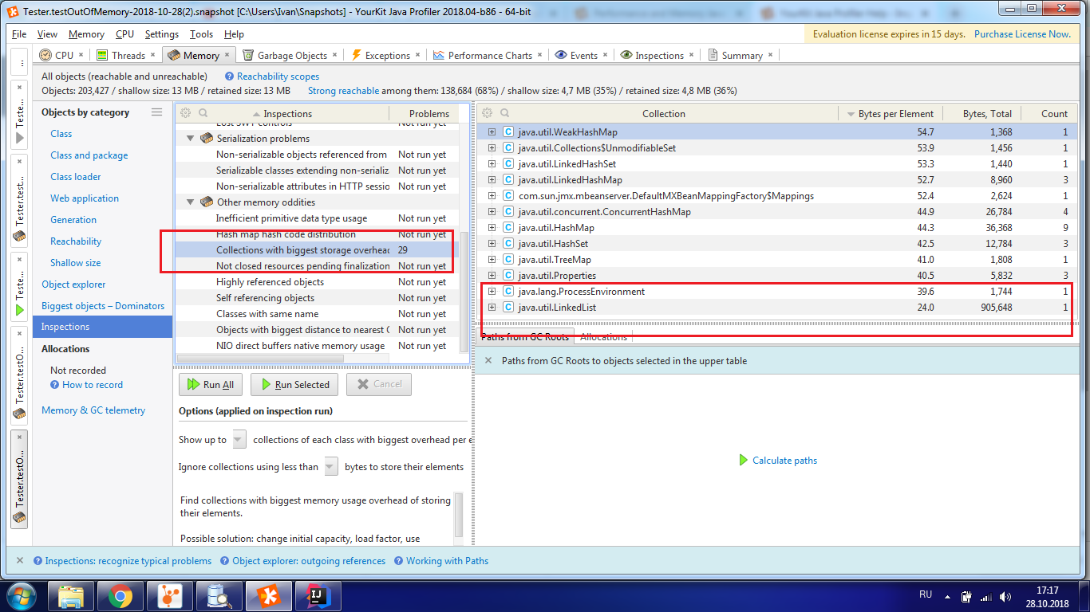

1. **Unclosed resources pending finalization**

