I started off by messaging some of the riders and instructors I knew some of these questions
- What's the most frustrating part of your typical ride a motorcycle?
- What do you worry about most before/during a ride?
- What makes you cancel or postpone a planned ride?
- If you could press one button on your phone before a ride that would make the journey better, what would it do
- What information do you wish you had access to while riding but don't?
- When riding with friends, what always seems to go wrong?
- How do you currently track your bike's maintenance?
- What safety features would make you feel more confident on long rides?
- Do you ever forget gear or equipment? How do you currently prevent this?
Riding Style:

What type of riding do you do most? (commuting, touring, sport, off-road, track)
Solo or group rides more often?
What's your typical ride duration and distance?

Do you use your phone while riding? How? (mounted, Bluetooth, not at all)
Would you pay for an app? Subscription or one-time?
What would make an app worth paying for?

"If you could design the perfect motorcycle app, what would it do?"
"What do non-riders not understand about what you need?"
"What's missing from the motorcycling world that cyclists or car drivers already have?"
then I decided to make it into a survey using google form
https://docs.google.com/forms/d/e/1FAIpQLScVN0mAEvZ72kLwEBuvgasPMrR0yvmdAxTYJZwYOaDcZdYtyw/viewform?usp=dialog
I started doing some of my on research :
Which involved
Maintain the belt and chain
App Idea
- Temperature changing every 10 km
- Rain probability by road segment
- Wind speed and direction warnings
- Alerts you mid-ride if conditions deteriorate ahead
- Suggests alternative routes to avoid bad weather

- Live location sharing with other bikers on the app

- Pre-planned stop points with automatic ETA updates

- One-tap emergency alerts to all riders in a specific radius

- Voice-activated controls (fully hands-free)

- Roadside assistance integration

- First aid guidance for motorcycle accidents

- Stolen bike reporting network

Core features
- Real-time weather overlaid on your entire route (not just destination)
- Shows temperature, rain probability, wind speed every 5-10 miles
- Alerts: "Heavy rain in 15 miles, alternative route available"
- Surface condition warnings (wet roads, ice, debris)
- Tracks all bike maintenance by mileage/time
- Reminders: chain lube, oil change, tire replacement, brake pads
- Gear lifespan tracking (helmet age, tire tread, jacket condition)
- Photo-based tire tread analyzer
- Service history with receipts stored
- Predictive alerts: "Chain service due in 200 miles"
- Live location sharing with "rider spread" alerts
- Pre-planned waypoints with automatic ETA updates
- One-tap emergency broadcast to all riders
- Voice-controlled (hands-free operation)
- Automatic fuel stop suggestions based on tank range
- Save and share custom routes
- Emergency contact alerts with GPS location
- Nearby mechanic/tow service finder
- First aid guidance for motorcycle accidents
- Stolen bike reporting network
Why this app is unique
Most of the apps do one thing this app will do everything the rider need in one place
Maintenance + gear tracking
Group ride coordination
Emergency safety features
Motorcycle-focused navigation
PHASE 0 : Research
- Distribute and analyse survey
- Interview 10 – 15 motorcyclist in depth
- Defining 2 – 3 CORE features
- Creating simple wireframe/sketch
- Feature specification documents
PHASE 1: Design
- Creating UI mock-up (7 – 9 ) screen max
- Designing user flow diagrams
- Choose simple tech stack
- Set up development environment
PHASE 2: Development
This will involve focusing on one primary feature and basic app structure
- Weather
- Basic road map
- Route inputs (start/end)
- Weather overlay on route
- Simple weather alerts

- Maintenance Tracker
- Add bike details
- Input maintenance schedules
- Show upcoming reminders
- Log completed maintenance
- Group Ride prototype
- Create/ join group
- Live location sharing
- Simple map view
- Emergency alert button
- Testing
- Testing with 5 to 10 motorcyclists
- Collect feedback
- Fixing bugs
- Documenting result

I also made a flier and dropped it in the Harley Davidson in Waterford and asked to put in their club

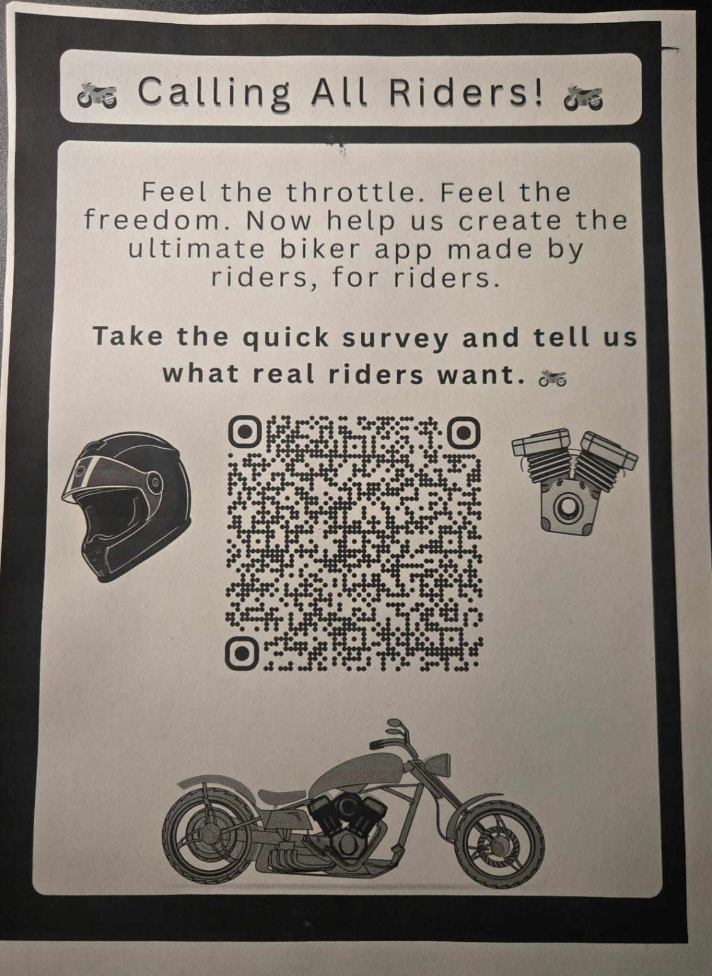
Looking at the survey most people were mainly concerned about the weather since weather is something that effects the bikers the most

Must- Have features (Core MVP)
- Route planning
User enters Start and end point
App displays route on the map
- Weather Along Route ( Primary feature)
Shows weather conditions along the entire route
Displays temp, rain chance, windspeed
Some kind of visual indicators like some icon or colours on map for routes or some stops
Shows weather at some key points like ( 10 – 20km)
- Weather Alerts
Automatically detects bad weather on route
Shows warning message
Highlights problem areas on map
Alert triggers cab be like:
- Rain probability > 70%
- Temperature < 5°C (ice risk)
- Wind speed > 40 km/h
- Any severe weather warnings
Example of the alert
Heavy rain expected between Portlaoise and Tipperary (100 – 150km). Consider alternative route or delay departure
- User profile
User can save their preferences
Save bike details (make/model)
- Emergency alert
Save emergency contacts (3-5 contacts)
Emergency alert button
Sends SMS/notification with GPS location
“I need help at [location]” message
- ride sharing
- generate shareable links
- can share via whatsapp email sms
- Photo upload
- User can upload hazards photos
- Attach location on map
- Other users can see photos
- Maybe(if I have enough time)
- Basic voice control
- “Start route planning”
-"Show weather" (voice trigger)
- "Emergency alert" (voice trigger)
- Uses browser's Web Speech API (maybe)

TECH Stack
- Front end
Which is going to be the primary framework
- React.js
I will be using it to navigate between pages like Home, route planners settings etc

UI
CSS or MUI
- Map display
- Leaflet.js + React-Leaflet this is free open source and no API key is required for it
- Weather services
- OpenWeatherMap API
This gets weather data (temp, rain, wind). It includes weather alerts current weather multiple location queries
- Backend and database
Firestore Database
- Store user profiles
- Save bike details
- Store emergency contacts
- Save hazard reports
- Store routes
Firebase Authentication
- Email/password login
- Google Sign-In
- Anonymous login
- Phone authentication
Firebase Storage
- Store hazard photos
- Store user profile pictures
- 5GB free storage
Firebase Cloud Messaging (FCM)
- Push notifications
- Weather alerts
- Emergency notifications

