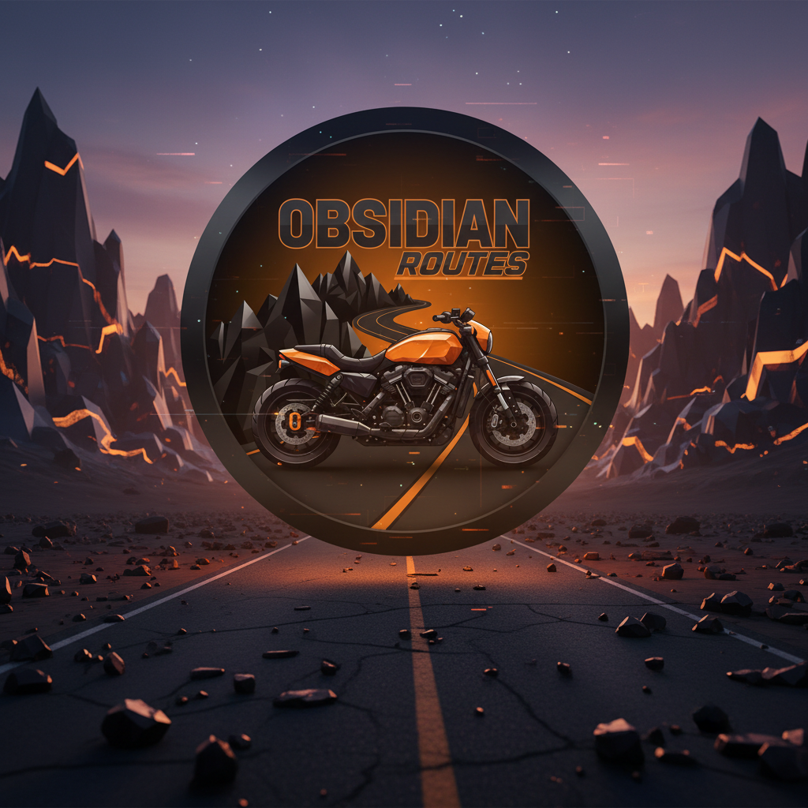
Obsidian Routes
App for bikers
(20094326) Namra Fatima | 1/7/26 | Thesis

Introduction

Background
The mobile phones are the main devices through which we interact with the internet and access digital services. Mobile app usage is everywhere across all the demographic, fundamentally changing how we navigate our daily lives. One of the well-known transformative cases had been GPS navigation. We don’t rely on paper maps anymore or even the separate GPS devices. Modern phones come equipped with built-in GPS chips that can tract our location with remarkable precision and provide step by step rote guidance. Large tech companies like google have invested billions in mapping infrastructure creating comprehensive digital representation of our streets, roads and motorways. These mapping apps provide a great directions for reaching the chosen destination, real-time traffic updates and even alternative route suggestions to help the users avoid obstructions.
For the average driver these navigation solutions have become indispensable tools that works smoothly in the daily commutes and long-distance travel. However the needs of a motorcyclists is significantly different from those who drive cars and existing navigation and the planning tools often fail to address the unique challenges that riders face on two wheels

Problem Statement and Motivation
Despite the advanced capabilities of modern mobile navigation and weather applications, the specific challenges faced by motorcyclists are often overlooked. Unlike the drivers who are protected within an enclosed vehicle, motorcyclist are directly exposed to environmental condition, making weather forecasting not just a convenience but an important safety concern. Sudden change can reduce visibility and road grip dramatically, strong winds can destabilized a motorcycle at a highway speeds and temperature below 5°C can lead to hypothermia and reduce dexterity all of these conditions are a serious threat to the riders safety
Currently most of the motorcyclists juggle multiple applications like checking the weather app for forecasting, switching to navigation app for planning a route, manually searching for the nearest mechanic or petrol station and keeping mental notes or paper records of maintenance schedules. This approach is not only inconvenient but also dangerous as it diverts attention away from the road and mental load during the rides. Furthermore weather application mainly provide forecast for static locations rather than dynamically analysing the entire route.
Another critical gap is the emergency situation. Suppose a breakdown occurs in a remote or unfamiliar area the motorcyclists often struggle to quickly communicate their exact location to emergency contact or roadside assistance services. The time spend going through multiple apps or trying to describe a location can be crucial in emergency scenario. Also motorcycle maintenance tracking remains largely manual, with riders relying on memory, paper logbook or some simple reminder apps that don’t account for specific service intervals and requirements of their particular bike model.
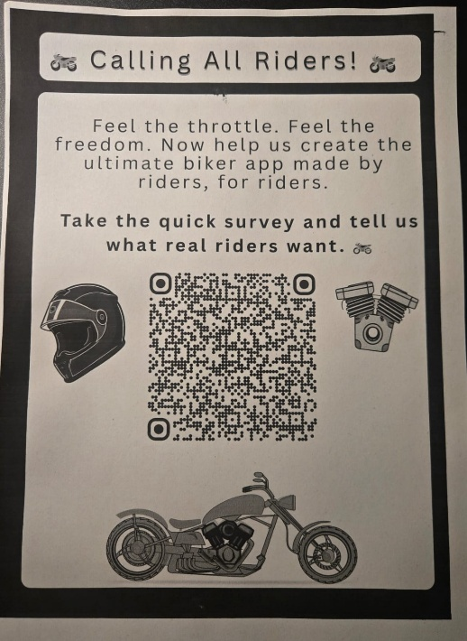
I conducted research for this project including surveys distributed at Harley-Davidson dealerships, and the motorcycle clubs such as The Southeast Reapers MCC, Celtic Thunder Hog and No Bullshit RC. They confirmed these pain points across riders of various experience level. Response from the survey consistently highlighted frustration with the weather unpredictability, the burden of switching between multiple apps while riding, anxiety about breakdown in remote locations, and difficulty maintaining the accurate service records. These issues validated the need for a integrated solution designed specifically for the biker community.

Goals and Objective
The primary goal of this application is to provide a close integrated platform that includes the essential tools motorcyclists need for safe and informed riding. The technical objective of obsidian routes are:
- Weather-Awar Route planning: This will help the system develop that overlays real-time and forecasted weather data directly onto planned routes providing riders with visual indicators of weather conditions at regular intervals like every 10 – 15 KM along the journey. This will help the rider to make informed decision about route selection and departure timing based on comprehensive environmental awareness.
- Proactive Safety Alerting: this will implement a notification system that automatically warns riders when weather conditions exceed a specific thresholds especially when rain probability is above 70%, temperature falls below 5C or the wind speed goes over 40Km/h. these alerts can be configurable based on riders experience and bike specifications
- Emergency response: This will help to create one-tap emergency SOS feature that instantly transmits the riders current GPS coordinates to a pre-configured emergency contact via SMS eliminating the need for manual location sharing or phone calls during critical situation
- Centralized Maintenance Management: This will give the using a digital maintenance log that tracks service history, calculates recommended service intervals based on milage and time and sends reminders for oil change , tire replacement and other maintenance task specific to the users motorcycle make and model

Solution Overview
Obsidian Routes is going to be a cross-platform mobile application developed using React Native which is designed to address the unique challenges faced by the motorcyclists through a rider- centric approach. This application will combine weather forecasting, route planning, emergency services and maintenance tracking into a single platform. It will eliminate the need for switching between multiple application while on the road.
The core functionality is t hat it uses real-time weather data from Weather API integrated with mapping services provided by Mapbox. Weather information is visualized as an overlay directly on the route map with data points displayed at 10-15 Km intervals to give rider a comprehensive view of conditions they will be encountering through their journey. This integration will allow dynamic route assessment where riders can identify the potential weather hazards beforehand and make informed decision about timing, alternative routes gear preparation.
Initially, Obsidian routes is developed with a focus on Ireland where the weather conditions and well established motorcycling communities create strong demand for such solution. This is An Android first development which will prioritizes the platform with largest user base in target market.
By addressing the user experience of current solutions and directly responding to the needs identified through community engagement and survey research Obsidian routes aims to become an essential safety companion for motorcyclists helping them top ride smarter and safer regardless of the conditions

