RFP Compliance Screening Tool
Project Report

1. Introduction
The RFP Compliance Screening Tool is a web-based application developed to automate the analysis of Request for Proposal (RFP) documents. Instead of manually reviewing lengthy procurement documents, users can upload multiple RFP PDF files simultaneously. The system extracts the document text, analyzes the requirements using a Large Language Model, and presents the results through an interactive dashboard.

2. Project Objectives
- Upload multiple RFP PDF documents through a single interface.
- Extract text from uploaded PDF files.
- Identify and organize deliverables in a Parent–Child hierarchy using actual RFP section headings.
- Extract evaluation criteria from RFP documents.
- Perform department-wise compliance analysis.
- Generate an overall GO / REVIEW / NO-GO recommendation.

3. System Overview
The application consists of an HTML/CSS/JavaScript frontend and a FastAPI backend. Users upload one or more PDF files through the dashboard. The backend extracts text using PyPDF, sends the extracted content to the Groq Llama-3.3-70B model, and receives structured JSON containing deliverables and evaluation criteria. Deliverables are grouped under their original RFP section headings, while compliance scoring is performed for Accounting, Legal, Operations, and Technical departments. The final results are displayed in separate dashboard tabs.

4. Implementation
Frontend:
• Drag-and-drop multiple PDF upload interface.
• Threshold sliders for GO/REVIEW/NO-GO.
• Tabs for Match Score, Deliverables, and Evaluation Criteria.
• PDF export of extracted deliverables.
Backend:
• FastAPI REST API.
• PDF text extraction using PyPDF.
• Groq API integration with Llama-3.3-70B.
• JSON parsing of model responses.
• Parent–Child deliverable generation.
• Department-wise compliance scoring.
• Overall verdict generation.

5. Results
The developed system successfully accepts multiple RFP documents, extracts structured deliverables, identifies evaluation criteria, computes department-wise compliance scores, and provides an overall bidding recommendation. The dashboard presents the extracted information in a clear and organized format, allowing users to review requirements efficiently.

6. Conclusion
The RFP Compliance Screening Tool streamlines the review of procurement documents by automating information extraction and compliance analysis. The implemented system reduces manual effort, organizes deliverables in a structured hierarchy, and assists users in making informed bid decisions through an intuitive dashboard.
Figure 1
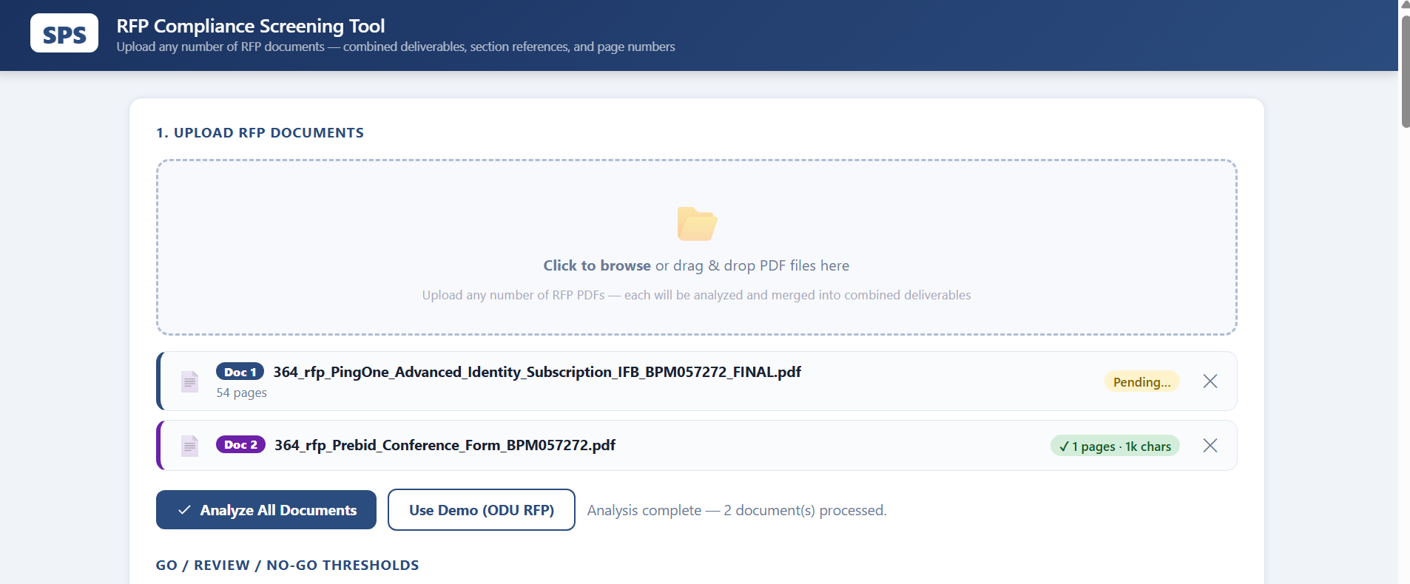
Figure 1: Screenshot of the RFP Compliance Screening Tool dashboard.

Figure 2
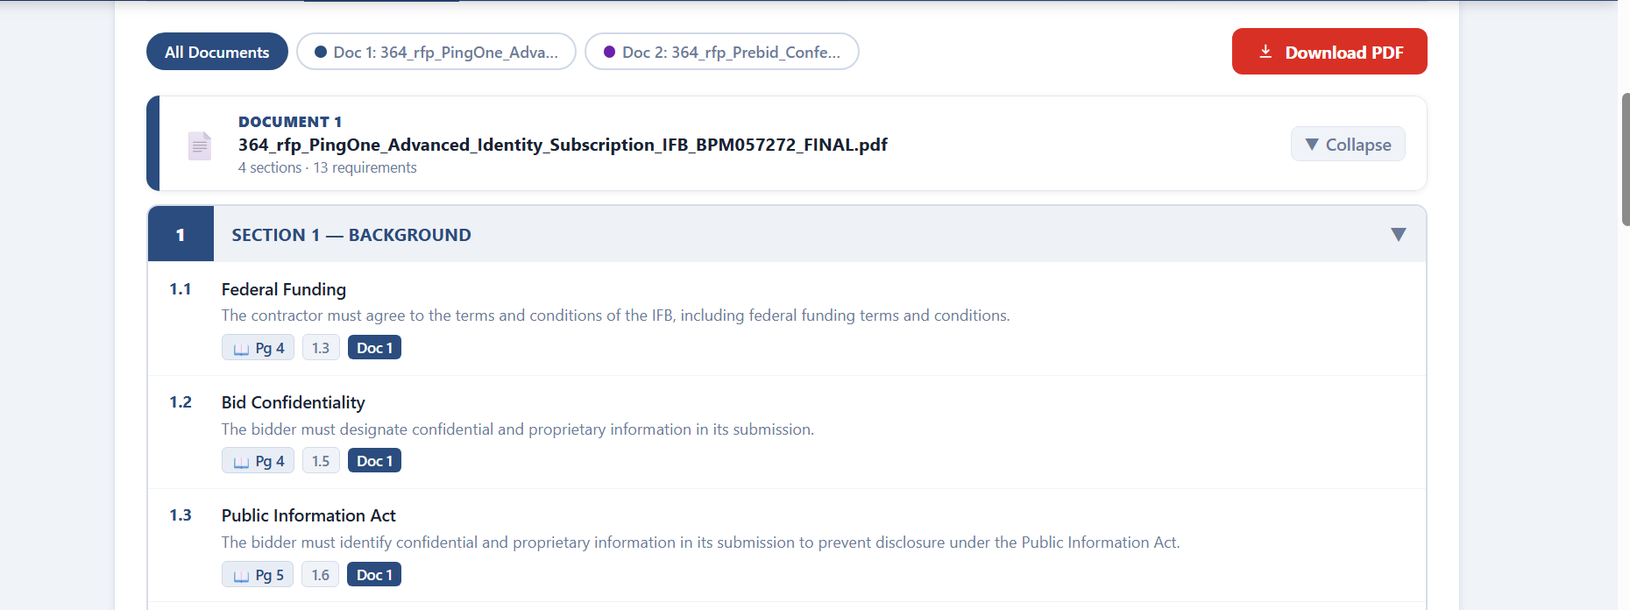
Figure 2: Screenshot of the RFP Compliance Screening Tool dashboard.
Figure 3
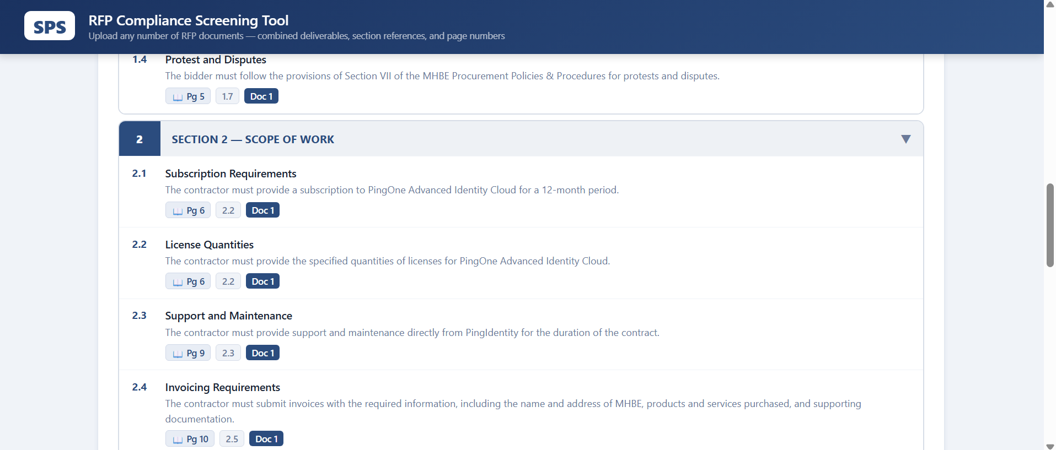
Figure 3: Screenshot of the RFP Compliance Screening Tool dashboard.
Figure 4
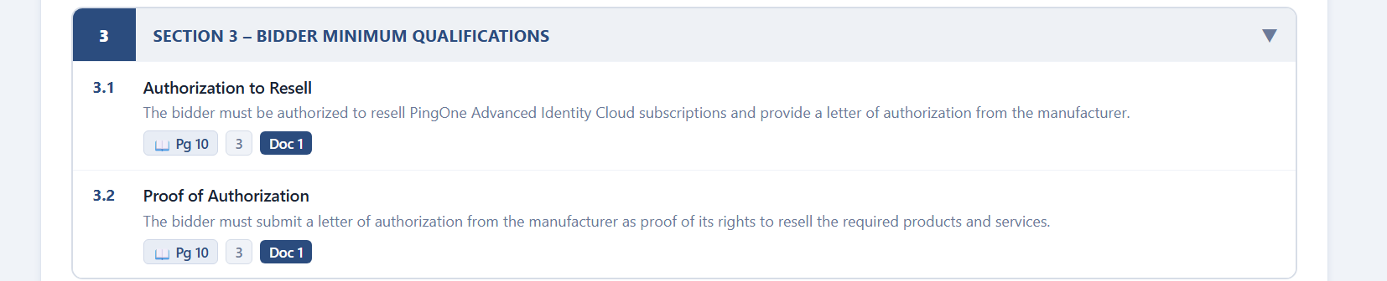
Figure 4: Screenshot of the RFP Compliance Screening Tool dashboard.
Figure 5
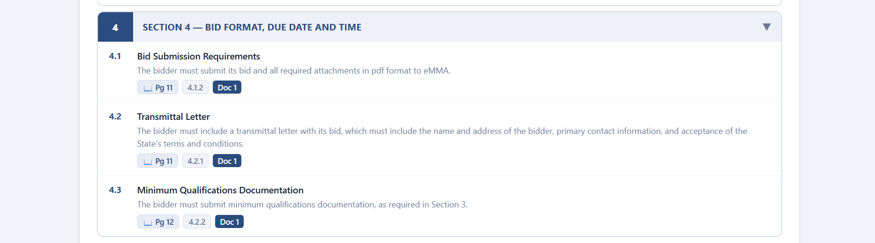
Figure 5: Screenshot of the RFP Compliance Screening Tool dashboard.

Figure 6
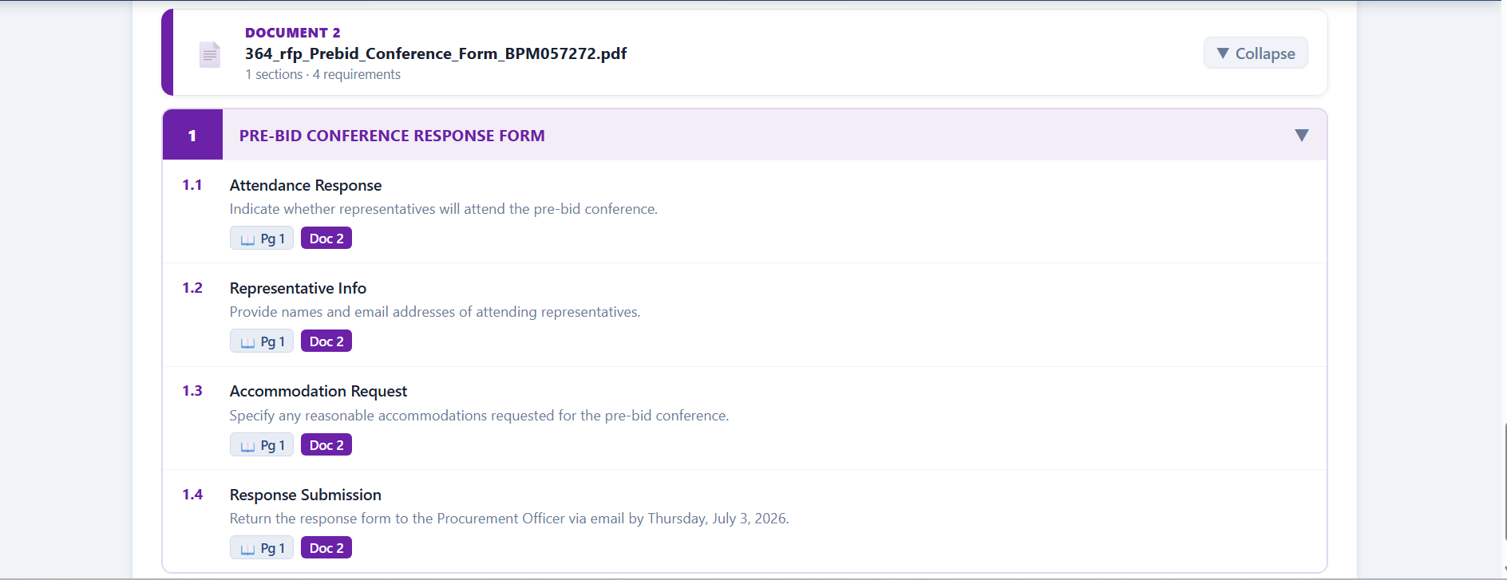
Figure 6: Screenshot of the RFP Compliance Screening Tool dashboard.

