SUCO Bank
Enterprise Payment Reconciliation Platform: Requirements and Design Specification

Table of Contents
- Introduction
- Existing System
- Proposed System
- Functional Requirements
- Non-Functional Requirements
- User Roles & Responsibilities
- System Architecture Overview
- Reconciliation Workflow
- System Design
- File Processing Framework
- Transaction Processing Engine
- Business Rule Engine
- Settlement Control and NTSL Validation

INTRODUCTION

Objective
Automate the reconciliation process currently performed manually in Excel for UPI, IMPS and ATM transactions.
The goal is to:
- Reduce manual effort
- Improve reconciliation accuracy
- Standardize exception handling
- Generate NPCI upload files automatically
- Provide auditability and reporting

EXISTING SYSTEM

Overview
The reconciliation process is currently performed manually using Microsoft Excel. Transaction data is collected from multiple banking systems and payment network files. Operations staff compare transaction records across these systems to identify matched transactions, investigate discrepancies, and prepare the necessary adjustment or reversal files.
The existing process relies heavily on manual comparison, filtering, and spreadsheet operations, making it time consuming and susceptible to operational errors.

Existing Reconciliation Workflow
The current reconciliation process consists of the following stages:
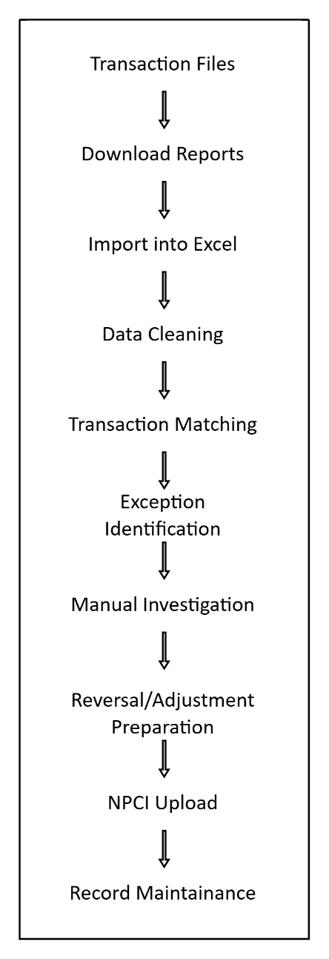

Data Sources
The reconciliation process receives transaction information from multiple systems.
Source | Description
Core Banking System(CBS) | Bank transaction records
NPCI Settlement Files | Settlement and transaction status from NPCI
Bank Switch | Transaction logs generated by the bank's switch
Merchant Files | Merchant-related transaction files
General Ledger | Pool account and settlement balances

As additional file types are identified during requirement gathering, this section will be updated.

Current Transaction Flow
A typical UPI transaction follows the path below:
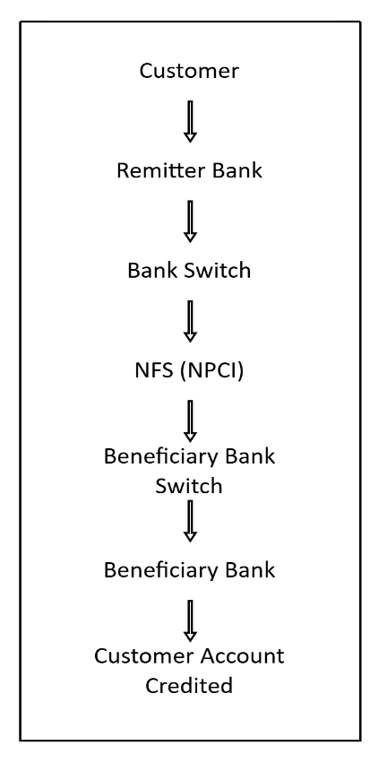
Transaction is available at multiple points in this flow.

Current Reconciliation Process
The operations team currently follows these activities:
- Download transaction reports from CBS, NPCI, and other systems.
- Import all files into Microsoft Excel.
- Verify file completeness and integrity.
- Compare transaction records across different sources.
- Identify matched and unmatched transactions.
- Investigate discrepancies manually.
- Classify exceptions according to operational procedures.
- Prepare reversal or adjustment files.
- Generate NPCI upload files.
- Maintain reconciliation records and supporting documentation.

Existing Challenges
Challenge | Impact
Manual exception classification | Inconsistent decision making
Manual comparison of files | High processing time
Spreadsheet based reconciliation | Difficult to scale
Multiple file formats | Increased complexity & processing delays
No centralized transaction repository | Limited historical analysis
Manual aging tracking | Risk of missing NPCI timelines

Limitation of the Existing System
The current process has the following limitations:
- Heavy dependency on Microsoft Excel
- No centralized database for reconciliation history
- Limited traceability of reconciliation decisions
- Manual monitoring of unresolved exceptions
- No maker-checker approval workflow
- Limited reporting and operational dashboards

Opportunities for Improvement
The proposed reconciliation platform aims to address the above limitations by introducing:
- Automated file ingestion
- Rule-based reconciliation
- Centralized transaction repository
- Exception management dashboard
- Maker-checker approval workflow

Proposed System

Overview
The proposed solution is a centralized reconciliation platform that automates the reconciliation of payment transactions across multiple banking systems. The platform is designed to eliminate manual spreadsheet-based reconciliation by providing automated transaction matching, rule-based exception classification, approval workflows, and reporting.
The initial implementation will support UPI reconciliation. The architecture will be modular to enable future support for IMPS, NEFT, RTGS, ATM, and other payment systems without major changes to the core platform.

Objectives
The proposed system aims to:
- Automate transaction reconciliation
- Reduce manual effort
- Improve reconciliation accuracy
- Standardize exception handling
- Improve operational efficiency
- Maintain centralized reconciliation history

Proposed Features
- Web-based application
- Database-backed reconciliation
- File upload
- Automated file validation
- Transaction matching
- Exception management dashboard
- Maker-checker workflow
- Audit logs

Functional Requirements

User Authentication
The system shall:
- Authenticate users
- Support role-based access
- Maintain user activity logs

File Management
The system shall:
- Upload reconciliation files
- Validate file structure
- Verify mandatory fields
- Maintain upload history
- Prevent duplicate uploads

Transaction Processing
The system shall:
- Read uploaded files
- Normalize transaction data
- Remove duplicate records
- Validate transaction fields
- Store transactions

Reconciliation
The system shall:
- Match transactions across systems
- Identify matched transactions
- Identify unmatched transactions
- Identify amount mismatches
- Identify status mismatches

Rule Engine
The system shall:
- Execute configurable reconciliation rules
- Classify exceptions
- Recommend actions
- Allow future rule additions without modifying source code

Exception Management
The system shall:
- Display unresolved exceptions
- Assign priorities
- Track ageing
- Allow remarks
- Track resolution status

Maker-Checker Workflow
The system shall:
- Allow a maker to generate reversal requests
- Require checker approval
- Prevent unauthorized uploads
- Record approval history

NPCI File Generation
Response/acknowledgement files will be generated in NPCI formats

Reports
The system shall generate:
- Daily/ monthly transaction volume reports
- Daily reconciliation report
- Exception report
- Ageing report
- Settlement report
- Approval report
- User activity report

Non-Functional Requirements
Performance
- Support large transaction volumes
- Complete reconciliation within acceptable operational timelines

Scalability
The system shall support additional payment modules without architectural changes.

Reliability
The platform shall ensure accurate reconciliation.

Maintainability
Business rules shall be configurable and easily updated.

Auditability
Every reconciliation activity shall be logged.

User Roles and Responsibilities
Administrator
- Manage users
- Configure rules
- Manage system settings

Operations User
- Upload files
- Execute reconciliation
- View reports

Maker
- Review exceptions
- Prepare adjustment files

Checker
- Approve or reject adjustments
- Authorize NPCI uploads

Auditor
- View logs
- Access reports
- Review approval history

System Architecture Overview
The platform consists of the following components:
- User Interface
- Authentication Module
- File Management Module
- Transaction Processing Engine
- Rule Engine
- Exception Management Module
- Approval Workflow
- Reporting Module
- Database
(A detailed diagram will be added in the later stages)

Reconciliation Workflow
The reconciliation workflow consists of the following stages:
- User uploads reconciliation files
- System validates file format
- Data is normalized
- Transactions are matched
- Rule engine classifies exceptions
- Results are stored
- Exceptions are reviewed
- Maker prepares adjustments
- Checker approves

System Design

Overview
The system design defines the major components of the reconciliation platform and the interaction between those components.
The platform is designed as a modular system so that UPI can be implemented initially and additional payment modules such as IMPS, NEFT, RTGS, and ATM can be added later.
Each payment module may use different source files, matching keys, reconciliation rules, error codes, and output formats. However, the common platform components shall remain reusable across all payment modules.

Major Components
The platform consists of the following components:
Component | Responsibility
Web interface | User login, file upload, exception review, approval, reporting and dashboard access
Authentication Module | User authentication, role-based access, and user activity logging
File Processing Framework | File upload, validation, decryption and normalization
Transaction Processing Engine | Transaction identification and matching
Business Rule Engine | Rule evaluation, exception classification and action recommendation
Exception Management Module | Exception tracking, ageing, remarks, assignment and resolution
Maker-Checker Workflow | Approval and rejection of adjustments, reversals and NPCI action files
NPCI File Generator | Generation of approved NPCI upload files
Database | Storage of files, transactions, reconciliation results, exceptions, approvals and audit logs
Reporting Module | Operational reports and user activity reports

Component Interaction
The reconciliation process follows the sequence below:
- User uploads reconciliation files through the Web Interface.
- File Processing Framework validates, decrypts, parses, and normalizes the source files.
- Normalized transaction records are stored in the Database.
- Transaction Processing Engine identifies matching transaction legs across participating registers.
- Transaction Processing Engine generates the Transaction Presence Matrix.
- Business Rule Engine evaluates the Transaction Presence Matrix.
- Reconciliation results and exceptions are stored in the Database.
- Exception Management Module displays unresolved exceptions for operational review.
- Maker prepares an adjustment, reversal, return, or other required action.
- Checker approves or rejects the action.
- NPCI File Generator creates the approved upload file, where applicable.
- Reporting Module generates operational and audit reports.

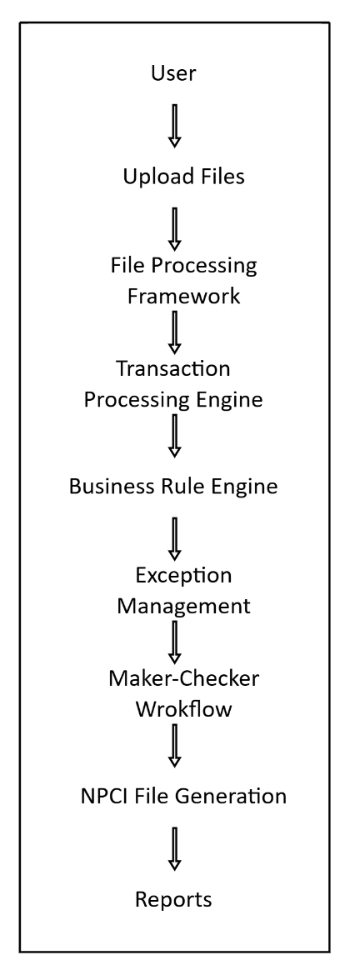
The flowchart illustrates the flow of information between system components, where each component receives processed information from the preceding component and provides its output as input to the next stage.

File Processing Framework

Overview
The File Processing Framework is responsible for receiving, validating, decrypting where required, parsing, and normalising reconciliation files.
The framework prepares source data in a common format before it is passed to the Transaction Processing Engine.

Source File Details
The system shall support the following source files.
Payment Module: UPI
File Type | Source System | Purpose
CBS GL Extract | Core Banking System | Bank debit and credit entries for UPI pool account reconciliation
Raw Data | NPCI URCS Portal | Issuer and acquirer transaction records
Merchant Raw Data | NPCI URCS Portal | Merchant issuer and merchant acquirer transaction records
DRC Report | NPCI URCS Portal | Debit reversal confirmation cases
Timeout Report | NPCI URCS Portal | Credit timeout and pending-credit cases
Adjustment Report | NPCI URCS Portal | Return, credit adjustment, and chargeback-related records
NTSL File | NPCI URCS Portal | Cycle-wise settlement, fee, tax, adjustment, and final settlement details

Payment Module: IMPS
File Type | Source System | Purpose
CBS GL Extract | Core Banking System | Bank debit and credit entries for IMPS pool account reconciliation
Issuer and Acquirer Files | NPCI URCS Portal | Transaction records for IMPS reconciliation
Timeout Report | NPCI URCS Portal | Pending and timeout-related transactions
Adjustment Report | NPCI URCS Portal | Return and adjustment records
NTSL File | NPCI URCS Portal | Cycle-wise settlement details

The Core Banking System extracts are downloaded in Excel format.
NPCI files may be received as encrypted files or compressed files. The system shall decrypt and extract files before processing, where required.
The exact source-file layout, column names, delimiter, encoding, and file extension shall be maintained in the File Configuration Repository.

File Type Definitions
National Payments Corporation of India (NPCI)
NPCI operates India’s retail payment and settlement systems, including UPI, IMPS, RuPay, and AePS.

UPI File Types

CBS GL Extract
A Core Banking System extract containing debit and credit entries in the UPI pool account. It is used to verify whether the corresponding bank account and pool account entries were affected.

Raw Data
NPCI transaction data containing the Bank’s issuer and acquirer transactions. It is used for transaction-level reconciliation using details such as transaction date, RRN, amount, transaction code, and transaction direction.

Merchant Raw Data
NPCI transaction data containing merchant issuer and merchant acquirer transactions. It is used to reconcile merchant-related UPI transactions, including P2M transactions.

DRC Report
Debit Reversal Confirmation report containing debit-response-failed transactions. It is used to determine whether a transaction was reversed online, requires manual reversal, or failed without an account debit.

Timeout Report
Report containing timeout-related credit transactions. It is used to determine whether the beneficiary account was credited online, requires manual credit, or requires return to the remitter.
Adjustment Report
Report containing return, credit-adjustment, and chargeback-related transactions. It is used to identify transactions requiring manual credit, return, chargeback action, or response to a chargeback.

NTSL File
Net Settlement File containing cycle-wise settlement information, including transaction count, debit amount, credit amount, adjustment amount, switching or processing fee, GST, penalty amount, and final settlement amount.

IMPS File Types

CBS GL Extract
A Core Banking System extract containing debit and credit entries in the IMPS pool account. It is used to verify the corresponding bank-account and pool-account entries.

Issuer and Acquirer Files
NPCI transaction files containing issuer and acquirer transaction records. They are used for transaction-level IMPS reconciliation using transaction reference number, amount, transaction date, status, and cycle details.

Timeout Reports
Report containing IMPS timeout or pending transactions. It is used to identify transactions that require verification against CBS and possible operational action.

Adjustment Reports
Report containing return and adjustment transactions. It is used to identify transactions requiring adjustment, reversal, or other configured action.

NTSL Files
Net Settlement File containing cycle-wise IMPS settlement information, including transaction count, transaction amount, fees, GST, adjustments, penalties, and final settlement amount.

Cycle-Wise File Processing
UPI and IMPS transactions are settled by NPCI in settlement cycles.
The File Processing Framework shall associate each source file and normalized transaction record with the applicable business date and settlement cycle.
For UPI, the SOP states that transactions are settled in eight cycles. Raw Data and Merchant Raw Data contain the Bank’s daily issuer and acquirer transactions across the settlement cycles.
[Add imps cycle-wise information and how these cycle-wise files will be handled]

Transaction Reference Number Extraction
The system shall extract the Retrieval Reference Number (RRN) from the relevant source files for transaction identification.
For UPI and IMPS, the SOP identifies the RRN as a 12-digit unique transaction reference number. The CBS GL Extract contains the RRN within the transaction remarks field.
The RRN extraction position, length, source field, and validation rule shall be maintained in the File Configuration Repository for each payment module and file type.
The system shall validate that the extracted RRN contains the expected number of digits before using it for transaction matching.

Source Data Normalization
The File Processing Framework shall normalize source-file values before transaction matching.
The system shall perform the following normalization activities where applicable:
- Extract RRN from the CBS remarks or narration field.
- Remove hyphens from STAN numbers.
- Convert RRN and other transaction-reference fields into a consistent format.
- Convert transaction amounts into the correct monetary value.
- Preserve transaction date and settlement-cycle information.
- Classify transactions as issuer, acquirer, merchant issuer, or merchant acquirer.
- Identify debit and credit transaction direction.
- Preserve source transaction code and response code.

The SOP indicates that raw-data amounts may require scaling before use. For example, a source value of 4000 may represent an actual transaction amount of 40.00. Therefore, the amount scale or decimal precision shall be configurable for each file type.

File Intake
The system shall support file upload through the Web Interface.
At the time of upload, the user shall select:
- Payment module
- File type
- Business date
- Settlement cycle
The system shall automatically record:
- File ID
- Original file name
- Source system
- File format
- File size
- File hash
- Upload date and time
- Uploaded user
- Encryption status
- Initial processing status
The system shall maintain the original uploaded file for audit, reprocessing, and investigation purposes.

File Structure and Content Validation
After file upload, the system shall validate the file against the configured definition for the selected payment module and file type.
The system shall validate:
- File format
- File name pattern
- Required headers and columns
- Mandatory field values
- Business date available in the file
- Settlement cycle available in the file
- Record count
- Duplicate file hash
- Compatibility between the selected file type and the actual file structure

The system shall compare the business date and settlement cycle selected during upload with the corresponding values available in the file.

The system shall reject files with invalid structure, missing required columns, invalid dates, incorrect settlement cycles, duplicate file hashes, or unsupported formats.

Rejected files shall be displayed in the File Validation Exception Queue with the reason for rejection.

After validation, the system shall record:
- Valid record count
- Rejected file record count
- Processing status
- Parser status
- Validation error details, where applicable

Reprocessing
The system shall allow a file to be reprocessed when a corrected source file is received.
The system shall not create duplicate transactions or duplicate reconciliation results during reprocessing.
The system shall retain the previous processing history, file version, and reason for reprocessing.

Transaction Processing Engine

Overview
The Transaction Processing Engine is responsible for identifying the same transaction across multiple participating registers.
The engine receives normalized transaction records from the File Processing Framework.
The engine is independent of payment-specific business rules. Its responsibility is to identify transaction legs, verify transaction presence, compare transaction details, and generate the Transaction Presence Matrix.

Transaction Registers
A transaction generated through a payment system may be recorded in multiple participating systems.

These systems are referred to as transaction registers.

For UPI reconciliation, a transaction may appear in:
- Core Banking System (CBS)
- Bank Switch
- NPCI
- General Ledger, where required for settlement control
- Destination Bank response, where four-way reconciliation is applicable

Each occurrence of the transaction in one of these systems is referred to as a transaction leg.

Add a flowchart?

Transaction Identification
The first responsibility of the Transaction Processing Engine is to uniquely identify the same transaction across multiple registers.

Each transaction shall be identified using one or more matching attributes, depending on the payment system being reconciled.

Typical matching keys include:
- Retrieval Reference Number (RRN)
- Unique Transaction Reference (UTR) (applicable to RTGS/NEFT transactions)
- Transaction Amount
- Transaction Date
- Transaction ID
- STAN number, where applicable

For UPI, the RRN shall be the primary transaction identifier.

Transaction amount, transaction date, transaction direction, and settlement cycle shall be used as supporting validation attributes.

For RTGS and NEFT transactions, the UTR serves as the primary transaction identifier.

Transaction Matching
The Transaction processing Engine shall group transaction legs belonging to the same transaction.
The engine shall compare matching attributes across registers, including:
- Transaction identifier
- Transaction amount
- Transaction date and time
- Debit or credit direction
- Transaction status
- Settlement cycle
- Response code, where applicable

Transaction Presence Verification
Once a transaction has been identified, the engine shall verify whether the transaction is present in every participating register.

For each transaction identifier, the engine performs the following checks:
- Is the transaction present in the CBS register?
- Is the transaction present in the Switch register?
- Is the transaction present in the NPCI register?
- Are transaction amounts identical across all registers?
- Are transaction statuses consistent across all registers?

This step is analogous to calling the roll for every transaction.
Rather than deciding which action to take, the engine simply records whether each transaction leg is present.
The output of this step is called the Transaction Presence Matrix.

Example?

What the engine finds | What it means | What to do
Present in all systems, amounts match | Transaction settled correctly | Mark as Reconciled
In Switch and NPCI, but not in CBS | Money moved but customer account not updated | Pass adjustment entry in CBS
In CBS, but not in NPCI | Customer debited but transaction never settled | Reverse / refund the customer
Present everywhere, but amounts differ | Amount mismatch between systems | Investigate and adjust the difference
In NPCI, but not in Switch | Settlement entry with no matching bank record | Raise with switch vendor / NPCI

Transaction Presence Matrix
The Transaction Presence Matrix shall provide a consolidated view of the transaction across participating registers.
It shall contain:
Field | Description
Transaction ID | RRN, UTR, or another configured primary identifier
Payment Module | UPI, IMPS, or other payment module
Business Date | Transaction or reconciliation date
Settlement Cycle | NPCI settlement cycle, where applicable
CBS Presence | Indicates whether the transaction is present in CBS
Switch Presence | Indicates whether the transaction is present in the Bank Switch
NPCI Presence | Indicates whether the transaction is present in NPCI files
GL Presence | Indicates whether the transaction is present in the General Ledger, where applicable
Amount Match | Indicates whether the transaction amount matches across registers
Status Match | Indicates whether the transaction status matches across registers
Error Code | Applicable error code or response code
Processing Status | Matched, Unmatched, or Pending Rule Evaluation
The Transaction Presence Matrix shall be passed to the Business Rule Engine for reconciliation decision-making.

Three-Way and Four-Way Reconciliation
The system shall support three-way reconciliation using CBS, Bank Switch, and NPCI registers.
The system shall support four-way reconciliation by including an additional register such as General Ledger, destination-bank response, or another payment-system register.
The Transaction Processing Engine shall remain independent of the number of participating registers.

Business Rule Engine

Overview
The Business Rule Engine evaluates the Transaction Presence Matrix generated by the Transaction Processing Engine.

Based on the presence or absence of a transaction across the participating registers, it determines the appropriate reconciliation outcome using predefined business rules.

The Business Rule Engine determines what each reconciliation pattern means and what operational action should follow.

Rule Evaluation
Each transaction pattern corresponds to a predefined reconciliation outcome.
Typical reconciliation patterns include:
Transaction Pattern | Reconciliation Status | Recommended Action
Present in CBS, Switch, NPCI (amounts match) | Reconciled | No action required
Present in Switch and NPCI, but missing in CBS | Exception | Adjustment required
Present in CBS, but missing in NPCI | Exception | Reversal required
Present in all registers, but amounts differ | Exception | Manual investigation required
Present in NPCI, but missing in Switch | Exception | Investigation with switch or NPCI required
Transaction contains an unmapped error code | Pending investigation | Manual review required

The Business Rule Engine shall assign a reconciliation status, recommended action, priority, and reason for every transaction.

Exception and Action Classification
The Business Rule Engine shall classify transactions into the following categories:
- Reconciled
- Exception
- Pending investigation
- Reversal Required
- Adjustment Required
- Manual Credit Required
- Return Required
- Chargeback Required
- No Financial Action Required
The final operational action shall be subject to the Maker-Checker Workflow.

Error Code and Response Code Management
The system shall maintain a centralized Error Code and Response Code Repository.
The repository shall support UPI, IMPS, and future payment modules.
The repository shall maintain:
Table

Rule Repository
Business rules shall not be hardcoded within the application.
Instead, they shall be maintained in an external rule repository such as a configuration file (for example, JSON or YAML) or a database table.
Benefits
Maintaining reconciliation rules outside the application code provides the following advantages:
- Business users can review reconciliation rules in a human-readable format.
- New reconciliation scenarios can be introduced without modifying the application logic.
- Existing rules can be updated without recompiling or redeploying the application.
- Rule changes remain independent of the Transaction Processing Engine.
- Different payment modules (UPI, IMPS, NEFT, RTGS, etc.) can maintain separate rule sets while using the same reconciliation engine.
- Rule versioning and change history can be maintained for audit purposes.

Rule Versioning and Auditability
The system shall maintain rule versioning and change history.
Every reconciliation result shall record the rule version used for evaluation.
Changes to reconciliation rules, error-code mappings, and action mappings shall be subject to authorized approval.

Responsibilities (section12 summarized)
The Business Rule Engine shall:
- Evaluate the Transaction Presence Matrix.
- Apply configured reconciliation rules.
- Classify transaction outcomes.
- Identify exceptions.
- Recommend operational actions.
- Apply error-code and response-code mappings.
- Assign priority and ageing requirements.
- Record the rule version used for each transaction.

Settlement Control and NTSL Validation

Overview
The system shall perform settlement control reconciliation using NTSL files.
Settlement control reconciliation shall be performed at settlement-cycle level and business-date level.

NTSL Validation
The system shall validate the following details available in NTSL files:
- Debit transaction amount
- Credit transaction amount
- Adjustment amount
- Switching or processing fee
- GST on fees
- Penalty amount
- Final settlement amount
- Transaction count

Settlement Reconciliation
The system shall compare CBS GL debit and credit totals with the corresponding NTSL settlement details.
The system shall calculate differences between:
- CBS debit and credit amounts
- NPCI debit and credit amounts
- Adjustment amounts
- Fees and GST
- Penalty amounts
- Final settlement amount

A settlement result shall be marked as tallied when the calculated difference is zero or matches a configured permissible difference.

Settlement Exceptions
A settlement-control exception shall be created when the calculated difference does not match the expected settlement amount.
The system shall identify contributing transactions, including timeout transactions, DRC cases, adjustments, fees, taxes, and penalties.
The system shall retain the settlement calculation, supporting records, and exception reason for audit purposes.

Exception Management

Maker-Checker Workflow

NPCI File Generation

Database Design

Front End Design

API?

Tools under consideration
Main application – Django, Django Rest framework
Database – postgresql or mysql
File parsing – python
Encrypted file handling –

