# Bansilal Ramnath Agarwal Charitable Trust’s

**Vishwakarma Institute of Technology, Pune-37**

*(Anautonomous Institute of Savitribai Phule Pune University)*



**Department of Computer Engineering**

|  |  |
| --- | --- |
| **Division** | **CS A** |
| **Batch** | **B1** |
| **Roll no.** | **79** |
| **Name** | **Namrata Rajendra Gaikwad** |

**Q.! Printing Hello World**

**Code:**

%{  
  
#undef yywrap  
#define yywrap() 1  
  
%}  
  
%%  
  
[\n] {  
printf("Hello World\n");  
}  
  
  
%%  
  
main()  
{  
yylex();

**Output:**

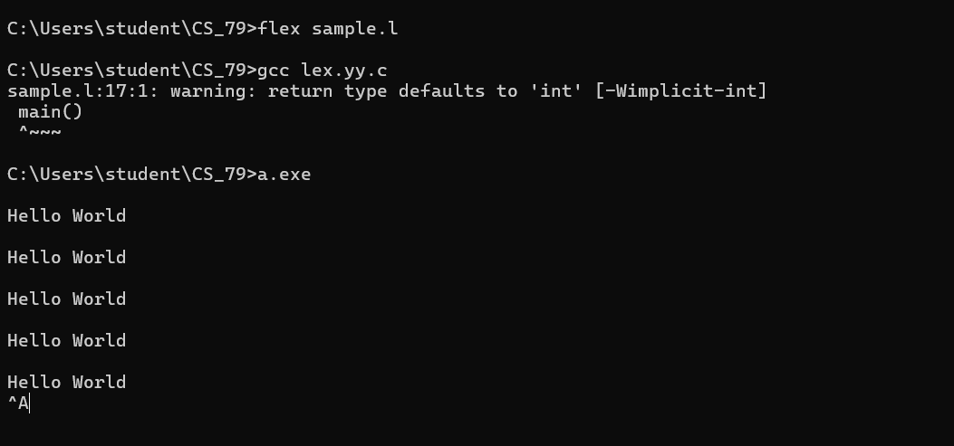

**Q.2.Print the string starting with 'a' and ending with ‘b’**

%{  
#undef yywrap  
#define yywrap() 1  
%}  
  
%%  
  
[aA][a-zA-Z0-9]*[bB] {  
    printf("Found string starting with 'a' and ending with 'b': %s\n", yytext);  
}  
  
%%  
  
int main() {  
    yylex(); // Start lexical analysis  
    return 0;  
}

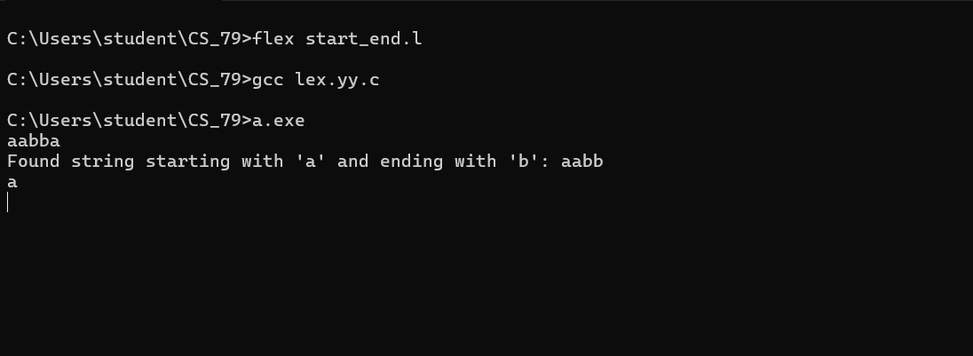

**Q.3. Check the third-to-last character.**

%{  
#undef yywrap  
#define yywrap() 1  
%}  
  
%%  
  
[a-b]*a[a-b][a-b]a {    
         
    int len = strlen(yytext);  
    if (len >= 3 && yytext[len - 3] == 'a') {  
        printf("Valid string: %s\n", yytext);  
    } else {  
        printf("Invalid string: %s\n", yytext);  
    }  
}  
  
.|\n {  
  
    printf("Invalid string: %s\n", yytext);  
}  
  
%%  
  
int main() {  
    yylex();  // Start lexical analysis  
    return 0;  
}

