**1) Self Join:**

1. A self join is a regular join, but the tables joined with itself.
2. We make 2 different aliases for the same table.
3. It is like we make a copy of the same table and join them after putting the conditions to get the desired results.

**Example:**

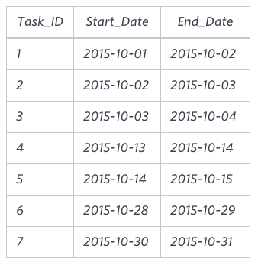

Here,

Let’s perform a Self Join where we can extract Start_Date who is also an End_Date.

**Query:**

select A.Start_Date from Project as A, Project as B where A.Start_Date=B.End_Date;

**Output:**

2015-10-02

2015-10-03

2015-10-14

**2) Decision Tree:**

* Decision Tree is a Supervised Machine Learning Algorithm.
* It can be used for solving regression as well as classification problems.



* It is important to select the right feature as a root node for splitting the tree and for this we can use **Entropy technique**.

**Entropy technique:**

* Entropy measures “Purity of Splitting”.
* We should aim to get the leaf node quickly and with good purity.



* Entropy= $-p (+) log_{2} (P+) - p(-) log_{2} p(-)$

Where,

P(+) : Percentage of +ve class

P(-) : Percentage of -ve class.

If we have to calculate the entropy of feature 1 (3yes/2No),

$-3/5 log_{2} 3/5 - 2/5 log_{2} 2/5$ = 0.78 bits

* Entropy ranges from 0 to 1. 1 will be the worst split however 0 will be the best.

**Information Gain :**

* In the Decision Tree we have to select the features and **Information gain** helps to get the best pattern to split adjusting the entropy.
* Information gain causes reduction in entropy and it is calculated by comparing entropy before and after transformation.

Constructing a decision tree is all about finding the right attribute which returns the highest information Gain.

**Gini Index (Gini Impurity) :**

**Gini index** or **Gini** impurity measures the degree or probability of a particular variable being wrongly classified when it is randomly chosen.

Gini Impurity = $1-{\sum_{i=1 }^{n}{}(p)2}^{}$

I.e = $1-[{( p_{+} )2 +( {p_{-} )2}^{}}^{}$

Let’s consider the split with 1 Entropy and it can be (3yes/3No)

Gini impurity = [ $1 - [(3/6)2^{} + (3/6)2^{}]$ =0.5

* When the probability of a positive class increases then your entropy also increases.
* If the entropy is 1 the Gini index will be 0.5
* The algorithm considers the gini index because it is computationally easy.