**UI Bugs 1280*800**

1. **Top Leader-Board:- In this section award score container was overlapping leaderboard panel.**

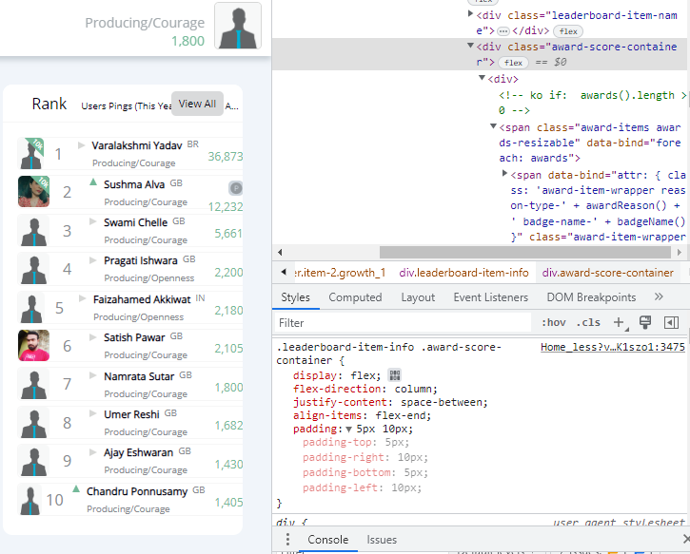

Padding for the award score container was 5px for top, bottom and 10px for left, right.

Then I changed it to 10px for top and bottom and it get fixed.

Changed code: -

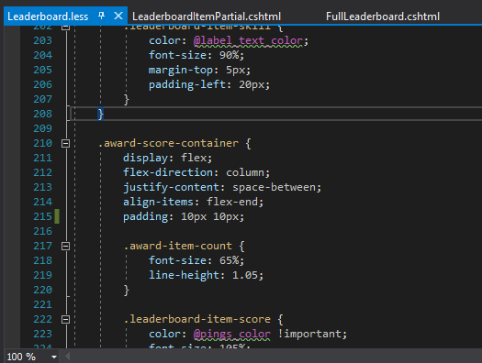

Output: -

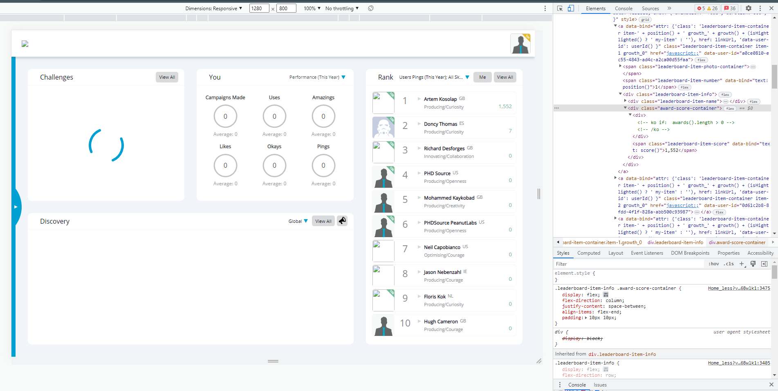

1. **Homepage – inbox panel/upload image: -- Open and upload buttons overlapping here.**

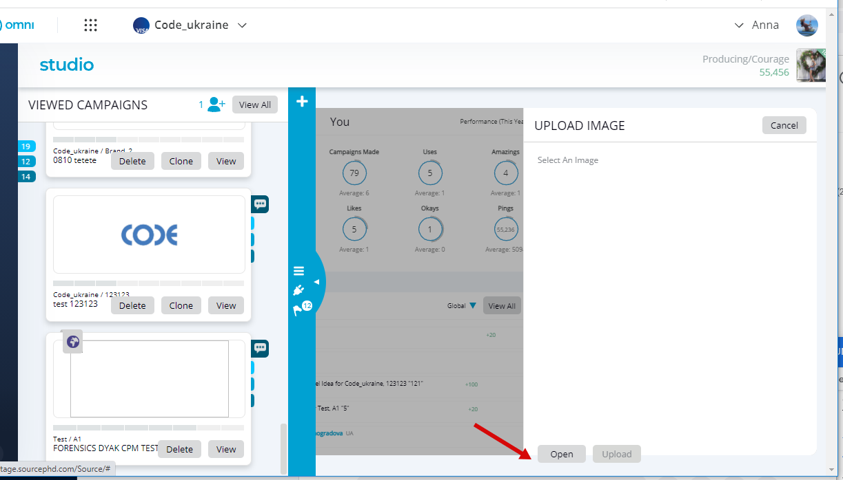

Fixed it by changing bottom of this vertical buttons ( 0px to 30px).

Changed code: -

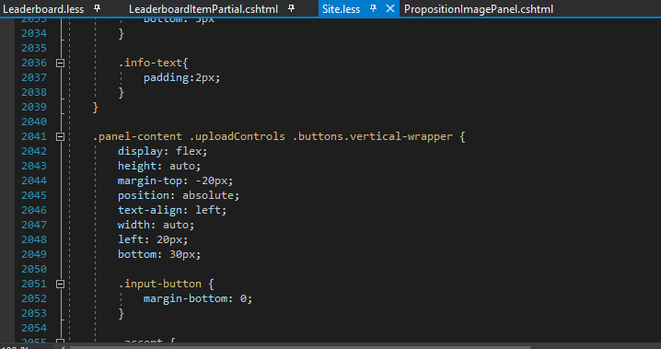

Output: -

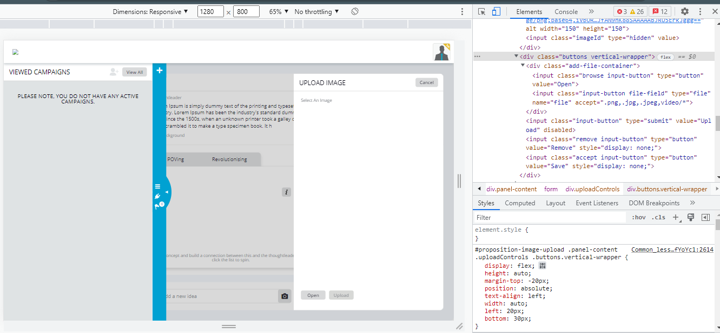

1. **Make the dot Smaller: -** 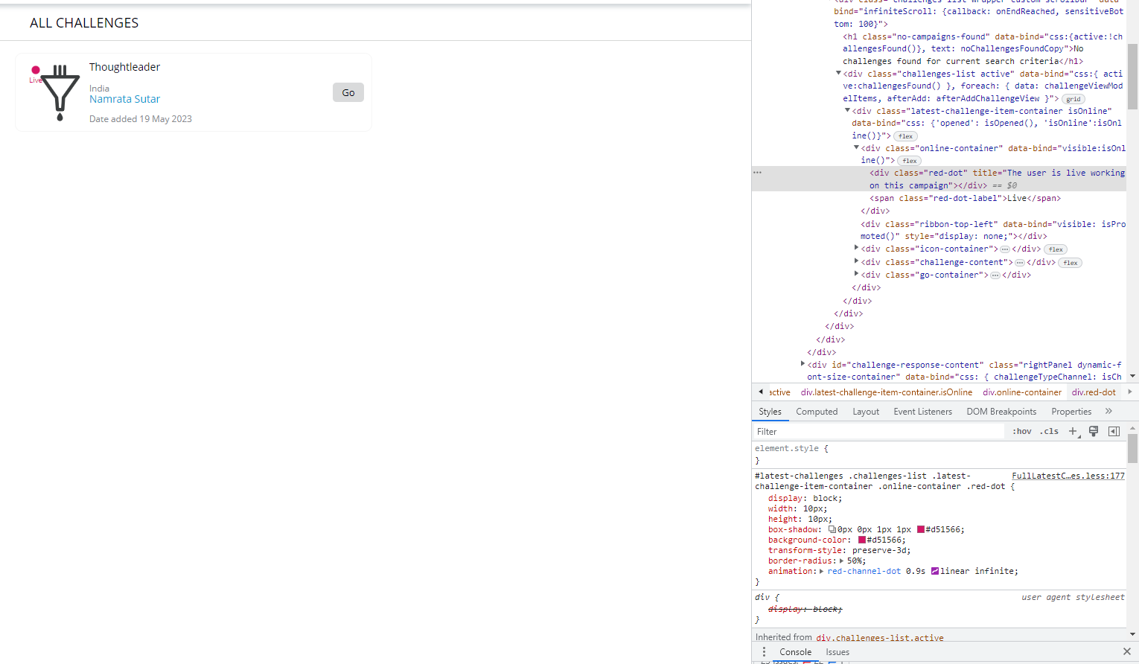

Changed code: - In LatestChallenges.less

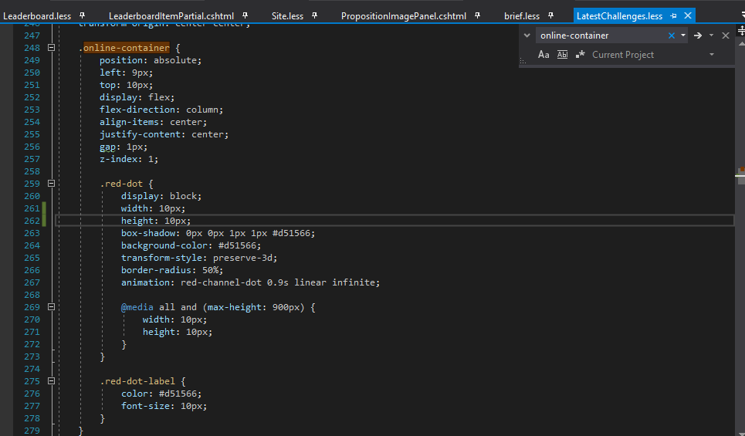

Changed code: - In FullLatestChallenges.less

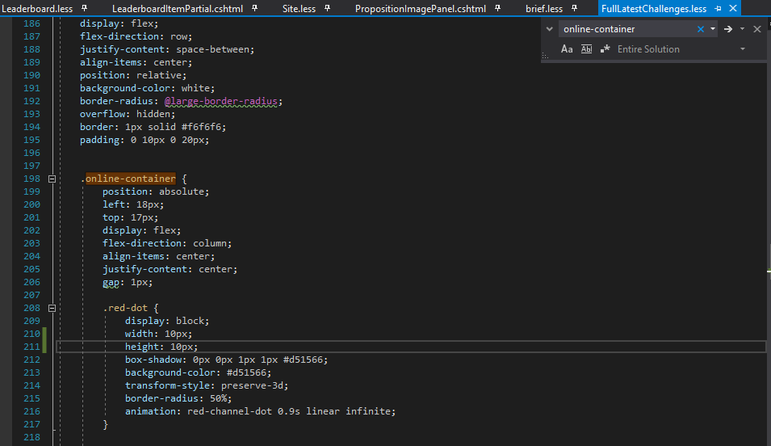

1. **Research: - Occasions is broken**

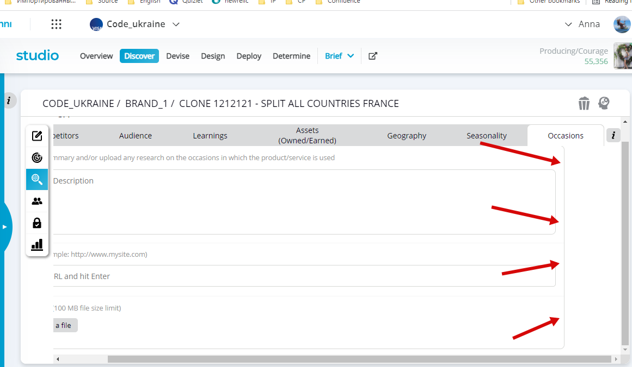

Changed code: - Increased width of this text area up to 100% plus 30px.

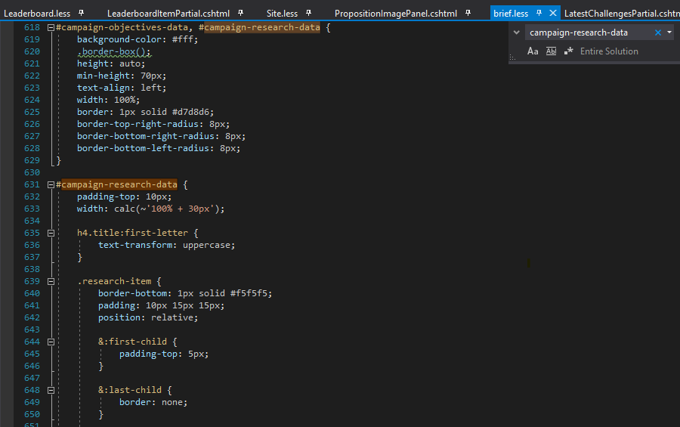

Output: -

