**REPORT**

FRESH VEGGIES

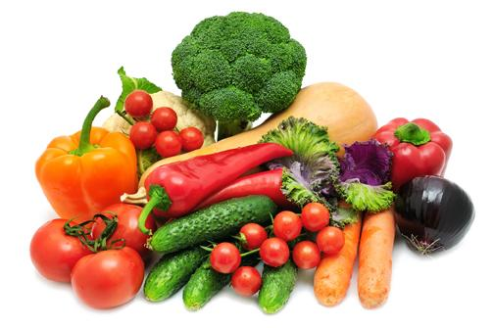

**ABSTRACT: -**

Fresh veggies is the website where you get the details of fruits and vegetables. Using the web technologies HTML & CSS the project is been developed.

HTML is the standard markup language for creating Web pages. HTML describes the structure of a Web page.HTML consists of a series of elements.HTML elements tell the browser how to display the content. CSS is the language we use to style an HTML document.

**Table of Contents**

* Introduction
* Proposed method with Architecture
* Methodology
* Implementation
* Conclusion

**INTRODUCTION: -**

Responsive Web design is the approach that suggests that design and development should respond to the user’s behaviour and environment based on screen size, platform and orientation.

A typical website is comprised of a set of files (each web page—home page, about page, etc.—is an individual file). Each file contains HTML code and content (text and images). Web pages are styled with files called Cascading Style Sheets (CSS). For ease of explanation, let’s say that a standard (non-responsive) website has a set of files and a few CSS files that govern the look of the site. A responsive website applies an alternate set of CSS files depending on the device being used to access the site. The site looks and ‘responds’ differently based on the device.

For example, while someone viewing the site from a desktop device sees a horizontally aligned navigation menu, someone viewing the site from a mobile device gets a vertically aligned navigation menu with larger text that is easier to read on a smaller screen.

So, in this project I have developed a responsive website which display fruits and vegetables.

**Proposed method with Architecture: -**

Waterfall is the most conventional software development methodology. In fact, it has been one of the most popular approaches for web development projects for several decades due to its plan-driven approach. The Waterfall approach requires a lot of structure and documentation.

ARCHITECTURE: -

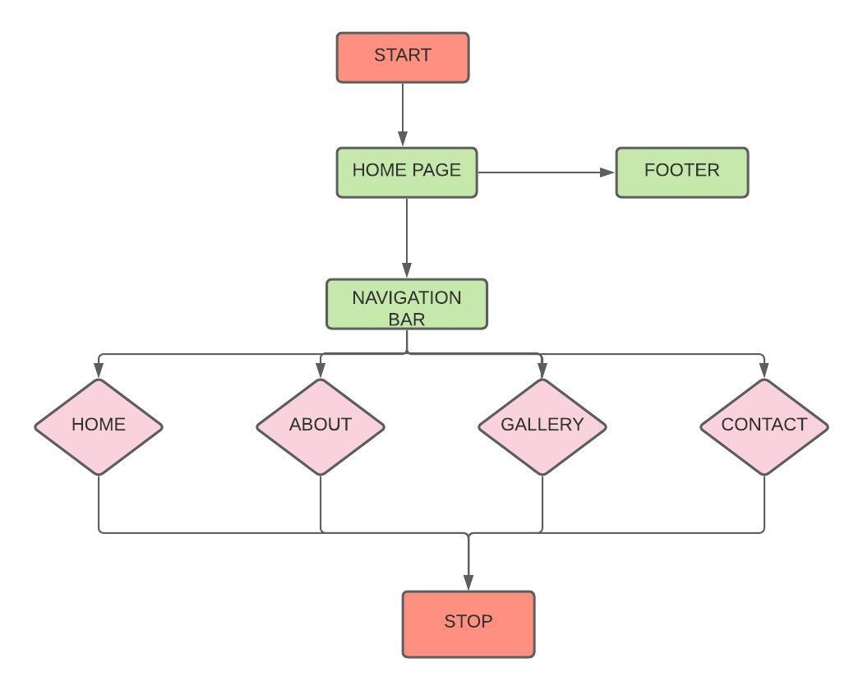

**Methodology: -**

Responsive Web design is the approach that suggests that design and development should respond to the user's behaviour and environment based on screen size, platform and orientation. The practice consists of a mix of flexible grids and layouts, images and an intelligent use of CSS media queries.

**Implementation: -**

A site designed with RWD adapts the layout to the viewing environment by using fluid, proportion-based grids, flexible images, and CSS3 media queries. The fluid grid concept calls for page-element sizing to be in relative units, such as percentages, rather than absolute units, such as pixels or points.

**Conclusion: -**

Hence, I have developed the project on responsive web design. By implementing web technologies HTML and CSS.