

**LA GRANDEE INTERNATIONAL COLLEGE**

**Simalchaur, Pokhara, Nepal**

Assignment II

**Submitted to**

Mr. Ashwin Poudel

La Grandee International College

Bachelor of Computer Application (BCA) Program

**Submitted by**

|  |  |  |  |
| --- | --- | --- | --- |
| **Name:** | **Course** | **Semester** | **P.U. Registration Number** |
| Namrata Bastola | BCA | 6th | 2022-1-53-0129 |

**Date: 4th May 2025**

1. **Question**

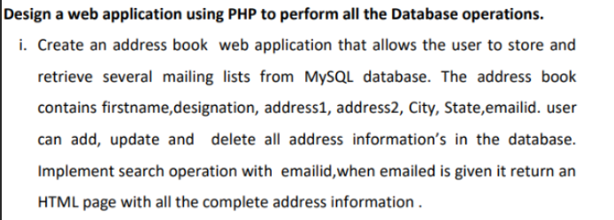

1. **Introduction**

This project is a basic Address Book web application built using HTML, PHP, and MySQL. The purpose is to manage and store user mailing details efficiently with full CRUD (Create, Read, Update, Delete) functionalities. The system validates user inputs before processing to prevent incorrect or incomplete entries. Upon successful validation, the data is securely stored in the MySQL database. Additionally, the application includes a search feature that retrieves and displays complete address information based on the provided email ID, offering a dynamic and responsive user experience.

**3.db.php**

<?php

$host = "localhost";

$user = "root";

$pass = "";

$dbname = "assignment2";

$conn = mysqli_connect($host, $user, $pass, $dbname);

if (!$conn) {

    die("Connection failed: " . mysqli_connect_error());

}

?>

**4.index.php**

<?php include 'db.php'; ?>

<!DOCTYPE html>

<html>

<head>

    <title>Address Book</title>

    <link rel="stylesheet" href="style.css">

</head>

<body>

<div class="container">

    <h2>Add New Contact</h2>

    <form action="insert.php" method="POST">

        <input name="firstname" placeholder="First Name" required>

        <input name="designation" placeholder="Designation">

        <input name="address1" placeholder="Address Line 1">

        <input name="address2" placeholder="Address Line 2">

        <input name="city" placeholder="City">

        <input name="state" placeholder="State">

        <input name="emailid" type="email" placeholder="Email" required>

        <button type="submit">Add Contact</button>

    </form>

    <h2>Search by Email</h2>

    <form action="search.php" method="GET">

        <input name="emailid" type="email" placeholder="Enter Email">

        <button type="submit">Search</button>

    </form>

    <h2>All Contacts</h2>

    <?php

    $result = mysqli_query($conn, "SELECT * FROM contacts");

    while($row = mysqli_fetch_assoc($result)) {

        echo "<div class='card'>

            <strong>{$row['firstname']}</strong> | {$row['emailid']}

            <a href='update.php?id={$row['id']}'>Edit</a> |

            <a href='delete.php?id={$row['id']}'>Delete</a>

        </div>";

    }

    ?>

</div>

</body>

</html>

**5.insert.php**

<?php

include 'db.php';

$firstname = $_POST['firstname'];

$designation = $_POST['designation'];

$address1 = $_POST['address1'];

$address2 = $_POST['address2'];

$city = $_POST['city'];

$state = $_POST['state'];

$emailid = $_POST['emailid'];

$query = "INSERT INTO contacts (firstname, designation, address1, address2, city, state, emailid)

VALUES ('$firstname', '$designation', '$address1', '$address2', '$city', '$state', '$emailid')";

if (mysqli_query($conn, $query)) {

    echo "Contact added. <a href='index.php'>Back</a>";

} else {

    echo "Error: " . mysqli_error($conn);

}

?>

**6.search.php**

<?php

include 'db.php';

$email = $_GET['emailid'];

$result = mysqli_query($conn, "SELECT * FROM contacts WHERE emailid='$email'");

if (mysqli_num_rows($result) > 0) {

    $row = mysqli_fetch_assoc($result);

    echo "<h2>Result for: $email</h2>";

    echo "<div class='card'>

        <p>Name: {$row['firstname']}</p>

        <p>Designation: {$row['designation']}</p>

        <p>Address: {$row['address1']}, {$row['address2']}</p>

        <p>City/State: {$row['city']} / {$row['state']}</p>

    </div>";

} else {

    echo "No result found. <a href='index.php'>Back</a>";

}

?>

**7.update.php**

<?php

include 'db.php';

$id = $_GET['id'];

if ($_SERVER['REQUEST_METHOD'] == 'POST') {

    $firstname = $_POST['firstname'];

    $designation = $_POST['designation'];

    $address1 = $_POST['address1'];

    $address2 = $_POST['address2'];

    $city = $_POST['city'];

    $state = $_POST['state'];

    $emailid = $_POST['emailid'];

    $update = "UPDATE contacts SET firstname='$firstname', designation='$designation', address1='$address1',

    address2='$address2', city='$city', state='$state', emailid='$emailid' WHERE id=$id";

    if (mysqli_query($conn, $update)) {

        echo "Updated! <a href='index.php'>Back</a>";

    } else {

        echo "Error updating: " . mysqli_error($conn);

    }

} else {

    $result = mysqli_query($conn, "SELECT * FROM contacts WHERE id=$id");

    $row = mysqli_fetch_assoc($result);

?>

<!DOCTYPE html>

<html>

<head><link rel="stylesheet" href="style.css"></head>

<body>

<div class="container">

    <h2>Edit Contact</h2>

    <form method="POST">

        <input name="firstname" value="<?= $row['firstname'] ?>">

        <input name="designation" value="<?= $row['designation'] ?>">

        <input name="address1" value="<?= $row['address1'] ?>">

        <input name="address2" value="<?= $row['address2'] ?>">

        <input name="city" value="<?= $row['city'] ?>">

        <input name="state" value="<?= $row['state'] ?>">

        <input name="emailid" value="<?= $row['emailid'] ?>">

        <button type="submit">Update</button>

    </form>

</div>

</body>

</html>

<?php } ?>

**8.delete.php**

<?php

include 'db.php';

$id = $_GET['id'];

mysqli_query($conn, "DELETE FROM contacts WHERE id=$id");

echo "Deleted. <a href='index.php'>Back</a>";

?>

**9.style.css**

body {

    background-color: #e9f5f9;

    font-family: 'Segoe UI', sans-serif;

    color: #333;

}

.container {

    max-width: 600px;

    margin: 50px auto;

    background: white;

    padding: 30px;

    border-radius: 10px;

    box-shadow: 0px 4px 10px rgba(0,0,0,0.1);

}

h2 {

    text-align: center;

    color: #2a7f62;

}

form {

    display: flex;

    flex-direction: column;

}

input {

    margin: 8px 0;

    padding: 10px;

    border: 1px solid #ccc;

    border-radius: 5px;

}

button {

    margin-top: 10px;

    padding: 10px;

    background-color: #2a7f62;

    color: white;

    border: none;

    border-radius: 5px;

    cursor: pointer;

}

button:hover {

    background-color: #246b52;

}

.card {

    background: #f4f4f4;

    padding: 15px;

    border-left: 5px solid #2a7f62;

    margin: 10px 0;

    border-radius: 5px;

}

**5.Output**

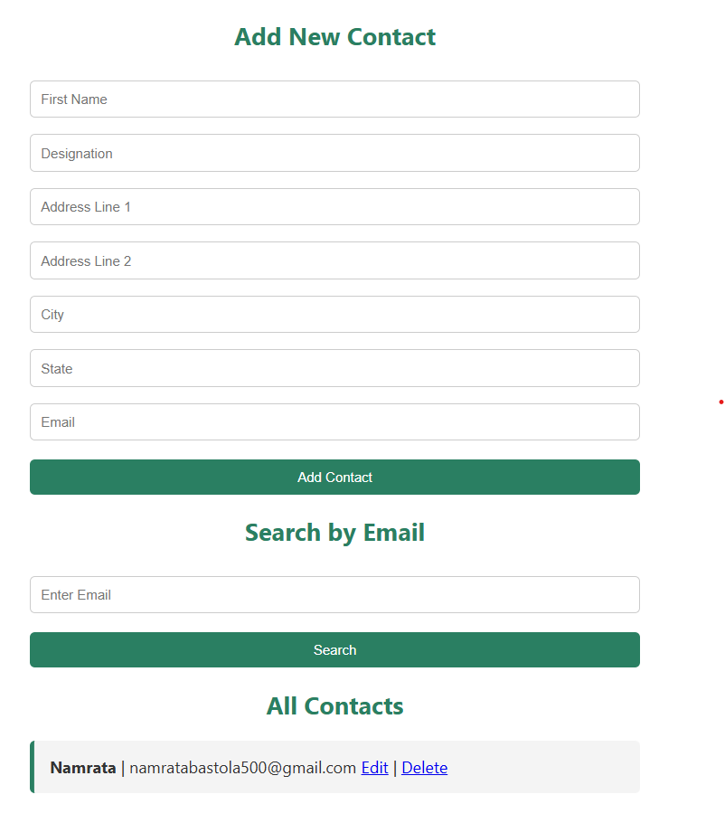

**6. Conclusion**

The system meets all assignment requirements and demonstrates the essential CRUD operations in a PHP-MySQL environment.