

**LA GRANDEE INTERNATIONAL COLLEGE**

**Simalchaur, Pokhara, Nepal**

Assignment III

**Submitted to**

Mr. Ashwin Poudel

La Grandee International College

Bachelor of Computer Application (BCA) Program

**Submitted by**

|  |  |  |  |
| --- | --- | --- | --- |
| **Name:** | **Course** | **Semester** | **P.U. Registration Number** |
| Namrata Bastola | BCA | 6th | 2022-1-53-0129 |

**Date: 4th May 2025**

1. **Question(a)**

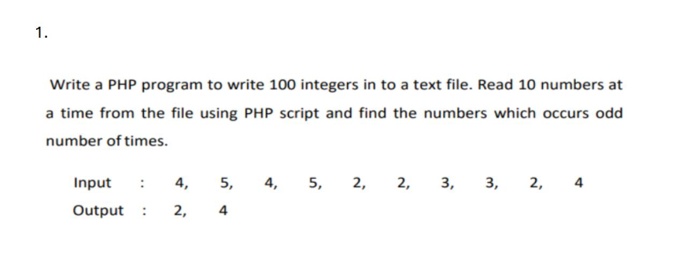

1. **Introduction**

This submission includes two PHP-based programs demonstrating file handling and data processing concepts:

1. **Resume & Photo Upload System** – A form-based web app using HTML and PHP where users upload a resume (PDF/DOC, ≤500KB) and a photograph (JPG/JPEG, ≤1MB). The system validates file type, size, and prevents duplicates before saving files into designated folders.
2. **Odd Frequency Finder** – A PHP script that writes 100 random integers to a text file, reads them 10 at a time, counts their occurrences, and displays the numbers that appear an odd number of times. It illustrates file I/O, array usage, and basic logic building.

**3.index.php**

<?php

// Step 1: Write 100 random numbers to a file

$file = fopen("numbers.txt", "w");

for ($i = 0; $i < 100; $i++) {

    fwrite($file, rand(1, 10) . " ");

}

fclose($file);

// Step 2: Read numbers from the file

$text = file_get_contents("numbers.txt");

$allNumbers = explode(" ", trim($text));

$numberCount = [];

// Step 3: Read 10 numbers at a time and count them

for ($i = 0; $i < count($allNumbers); $i += 10) {

    $tenNumbers = array_slice($allNumbers, $i, 10);

    foreach ($tenNumbers as $oneNumber) {

        if ($oneNumber !== "") {

            if (isset($numberCount[$oneNumber])) {

                $numberCount[$oneNumber]++;

            } else {

                $numberCount[$oneNumber] = 1;

            }

        }

    }

}

// Step 4: Show numbers that appear odd number of times

echo "Numbers that appear odd number of times:\n";

foreach ($numberCount as $number => $times) {

    if ($times % 2 != 0) {

        echo "$number appears $times times\n";

    }

}

?>

**4.resume_upload.html**

<!DOCTYPE html>

<html>

  <head>

    <title>Jobseeker File Upload</title>

  </head>

  <body>

    <h2>Upload Resume and Photograph</h2>

    <form action="upload.php" method="POST" enctype="multipart/form-data">

      <label>Resume (PDF/DOC, Max 500KB):</label><br />

      <input type="file" name="resume" required /><br /><br />

      <label>Photograph (JPG/JPEG, Max 1MB):</label><br />

      <input type="file" name="photo" required /><br /><br />

      <input type="submit" value="Upload" />

    </form>

  </body>

</html>

**5.upload.php**

<?php

$resumeDir = "resumes/";

$photoDir = "photos/";

if (!is_dir($resumeDir)) {

    mkdir($resumeDir, 0777, true);

}

if (!is_dir($photoDir)) {

    mkdir($photoDir, 0777, true);

}

if (isset($_FILES['resume']) && is_uploaded_file($_FILES['resume']['tmp_name'])) {

    $resume = $_FILES['resume'];

    $resumeName = basename($resume['name']);

    $resumePath = $resumeDir . $resumeName;

    $resumeType = strtolower(pathinfo($resumePath, PATHINFO_EXTENSION));

    $resumeSize = $resume['size'];

    if (file_exists($resumePath)) {

        echo "Resume file already exists.<br>";

    } elseif (!in_array($resumeType, ['pdf', 'doc'])) {

        echo "Only PDF or DOC allowed for resume.<br>";

    } elseif ($resumeSize > 512000) {

        echo "Resume file must be less than 500KB.<br>";

    } else {

        move_uploaded_file($resume['tmp_name'], $resumePath);

        echo "Resume uploaded successfully.<br>";

    }

}

if (isset($_FILES['photo']) && is_uploaded_file($_FILES['photo']['tmp_name'])) {

    $photo = $_FILES['photo'];

    $photoName = basename($photo['name']);

    $photoPath = $photoDir . $photoName;

    $photoType = strtolower(pathinfo($photoPath, PATHINFO_EXTENSION));

    $photoSize = $photo['size'];

    if (file_exists($photoPath)) {

        echo "Photo file already exists.<br>";

    } elseif (!in_array($photoType, ['jpg', 'jpeg'])) {

        echo "Only JPG or JPEG allowed for photo.<br>";

    } elseif ($photoSize > 1048576) {

        echo "Photo file must be less than 1MB.<br>";

    } else {

        move_uploaded_file($photo['tmp_name'], $photoPath);

        echo "Photo uploaded successfully.<br>";

    }

}

?>

**6.Snapshots**

**i.**

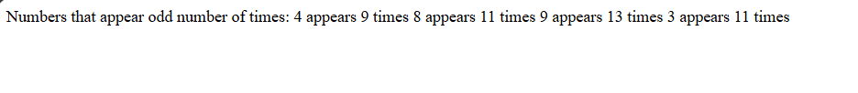

**ii.**

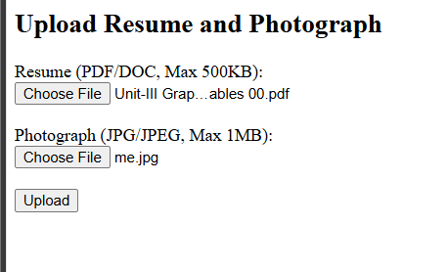

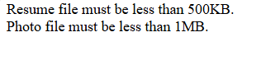

**7.Github Repo(https://github.com/Namrataaa14/WEB-II.git)**

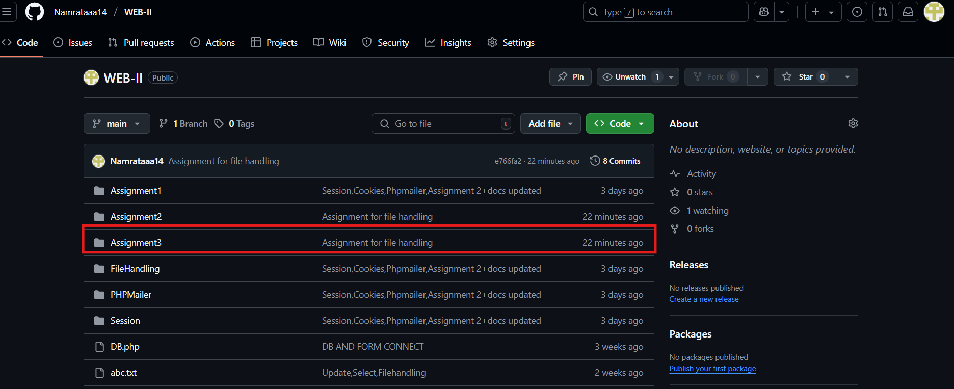

**8. Conclusion**

Both programs demonstrate essential PHP skills through practical use cases. The file upload system ensures secure and validated storage of user files, reflecting real-world form handling. The integer frequency program highlights file I/O and logical processing in PHP. Together, they meet assignment goals and strengthen understanding of core PHP concepts.