Simulation of College Bus

By Namrata Doddamani

1. Intent:

This Project is on “Simulation of College Bus” which is a demo of implementation of Computer Graphics using *OpenGL* *Functions.* It is a User interactive program where in the User can view the required displayby making use of the input device like Keyboard. The project demonstrates the simulation of a college bus. The project consists of a virtual world with numerous elements like a bus, the bus-stop, a student, the college etc. The main objective of this project is to drive the bus to the bus-stop, pick up the student and drop her to the college.

Initially, the bus is driven to the bus-stop where the student is waiting, on reaching the bus-stop the student boards the bus. The bus is then driven to the respective college. On reaching the college, the student gets down the bus and then it is driven to the parking lot.

Keyboard is mainly used as interface to perform the necessary operations in the project with respect to controlling the movement of the bus.

The project, so described is successfully implemented using many built in functions available in GLUT library in Open Graphics Library (OpenGL) package. OpenGL API functions were used extensively for implementing the drawing objects like Polygons, Points and Lines. After the completion of the static model, the animation effects were implemented using the translation *function*.

1. Scope:

Working on this project has been a rewarding experience and will enable me to design more complex graphics projects in future. This project was bit time consuming, but gave lots of knowledge, skills. The project was also completed in the stipulated time frame.

There is still scope left in the development of project like, after the bus has dropped the girl at her college the developer can create a situation in which the bus is required to be parked properly at the parking lot. The introduction screen can also be modified further by embedding buttons like “Press to go to next screen” etc.

By developing this particular project, I have learnt the basics of computer graphics and in future by developing it further I shall learn more and implement this in using 3D graphics.

1. Output:

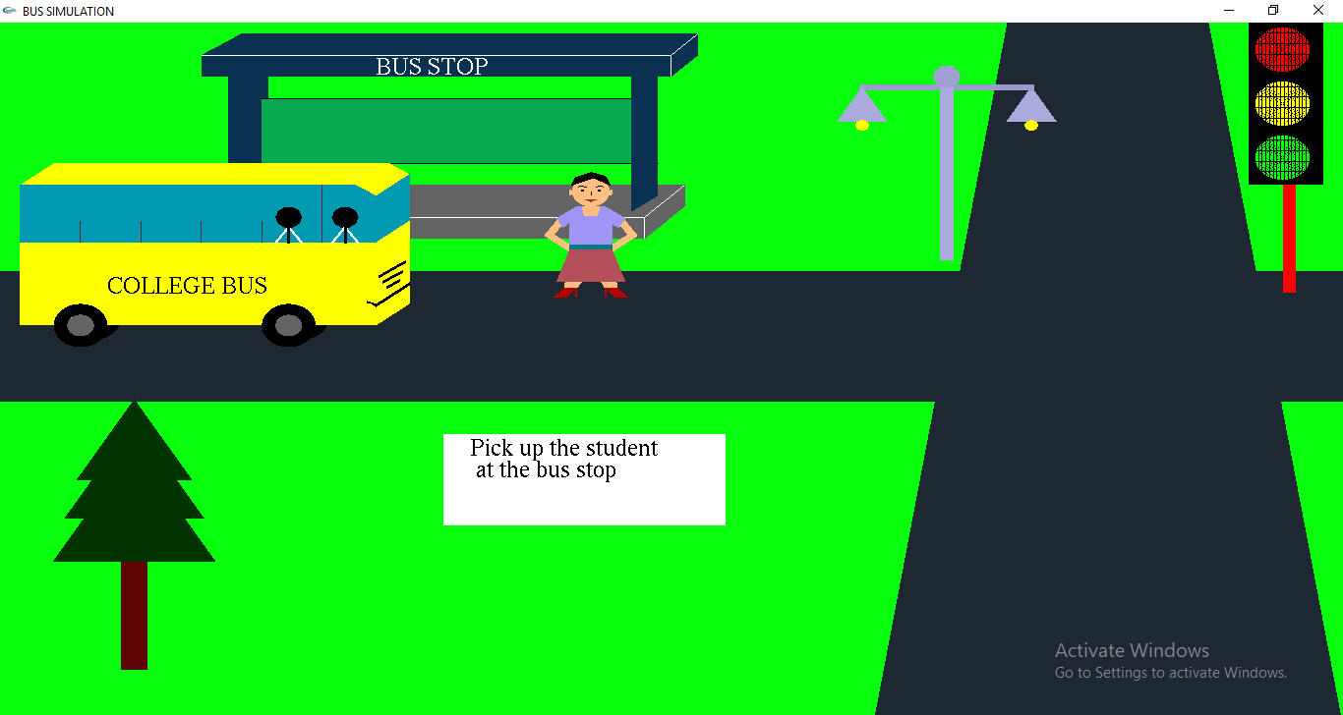

**Fig 3.1:** Bus stop view

The above figure shows the girl waiting as the bus arrives at the bus stop.

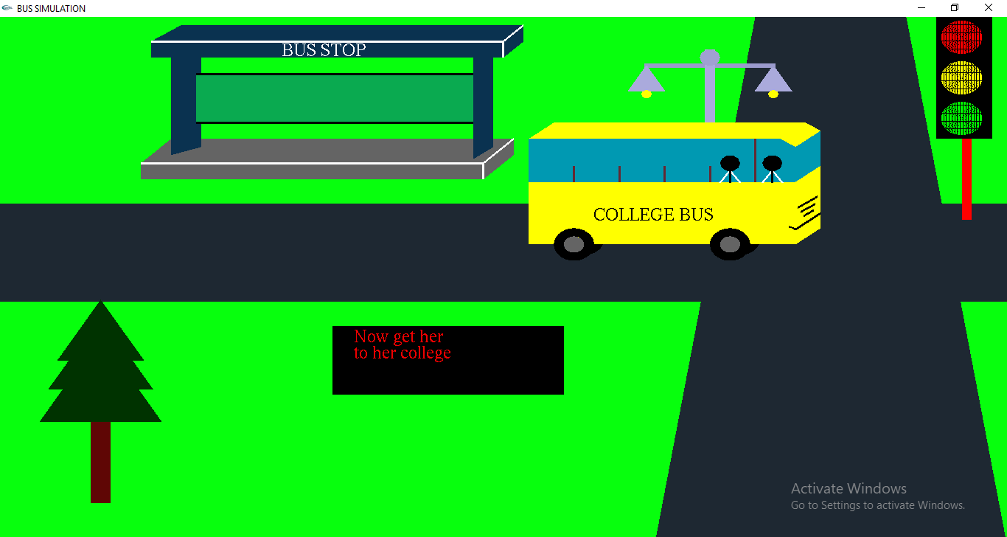

**Fig 3.2:** Arrival of bus

The above figure shows that the girl has boarded the bus and the bus is moving towards the end of the screen as the right button is pressed.

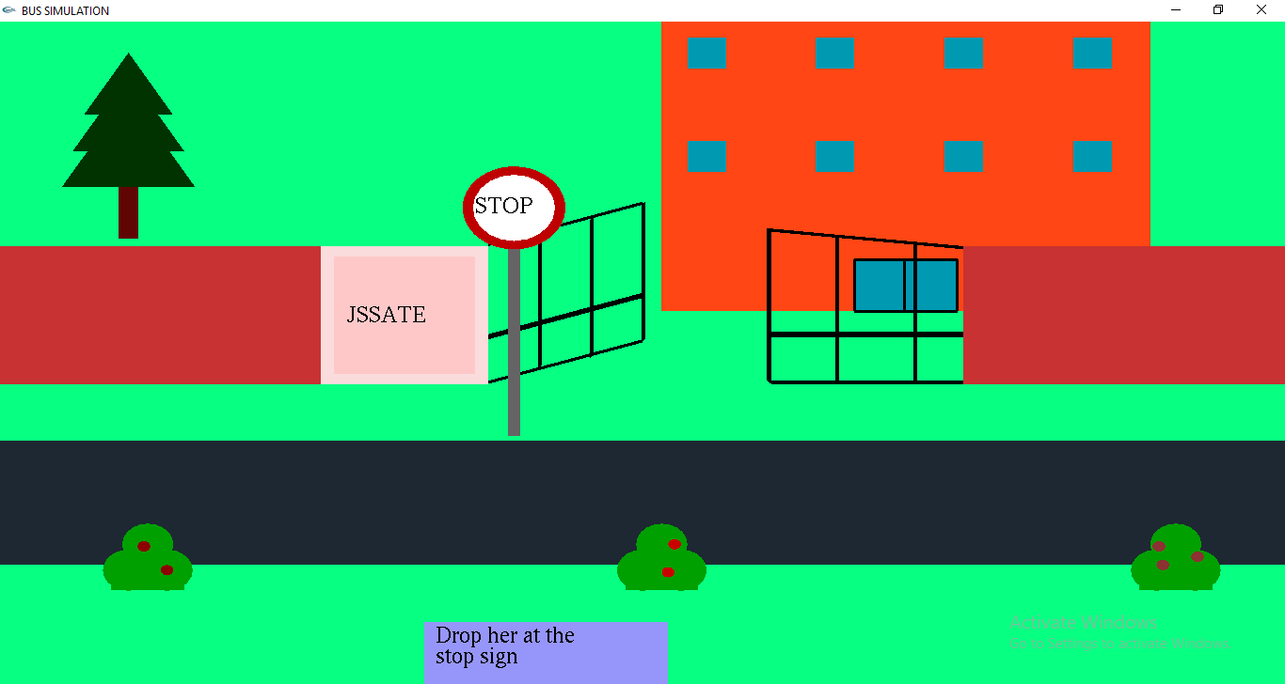

**Fig 3.3:** College view

The above figure is the next screen which depicts the girl’s college. The bus has not yet arrived to the scene.

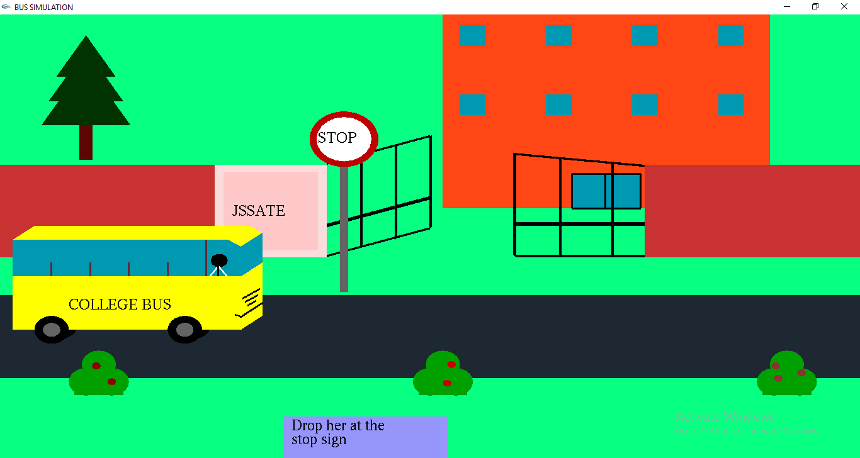

**Fig 3.4:** Bus reaching college

The above figure shows that the bus is about to reach the college and the girl is ready to get down along with the student.

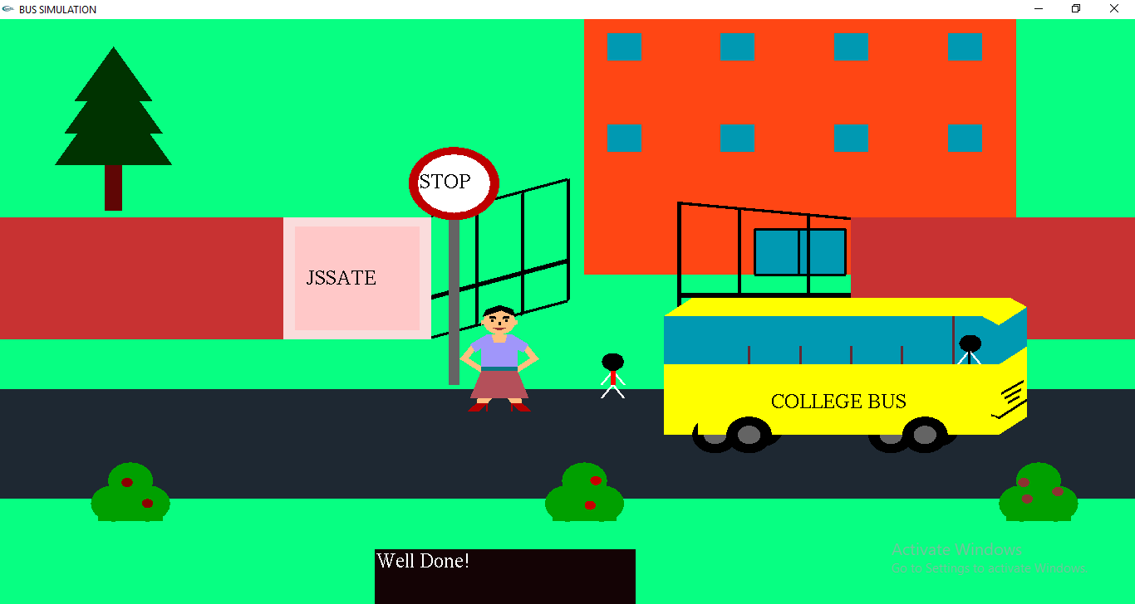

**Fig 3.5:** Dropping students

The above figure shows both the girl and the student get down near the college and the bus departs from the scene

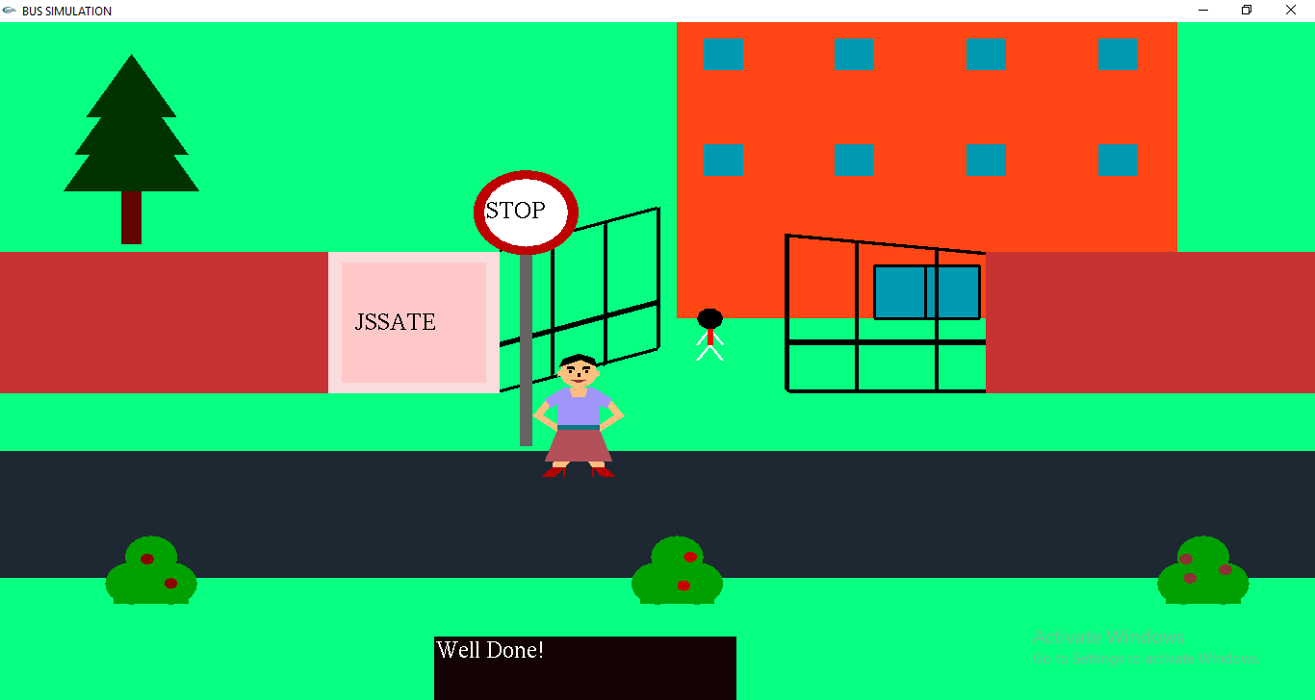

**Fig 3.6:** Motion of student

The above figure shows the student walking to the college and is ready to attend classes. The girl is still waiting at the stop sign.