**Practical no:05**

**Aim:** To demonstrate interfaces.

**Output:**

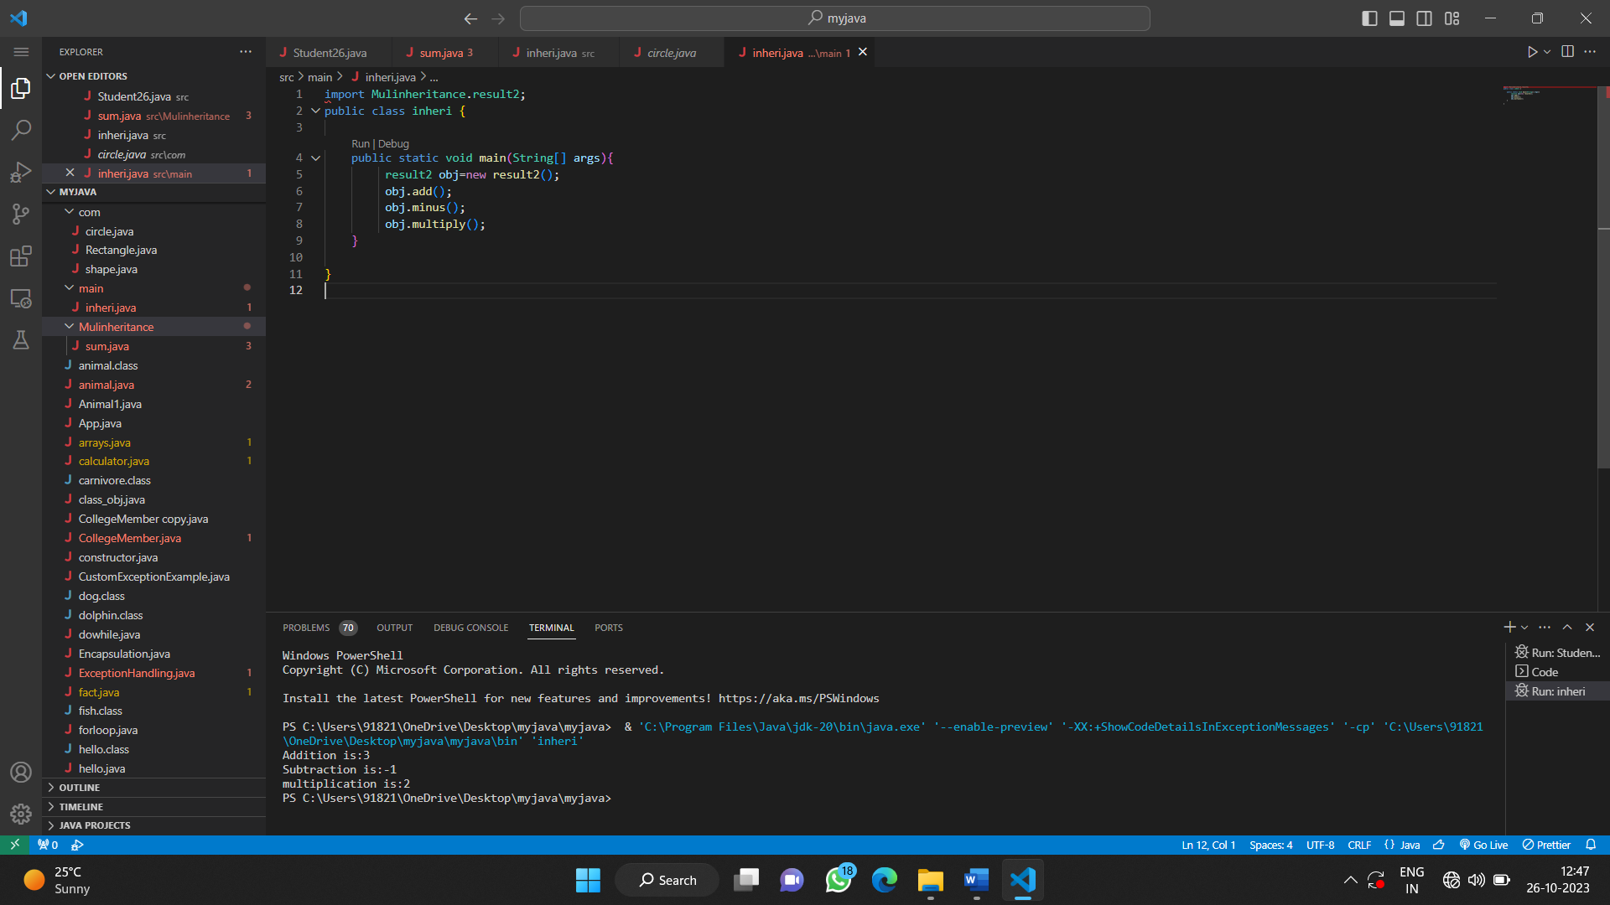

**Practical no:05**

**Aim:** To demonstrate interfaces.

**Program**

package Mulinheritance;

public interface sum {

void add();

}

public interface sub {

void minus();

}

public interface result extends sum,sub {

void multiply();

}

public class result2 implements result {

int a=1;

int b=2,c,d,e;

public void add(){

c =a+b;

System.out.println("Addition is:"+c);

}

public void minus(){

d=a-b;

System.out.println("Subtraction is:"+d);

}

public void multiply(){

e=a*b;

System.out.println("multiplication is:"+e);

}

}

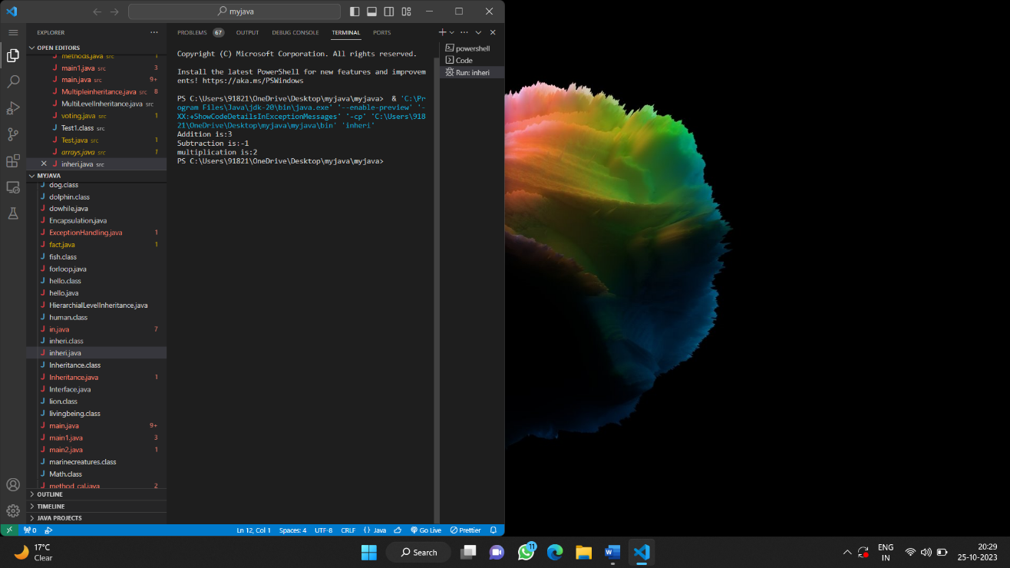

import Mulinheritance.result2;

public class inheri {

public static void main(String[] args){

result2 obj=new result2();

obj.add();

obj.minus();

obj.multiply();

}

}

**Practical no:06**

**Aim:** To demonstrate static variable and method.

**Output:**

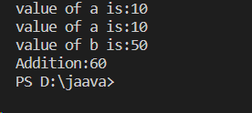

**Practical no:06**

**Aim:** To demonstrate static variable and method.

**Program:**

class demo{

static int a=40;

int b;

demo(int b){

this.b=b;}

static void change(){

a=10;}

void add(){

display();

System.out.println("value of a is:"+a);

System.out.println("value of b is:"+b);

System.out.println("Addition:"+(a+b));}

static void display(){

System.out.println("value of a is:"+a);

}

}

public class static1 {

public static void main(String[] args){

demo.change();

demo obj=new demo(50);

obj.add();

}

}