Attendance management system

*A PROJECT REPORT*

*Submitted to*

**HIMACHAL PRADESH TECHNICAL UNIVERSITY, HAMIRPUR**

*by*

**namrata (21010203026)**

*in partial fulfillment for the award of the degree of*

**BACHELOR OF TECHNOLOGY**

*in*

**COMPUTER SCIENCE & ENGINEERING**

## DEPARTMENT OF COMPUTER SCIENCE & ENGINEERING

ATAL BIHARI VAJPAYEE GOVT. INSTITUTE OF ENGINEERING & TECHNOLOGY

## PRAGATINAGAR, SHIMLA, HIMACHAL PRADESH

**november 2023**

# ACKNOWLEDGEMENT

I am very grateful to my Industrial Training Project guide Ms. Prasanna sharma for giving her valuable time and constructive guidance in preparing the Industrial Training Project. It would not have been possible to complete this Industrial Training Project in short period of time without her kind encouragement and valuable guidance.

Date: 29/10/2023 Signature

namrata

21010203026

# CERTIFICATE

I hereby certify that the work which is being presented in the B.Tech. Project Work- I Report entitled “**ATTENDANCE MANAGEMENT**”, in partial fulfillment of the requirements for the award of the **Bachelor of Technology in Computer Science & Engineering** and submitted to the Department of Computer Science & Engineering of Atal Bihari Vajpayee Govt. Institute of Engineering & Technology, Pragatinagar, Shimla, HP is an authentic record of my own work carried out during a period from August 2023 under the supervision of **Ms. Prasanna sharma.**

*Signature*

*Namrata*

*2010103026*

This is to certify that the above statement made by the candidate is correct to the best of my knowledge.

Date: 029/10/2023 Ms. Prasanna sharma

## Head

Computer Science & Engineering Department

Atal Bihari Vajpayee Govt. Institute of Engineering & Technology, Pragatinagar

# ABSTRACT

Student attendance management system deals with the maintenance of the student’s attendance details. It is generates the attendance of the student on basis of presence in class. It is maintained on the daily basis of their attendance. The staffs will be provided with the separate username & password to make the student’s status. The staffs handling the particular subjects responsible to make the attendance for all students. Only if the student present on that particular period, the attendance will be calculated. The students attendance reports based on weekly and consolidate will be generate

# TABLE OF CONTENTS

|  |  |  |
| --- | --- | --- |
| **CHAPTER NO.** | **CONTENTS** | **PAGE NO.** |
| 1 | INTRODUCTION   * 1. INTRODUCTION TO JAVA   2. ECLIPSE   3. INTRODUCTION TO PROJECT | 1-5 |
| 2 | SOFTWARE AND HARDWARE SPECIFICATION   * 1. SOFTWARE SPECIFICATION   2. HARDWARE SPECIFICATION | 6-8 |
| 3 | SYSTEM ANALYSIS   * 1. IDENTIFCATION OF NEED   2. PRELIMINARY INVESTIGATION | 9 -12 |
| 4 | FEASIBILITY STUDY   * 1. TECHNICAL FEASIBILITY   2. ECONOMICAL FEASIBILITY   3. OPERATIONAL FEASIBILITY | 13 -14 |
| 5 | ANALYSIS  5.1 ANALYSIS | 15 -19 |
| 6 | S/W ENGINEERING, PARADIGM APPLIED | 20-23 |
| 7 | SYSTEM DESIGN | 24-25 |
| 8 | PROJECT SCREENSHOTS | 26-40 |
| 9 | TESTING | 41-44 |
| 10 | IMPLEMENTATION & MAINTENANCE | 45-46 |
| 11 | SYSTEM SECURITY MEASURES | 47-48 |
| 12 | VARIOUS TYPES OF MODULES | 49-50 |
| 13 | CONCLUSION | 51 |
| 14 | REFERENCES | 52 |

**LIST OF TABLES**

|  |  |  |
| --- | --- | --- |
| **S. NO** | **TABLE NAME** | **TABLE NO.** |
| 1 | SOFTWARE SPECIFICATION | TABLE 2.1 |
| 2 | HARDWARE SPECIFICATION | TABLE 2.2 |
| 3 | ADMIN TABLE | TABLE 5.1 |
| 4 | USER TABLE | TABLE 5.2 |
| 5 | SUBJECT TABLE | TABLE 5.3 |

# LIST OF FIGURES

|  |  |  |
| --- | --- | --- |
| **SR. NO.** | **FIGURE NAME** | **FIGURE NO.** |
| 1 | APPLICATIONS OF JAVA | FIG 1.1 |
| 3 | USE CASE DIAGRAM FOR ADMIN | FIG 5.1 |
| 4 | USE CASE DIAGRAM FOR USER | FIG 5.2 |
| 5 | ZERO LEVEL DFD | FIG 5.3 |
| 6 | SOFTWARE PARADIGM | FIG 6.1 |
| 7 | SYSTEM DESIGN | FIG 7.1 |
| 8 | WHITE BOX TESTING | FIG 9.1 |
| 9 | BLACK BOX TESTING | FIG 9.2 |
| 10 | MVC FRAMEWORK | FIG 10.1 |
| 11 | POJO | FIG 10.2 |
| 12 | MODULES | FIG 12.1 |

**CHAPTER-1 INTRODUCTION**

## INTRODUCTION TO JAVA:

Java is a class-based, object-oriented, high-level programming language that aims to minimize implementation dependencies. The goal of this general-purpose programming language is to enable programmers to create code once and have it run anywhere. This means that once code has been compiled, it can run on any platform that supports Java without requiring recompilation.Generally, Java programs are compiled to bytecode, which is compatible with any Java virtual machine (JVM) and can operate on any kind of computer architecture. Java has fewer low-level features than both C and C++, but it has a syntax that is similar to both of them. Traditional compiled languages usually do not offer dynamic features like reflection and runtime code modification, but the Java runtime does.

## Applications of Java:

Fig 1.1: Applications of Java

## ECLIPSE:

Eclipse is an integrated development environment (IDE) used in computer programming, and in 2014 was the most widely used Java IDE in one websites poll. It contains a base workspace and an extensible plug-in system for customizing the environment. Eclipse is written mostly in Java and its primary use is for developing Java applications.



## Features:

## Free and Open Source.

## Most used Java IDE.

## Can be used to develop applications in other languages such as C++, Ruby, etc.

## Rich Client Platform.

## Refactoring

## Code Completion

## INTRODUCTION TO PROJECT:

“Attendance Management System” is software developed for maintaining the attendance of the student on the daily basis in the collage. Here the staffs, who are handling the subjects, will be responsible to mark the attendance of the students. Each staff will be given with a separate username and password based on the subject they handle. An accurate report based on the student attendance is generated here. This system will also help in evaluating attendance eligibility criteria of a student. Report of the student’s attendance on weekly and monthly basis is generated.

## Purpose

Redundant data will be avoided and less human labor will be required thanks to this approach. It is not possible to generate efficient reports if the attendance is manually maintained. Based on attendance, the system may produce effective weekly reports that are consolidated. Since attendance is recorded in registers, administrators and staff have long faced challenges in keeping up with this work. Alternatively, the program can store data for a long time and retrieve it as needed.

## Scope

* + - * To be filled

## Objectives

Attendance Management System basically has two main modules for proper functioning

* Admin module is has rights for creating any new entry of faculty and student details.
* User has a rights of making daily attendance, generating report. Attendance report can be taken by given details of student details, date, class.

## Features Of Project:

* **Admin making the quiz:**

Admin has the rights to add questions in any quiz. But currently the quiz contains twenty questions per subject.

## Registration and Login:

Users have to register first and then login to take any quiz so no any unauthorized user can login without giving his credentials.

## Taking of quiz:

Users can select any subject to take quiz and test their knowledge and gain knowledge from their mistakes.

## Accessibility:

Enable the users to take the quizzes from anywhere with an internet connection, promoting flexibility and accessibility**.**

## User-friendly interface:

Design an intuitive and user-friendly interface for the participants.

## No need of paper:

There is no need of papers because of theoretical multiple-choice question in the quiz.

## Limitations Of Project:

* To be filled

# CHAPTER-2

**SOFTWARE AND HARDWARE SPECIFICATION**

## SOFTWARE SPECIFICATION:

Table 2.1: S/w Specification

|  |  |
| --- | --- |
| **Item** | **Description** |
| Development Tools | Java Development Kit (JDK) 19 version.  Integrated Development Environment (IDE) Eclipse |
| Web Technologies | TBD |
| Database | MySQL, JDBC (Java Database Connectivity) libraries |
| Framework/Libraries | Eclipse Tomcat Server |
| Web Browsers | Chrome, Microsoft Edge or any other web browsers |
| Operating System | Windows XP or higher |

## HARDWARE SPECIFICATION:

Table 2.2: H/w Specification

|  |  |
| --- | --- |
| **Item** | **Description** |
| RAM | 4GB or higher |
| Hard disk | 128 GB or higher |
| Processor | Intel Pentium 4( 1.50 GHZ) or above |

## Detailed description of software requirements:

* **JDK:** TBD
* **Tomcat server Eclipse IDE:** TBD
* **JSP:** JSP technology is used to create web application just like Servlet technology. It can be thought of as an extension to Servlet because it provides more functiona lity than servlet such as expression language, JSTL, etc. A JSP page consists of HTML tags and JSP tags. The JSP pages are easier to maintain than Servlet because we can separate designing and development. It provides some additional features such as Expression Language, Custom Tags, etc.
* **Servlet:**
* **Windows 10:** The windows operating system is a series developed by Microsoft. Each version of window has a graphical user interface, which allows users to view files and folders in windows. For the past two decades, Window Personal Computer Home is designed for both computing and commercial purposes. So, we are using this, operating system to execute all the functioning and procedure for the completion of this system.
* **MYSQL:** Significant performance and security enhancements have been made to MySQL. However, like with any database version upgrade, there are a few things to consider before putting the system into production to prevent difficult problems like data loss, protracted outage, or even a rollback during the migration process.
* **Web browser:** A web browser is a piece of software that makes it possible for users to access, navigate, and view web pages. A web browser is commonly referred to as a "browser" short. The main purposes of browsers are to show and access webpages on the Internet and other types of content made with XML (Extensible Mark-up Language) and HTML (Hypertext Mark-up Language), among other languages. Around the world, various web browsers are in use. Here, Google Chrome is the browser of choice.

# CHAPTER-3 SYSTEM ANALYSIS

Analysis can be defined as breaking up of any whole so as to find out their nature, function etc. It defines design as to make preliminary sketches of; to sketch a pattern or outline for plan. To plan and carry out especially by artistic arrangement or in a skillful wall. System analysis and design can be characterized as a set of techniques and processes, a community of interests, a culture and an intellectual orientation. The various tasks in the system analysis include the following.

* Understanding application.
* Planning.
* Scheduling.
* Developing candidate solution.
* Performing trade studies.
* Performing cost benefit analysis.
* Recommending alternative solutions.
* Selling of the system.
* Supervising, installing and maintaining the system.

This system manages to the analysis of the report creation and develops manual entry of the student attendance. First design the students entry form, staff allocation and time table allocation forms. This project will helps the attendance system for the department calculate percentage and reports for eligibility criteria of examination .The application attendance entry system will provide flexible report for all students.

**IDENTIIFCATION OF NEED:**

To overcome the drawbacks of the existing system, the proposed system has been evolved. This project aims to reduce the paper work and saving time to generate accurate results from the student’s attendance. The system provides with the best user interface. The efficient reports can be generated by using this proposed system.

Advantages of Proposed System

* It is trouble-free to use
* It is a relatively fast approach to enter attendance
* Is highly reliable, approximate result from user
* Best user Interface
* Efficient reports

## Identifying Functional Requirements

Compiled a detailed list of functionalities required in the Admin and users modules based on the gathered requirements.

## Defining Non-Functional Requirements

Defined non-functional requirements such as system performance, security, scalability, usability, and data privacy to ensure the system meets desired standards.

## Analyzing Data Flow

Mapped the flow of data within the system, identifying inputs, processes, and outputs at different stages of system usage.

## Security and Access Control Analysis

Conducted a thorough analysis to identify potential security threats and risks, and formulated strategies to mitigate them, including the use of encryption methods and secure login mechanisms.

## Design and Analysis

Evaluated the system's performance requirements, including response times, concurrent user handling, and database optimization to ensure optimal performance under varying load conditions.

## Integration Points and Interactions

Defined the integration points of the system with external entities, such as email services for notifications, and analyzed how data would be exchanged securely.

## User Experience Analysis

Conducted usability testing and analyzed user feedback to refine the user interface and enhance the overall user experience in both the Admin and Users modules.

## Technology Stack Selection

Assessed various technologies and frameworks suitable for developing a web-based application, considering factors like scalability, ease of development, and compatibility with project objectives.

## Architecture Design

Designed the system's architecture, including the overall system structure, component interactions, database design, and the flow of data and control between various modules.

## Risk Analysis

Identified potential risks in the project development lifecycle and devised risk mitigation strategies to ensure smooth project execution.

## Feasibility Study

Conducted a thorough analysis of the project's economic, technical, and operational feasibility to ensure its viability and success.

## IDENTIFCATION OF NEED

* + 1. **Existing System:**

Existing System is a manual one in which users take the quizzes on the papers. And this is difficult to manage all the quiz papers and there is also wastage of papers for these quizzes.

There are also various quiz applications exist in the internet with different criteria. Each of the existing applications has their own goodness and problems. In this online quiz application which is designed and implemented in JSP based we try to overcome the existing problems with following features:

* + - * Remove source confuse issue.
      * Better management
      * Connection to database for better storing of data
      * Better frontend management
      * Better backend management
      * Try to decrease error issuer during runtime Problem in paper based system:
* The paper based quizzes are not so much interactive to users.
* It will take time to display result to user.
* Wastage of papers.
* Participants are not able to see their mistakes.

So we decided to develop this application to manage everything related to quizzes and make the quiz available to all anywhere and anytime.

## Need of the system:

This application is mainly developed to replace the paperwork. We have to develop an application which can help the students to assess their knowledge and save their time and efforts. This application also helps the students to gain knowledge.

Our aim is to develop an application for the users in which a user can attempt any number of quizzes related to his/her choice given in application.

Proposed system provides the following facilities:

* Any user can easily register and login to take the quiz.
* The user can see their score after attempting the quiz.
* The user can see their correct and incorrect answers after attempting the quiz. Firstly, we have to make interfaces for users like Home Page, Registration, Login Page, Subjects for Quiz, Questions of selected subject for quiz, Result page after attempting the quiz. These all pages have connectivity with the server and database. So, that it can work properly.

Here the admin is able to see the details of registered students and also can add the questions to any of the quiz. He can also add or remove the students from the list.

In this application firstly the user needs to register and then login using email and password. Then the user can choose any of the quiz of his/her choice. Before starting the quiz there are instructions about the quiz for the users. Then the user will select the subject to take the quiz. After attempting all the questions in the quiz the user will able to see his/her result and right or wrong answers.

## PRELIMINARY INVESTIGATION: TBD

~~Preliminary investigation for the Online Quiz System involves gathering essential information to understand the~~ project's context objectives, and initial requirements. Here's a structured approach for conducting a preliminary investigation:

## Project Overview:

Understand the project's purpose, which is to develop a web-based application for efficient organization and management of online quizzes for students. Familiar ize yourself with core modules: Admin and User, and their respective functionalities.

## Identify Stakeholders:

List and identify the primary stakeholders involved, such as admin, user, and any other relevant parties. Understand their roles, needs, and expectations regarding the system.

## Meet with Stakeholders:

Schedule meetings or interviews with stakeholders to discuss the objectives, expectations, and requirements they have for the online quiz system. Document their feedback and insights.

## Current System Assessment:

Evaluate any existing systems or processes currently in use for conducting online quiz. Identify the strengths, weaknesses, and limitations of the current approach.

## Business Process Analysis:

Analyze the current business processes related to online quiz system. Understand how information is currently collected, stored, accessed, and managed.

## Needs Assessment:

Gather information on the needs and pain points of admin and user. Identify what functionalities are lacking in the existing systems and processes.

## Technology Assessment:

Research and assess the technology landscape to identify suitable platforms, frameworks, and tools that can be utilized to develop the online quiz system. Consider factors like scalability, security, and compatibility.

## Risk Assessment:

Identify potential risks and challenges that may arise during the development and implementation of the online quiz system. Assess their impact and likelihood.

## Project Objectives and Scope:

Define the high- level objectives and scope of the project based on the gathered information. Ensure that the objectives align with the needs of the stakeholders and the goals of the educational institution.

As important outcome of the preliminary investigation is the determination that the system request is feasible.

# CHAPTER-4 FEASIBILITY STUDY

As soon as the goals are defined, the feasibility analysis begins. Starting from a wide range of generations. Possible solution to give indication of new system

It should look lime colored. This is where creativity and imagination come into play. Analysts must think. Find new ways to do things – generate new ideas. No need to elaborate. System operation is not yet complete. The solution must contain enough information to create it. Create a reasonable estimate of project costs and show users what the new thing will look like. The system fits the organization. It is important not to try too hard. Only at this stage does it become clear that the project is not worth it or that there is a need for it. The original goal has changed significantly. Feasibility of a new system means ensuring that the new system, which we are going to implement, is efficient and affordable. There are various types of feasibility to be determined. They are,

## TECHNICAL FEASIBILITY:

The technical requirement for the system is economic and it does not use any other additional Hardware and software. Technical evaluation must also assess whether the existing systems can be upgraded to use the new technology and whether the organization has the expertise to use it. Install all upgrades framework into the .Net package supported widows based application. this application depends on Microsoft office and intranet service ,database. Enter their attendance and generate report to excel sheet.

## ECONOMICAL FEASIBILITY:

Development of this application is highly economically feasible. The only thing to be done is making an environment with an effective supervision. It is cost effective in the sense that has eliminated the paper work completely. The system is also time effective because the calculations are automated which are made at the end of the month or as per the user requirement. management the economic justification for the new system. No Extra cost for set up of operating environme nt needed as the computer is already in use for other purposes.

## OPERATIONAL FEASIBILITY:

The system working is quite easy to use and learn due to its simple but attractive interface. User requires no special training for operating the system. Technical performance include issues such as determining whether the system can provide the right information for the Department personnel student details, and whether the system can be organized so that it always delivers this information at the right place and on time using intranet services. Acceptance revolves around the current system and its personnel.

The proposed system is operationally feasible because of the following reasons:

* Saves time and efforts.
* Cost-effective.
* No unauthorized user can access it.
  1. **ANALYSIS**

# CHAPTER-5 ANALYSIS

The system should be designed in such a way that only authorized people should be allowed to access some particular modules. The records should be modified by only administrators and no one else. The user should always be in control of the application and not the vice versa. The user interface should be consistent so that the user can handle the application with ease and speed. The application should be visually, conceptually clear.

## SYSTEM FLOW DIAGRAM:

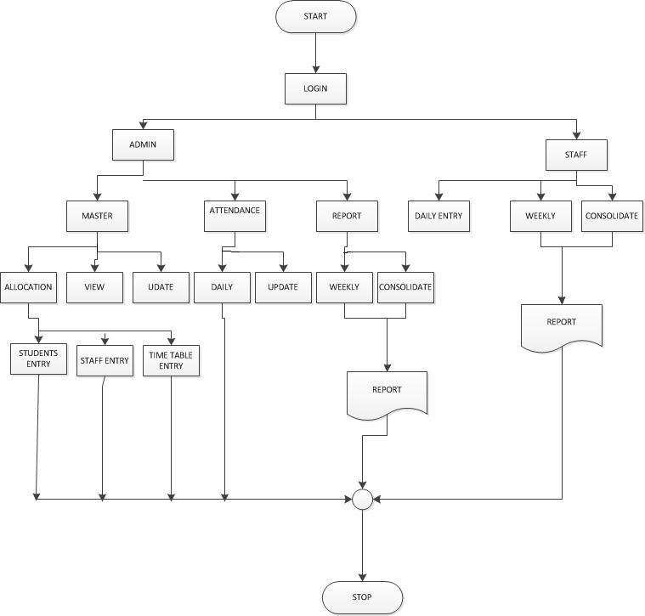

Figure 5.1.1-System Flow Diagram

Use case diagrams model behaviour within a system and helps the developers understand of what the user require. The stick man represents what’s caled an actor. Use case diagram consists of use cases and actors and shows the interaction between the use case and actors.

* The purpose is to show the interactions between the use case and actor.
* To represent the system requirements from user’s perspective.
* An actor could be the end-user of the system or an external system.

## Data flow diagram:

## 5.2.1 DFD level 0



ATTANDANCE MANAGEMENT SYSTEM

USER

REPORT

DATABASE

Figure 5.5.1-DataFlowDiagram Level1

### **5.2.2** **DFD level 1:**



ENTRY

LOGIN

INVALID

UID / PWD

AUTHENDICAT

ION

CHECK

USER

DATABASE

ADMIN

ACCESS

STAFF

ACCESS

PERSON

Fig 5.2.2: DataFlowDiagram Level1

### **5.2.3** **DFD level 2:**

### **5.2.3.1** **Admin:**

Stored data from

database



ALLOCATION

Get details

STUDENTS

contribution

VIEW

ATTANDANCE

ACCESS

Stored data from

database

STAFFS

Get details

TIME TABLE

UPDATE

REPORT

ADMIN

contribution

Figure 5.5.3.1-DataFlowDiagram Level2

**5.2.3.1** **Staffs:**



UPDATE

ATTENDANCE

Attendance

entry

Attendance table

REPORT

USER



UPDATE

ATTENDANCE

Attendance

entry

Attendance table

REPORT

USER

*Stored attendance*

*Stored attendance*

Update attendance

Input Attendance



UPDATE

ATTENDANCE

Attendance

entry

Attendance table

REPORT

USER

* It is beneficial for communicating existing system knowledge to the users.
* A straightforward graphical technique which is easy to recognise.
* DFDs can provide a detailed representation of system components.
* It is used as the part of system documentation file.
* DFDs are easier to understand by technical and nontechnical audiences
* It supports the logic behind the data flow within the system.

## Disadvantages of data flow diagram:

* It make the programmers little confusing concerning the system.
* The biggest drawback of the DFD is that it simply takes a long time to create, so long that the analyst may not receive support from management to complete it.
* Physical considerations are left out.

## Data Tables:

**Admin table:** (Table name is adminlogin)

Table 5.1: Admin Table

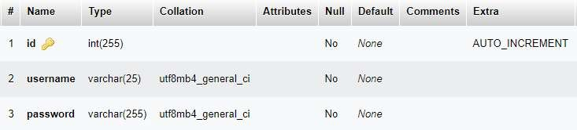

**User Table:** (Table name is registeruser)

Table 5.2: User Table

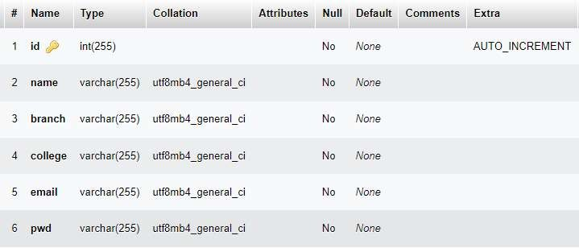

**Subject Table:** (Table name is subjects)

Table 5.3: Subject Table

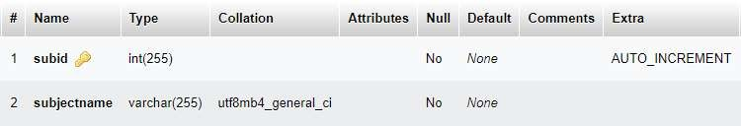

**Questions Table:** (Table name is addquestions)

Table 5.4: Questions Table

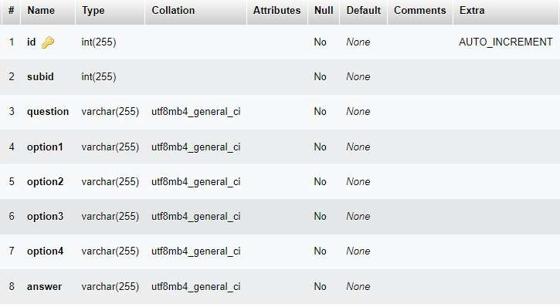

Figure 7.1 Entity relationship Diagram

# CHAPTER-8 PROJECT SCREENSHOTS

For designing and implementing of attendance management System application we used HTML, CSS, JavaScript and SQL server with the context of Java and JSP. Following pages have been designed using HTML, CSS and JavaScript to handle the defined objective of this project.

## login Page:

This is the first page which user observe after running the project. This page will allow the user to login or register. Home page is the default or front page of a site.

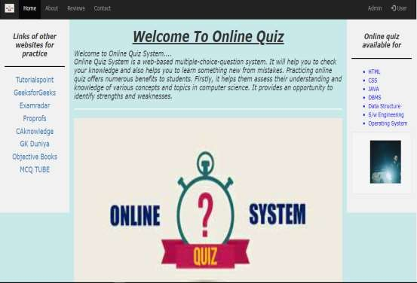It is the first page that visitors see when they load a URL. A web managers can control the login page as a way of directing the user experience.

This login page contains hyperlink which will lead the user to another web page.

.

## Student registration:

When the user wants to contact with administrator, he can click on contact.

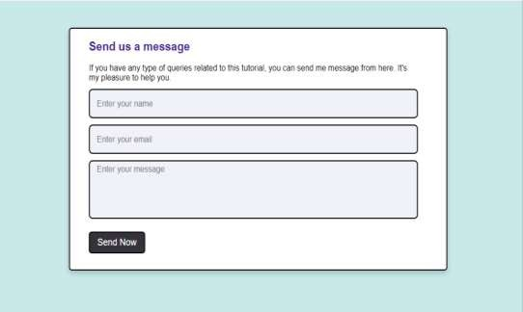

## Course creation :

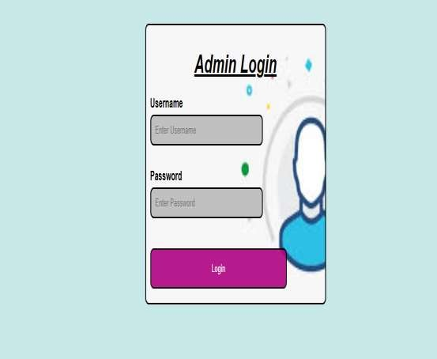

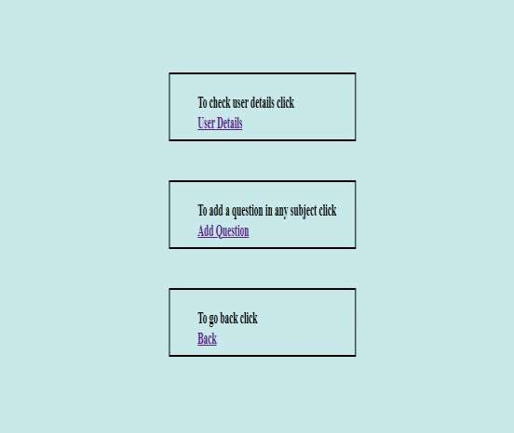After logging in with the predefined username and password, admin will lead to the page shown below:

In this page we are having three accessibility rights for the admin through which the admin can modify following:

* User Details
* Add Question
* Back

When the admin clicks on User Details:

Here the list of all registered students will be displayed to admin. Now when admin click on the Add Questions:

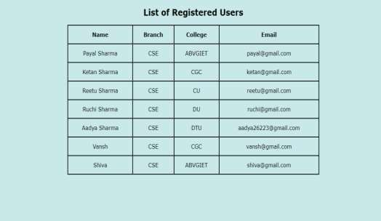

A page will open to add question by selecting the subject from dropdown.

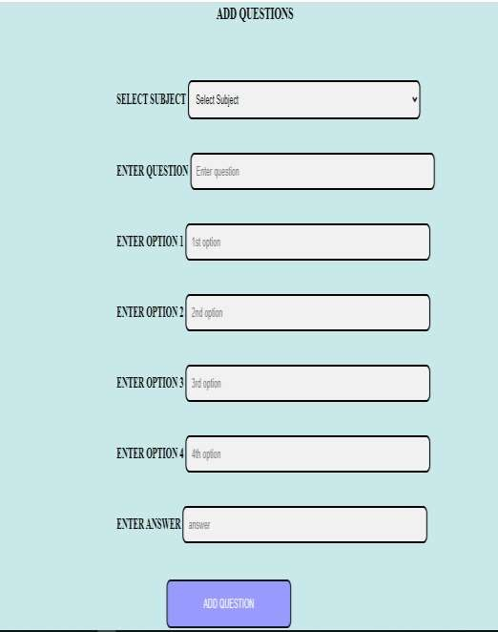

To go back Admin will click on Back



The user will able to register, login, see list of subjects, able to select a subject for quiz and can check their results.

**User Login Page:** When the user clicks on the “User” on the navigation bar**,** User login window will open.

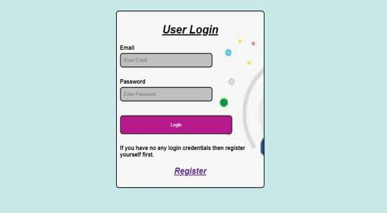

**Registration Page:** If the user does not have login credentials, then he have to register first. So, after clicking on “Register” the registration page wil be open.

Here, the user will have to provide information like:

* Name
* Branch
* College
* Email
* 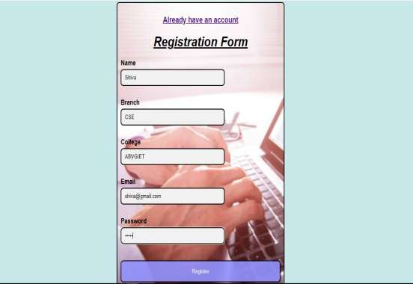Password

After registration, the user will have to use the email and password that they have entered in the registration page, with that only they can login in this page.

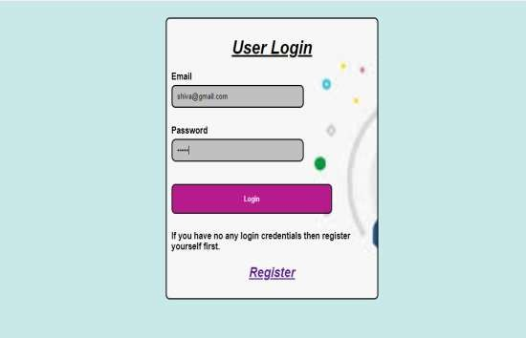

After clicking on login button, the user will able to see the list of subjects that are available for the quiz.

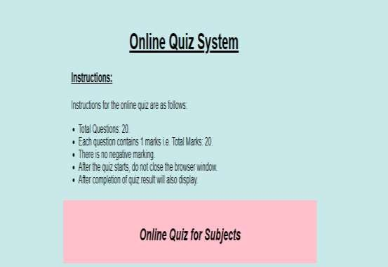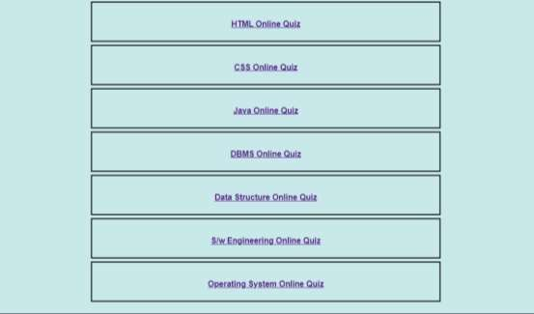

In this page, the online quiz system will be displayed, in which instructions to attempt the quiz are written. Along with the instructions, there are certain hyperlinks provided for the different web pages on clicking which users will lead to the desired test of the subject that they want to appear for. Basically there are seven subjects mentioned here, in which users can attempt the quiz and can test their knowledge.

## When the user selects the HTML Online Quiz:

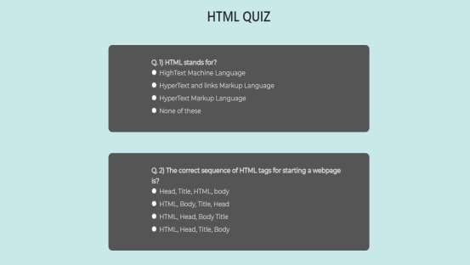

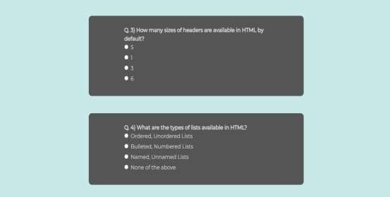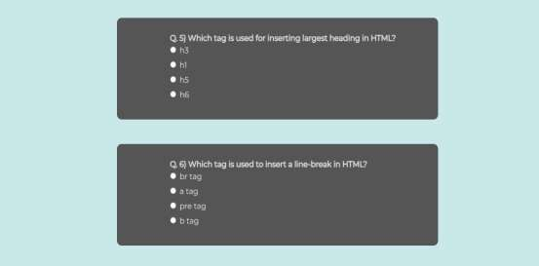

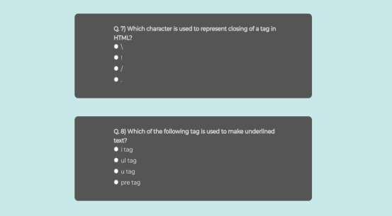

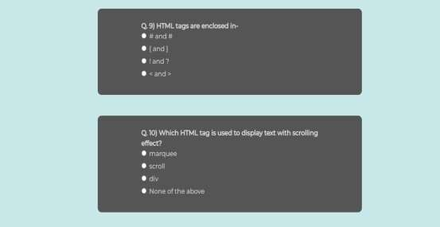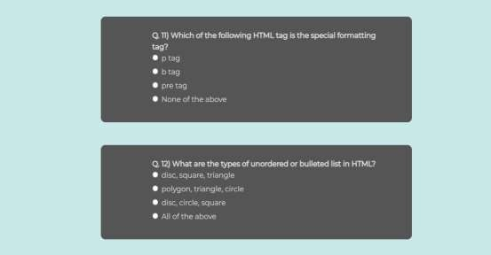

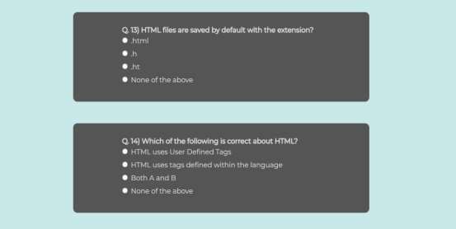

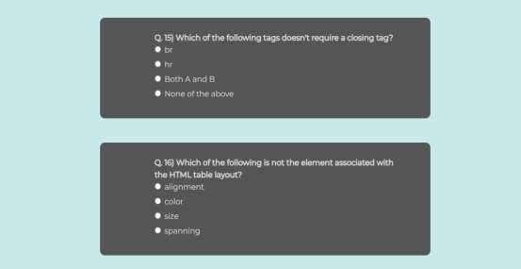

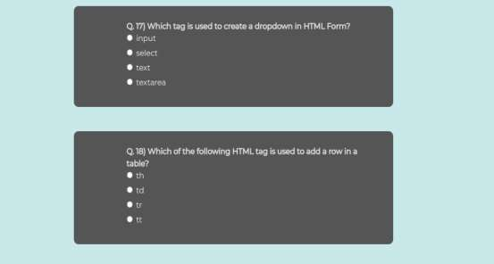

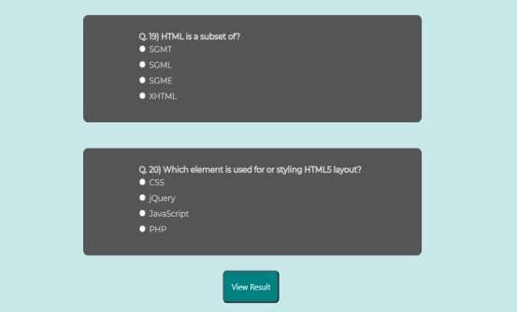

After selecting the answers for the given question, a button is displayed which is “View Result”. When the user will click on this button then the “User Selected Answer” and the “Correct Answers” of each question will appear on the screen and total marks will also appear on screen. Through which user can view their selected answers as well as the correct answers.

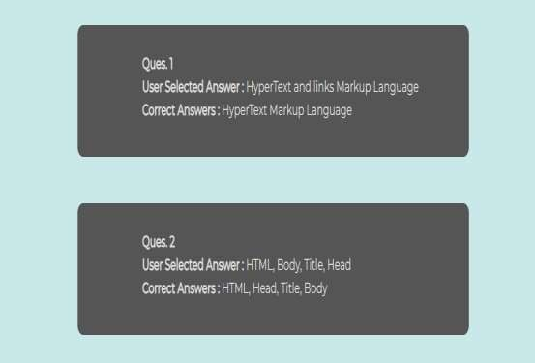

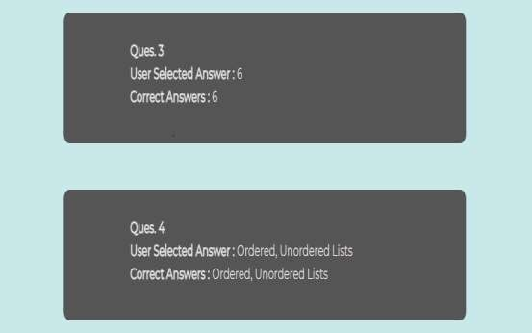

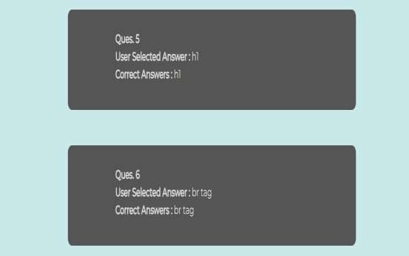

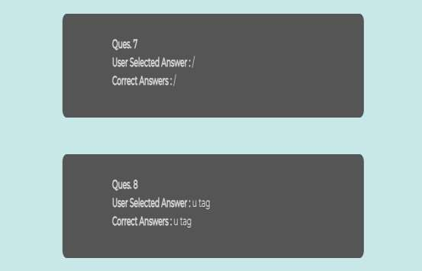

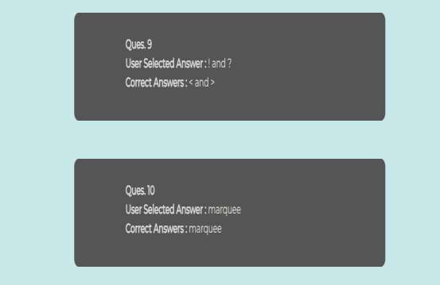

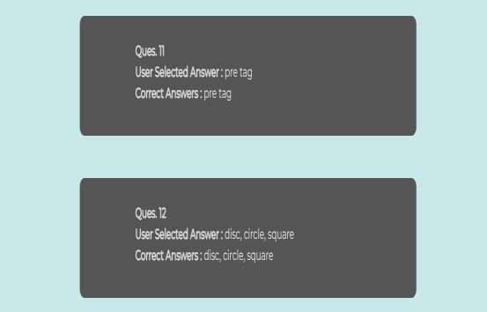

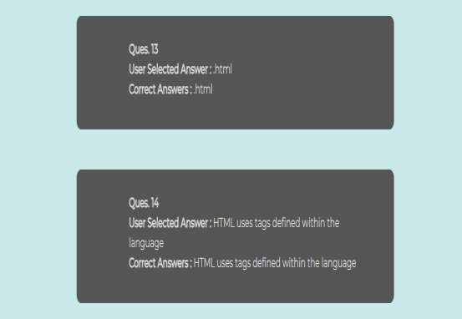

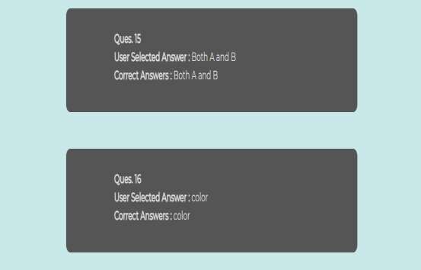

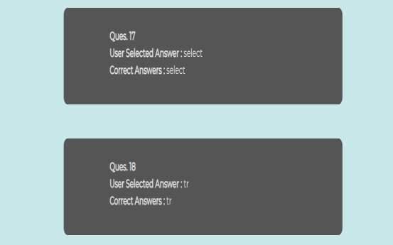

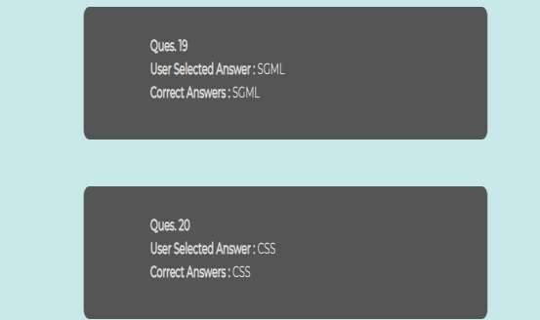

Here the user can also see his total marks that are obtained in the quiz:

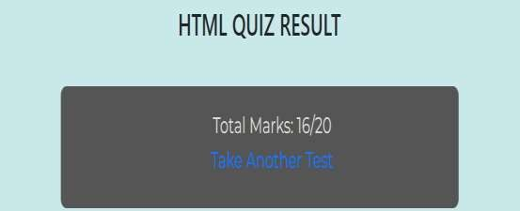

All other quizzes will work same as HTML quiz. Here the user will able to choose any subject from list of subjects available for quiz. Then he will take test and able to see result also. Available quiz subjects are: CSS, Java, DBMS, DSA, Software Engineer ing, and Operating System.

# CHAPTER-9 TESTING

## 9.1.1 Introduction

Software testing is the process of finding errors in the developed product. It also checks whether the real outcomes can match expected results, as well as aids in the identification of defects, missing requirements, or gaps.

Testing is the penultimate step before the launch of the product to the market. It includes examination, analysis, observation, and evaluation of different aspects of a product.

Professional software tester use a combination of manual testing with automated tools. After conducting tests, the testers report the results to the development team. The end goal is to deliver a quality product to the customer, which is why software testing is so important.

## 9.1.2 Test Case

Test case is an object for execution for other modules in the architecture does not represent any interaction by itself. A test case is a set of sequential steps to execute a test operating on a set of predefined inputs to produce certain expected outputs. There are two types of test cases:-manual and automated. A manual test case is executed manually while an automated test case is executed using automation.

In system testing, test data should cover the possible values of each parameter based on the requirements. Since testing every value is impractical, a few values should be chosen from each equivalence class. An equivalence class is a set of values that should all be treated the same.

Ideally, test cases that check error conditions are written separately from the functional test cases and should have steps to verify the error messages and logs. Realistically, if functional test cases are not yet written, it is ok for testers to check for error conditions when performing normal functional test cases. It should be clear which test data, if any is expected to trigger errors.

## TEST CASES

## 9.1.2.1 Agent and admin login form

|  |  |  |  |  |  |  |  |
| --- | --- | --- | --- | --- | --- | --- | --- |
| **Sno** | **Test case id** | **Test case name** | **Test case desc** | **Step** | **Expected result** | **Actual Result** | **Test case status**  **pass/fail** |
| 1 | Login | Validate login | To verify that login name on login page | Enter the login email and password and click submit button | Login successful or an error message “In valid login or password”  must be displayed | Login successful | Pass |
| 2 | Login Staff | Validate login | To verify that login name on login page | Enter the login name and password and click submit button | Login successful or an error message “In valid login or password” must be  displayed | Login successful | Pass |
| 3 | Password | Validate password | To verify that password on login page | Enter password and login name click  submit button | An error message “password invalid” must be displayed | An error message “password invalid” must be displayed | fail |

## 9.1.2.2 Master Form

|  |  |  |  |  |  |  |  |
| --- | --- | --- | --- | --- | --- | --- | --- |
| **Sn** | **Test** | **Test** | **Test** | **Step** | **Expected result** | **Actual** | **Test** |
| **o** | **case** | **case** | **case** |  |  | **Result** | **case** |
|  | **id** | **name** | **desc** |  |  |  | **status** |
|  |  |  |  |  |  |  | **pass/fai** |
|  |  |  |  |  |  |  | **l** |
| 1 | Creat | Validate | To | Nothing | An error message | Inserted | Pass |
|  | e | allocatio | allocate | entered | student name not | succesfu |  |
|  | suden | n form | separate | and click | equal to null must | l |  |
|  | t |  | roll no | submit | be displayed |  |  |
|  | detail |  | for the | button |  |  |  |
|  | s |  | students |  |  |  |  |
| 2 | Creat | Validate | To | Nothing | An error message | Inserted | Pass |
|  | e staff | allocatio | allocate | entered | staff details | succesfu |  |
|  | detail | n form | separate | and click | password,usernam | l |  |
|  | s |  | subject | submit | e not equal to null |  |  |
|  |  |  | usernam | button | must be displayed |  |  |
|  |  |  | e |  |  |  |  |
|  |  |  | passwor |  |  |  |  |
|  |  |  | d for the |  |  |  |  |
|  |  |  | staffs |  |  |  |  |
| 3 | Creat | Validate | To | Nothing | An error message | Inserted | Pass |
|  | e time | allocate | verify | entered | not click not | succesfu |  |
|  | table | period | that data | and click | allocation subject | l |  |
|  |  | form | stored | submit | table not equal to |  |  |
|  |  |  | on | button | null must be |  |  |
|  |  |  | database |  | displayed |  |  |
| 4 | View | Check | To | generate | An error message | An error | fail |
|  |  | details of | verify | d | return null will be | message |  |
|  |  | all data | that data |  | displayed | return |  |
|  |  |  | stored |  |  | null will |  |
|  |  |  | on |  |  | be |  |
|  |  |  | database |  |  | displaye |  |
|  |  |  |  |  |  | d |  |

# XXXX TBD xxxxxx

* .

# CHAPTER-12 VARIOUS TYPES OF MODULES

## Modules in the project:

The application is divided into various modules, each of which caters to a specific need.

## Home Page of this project:

The Home Page is the web application to be displayed which will serve as the central hub for both admin and users, offering an overview of the user's profile and key information. This page will include all the information that a user is required to be known.

## User Module:

* **User Registration Page:**

In this page user will do their registration and generate a password for their login. Using that email and password they can further login in that portal. This registration page may include Name, Branch, College, email and password.

## User Login Page:

In this page user can login with the email and password that they have entered in previous registration page.

## View- Subject Page:

This page will include the further process in which user is asked to select the subject they want to assess and then it will lead them to another page.

## Display Quiz Page:

This page will display the list of questions of that particular subject which user has selected.

## Display Result Page:

This page will display the result to the user after attempting the quiz. This will help the students to gain more knowledge.

## Admin Module:

* **Admin Login Page:**

This page will allow admin to login. As the username and password of the admin will be stored in the database, using which the admin can log in only.

## Admin Panel Page:

After logging in the admin panel will be displayed, in which the admin is allowed to modification. As admin can add the number of cities, or details to be displayed for users. They can also see the number of users who have logged in to their page and their details as well.

Fig 12.1: Modules

# CHAPTER-13 CONCLUSION

After completion of this project we have concluded that this web application works as per the need and requirement of the client and is user friendly. Also this mini project helped me to understand the design, code and implementation processes which are performed while making any project. Many concepts were revised and many of them were very new which were learnt in making of this web application.

## 5.1 FUTURE SCOPE

This project has a vast scope as many other functionalities can be added to it. The participants can login and take any quiz of given subjects of Computer Science field. The participants can check their results immediately after attempting the quiz.

## Extended Functionalities:

In the future, the project can extend its various functionalities as we can add team features in it in which user are allowed to attempt the quiz in a certain group.

## Mobile Application:

Develop a mobile application version of the platform, allowing students to access its features on-the-go. This mobile solution enhances accessibility and convenience.

## Easy Accessibility:

With the advent of World Wide Web, it is observed widely that there is a rapid rise in the number of online quiz portals which allow users to assess their knowledge and can improve their knowledge.

# CHAPTER-14 REFERNCES

* + [https://itsourcecode.com/free-projects/java-projects/quiz- management-](https://itsourcecode.com/free-projects/java-projects/quiz-management-system-project-in-java-with-source-code/) [system-project-in-java-with-source-code/](https://itsourcecode.com/free-projects/java-projects/quiz-management-system-project-in-java-with-source-code/)
  + <https://codewithcurious.com/projects/quiz-game-using-java/>
  + <https://github.com/topics/quiz-application?l=java>