List of Sample Checkout Test Case Screenshots

# Test Case 1: Quantity Range

### Example Data 1: Value 0

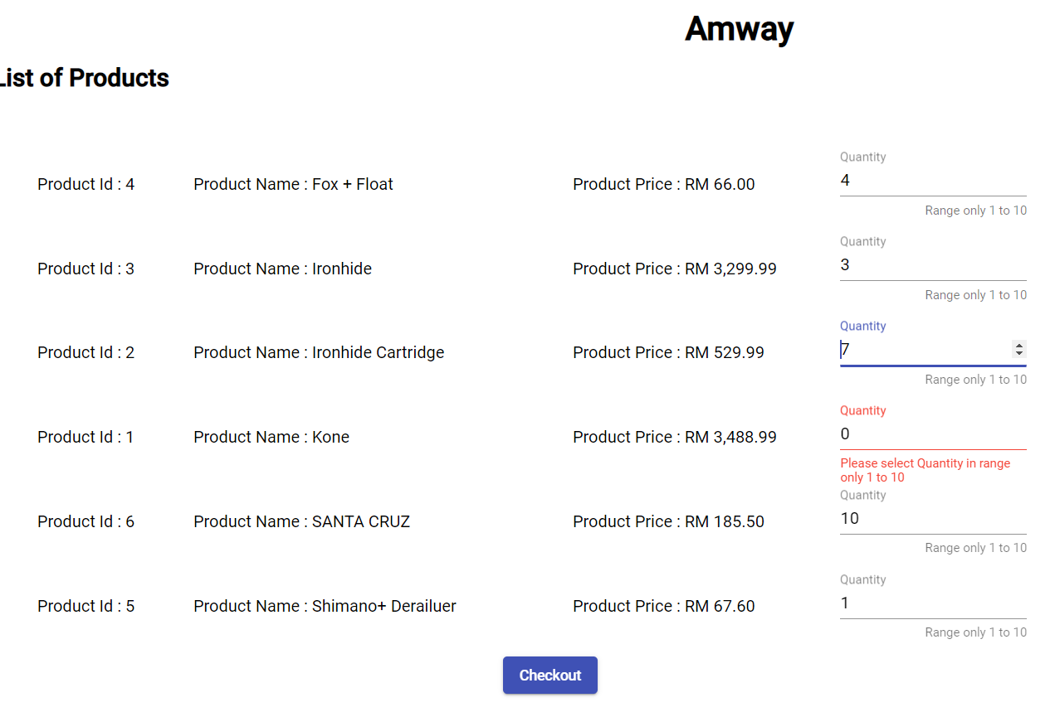

Figure :Test Case 1: Quantity Range- Value =0

### Example Data 2: Value (-ve) : -3

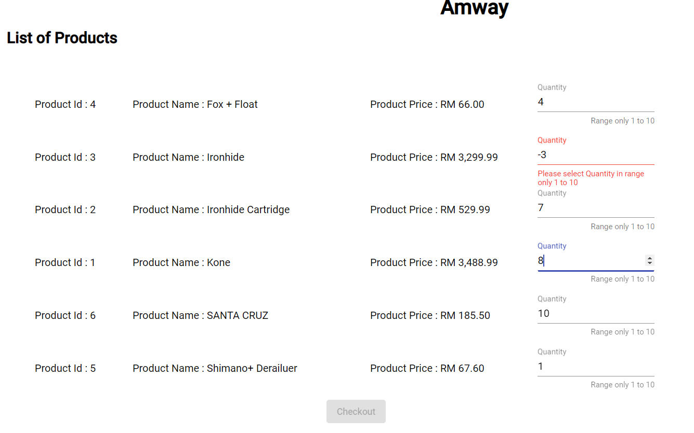

Figure :Test Case 1: Quantity Range- Value = -3

### Example Data 3: Value (more than 10) : 19

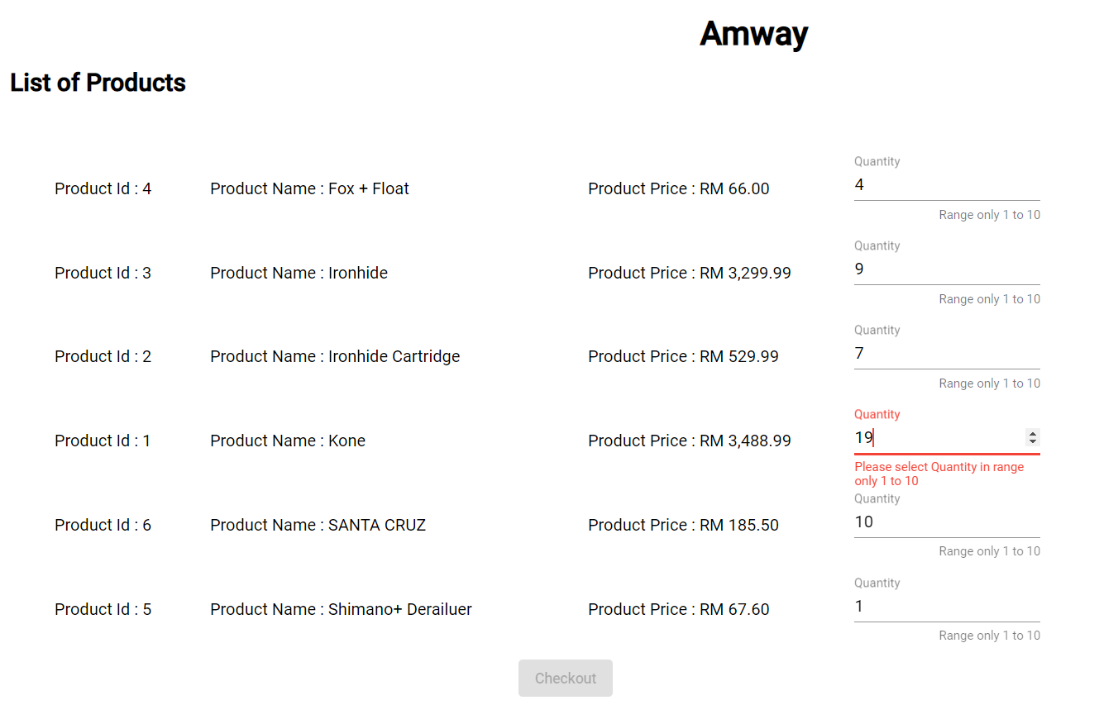

Figure :Test Case 1: Quantity Range- Value = 19

# Test Case 2: Total Value

### Total amount calculated according to the quantity given

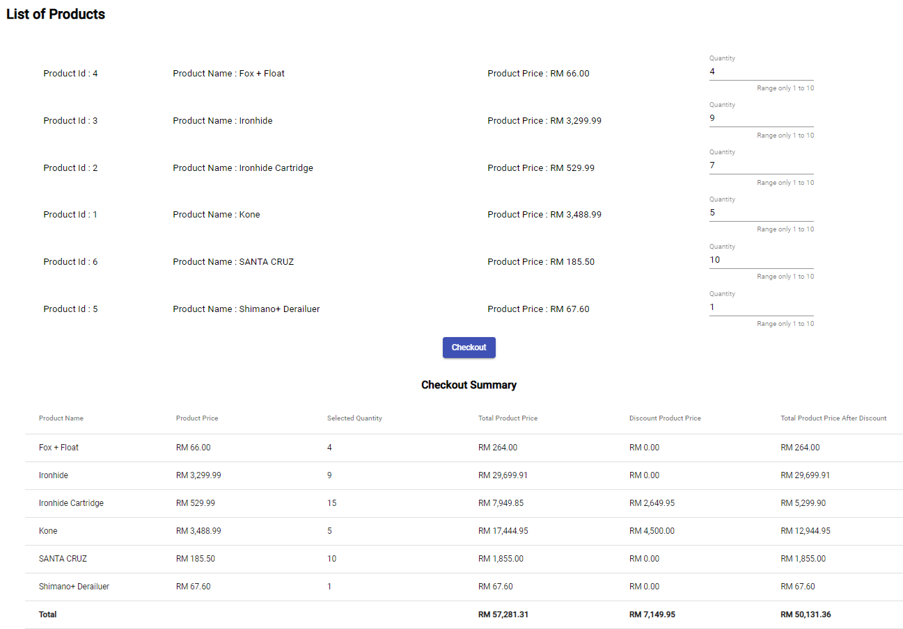

Figure :Total Value Calculation

# Test Case 3: Discounted Calculation

### Discount on product Kone: Quantity - 6

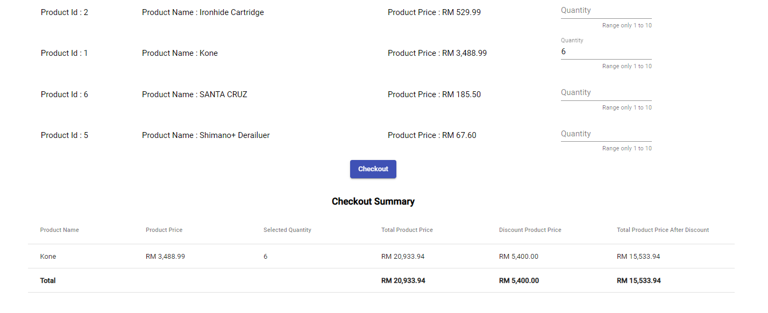

Figure :Test Case 3:Discount Kone: Qty - 6

### No Discount on product Kone: Quantity – 2

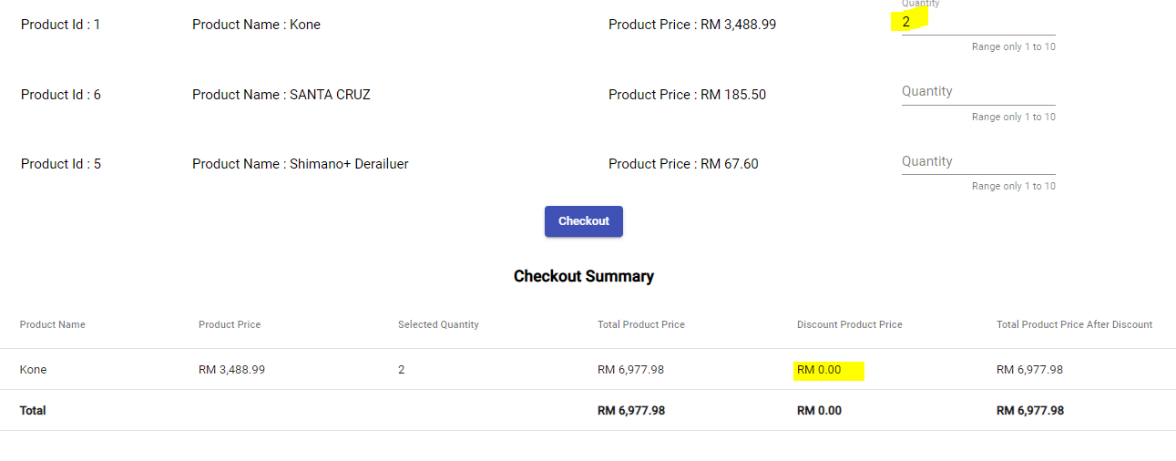

Figure :Test Case 3:Discount Kone: Qty – 2

# Test Case 4: Discount Calculation – Ironhide Cartridge

### No Discount on quantity - 1

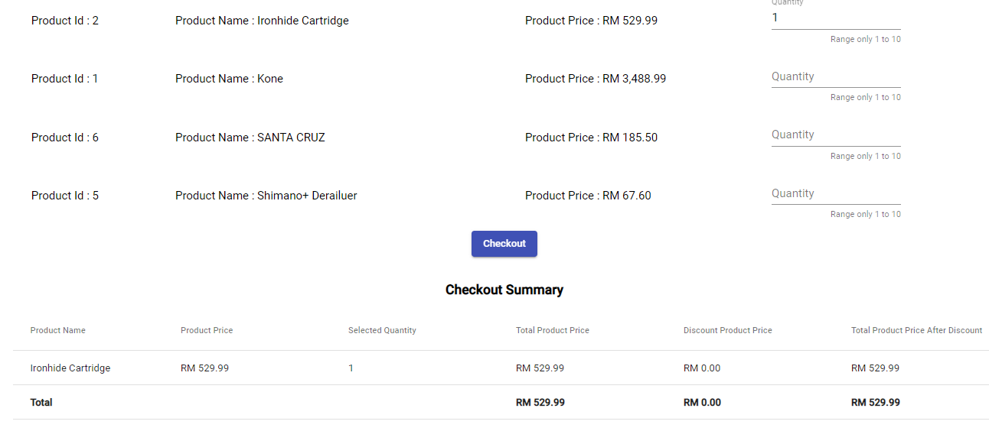

Figure :Test Case 4:Discount Ironhide Cartridge: Qty – 1

### Discount on quantity – 2

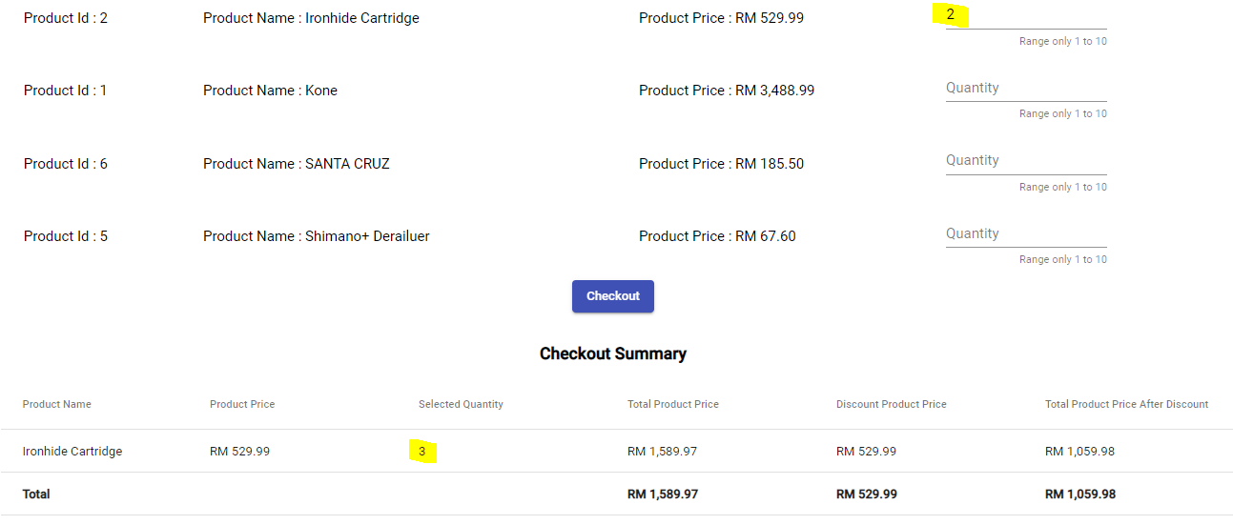

Figure :Test Case 4:Discount Ironhide Cartridge: Qty – 2

### Discount on quantity – 4

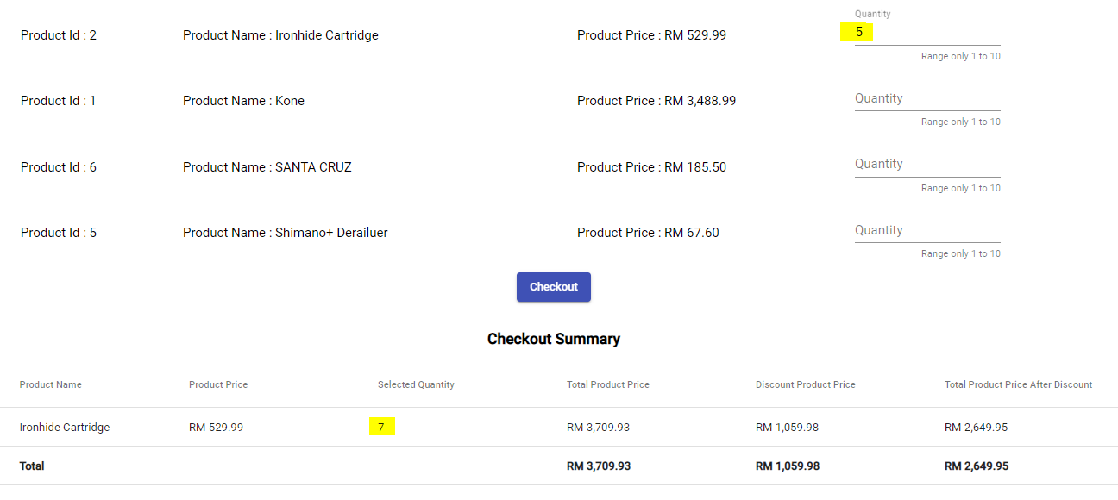

Figure :Test Case 4:Discount Ironhide Cartridge: Qty – 5