Itgalpura, Rajanakunte, Bengaluru - 560064

**School of Engineering**

A Project Report on

# “REAL TIME VEHICLE TRACKING SYSTEM”

Submitted in partial fulfillment of the requirement for the course

Innovative Projects using Raspberry Pi (**ECE2011**)

Submitted by   
 Group: IPR-151

|  |  |
| --- | --- |
| Student Name | Roll No |
| DERANGULA KIRANMAYEE | 20231CSE0090 |
| NAMRATHA | 20231CSE0085 |
| VENNAPUSA CHARITHA REDDY | 20231CSE0056 |
| KALLAMADI AKSHAY | 20231CSE0092 |
| BELLAM RAJENDRA | 20231CSE0044 |
| PEMMA GEETHA | 20231ECE0036 |

Under the supervision of

**Guide name: Dr.Bhavana A**

**Designation: Assistant professor**

**Department: Computer Science and Engineering**

DEC-2024

**Abstract :**

This research focuses on developing and implementing a robust real-time vehicle tracking system. The system leverages a combination of advanced technologies, including GPS (Global Positioning System) and IoT (Internet of Things) sensors, to accurately monitor the location and status of vehicles in real-time. The core functionality encompasses continuous vehicle position tracking, geofencing capabilities for defining virtual boundaries and triggering alerts upon breaches, and historical data logging for comprehensive analysis and reporting. The system offers a user-friendly interface accessible via a web application, enabling seamless monitoring and control. Key benefits include enhanced fleet management efficiency, improved security and safety, optimized route planning, and reduced operational costs. The system is designed with scalability and adaptability in mind, accommodating diverse fleet sizes and application requirements. Furthermore, the integration of data analytics and machine learning algorithms empowers users to gain valuable insights into vehicle behavior, identify potential risks, and make data-driven decisions to optimize operations and enhance overall fleet performance.

**Introduction:**

**Real-Time Vehicle Tracking Systems:** Real-time vehicle tracking systems (RTVTS) have revolutionized the way we monitor and manage vehicles across various industries. These sophisticated systems leverage cutting-edge technologies like GPS (Global Positioning System).

**Key Components of an RTVTS:**

**GPS Receiver:** This device receives signals from GPS satellites to determine the precise location (latitude and longitude) of the vehicle.

**Vehicle Unit:** This unit integrates the GPS receiver, GSM module, and other sensors (e.g., accelerometer, fuel level sensor) within the vehicle.

**User Interface:** A web or mobile application that allows users to access and visualize vehicle locations, track movement history, and generate reports.

**How RTVTS Works:**

**1. Location Tracking:** The GPS receiver in the vehicle unit continuously determines its location.

**2. Data Processing:** The central monitoring station receives and processes the data, updating the vehicle's position on the system map.

**3. User Access:** Authorized users can access the system via the user interface to view real-time location information, historical data, and generate reports.

**Benefits of RTVTS:**

**Enhanced Security:** Real-time tracking helps prevent theft and unauthorized vehicle use.

**Improved Fleet Management:** Optimize routes, reduce fuel consumption, and improve driver behavior.

**Increased Efficiency:** Streamline delivery operations, improve customer service, and enhance overall productivity.

**Cost Savings:** Reduce fuel costs, minimize vehicle downtime, and streamline maintenance schedules.

**Future Trends in RTVTS:**

**Integration with IOT:** Connecting vehicles to the Internet of Things (IOT) for enhanced data collection and analysis.

**Artificial Intelligence (AI) and Machine Learning:** Utilizing AI and ML for predictive maintenance, driver behavior analysis, and route optimization.

**Big Data Analytics:** Leveraging big data analytics to gain deeper insights into vehicle usage patterns and operational efficiency.

**Related Work:**

**1. Introduction**

Real-time vehicle tracking systems (RTVTS) have become an indispensable tool across various industries, including transportation, logistics, and fleet management. These systems leverage GPS technology and telematics to monitor the location, speed, and other vital parameters of vehicles in real-time. This paper provides a comprehensive review of related work on RTVTS, covering key technologies, applications, challenges, and future trends.

**2. Key Technologies**

**Global Positioning System (GPS):** GPS is the cornerstone of RTVTS, providing precise location data based on satellite signals.

**Telematics:** Telematics involves the integration of telecommunications and informatics to remotely monitor and control vehicles. It encompasses various technologies, including:

**Cellular Networks:** Enable real-time data transmission from the vehicle to a central server.

**On-Board Diagnostics (OBD-II):** Accesses vehicle data, such as engine performance and fuel consumption.

**Sensors:** Collect data on various parameters, including temperature, speed, acceleration, humidity, and pressure.

**Internet of Things (IOT):** IOT enables seamless connectivity between vehicles, infrastructure, and other devices, facilitating data exchange and remote control.

**Artificial Intelligence (AI) and Machine Learning (ML):** AI and ML algorithms can analyze vast amounts of data to optimize routes, predict maintenance needs, and improve overall fleet efficiency.

**3. Applications of RTVTS**

* **Fleet Management:**

**Route Optimization:** Optimizes delivery routes to minimize travel time and fuel consumption.

**Driver Behavior Monitoring:** Tracks driver behavior, such as speeding, harsh braking, and idling, to improve safety and reduce fuel costs.

**Vehicle Maintenance:** Predicts maintenance needs based on vehicle data, reducing downtime and maintenance costs.

**Logistics and Supply Chain Management:**

**Real-time Tracking of Shipments:** Monitors the location and status of shipments, ensuring timely delivery and improving customer satisfaction.

**Inventory Management:** Tracks inventory levels in real-time, optimizing stock levels and reducing inventory costs.

* **Emergency Services:**

**Dispatch Optimization:** This involves optimizing the dispatch of emergency vehicles, such as ambulances and fire trucks, to minimize response times.

**Asset Tracking:** Tracks the location of critical assets, such as medical equipment and rescue vehicles.

* **Personal Use:**

**Vehicle Recovery:** Helps locate stolen vehicles.

**Parental Control:** Monitors the location and driving behavior of young drivers.

**Emergency Assistance:** Provides automatic emergency assistance in case of accidents.

**4. Challenges and Limitations**

**Signal Interference:** GPS signals can be obstructed by tall buildings, tunnels, and dense foliage, leading to inaccurate location data.

**Data Security and Privacy:** Ensuring the security and privacy of sensitive vehicle and driver data is crucial.

**Cost:** The initial investment and ongoing maintenance costs of RTVTS can be significant.

**Battery Life:** The battery life of tracking devices can be a concern, especially for battery-powered devices.

**Integration with Existing Systems:** Integrating RTVTS with existing enterprise systems can be complex and time-consuming.

**5. Future Trends**

**Integration with Autonomous Vehicles:** RTVTS will play a crucial role in the development of autonomous vehicles, providing real-time location data and situational awareness.

**Advanced Analytics and Predictive Modeling:** The use of AI and ML will enable more sophisticated analysis of vehicle data, leading to improved decision-making and predictive maintenance.

**Edge Computing:** Processing data at the edge of the network will reduce latency and improve real-time responsiveness.

**Blockchain Technology:** Blockchain can be used to enhance data security and transparency in supply chain management.

**5G Connectivity:** 5G networks will provide faster and more reliable connectivity, enabling real-time, high-definition video streaming and other advanced applications.

**6. Conclusion**

RTVTS has revolutionized the way we manage vehicles and fleets, offering numerous benefits across various industries. As technology continues to evolve, we can expect to see even more innovative applications of RTVTS in the future. By addressing the challenges and embracing emerging trends, RTVTS will continue to play a vital role in improving efficiency, safety, and sustainability in the transportation sector.

**Implementation:**

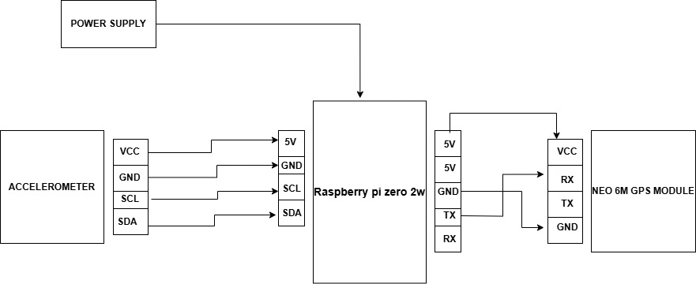

This block diagram represents a **vehicle tracking or motion-based monitoring system** using a **Raspberry Pi Zero 2W**, an **accelerometer**, and a **NEO-6M GPS module**. Let’s explore the detailed description of each component, the interfaces, and the communication protocols used in this setup.

## ****1. Power Supply****

* The power supply is critical to power the entire system.
* **Function**:
  + It provides a stable **5V power source** to the **Raspberry Pi Zero 2W**.
  + Once powered, the Raspberry Pi subsequently powers the connected peripherals (the accelerometer and GPS module) through its 5V pin.
* The **GND** (ground) pin is connected across all devices to ensure a common ground, which is necessary for stable communication and power delivery.

## ****2. Raspberry Pi Zero 2W****

The **Raspberry Pi Zero 2W** acts as the central processing unit (CPU) in this system. It is responsible for interfacing with the peripherals (accelerometer and GPS module), collecting data, and performing necessary computations. Below are its roles:

* **Power Distribution**:
  + The Raspberry Pi receives **5V** from the power supply and distributes it to the peripherals (accelerometer and GPS module).
* **Communication with Accelerometer**:
  + The accelerometer connects to the Raspberry Pi via the **I2C protocol**, using the following pins:
    - **SCL (Serial Clock Line):** A clock signal to synchronize data transmission.
    - **SDA (Serial Data Line):** Carries the data from the accelerometer to the Raspberry Pi.
* **Communication with the GPS Module**:
  + The **NEO-6M GPS module** communicates with the Raspberry Pi via the **UART protocol** (Universal Asynchronous Receiver/Transmitter):
    - **TX (Transmit):** Sends GPS data from the module to the Raspberry Pi.
    - **RX (Receive):** Allows the Raspberry Pi to send commands to the GPS module, if needed.

Thus, the Raspberry Pi serves as the intermediary that collects and processes data from both devices.

## ****3. Accelerometer****

The accelerometer is a sensor that detects motion, acceleration, and tilt in three axes (**X, Y, Z**). This is useful for tracking movement patterns or monitoring vibrations.

### ****Key Connections****:

* **VCC (Voltage):** Connects to the **5V pin** of the Raspberry Pi to receive power.
* **GND (Ground):** Connects to the common ground pin of the Raspberry Pi.
* **SCL (Clock Line):** Synchronizes data transmission between the accelerometer and Raspberry Pi.
* **SDA (Data Line):** Sends sensor data (motion values) to the Raspberry Pi.

## ****4. NEO-6M GPS Module****

The **NEO-6M GPS module** is a widely used GPS receiver that provides accurate location data (latitude, longitude, and altitude). It tracks signals from multiple satellites to determine the position of the system.

### ****Key Connections****:

* **VCC (Voltage):** Connects to the **5V pin** of the Raspberry Pi to receive power.
* **GND (Ground):** Connects to the common ground pin.
* **TX (Transmit Pin):** Sends GPS data from the module to the Raspberry Pi's **RX pin**.
* **RX (Receive Pin):** Allows commands to be sent to the GPS module (not always used here).

### ****Communication Protocol****:

The **UART (Universal Asynchronous Receiver/Transmitter)** protocol is used:

* UART is an **asynchronous communication protocol** that does not require a clock line.
* Data is sent as serial bits over the **TX** pin of the GPS module to the **RX** pin of the Raspberry Pi.

### ****Data Collected****:

* **Latitude** and **Longitude**: Provide the real-time geographic location.
* **Altitude**: Gives the elevation above sea level.
* **Time and Date**: Obtained from GPS satellites.
* **Speed** and **Direction**: Optional fields from the GPS signal.

This module is critical for real-time vehicle tracking or any other location-based project.

## ****Conclusion****

The block diagram showcases a powerful and compact setup combining a **Raspberry Pi Zero 2W** with an **accelerometer** and a **NEO-6M GPS module**. Each component plays a key role:

* The **Raspberry Pi Zero 2W** processes and manages data.
* The **accelerometer** monitors motion.
* The **NEO-6M GPS** module provides precise location data.

The seamless integration of **I2C** (for accelerometer) and **UART** (for GPS module) communication protocols makes this system reliable, efficient, and suitable for real-world applications like **real-time vehicle tracking** and **accident detection systems**.

**System requirement specifications:**

**Hardware Components**

**GPS Receiver:** This is the core component, responsible for receiving signals from GPS satellites to determine the vehicle's precise location (latitude, longitude, and altitude).

**Power Supply:** This can be a vehicle battery or a dedicated power source to keep the system running continuously.

**Antenna**: This ensures optimal reception of GPS and cellular signals.

**Sensors**: These can include an accelerometer(gyroscope) to provide additional information about the vehicle's status.

**Software Components**

**Embedded Software:**

GPS receiver

Processing GPS data

Formatting data for transmission

Managing power consumption

**Server-Side Software:** This runs on a central server and is responsible for:

Receiving and storing location data from vehicles

Processing and analyzing data

Providing a user interface for tracking and managing vehicles

**Mapping Software:** This is used to visualize vehicle locations on a map, often integrating with online mapping services like OpenStreetMap.

**User Interface:** This can be a web-based application that allows users to:

Track vehicles in real-time

View historical location data

Generate reports

**Popular Software and Platforms**

Google Maps API: For mapping and visualization

Telematics Platforms: These provide a comprehensive solution for fleet management, including real-time tracking, route optimization, and fuel monitoring. Examples include:

**Custom-built Software:** For businesses with specific needs, custom software development may be necessary to tailor the system to their requirements.

By combining these hardware and software components, real-time vehicle tracking systems provide valuable insights into vehicle movements, enabling businesses to optimize operations, improve safety, and enhance customer service.

**Results (Model’s image):**

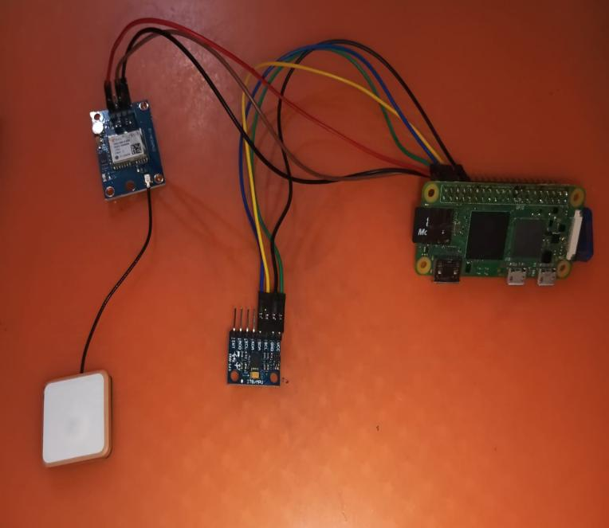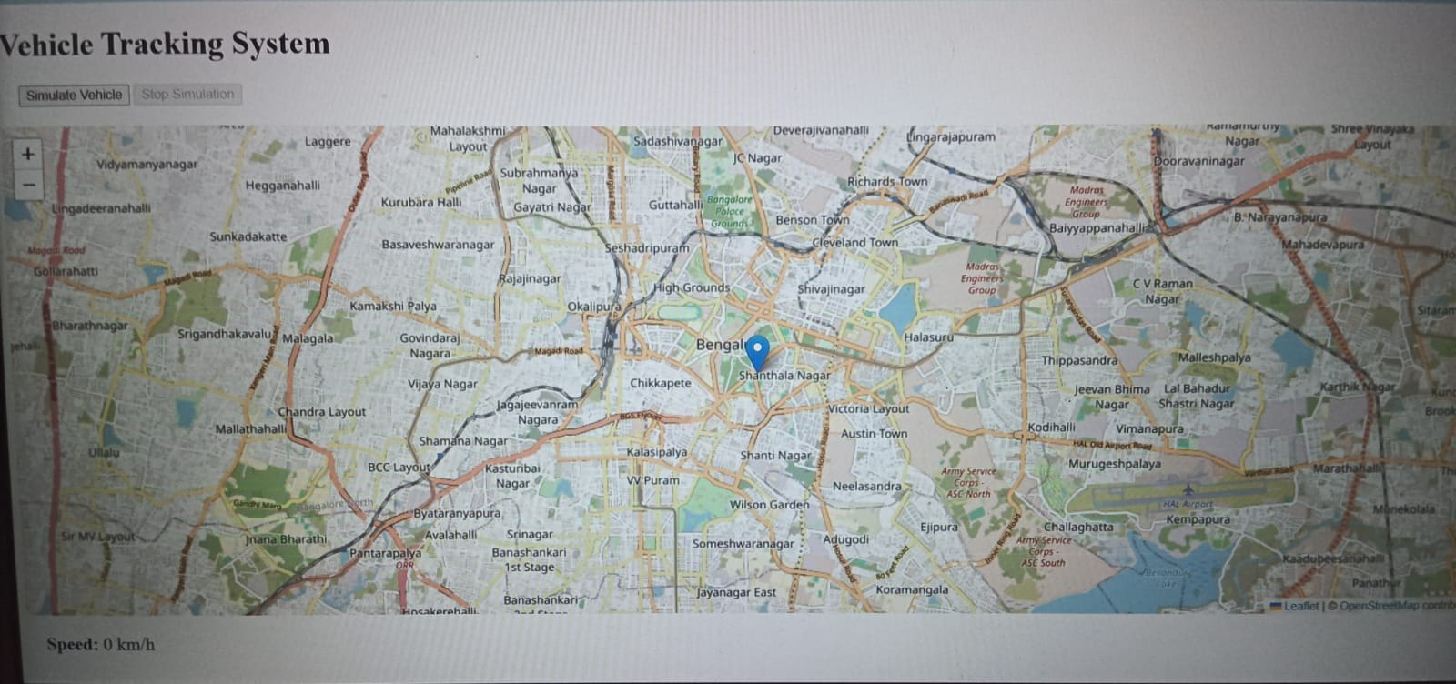

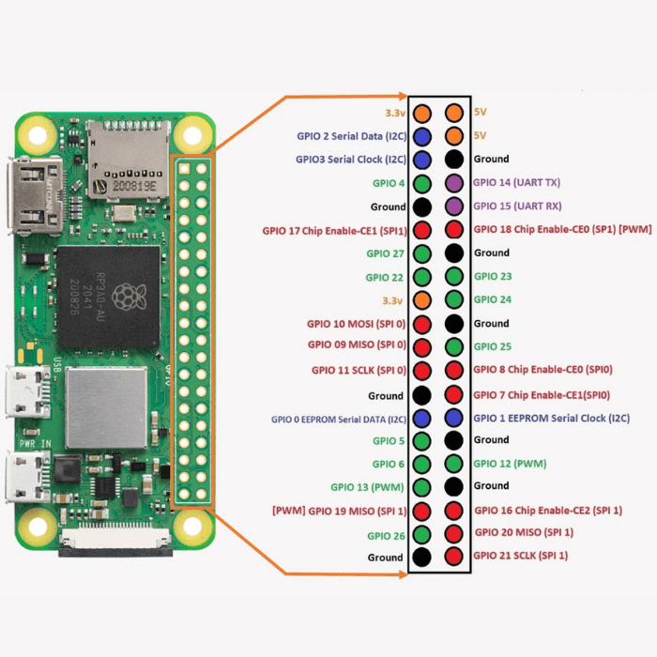

The **Real-Time Vehicle Tracking System** is an innovative model that combines **Raspberry Pi Zero 2W**, an **accelerometer**, and a **NEO-6M GPS module** to monitor and track vehicle location and movement in real time. The Raspberry Pi acts as the central controller, managing data collection and processing. The accelerometer detects the vehicle's **movement**, acceleration, and tilt in three axes (X, Y, Z), which helps in identifying sudden stops, vibrations, or deviations, potentially signaling accidents or abnormal behavior. Simultaneously, the GPS module retrieves **accurate location data** such as latitude, longitude, speed, and altitude using satellite signals. These readings allow the system to provide precise location tracking, enabling real-time monitoring of vehicles across remote locations.

This system is ideal for **fleet management**, public transportation, logistics, and vehicle safety applications. By integrating data from the accelerometer and GPS module, the model ensures accurate tracking while also monitoring movement dynamics for enhanced safety analysis. The collected information can be displayed on a **web interface** or **centralized database** where administrators or users can view the live location of the vehicle on a map. Additional functionalities like accident detection, path logging, and alerts can also be implemented to notify concerned parties of critical events, making the system robust and scalable for smart vehicle management solutions.

**Conclusion:**

The implementation of real-time vehicle tracking systems represents a transformative advancement in transportation management, logistics, and personal vehicle security. By leveraging technologies such as GPS and IOT, these systems provide a seamless and accurate means of monitoring vehicle locations in real time, enabling businesses and individuals to make informed decisions and improve operational efficiency. Their impact extends across various sectors, including logistics, public transportation, emergency response, and personal asset protection.

One of the most significant benefits of real-time vehicle tracking lies in its ability to streamline fleet operations. For businesses, this system enables precise route optimization, leading to reduced travel times, lower fuel consumption, and minimized maintenance costs. Furthermore, real-time data facilitates better planning and scheduling, which helps improve customer satisfaction through timely deliveries and enhanced service reliability. These efficiencies contribute to cost savings and increased profitability for organizations, making the technology a valuable investment.

In terms of security, real-time tracking systems offer robust solutions against vehicle theft and unauthorized usage. Features such as geofencing and instant alerts ensure that vehicle owners or fleet managers can respond immediately to any breaches or anomalies. Moreover, these systems are instrumental in emergency situations. For instance, when an accident or breakdown occurs, precise location tracking enables faster assistance from rescue or repair teams, reducing potential risks and downtime.

On a personal level, real-time vehicle tracking has become a tool for ensuring safety and convenience. Parents can monitor school buses to confirm their children’s safe arrivals and departures, while individuals can track personal vehicles for added peace of mind. The technology also encourages eco-friendly practices by reducing idle times, optimizing routes, and minimizing emissions, aligning with global sustainability goals.

However, the adoption of real-time vehicle tracking systems is not without challenges. The initial costs of installation and maintenance can be significant, particularly for small businesses or individual users. Additionally, concerns about data privacy and security must be addressed to ensure that sensitive location information is not misused. Dependence on reliable internet connectivity may also pose limitations in remote or underdeveloped areas. These challenges highlight the importance of continued innovation, investment in infrastructure, and the development of robust data protection measures to enhance system reliability and trust.

In conclusion, real-time vehicle tracking systems are pivotal in shaping the future of transportation and logistics. Their ability to deliver real-time insights, enhance security, and promote efficiency makes them an essential tool for individuals and businesses alike. As technology continues to evolve, the potential of these systems to create smarter, safer, and more sustainable transportation networks will only expand. Embracing these advancements ensures not only operational success but also a step toward a more connected and efficient world.

窗体顶端

**References:** Add 20 References, this must be cited in the text

* **Tutorials for Real-Time Vehicle Tracking:**

[**https://youtu.be/OWP3D-51vIc?feature=shared**](https://youtu.be/OWP3D-51vIc?feature=shared)

* **Tools and Visualization:**

1. OpenStreet Map

### ****Research Papers and Case Studies****

### **A Real-Time Vehicle Tracking System Using Raspberry Pi and GPS**: Research work that explores GPS-based vehicle tracking and mapping. <https://ieeexplore.ieee.org/document/8466801>

### ****Official OpenStreetMap Website****: Start exploring OpenStreetMap, understand its capabilities, and access the free world map data. <https://www.openstreetmap.org>

### ****Python Libraries for OpenStreetMap****

**OSMnx**:  
A Python library for retrieving, modeling, analyzing, and visualizing OpenStreetMap data. It’s ideal for working with street maps.

* + Installation: pip install osmnx
  + Documentation: <https://osmnx.readthedocs.io/>

**Geopy**:  
A Python library for geocoding, reverse geocoding, and calculating distances using OpenStreetMap services (like Nominatim).

* + Installation: pip install geopy
  + Documentation: <https://geopy.readthedocs.io>

**Official Site**: <https://www.openstreetmap.org>