PBJ Documentation

Step 1: Get all the ingredients required for PBJ sandwich:

* A clean flat food production surface like a cutting board.
* Peanut butter
* Jelly/Jam
* Bread of your choice e.g. white, whole wheat, honey wheat etc.
* Two clean butter knives.

Step 2: Open the desired bread packet and take out two slices of bread and place it side by side horizontally on the flat surface as shown in the picture below.

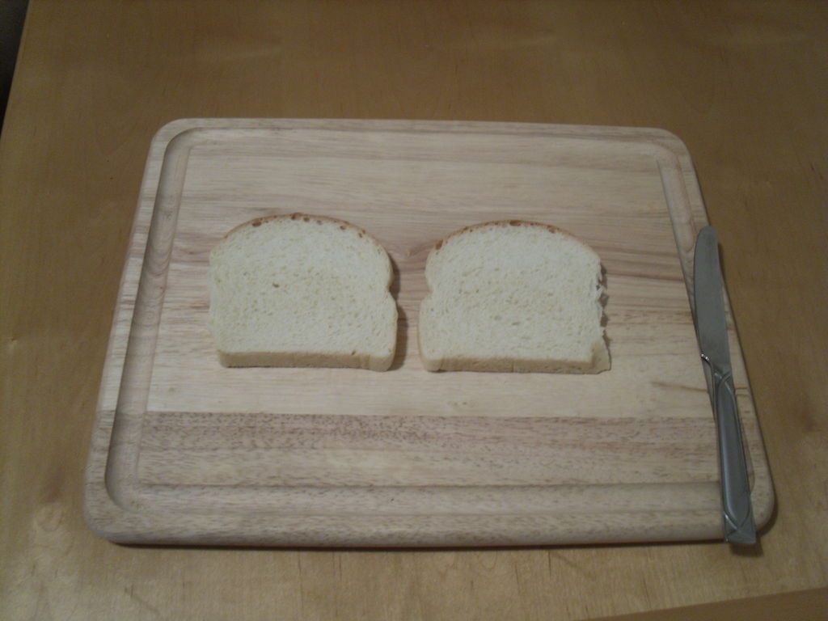

Figure 1: Laying out bread.

Step 3: Open the peanut butter bottle and scoop a dollop of butter using the butter knife. Apply this peanut butter evenly on the upper face of both the bread slices and spread it to form a uniform coating on the bread. Apply the desired amount of peanut butter. Applying peanut butter on both the slices will prevent the sandwich from becoming soggy when jam is applied.

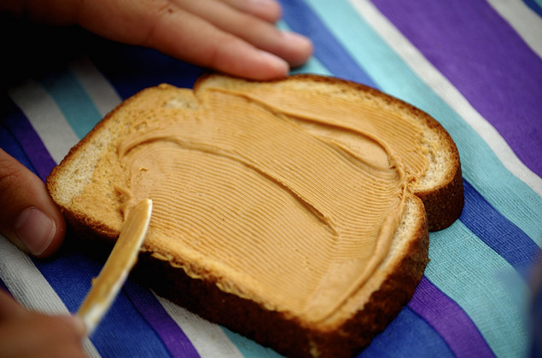

Figure 2: Applying peanut butter.

Step 4: Using the other unused butter knife scoop a dollop of jelly from the jelly bottle and spread it evenly on top of the peanut butter layer only on one of the bread slices. Apply the desired amount of jam.

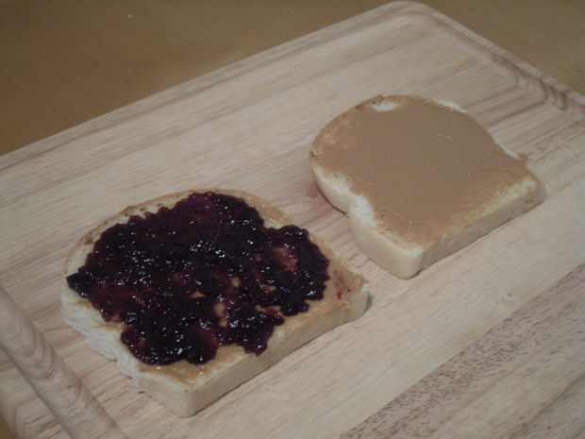

Figure 3: Applying Jam on peanut butter.

Step 5:

* Pick up the bread slice not containing the jelly and flip it over on top of the other slice. PBJ sandwich is ready with peanut butter on top and bottom and jam in the center.

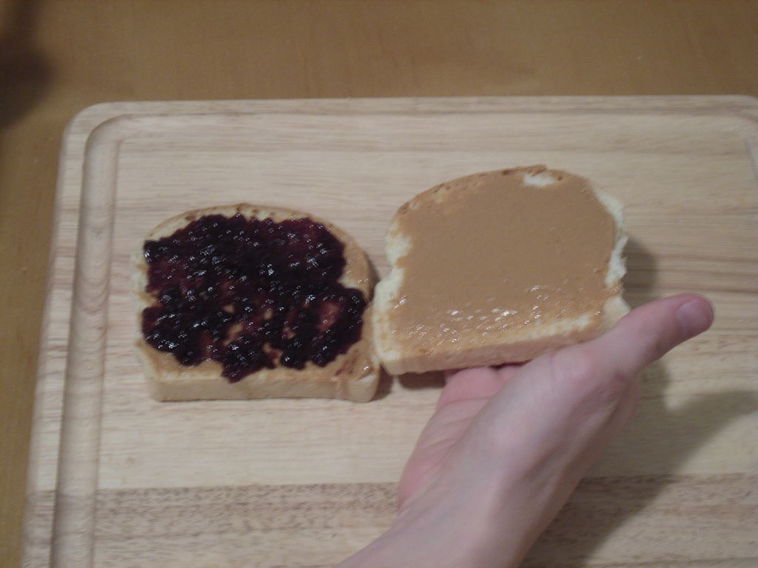

Figure 4: Combining both the slices.

* If you want to have the sandwich grilled, then apply some plain butter on both the outer sides on the sandwich and place it on the grill till it gets grilled properly on both sides. Grilled PBJ sandwich is ready.

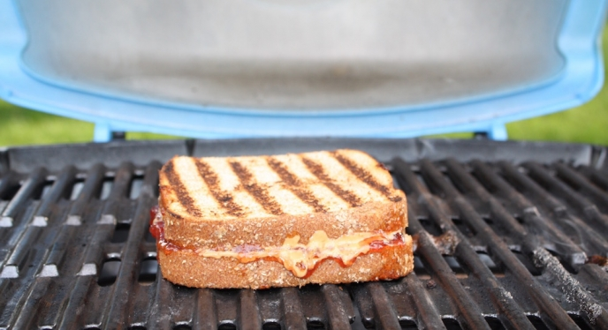

Figure 5: Grilled Peanut Butter Jelly sandwich.

Flowchart for making a PBJ sandwich

Get all the ingredients and tools required for making a PBJ sandwich.

Remove two slices of bread and lay them horizontally side by side on the clean surface.

Open the peanut butter bottle and scoop a dollop of butter using the butter knife. Apply this peanut butter evenly on the upper face of both the bread slices and spread it to form a uniform coating on the bread.

Using the other unused butter knife scoop a dollop of jelly from the jelly bottle and spread it evenly on top of the peanut butter layer only on one of the bread slices.

Pick up the bread slice not containing the jelly and flip it over on top of the other slice

Apply some plain butter on both the outer sides on the sandwich and place it on the grill till it gets grilled properly on both sides.

If you want Yes

the sandwich grilled?

No

PBJ sandwich is Ready!!

References

Figure 1: Kzavoral. Kzavoral in sandwiches. Retrieved on October 27, 2016 from [www.instructables.com](http://www.instructables.com), <http://www.instructables.com/id/How-To-Make-a-Perfect-Peanut-Butter-and-Jelly-Sand/step2/Prepare-the-Bread/>

Figure 2: Rachel. Rachel’s blog. Retrieved on October 27, 2016 from <https://www.google.com/search?rlz=1C1CHZL_enUS709US709&biw=1366&bih=613&tbm=isch&sa=1&q=applying+peanut+butter+on+top+of+bread&oq=applying+peanut+butter+on+top+of+bread&gs_l=img.3...55815.58095.0.58677.0.0.0.0.0.0.0.0..0.0....0...1c.1.64.img..0.0.0.mBq6Ads7v6s#imgrc=gH92vduCxMLogM%3A>

Figure 3: Kzavoral. Kzavoral in sandwiches. Retrieved on October 27, 2016 from [www.instructables.com](http://www.instructables.com), <http://www.instructables.com/id/How-To-Make-a-Perfect-Peanut-Butter-and-Jelly-Sand/step4/Apply-Jelly/>

Figure 4: Kzavoral. Kzavoral in sandwiches. Retrieved on October 27, 2016 from [www.instructables.com](http://www.instructables.com), <http://www.instructables.com/id/How-To-Make-a-Perfect-Peanut-Butter-and-Jelly-Sand/step5/Combine-Both-Slices-of-Bread/>

Figure 5: Peanut butter & Jelly grilled. Retrieved on October 27, 2016 from <https://www.google.com/search?rlz=1C1CHZL_enUS709US709&biw=1366&bih=613&tbm=isch&sa=1&q=peanut+butter+jelly+sandwich+on+a+grill&oq=peanut+butter+jelly+sandwich+on+a+grill&gs_l=img.3...242310.244946.0.245165.0.0.0.0.0.0.0.0..0.0....0...1c.1.64.img..0.0.0.OG4MHv4ehOE#imgrc=gQ8ST0E-HD3PQM%3A>

Word count: 451