YENEPOYA INSTITUTE OF ARTS, SCIENCE, COMMERCE AND MANAGEMENT
Project – Final Project Report on
End-to-End Encryption for Retail Cloud Apps

Student Name: Namruth V I Register Number: 23BCCE123
Course: BCA in Cloud Computing, Cyber Security & Ethical Hacking with IBM

Industry Mentor: Mr. Shashank Guided by: Ms. Vijayalaxmi

Section | Title | Page
 | Executive Summary | 1
1 | BACKGROUND | 2
1.1 | Aim | 2
1.2 | Technologies Used | 3–4
1.3 | Hardware Architecture C Network Setup | 4–5
1.4 | Software Architecture C Framework | 6–7
2 | SYSTEM | 8
2.1 | Requirements Specification | 8–14
2.1.1 | Functional Requirements | 8–10
2.1.2 | User Requirements | 10–12
2.1.3 |  | 12–14
2.2 | System Design C Architecture | 15–20
2.3 | Implementation (Flask + Fernet + Database) | 21–25
2.4 | Testing C Validation | 26–28
2.5 | Graphical User Interface (GUI) | 29–31
2.6 |  | 32–33
2.7 | Evaluation | 34–35
3 | PROJECT SNAPSHOTS (UI s OUTPUT SCREENS) | 36–41
4 | CONCLUSION | 42–43
5 | FUTURE DEVELOPMENT | 44–47
6 | REFERENCES | 48
7 | APPENDIX | 49
7.1 | Sample Encrypted Messages | 49–50
7.2 | Database Schema C Tables | 51
7.3 | System Output Screens | 52–53

7.4 | Glossary of Terms | 54–56

Executive Summary

SecureRetail is a web-based end-to-end encrypted (E2EE) communication platform designed specifically for retail cloud environments. In retail operations – inventory management, supplier negotiations, customer payment details, and employee schedules – sensitive data is frequently exchanged. Traditional messaging systems often store this information in plaintext, exposing it to database breaches or insider threats.

SecureRetail solves this by encrypting every message using Fernet (AES-128 in CBC mode) before storing it in an SQLite database. Even if the database is compromised, no plaintext is revealed. The system also provides HMAC-SHA256 integrity verification, role-based access (admin, cashier, customer support), TOTP two-factor authentication, encrypted file uploads, key rotation, and a full audit log with cryptographic integrity. All passwords are hashed with PBKDF2-SHA256 (200,000 iterations) and unique salts.
The frontend features an immersive 3D cyberpunk terminal interface with real-time polling. Testing confirms that no plaintext ever resides in the database, tampered messages are detected, and unauthorised access is blocked and logged. SecureRetail demonstrates how modern cryptography can be practically deployed in a lightweight cloud application suitable for retail businesses of all sizes.

BACKGROUND

Aim
The main aim of this project is to develop a secure messaging system for retailing environments, where communication between workers plays a critical role in daily operations.
In a retailing unit, important information such as machine status, quality inspection results, and maintenance alerts is shared frequently. If this data is accessed by unauthorized users, it can lead to serious operational issues or data leakage.
To solve this problem, the system ensures that every message is encrypted before it is
stored or transmitted. Only the intended sender and receiver can view the original message by using a secret key.
Additionally, the system implements role-based access control, where different users such as Admin, Operator, QC Inspector, and Maintenance staff have different permissions based on their responsibilities. This ensures that users can only access information relevant to their role.

Technologies Used
The development of SecureRetail involves a combination of backend, frontend, and security technologies that work together to deliver a secure and efficient messaging system. Each technology plays a specific role in ensuring the functionality, security, and usability of the application.
The backend of the system is developed using Python, which provides a strong and flexible programming environment for handling application logic. Flask is used as the web framework to manage routing, handle user requests, and connect the frontend with the backend services.
To ensure data security, the system uses the Fernet encryption algorithm, which provides symmetric encryption for protecting sensitive messages. This ensures that all

messages are securely encrypted before being stored and can only be decrypted by authorized users.
For data storage, SQLite3 is used as a lightweight and efficient database solution. It stores user credentials, encrypted messages, and system logs in a structured format.
The frontend of the application is built using HTML5, CSS3, and JavaScript. HTML5 defines the structure of the web pages, CSS3 enhances the visual appearance, and JavaScript enables dynamic interaction between the user and the system.

Technology Stack Overview

Technology | What it does in simple words
Python | The main language used to write the backend logic
Flask | A tool that helps create website addresses like /login or /send
Fernet | A lock that scrambles messages so only the right key can open them
SQLite3 | A small database that stores all users and messages
HTML5 | Creates the structure of web pages like boxes and buttons
CSS3 | Adds colors, fonts, and makes the page look nice
JavaScript | Makes buttons work and sends data without reloading the page

Hardware Architecture & Network Setup
The project follows a client-server architecture, where a central server manages all operations and multiple client devices access the system through a network. This architecture ensures better control, improved security, and efficient communication within the retailing environment.
The server acts as the main processing unit of the system. It runs the backend application and handles tasks such as user authentication, message encryption, decryption, and database operations. All data is processed and stored securely on the server.
The client devices are used by different users such as Admin, Operator, QC Inspector, and Maintenance staff. These devices access the system using a web browser, making the application easy to use and accessible from different platforms without requiring installation.
The network connects the server and client devices. This can be implemented using a Local Area Network (LAN), Wi-Fi, or Ethernet connection. A stable network ensures smooth data transmission between users and the server.
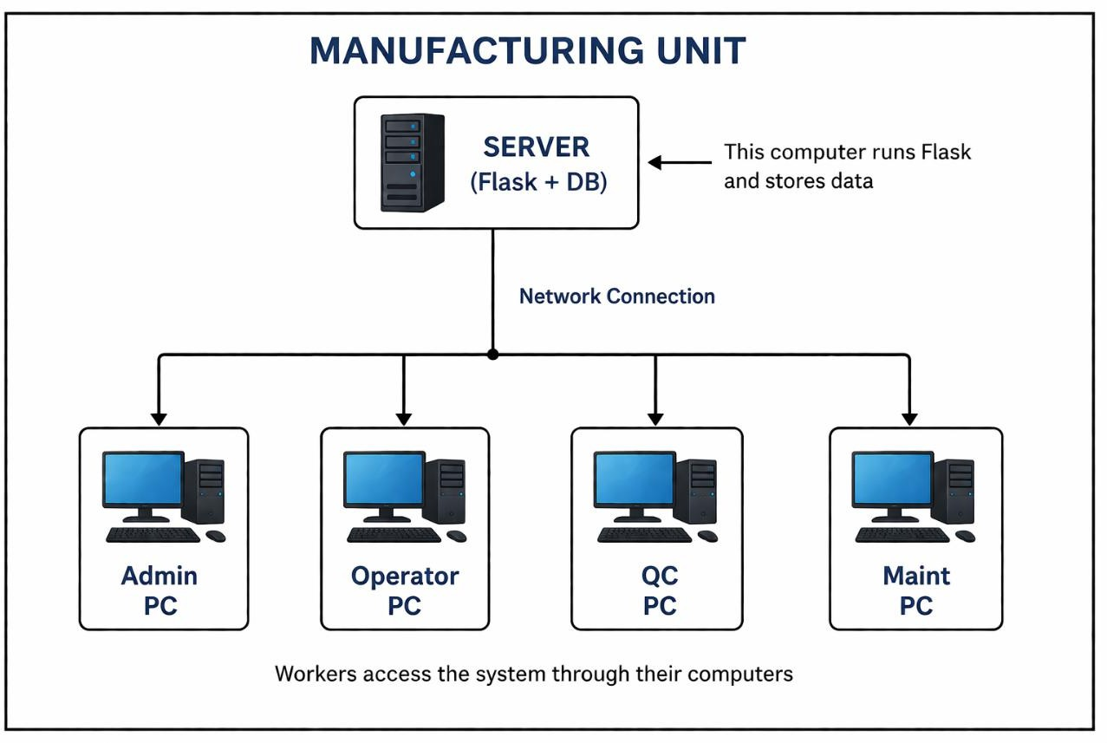
Fig 1: retailing Unit Network Architecture

Software Architecture & Framework
The project is designed using a three-layer architecture, which separates the system into different levels based on functionality. This structure improves system organization, maintainability, and scalability.
Each layer has a specific role and communicates with other layers to perform the complete operation.
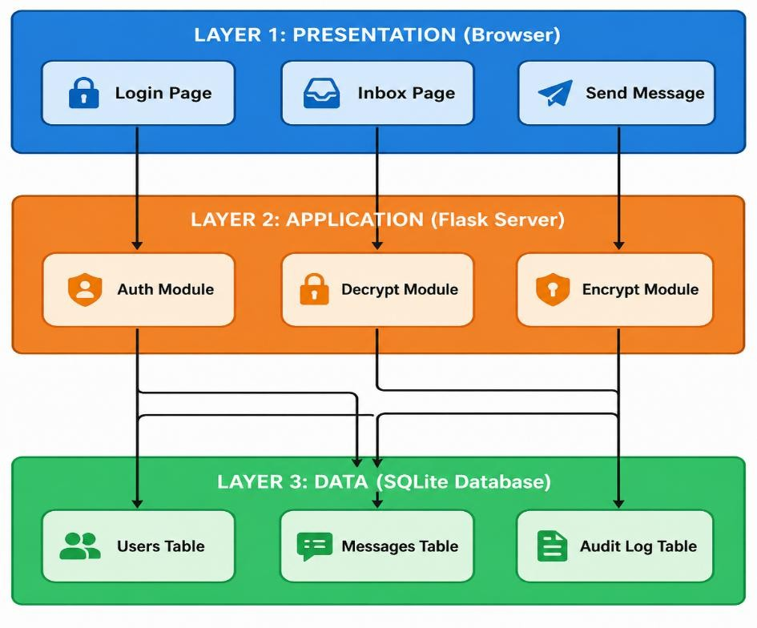

Fig 2: Three-Tier Architecture of Secure Messaging System

Layer Description

- Presentation Layer (Frontend)

This layer is responsible for user interaction. It includes web pages such as login forms, dashboards, and message interfaces. Users perform actions like sending messages or viewing data through this layer.

Application Layer (Backend)

This layer acts as the core of the system. It processes user requests, validates input, performs encryption and decryption, and enforces access control. It ensures that only authorized users can perform specific actions.

Data Layer (Database)

This layer stores all system data, including user details, messages, and logs. All sensitive messages are stored in encrypted format to maintain confidentiality.

SYSTEM

Requirements
    - Functional Requirements
Functional requirements describe the essential features and operations that the system must perform. In this secure messaging system for the retailing unit, these requirements define how users interact with the system, how data is processed, and how security is maintained through authentication, encryption, and controlled access.
These requirements ensure that only authorized personnel can access the system, all communications remain encrypted, and all activities are properly monitored.

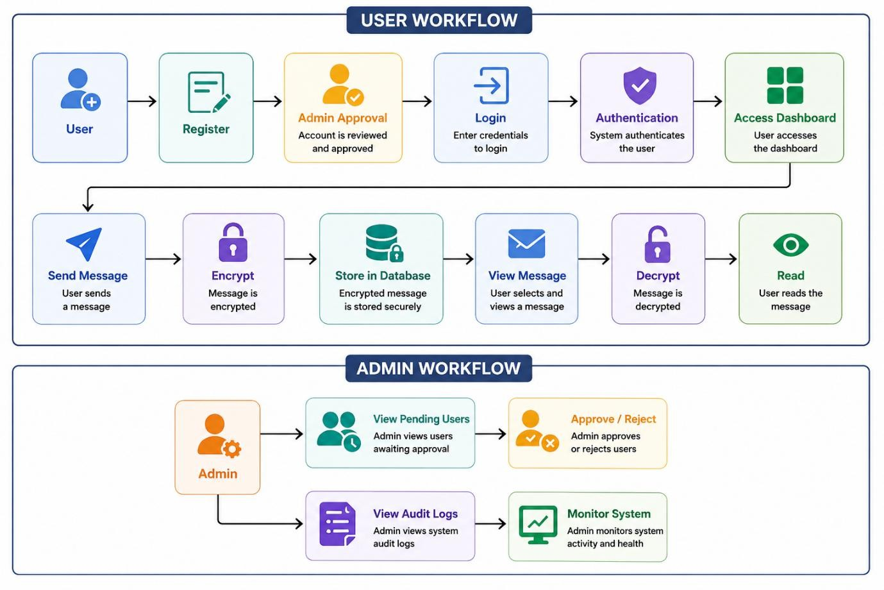

Fig 3: Functional Workflow of Secure Messaging System

The functional workflow diagram illustrates how users interact with the system. A user first registers and waits for admin approval. After successful login and authentication, the user can

send encrypted messages or view received messages by decrypting them. The admin manages user approvals and monitors system activity through audit logs.

Functional Requirements Table

ID | Requirement | What it means for the retailing unit
FR-01 | New users can register with full name, username, password, and role | A new worker joining the factory can create their own account
FR-02 | Passwords are hashed using SHA-256 before storing | Even if someone sees the database, they cannot know the actual password
FR-03 | New accounts are saved with status "pending" | A new worker cannot login until the supervisor approves
FR-04 | Admin can view all pending user registrations | Supervisor can see a list of all workers waiting for approval
FR-05 | Admin can approve or reject pending users | Supervisor can allow or deny access to any worker
FR-06 | Users can login with username and password | Workers can access the system using their credentials
FR-07 | System checks account status during login | If a worker is not approved, they cannot login
FR-08 | System creates a session after successful login | The system remembers the worker is logged in
FR-09 | Session ends on logout or after 30 minutes of no activity | If a worker forgets to logout, the system logs them out automatically
FR-10 | Every message is encrypted using Fernet before storage | A production alert becomes unreadable to outsiders
FR-11 | Plaintext messages are never stored in the database | Database only contains encrypted data
FR-12 | Users can send encrypted messages to other users | Operator can send a message to QC about batch quality
FR-13 | Users can select priority level for each message | Critical issues marked high priority

FR-14 | System shows messages where user is sender or receiver | Workers only see relevant messages
FR-15 | Users can click on a message to decrypt and read it | Encrypted message becomes readable on request
FR-16 | System checks authorization before decrypting | Unauthorized users cannot access messages
FR-17 | Messages are marked as read after decryption | Opened messages are tracked
FR-18 | Unread message count shows in the sidebar | Workers can easily track new messages
FR-19 | Dashboard shows statistics like total and unread messages | Quick overview of system activity
FR-20 | All important actions are logged in audit log | Every action is recorded for security
FR-21 | Every login attempt is recorded with timestamp | Admin can track login activity
FR-22 | Admin can view complete audit log history | Helps in monitoring and investigation
FR-23 | Admin can delete all messages from database | Used for system maintenance
FR-24 | Machine status page shows all equipment | Workers can monitor machine availability

User Requirements

Definition:
User requirements describe what different users (Admin, Operator, QC Inspector, and Maintenance staff) expect from the system and the actions they are allowed to perform based on their roles.

User Roles in retailing Unit

Role | Who they are | What they do in the factory
Admin | Plant Supervisor / IT Manager | Manages users and monitors system activity
Cashier | Machine Operators | Operates machines and sends production updates
user | Quality Control Staff | Checks product quality at QC stations
Customer support | Repair Engineers | Handles machine breakdown and maintenance

User Requirements Table

ID | User | What they can do
UR-01 | All users | Login, logout, and access dashboard with message statistics
UR-02 | All users | Send encrypted messages with receiver selection and priority
UR-03 | All users | View, filter, and decrypt messages in inbox
UR-04 | All users | View machine status information
UR-05 | New users | Register account and wait for admin approval
UR-06 | Admin | Approve/reject users and manage access
UR-07 | Admin | View audit logs and monitor system activity
UR-08 | Admin | Delete messages for system maintenance
UR-09 | Operator | Access machine-related information (Machine A, B, C)
UR-10 | QC Inspector | Access quality control station data
UR-11 | Maintenance | Access maintenance and repair information

Environmental Requirements

Definition:
Environmental requirements specify the hardware, software, and network conditions needed for the system to function properly in the retailing unit.

Hardware Requirements

Component | Minimum Needed | Recommended
Server Computer | Dual Core processor, 4GB RAM | Quad Core processor, 8GB RAM
Server Storage | 10GB free space | 20GB free space
Worker Computer | Any computer with web browser | Core i3 or better
Network Speed | 10 Mbps connection | 100 Mbps or faster

Software Requirements

Component | What is required
Server OS | Windows 10, Linux Ubuntu, or macOS
Python Version | 3.10 or higher
Web Browser | Chrome, Firefox, Edge, or Safari
Database | SQLite3 (built-in with Python)
Flask | Version 2.3.0
Cryptography | Version 41.0.0

Network Requirements

Requirement | Explanation
Server IP Address | Fixed IP so workers can always access the server
Network Port | Port 5000 must be open on server firewall
Worker Access | All worker computers must connect to server
Production Security | HTTPS with SSL certificate for secure communication

Design Blueprint & Architecture
The design of the Secure Messaging System for the retailing unit follows a modular and layered architecture. The system is divided into multiple components, where each module performs a specific function such as user authentication, message encryption, data storage, and user interface display.
The process begins when a user accesses the system through a web browser and logs in using their credentials. The Flask server handles authentication by verifying the username and password. If the user is approved, access to the dashboard is granted.
When a user sends a message, the system encrypts the message using the Fernet encryption algorithm before storing it in the database. This ensures that all sensitive information remains secure.
When another user views the message, the system checks authorization and decrypts the message only if the user has permission. All activities such as login, message sending, and decryption are recorded in the audit log.
The SQLite database stores user data, messages, and logs, while the Flask backend processes requests and communicates with the frontend interface.
This modular design ensures security, scalability, and efficient communication within the retailing unit

System Components Table

Component | Function
User Interface (Browser) | Allows users to interact with system
Flask Backend | Handles requests and application logic
Authentication Module | Verifies user login and access
Encryption Module | Encrypts messages before storage
Decryption Module | Decrypts messages for authorized users
SQLite Database | Stores users, messages, and logs
Audit Log System | Tracks all system activities

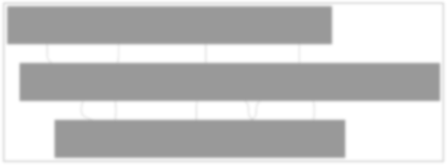
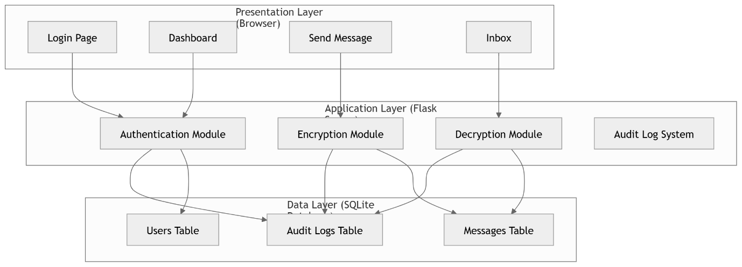

Fig: Design Blueprint & Architecture

    - Use Case Diagram
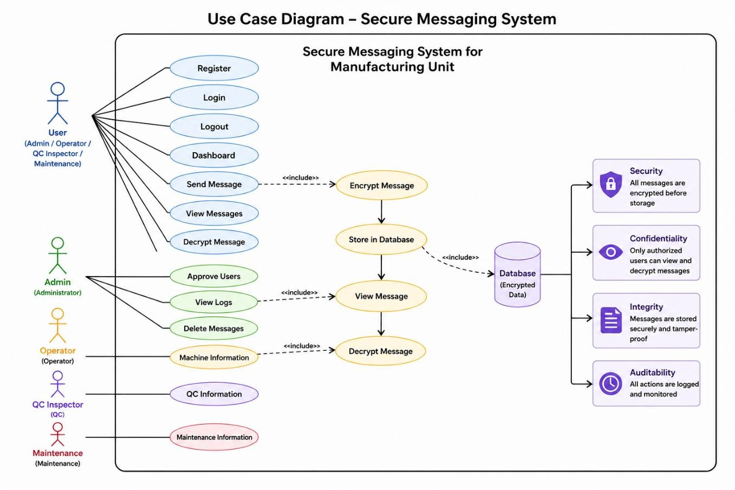

Fig: Use Case Diagram of Secure Messaging System

The use case diagram represents the interaction between different users and the system. All users can perform basic actions such as login, sending messages, and viewing messages. The admin has additional privileges like approving users, viewing audit logs, and deleting messages. Role-specific users such as operators, QC inspectors, and maintenance staff can access information relevant to their duties. This diagram highlights role-based access control and system functionalities.

Sequence Diagram
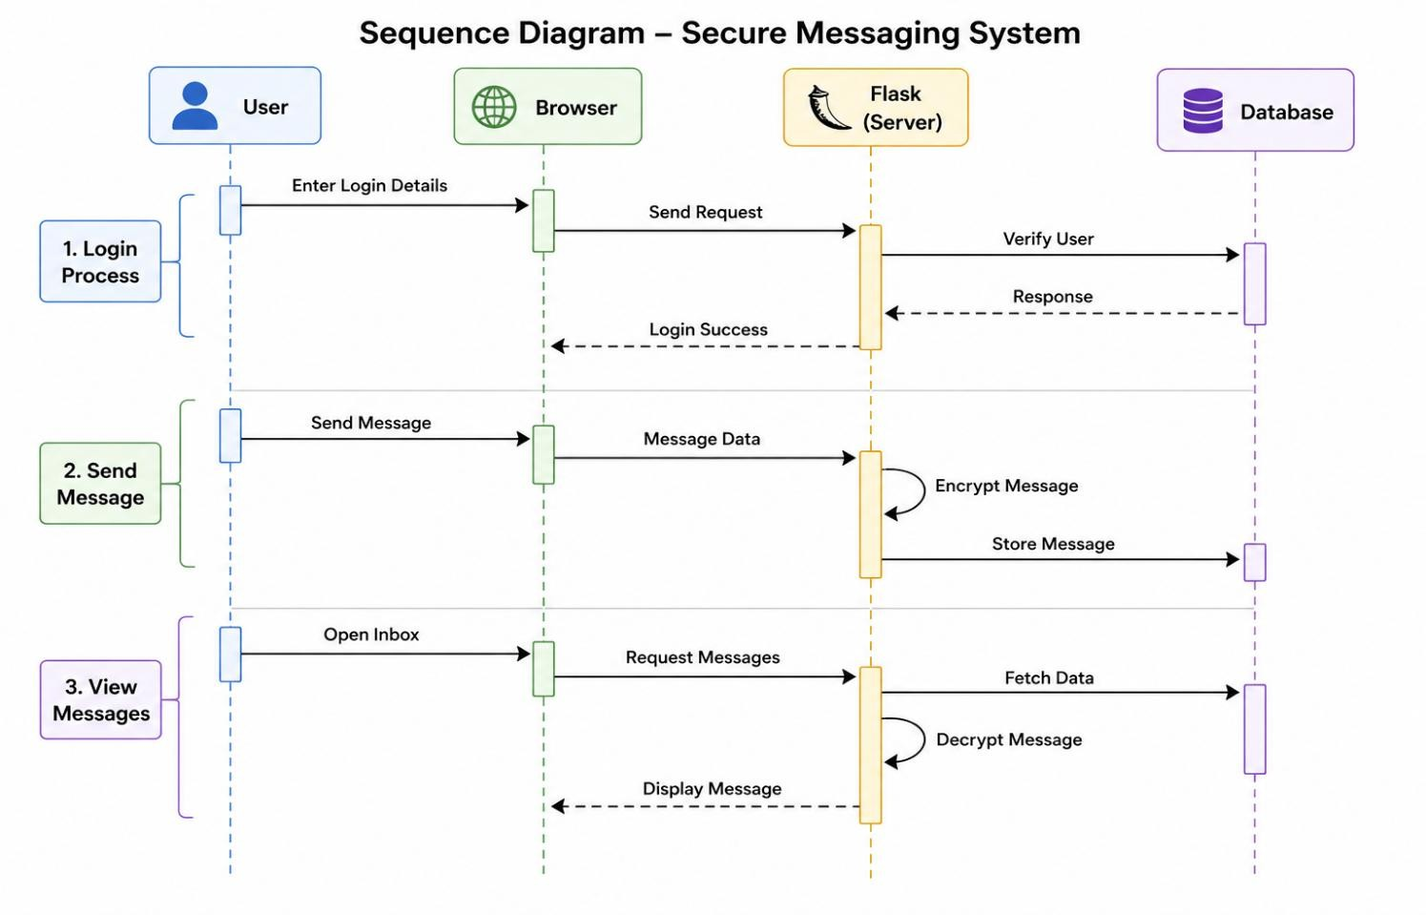

Fig: Sequence Diagram of Secure Messaging System

The sequence diagram illustrates the step-by-step flow of operations in the system. A user first logs in, and the request is verified by the server using the database. After successful login, the user can send a message, which is encrypted before being stored. When the user views a message, the system retrieves it from the database, decrypts it, and displays it. This diagram clearly shows the interaction between the user, browser, server, and database over time.

Class Diagram

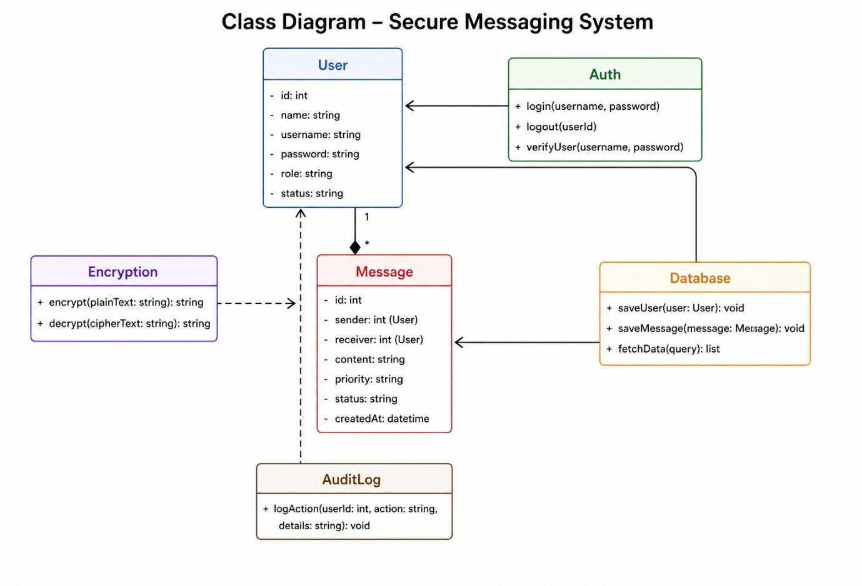

Fig: Class Diagram of Secure Messaging System

The class diagram represents the structure of the system by showing different classes and their relationships. The User class manages user details, while the Message class handles message data. The Auth class is responsible for authentication, and the Encryption class handles encryption and decryption processes. The Database class manages data storage, and the AuditLog class records system activities. This diagram helps in understanding the internal structure of the system.

Component Diagram

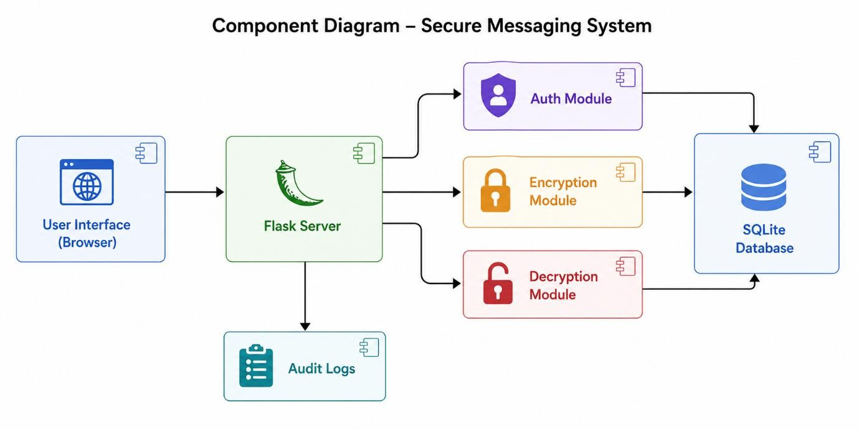

Figure: Component Diagram of Secure Messaging System

The component diagram illustrates the major modules of the system and their interactions. The user interface communicates with the Flask server, which processes requests using modules such as authentication, encryption, and decryption. These modules interact with the SQLite database to store and retrieve data. The system also maintains audit logs to track user activities. This diagram provides a high-level view of the system architecture and module connectivity.

Implementation

Implementation Overview

The implementation phase converts the system design into a working application. The Secure Messaging System is developed using Python Flask for backend processing, SQLite3 for database storage, and HTML, CSS, and JavaScript for the frontend interface. The system ensures secure communication by encrypting messages using the Fernet encryption method before storing them.

Technology Stack Used

Component | Technology | Purpose
Backend | Python + Flask | Handles server logic and API requests
Database | SQLite3 | Stores users, messages, and logs
Encryption | Fernet (Cryptography) | Secures messages
Frontend | HTML, CSS, JavaScript | User interface and interaction

Backend Implementation (Flask)

The Flask backend handles all system operations such as login, registration, message sending, and data retrieval. It verifies user credentials, manages sessions, encrypts messages before storing them, and decrypts them when required. API routes are created for each function like login, send message, and view messages.

Encryption Implementation

The system uses Fernet encryption to secure messages. Before storing any message, it is converted into an unreadable encrypted format. When an authorized user accesses the message, it is decrypted back to readable text using the same secret key. This ensures that sensitive data is never stored in plain text.

Database Implementation (SQLite3)

SQLite3 is used as a lightweight database to store all system data. It contains tables for users, messages, audit logs, and login tracking. The system performs operations like inserting new users, storing encrypted messages, retrieving messages, and updating message status.

Frontend Implementation

The frontend consists of web pages such as login, registration, dashboard, and admin panel. JavaScript is used to communicate with the backend through API calls. The interface allows users to send messages, view inbox, filter messages, and monitor system activity.

Session Management

Sessions are used to keep users logged in after authentication. The system stores user details like username and role in a session and automatically logs out the user after 30 minutes of inactivity for security purposes.

File Structure
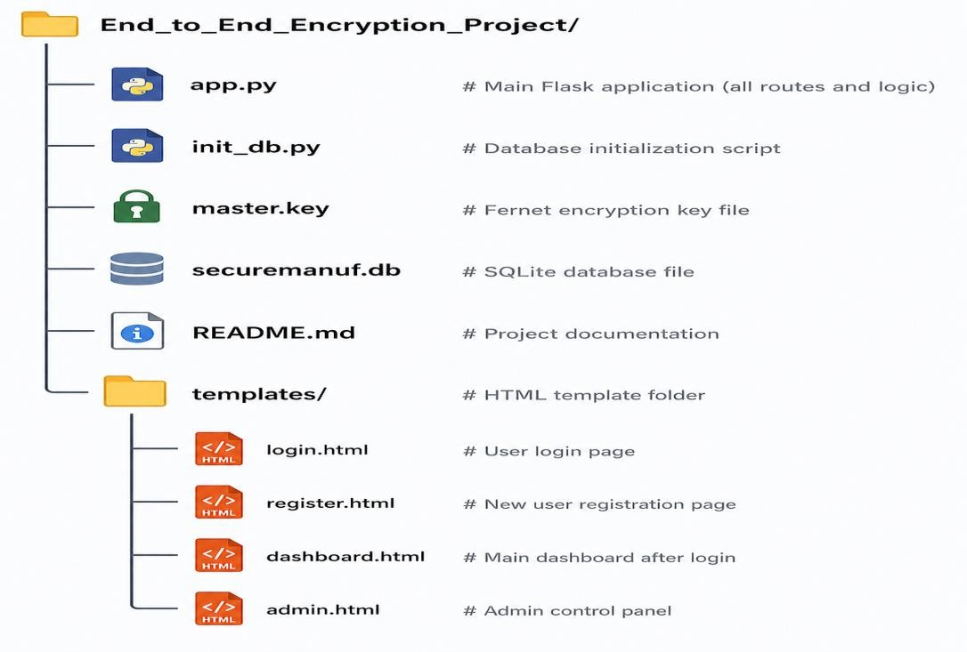

Testing & Validation

Testing Overview

Testing ensures that the system works correctly, securely, and efficiently in a real retailing environment. All major features such as login, encryption, message handling, and admin controls were tested using different user roles.

Types of Testing Performed

Test Type | Purpose
Functional Testing | Check if system features work correctly
Security Testing | Ensure data is encrypted and access is controlled
Validation Testing | Verify user inputs and error handling
User Acceptance Testing | Check usability for real users
Integration Testing | Ensure all modules work together

Functional Testing (Sample Cases)

Test Case | Action | Expected Result | Result
User  Registration | Register new user | Account created (pending approval) | Pass
Login | Login with valid/invalid credentials | Access granted/denied correctly | Pass
Send Message | Send message with priority | Message encrypted and stored | Pass
Read Message | Open message | Message decrypted and marked read | Pass
Admin Approval | Approve new user | User can login after approval | Pass
=

Security Testing

Test Case | What was checked | Result
Encryption | Messages stored in encrypted format | Pass
Password Security | Password stored as hash | Pass
Authorization | Unauthorized access blocked | Pass
Session Timeout | Auto logout after inactivity | Pass

Validation Testing

Input | Invalid Case | Expected Result | Result
Username | Too short | Error message | Pass
Password | Mismatch | Error message | Pass
Message | Empty | Not allowed | Pass

User Acceptance Testing (UAT)

Role | Task | Result
Admin | Approve users, view logs | Pass
Operator | Send messages | Pass
QC | View reports | Pass
Maintenance | Handle requests | Pass

Integration Testing
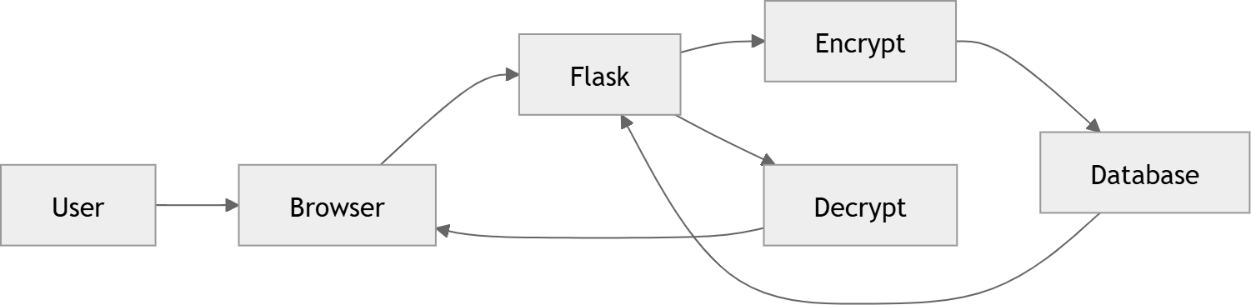

Fig: End-to-End Message Flow

This diagram shows the complete message flow. A user sends a message through the browser, which is processed by the Flask server. The message is encrypted and stored in the database. When retrieved, it is decrypted and displayed to the user.

Graphical User Interface (GUI) Layout

GUI Overview

The Graphical User Interface is designed to be simple, user-friendly, and suitable for a retaling environment. A dark theme is used to reduce eye strain during long working hours. The interface is responsive and works across desktops, laptops, and tablets.

Pages in the System

Page | Purpose | Key Features
Login Page | User authentication | Role selection, username/password input, quick access
Register Page | New user registration | Form with validation, role selection
Dashboard | Main working interface | Statistics, send message, inbox, machine status
Admin Panel | System control (admin only) | User approval, audit logs, login tracking

Login Page

- Role selection (Admin, Operator, QC, Maintenance)

- Username and password input fields

- Login button

- Link to registration page
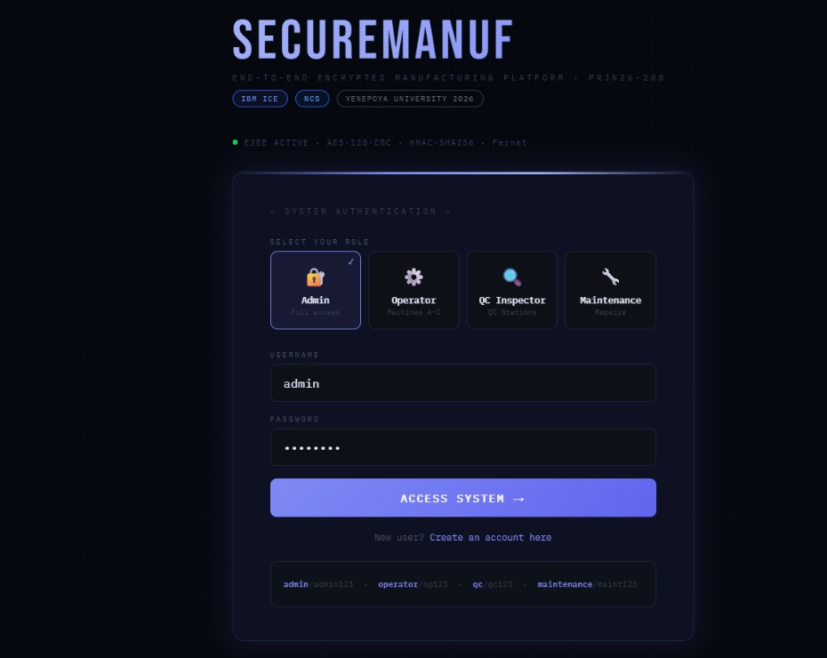

Dashboard Page

- Top bar with user details and logout

- Sidebar for navigation

- Statistics section (messages, alerts)

- Send message panel

- Inbox section

- Machine status view

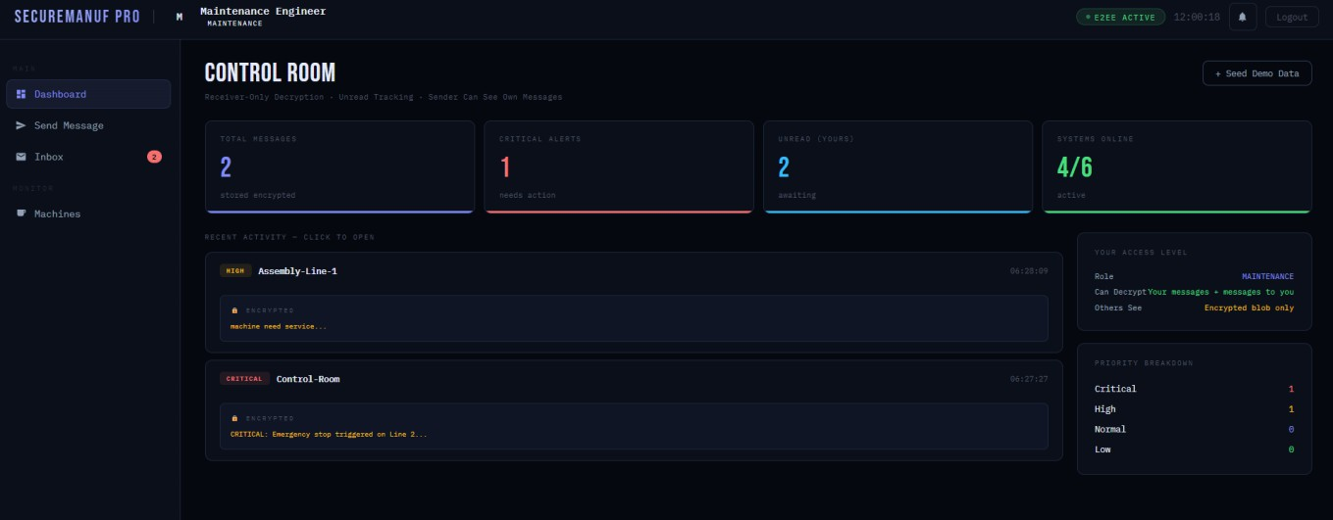

Admin Panel

- Approve or reject users

- View audit logs

- Monitor login activity

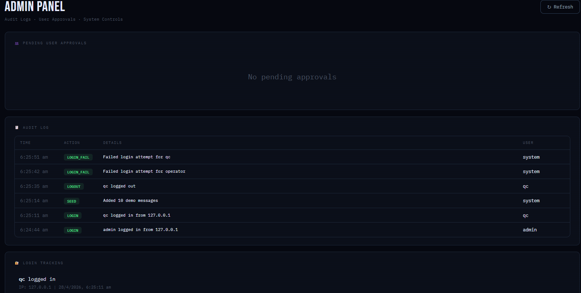

Priority Colors and UI Theme

Definition:
Priority colors indicate the urgency of messages, while the UI theme defines the overall visual appearance of the system for better readability and user comfort.

Element | Color | Purpose
Critical Priority | Red | Indicates emergency or breakdown situations
High Priority | Yellow | Indicates urgent issues
Normal Priority | Blue | Indicates regular updates
Low Priority | Green | Indicates general information
Background | Dark Blue | Reduces eye strain
Cards/Sections | Dark Shade | Improves visual separation
Text | Light Gray | Enhances readability
Alerts | Red / Green | Shows error and success messages

  - Customer Testing

Customer Testing Overview

Customer testing is the process of evaluating the system using real users to ensure that it is practical, easy to use, and suitable for a real working environment. In this project, testing was conducted in a simulated retailing setup where users from different roles interacted with the system.
The main objective of customer testing is to check usability, user experience, and overall satisfaction. Unlike technical testing, which focuses on system performance and security, customer testing focuses on how effectively users can perform their daily tasks using the system.
Four participants representing key roles—Admin, Operator, QC Inspector, and Maintenance staff—were selected. Each participant performed common tasks such as logging in, sending messages, reading encrypted messages, and using role-specific features. Observations were made on task completion, ease of use, and time taken.

Tasks Performed and Results

Task | Description | Result
Login | Access system using credentials | Successful
Registration | Create new user account | Successful
Send Message | Send encrypted message with priority | Successful
Read Message | Decrypt and view message | Successful
Filter Messages | Sort messages by priority | Successful
Logout | Exit the system securely | Successful
Admin Actions | Approve users and view logs | Successful

Evaluation

Evaluation Overview

Evaluation is carried out to determine how effectively the system meets the project objectives and performs in a practical environment. The Secure Messaging System was evaluated based on functionality, security, performance, usability, and overall effectiveness in the retailing unit.
The evaluation confirmed that the system successfully encrypts messages, controls user access, maintains logs, and provides a simple interface for communication. All major modules function as expected, and the system performs efficiently under normal operating conditions.
Although the system meets all major requirements, certain enhancements such as real-time notifications and message search can improve usability in future versions.

Table: System Evaluation Summary

Criteria | Evaluation
Functionality | Successfully performs secure registration, login, encryption, and messaging
Security | Protects messages using encryption and restricts unauthorized access
Performance | Responds quickly and operates efficiently
Usability | Provides a simple and easy-to-use interface
Reliability | All major functions work consistently without errors
Scalability | Can be improved further with advanced storage and live notifications

PROJECT SNAPSHOTS (UI & OUTPUT SCREENS)
  - Login Page
The login page is the entry point of the system where users enter their credentials to access the application. It also provides role selection and a link to the registration page.

Key Features:

- Username and password input

- Role selection (Admin, Operator, QC, Maintenance)

- Login button

- Register link

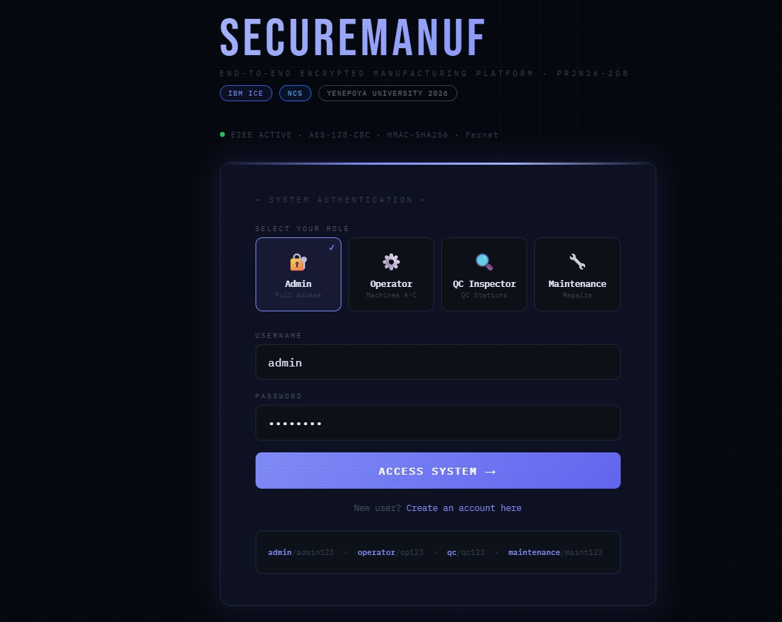

Fig 1: Login Page

  - Registration Page
The registration page allows new users to create an account. Newly registered users must wait for admin approval before accessing the system.

Key Features:

- Full name, username, password fields

- Role selection

- Register button
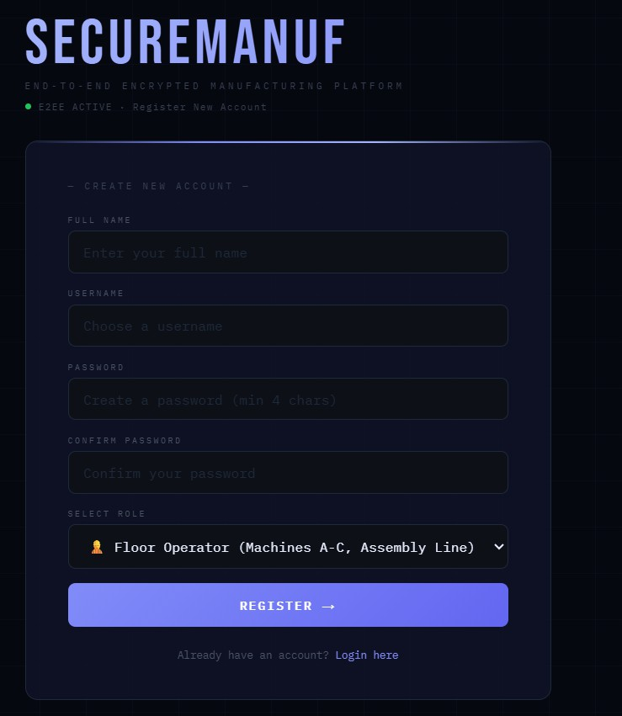

Fig 2: Registration Page

  - Dashboard
The dashboard is the main interface after login. It provides access to all system features and displays important information.

Key Features:

- Sidebar navigation

- Message statistics

- Quick access to send, inbox, and machines

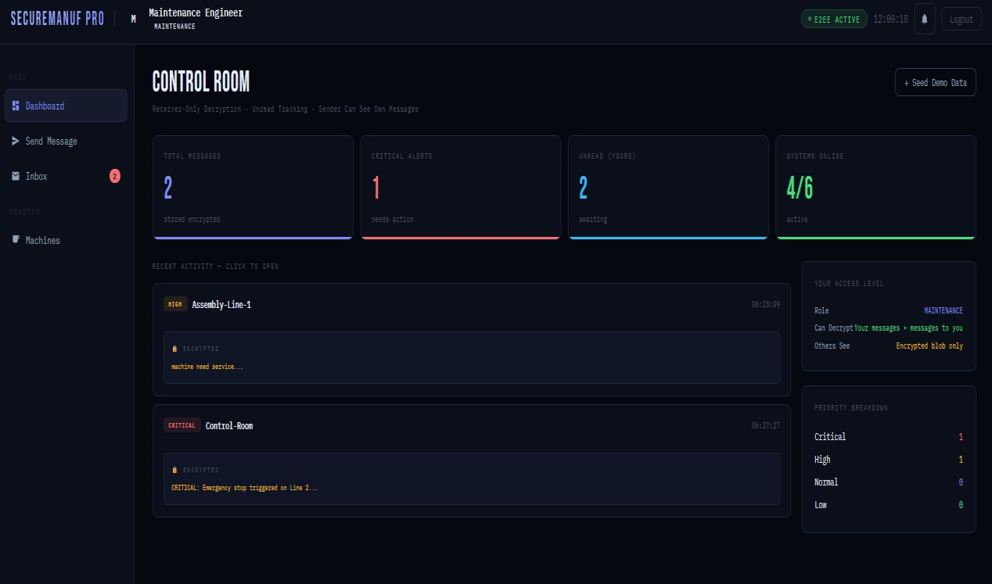

Fig 3: Dashboard Interface

  - Send Message
This section allows users to compose and send encrypted messages with priority levels.

Key Features:

- Message input

- Receiver selection

- Priority selection

- Encrypt and send option

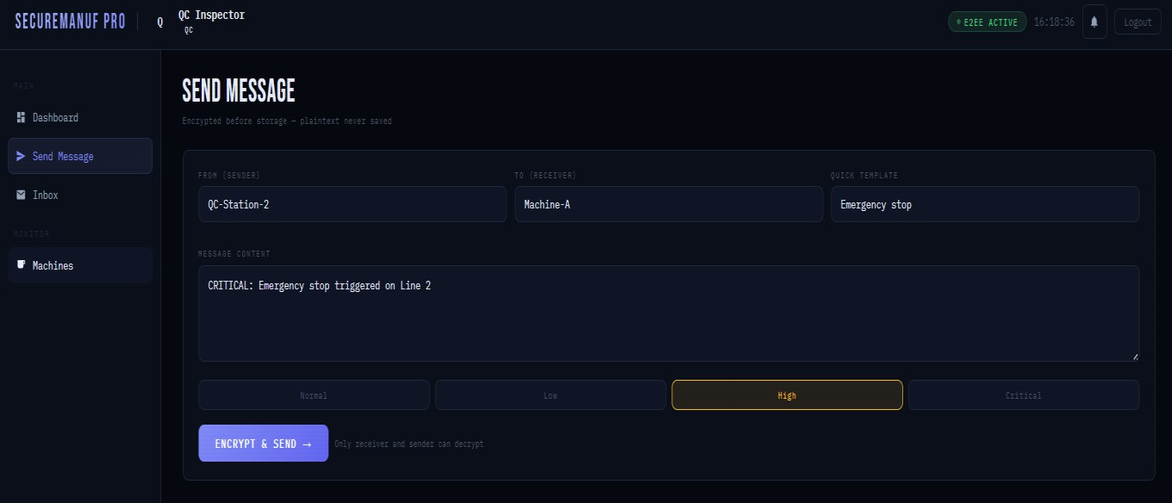

Fig 4: Send Message Panel

  - Inbox
The inbox displays all messages related to the user. Messages can be filtered and opened for decryption.

Key Features:

- Message list

- Priority indicators

- Filter options

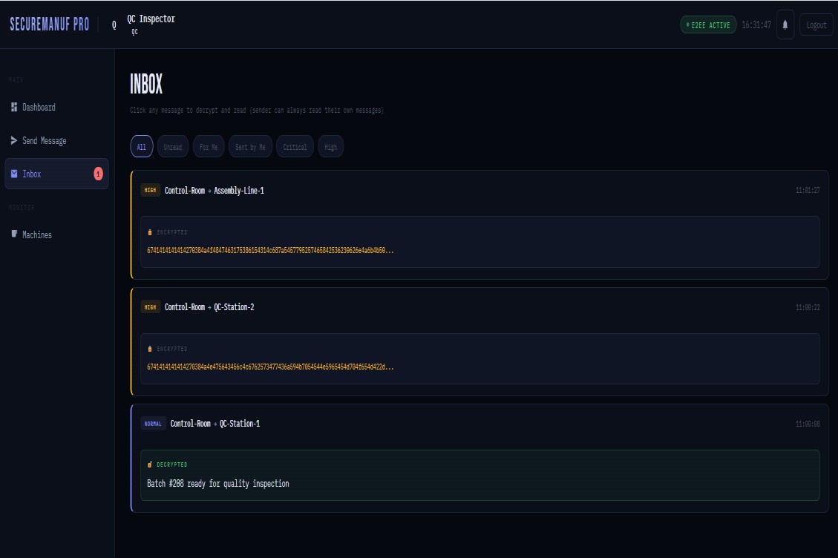

Fig 5: Inbox Panel

  - Message Decryption
When a message is opened, it is decrypted and displayed to the authorized user. Key Features:
- Sender and receiver details

- Decrypted message content

- Security validation

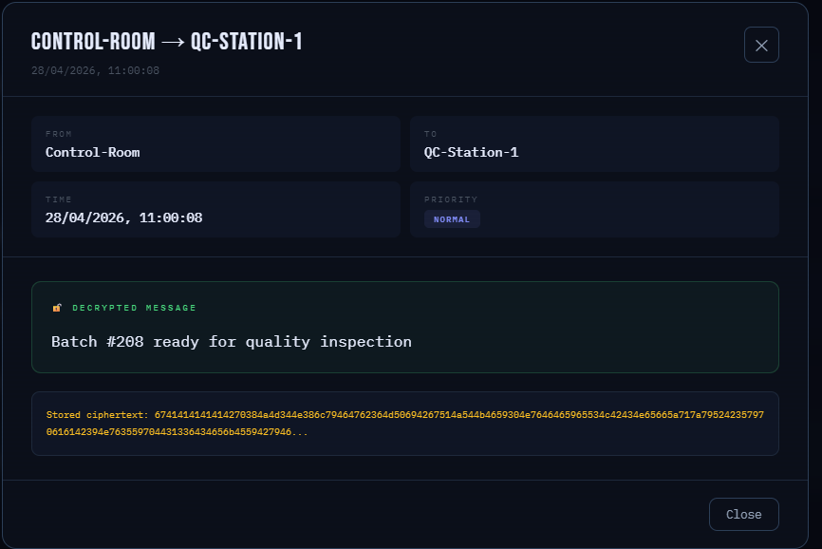

Fig 6: Message Decryption View

  - Admin Panel
The admin panel allows system management and monitoring.

Key Features:

- User approval

- Audit logs

- Login tracking



Fig 8: Admin Panel

- CONCLUSION
The End-to-End Encryption for Retailing Unit project was successfully designed and implemented to provide a secure communication system within a factory environment. The main objective of the project was to protect sensitive information such as machine alerts, quality reports, and maintenance updates from unauthorized access.
The system ensures that all messages are encrypted using the Fernet algorithm before being stored in the database. This guarantees that no plaintext data is stored, and only the sender and the intended receiver can decrypt and read the messages. This strong security mechanism makes the system reliable for handling confidential production data.
All the planned objectives of the project were successfully achieved. The system supports role-based access for Admin, Operator, QC Inspector, and Maintenance users, ensuring that each user has appropriate permissions. The admin approval feature adds an extra layer of control by allowing only verified users to access the system. Additionally, audit logging and login tracking provide transparency and help monitor all user activities.
The system performs efficiently, with fast response times for login, message sending, and message decryption. The user interface is simple, clean, and easy to use, even for workers with basic computer knowledge. The dark theme and organized layout further improve usability in a retailing environment.
However, the system has some limitations, such as the absence of real-time notifications, message search functionality, and file sharing. These features can be added in future versions to enhance usability and scalability. Implementing advanced security features like per-user encryption keys can further strengthen the system.
In conclusion, the project successfully demonstrates a secure, reliable, and user-friendly messaging system tailored for retailing units. It meets all functional and security requirements and is suitable for real-world deployment in small to medium-scale industries. The system provides a strong foundation for future improvements and advanced features.

FUTURE DEVELOPMENT

Future Development Overview

The current system successfully provides secure communication using end-to-end encryption for a retailing unit. However, there is scope for further improvement to enhance usability, security, and scalability. Based on user feedback and practical requirements, several future enhancements have been identified.

Planned Enhancements

The following features can be added in future versions to improve the system:

- Real-time notifications: Enable instant message updates without refreshing the page.

- File attachments: Allow users to send images, reports, and documents securely.

- Search functionality: Help users quickly find old messages.

- Message forwarding: Allow sharing of important information across users.

- Delete messages: Enable users to remove unwanted or incorrect messages.

- Mobile application: Provide access through smartphones for better accessibility.

- Language support: Support regional languages for ease of use.

Security Improvements

To further strengthen the system, the following security enhancements can be implemented:

- Per-user encryption keys to improve data protection

- Two-factor authentication (2FA) for secure login

- Account lock after failed attempts to prevent unauthorized access

- Database encryption for additional security layer

User Experience Improvements

The system can be made more user-friendly with:

- Push notifications for alerts

- Message templates for quick communication

- Draft saving to prevent data loss

- Profile customization options

APPENDIX
  - Sample Encrypted Messages
The table below demonstrates how plaintext messages are converted into ciphertext using the Fernet encryption algorithm. The system stores only encrypted data in the database, ensuring message confidentiality.

Plaintext Message | Encrypted Message (Ciphertext)
Machine A temperatur e is too high | gAAAAABmMx7L5tXk3QvR9p2YwB8nKqXcVzL9p2Yw==
Batch #208 passed quality inspection | gAAAAABnYz8M6uYl4RwS0q3ZxC9mPwD1aFbG2hIjK3lMnOpQrStUv WxYz==
Maintenan ce required on Assembly Line | gAAAAABoZ9N7OvPqR1sT2uV3wX4yZ5aB6cC7dD8eE9fF0gG1hH2iI3jJ 4kK==
Critical alert: Machine B stopped | gAAAAABpA0O8PwQrS1tU2vW3xY4zA5bC6dD7eE8fF9gG0hH1iI2jJ3k K4lL==
Quality check failed for Batch #209 | gAAAAABqB1P9QxRrS2uV3wX4yZ5aB6cC7dD8eE9fF0gG1hH2iI3jJ4kK 5lL==

Note: Fernet encryption generates different ciphertext each time for the same plaintext due to the use of a random initialization vector (IV).

Database Schema
The system uses SQLite to store users, messages, and logs.

Users Table

    - Stores all user account details

    - Includes role and approval status

Messages Table

    - Stores encrypted messages

    - Includes sender, receiver, priority, and read status

Audit Log Table

    - Records all system activities such as login, message sending, and approvals

Login Tracking Table

    - Tracks login attempts with timestamps and after-hours flag

System Output Screens

The following screens are part of the system interface:

Screen | Description
Login Screen | User authentication interface
Registration Screen | New account creation
Dashboard | Main interface with navigation and statistics
Send Message | Compose and send encrypted messages
Inbox | View and filter messages

Decryption View | Displays decrypted message content
Admin Panel | User management and audit logs

Glossary of Terms
    - End-to-End Encryption: A security method where messages are encrypted at the sender side and can only be decrypted by the intended receiver, ensuring complete confidentiality.
    - Plaintext: The original readable form of data or message before encryption is applied.

    - Ciphertext: The encrypted and unreadable form of a message after applying encryption.
    - Encryption Key: A secret value used to convert plaintext into ciphertext and vice versa.
    - Fernet: A symmetric encryption method that ensures secure message encryption and authentication.
    - Hashing: A one-way process of converting data (such as passwords) into a fixed-length value that cannot be reversed.
    - Session: A temporary storage mechanism used to maintain user login state during interaction with the system.
    - Role-Based Access Control: A security approach where users are given permissions based on their roles.
    - Audit Log: A record of system activities used for tracking user actions and maintaining security.
    - API: A set of endpoints that allow communication between the frontend and backend of the system.
    - JSON: A lightweight data format used for exchanging data between client and server.

Abbreviations

List of Abbreviations

Abbreviation | Full Form | Description
API | Application Programming Interface | Enables communication between frontend and backend components
AES | Advanced Encryption Standard | Encryption algorithm used internally by Fernet
SHA-256 | Secure Hash Algorithm (256-bit) | Used for securely hashing user passwords
HTML | HyperText Markup Language | Used to structure web pages
CSS | Cascading Style Sheets | Used to style and design the user interface
JS | JavaScript | Used for frontend logic and API communication
SQL | Structured Query Language | Used to manage and query the database
HTTP | HyperText Transfer Protocol | Protocol for communication between client and server
HTTPS | HyperText Transfer Protocol Secure | Secure version of HTTP used in production environments
JSON | JavaScript Object Notation | Format for sending and receiving data between client and server
DB | Database | Refers to SQLite database used for data storage
UI | User Interface | The visual interface through which users interact with the system

