1. **Features**
2. **Home page**

At the top of the home page is a navigation bar with a search bar and a button that will suggest the spelling, a link to the login page, profile page, our GitHub page, our Trello page, and a list of the top ten games on steam.

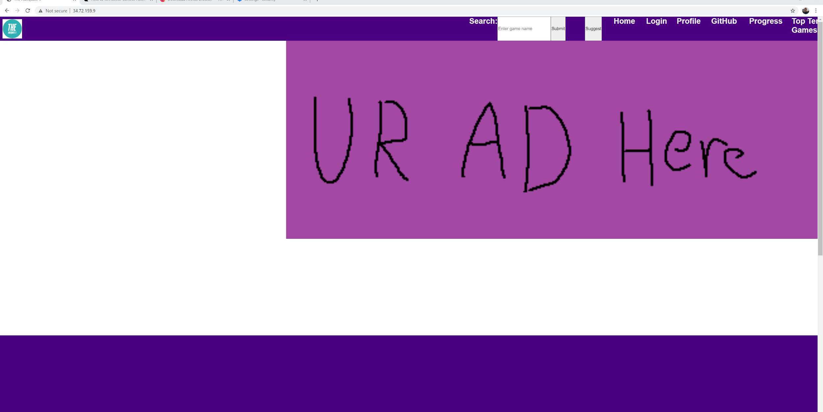

Below that, there is a list of featured games. Clicking one of these games will bring you to the game page as if you had searched for it with **C**.



1. **Registering and logging in**

To Register and log in, navigate to the Login tab on the top of the home page.

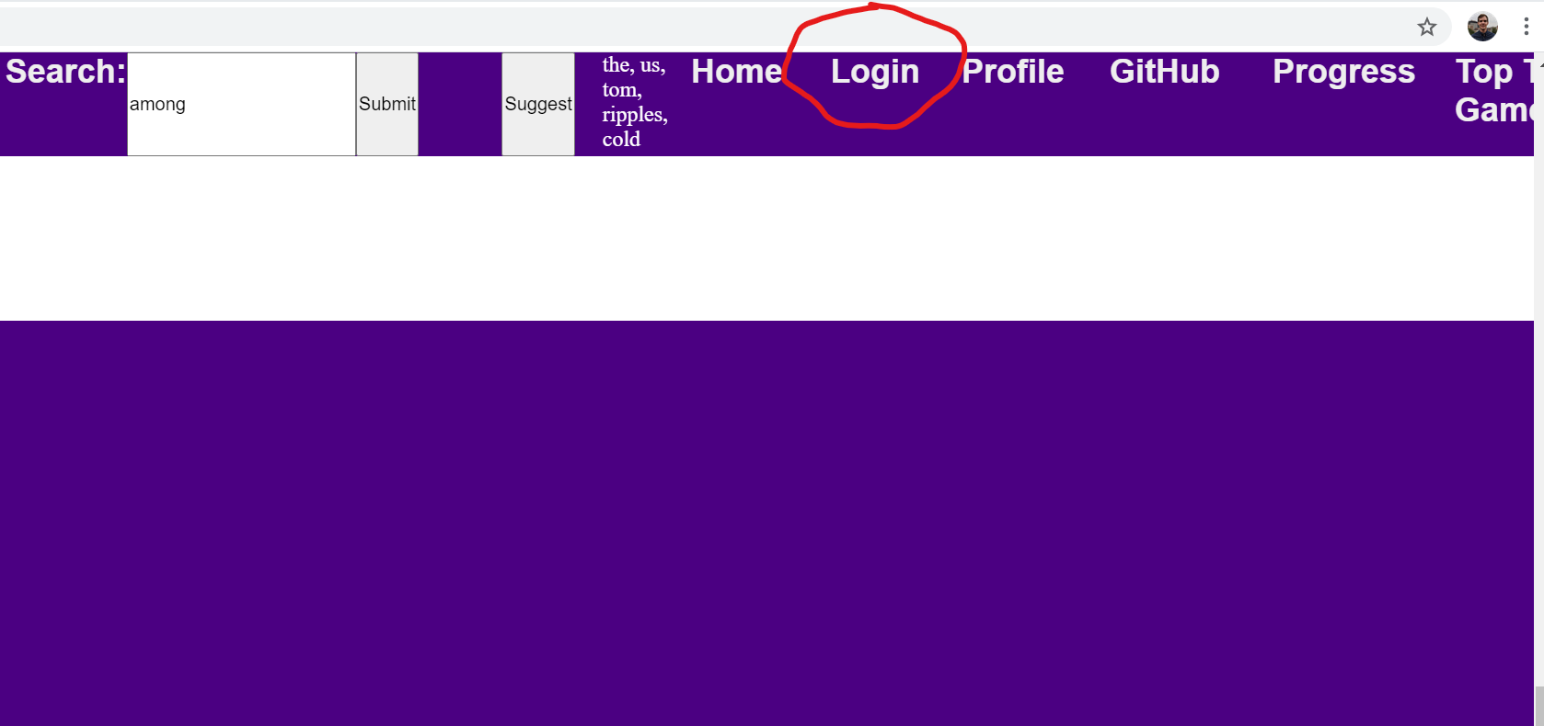

Once there, click on the Signup link to create an account.

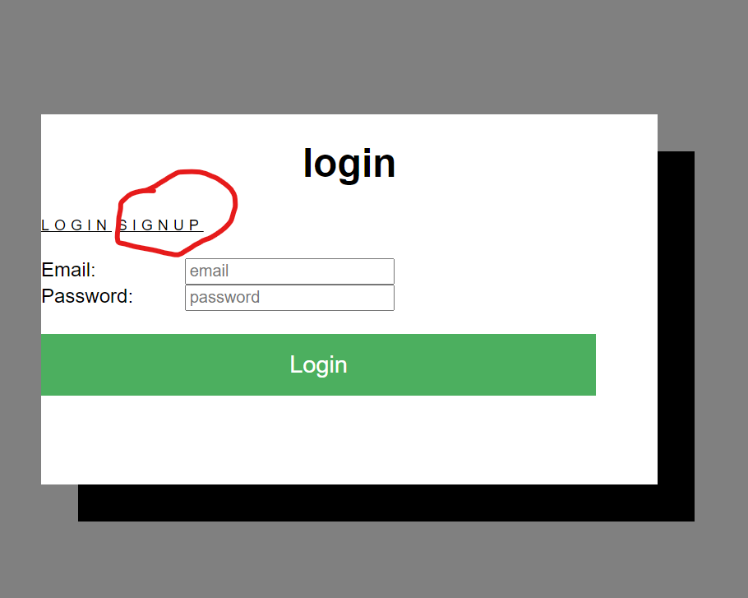

This will bring the user to the signup/register page

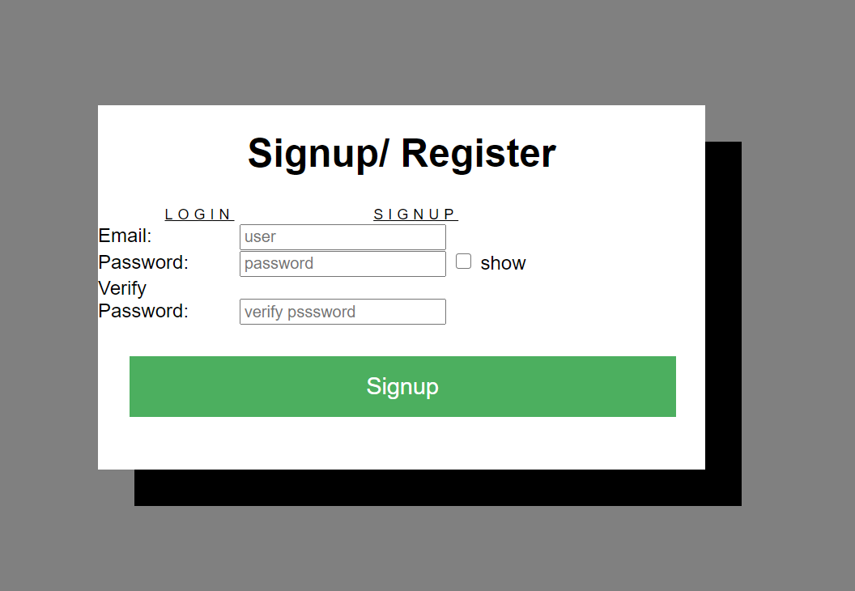

Enter the email that you want to receive sale notifications at, and then choose any password.

After an account has been successfully created, the user will be redirected to the login page. Enter your email and password and then hit the login button.

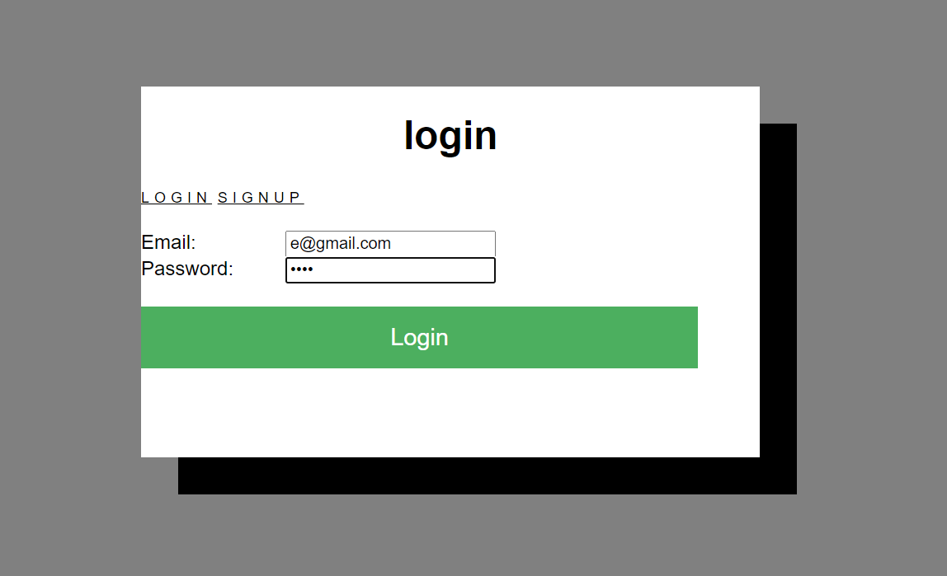

After a successful login, the user will be brought to their user page that displays games they are subscribed to. For this example, the page is blank because this test user isn’t subscribed to any games yet.

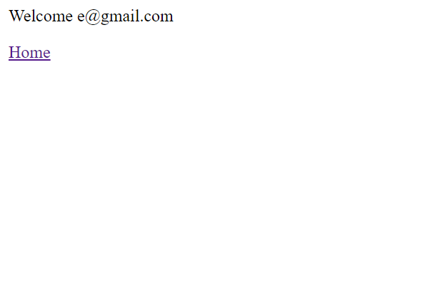

Hit the Home link to return to the main page.

1. Searching and using the suggest button

To use the suggestion, type the name of the game you are thinking of into the search bar.

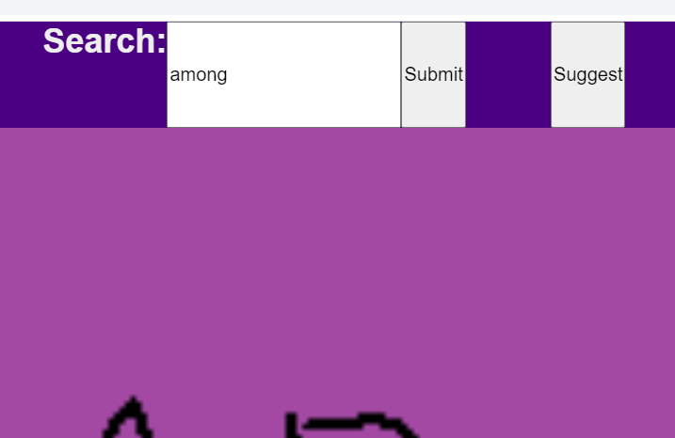

For this example I am trying to find “Among Us” but can’t remember the second word in the name. Next, Hit the suggest button and wait a few seconds.

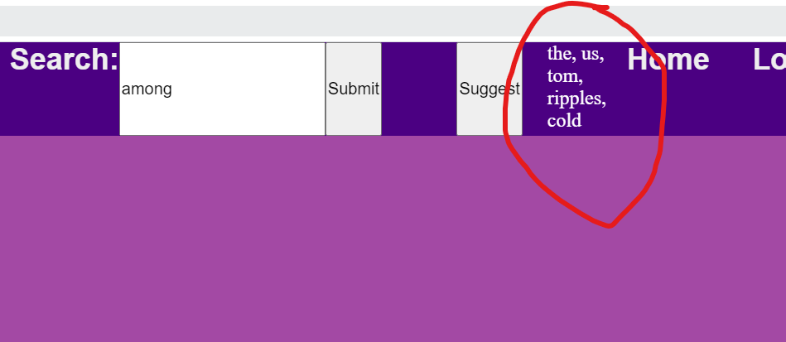

Here the AI returns what it thinks the next word might be. The game I am looking for is the second suggestion. So next I will finish typing out the game and then hit submit.

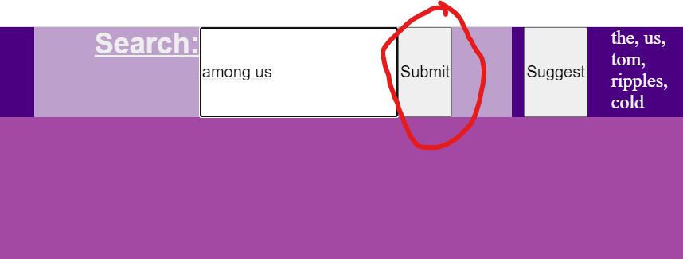

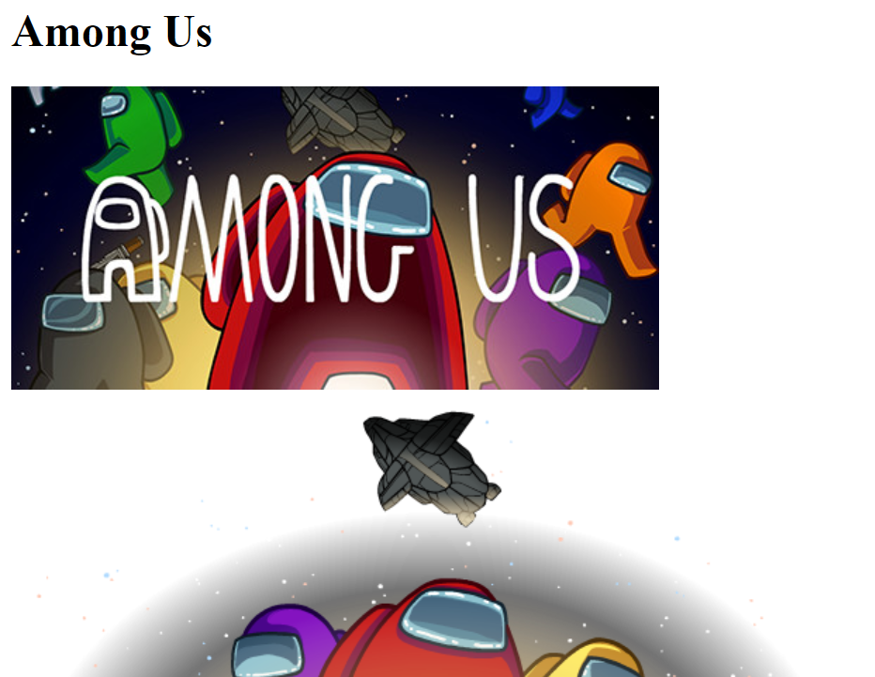

This takes me to a page that has all the information about the game. Scroll down to see all the info.

1. **Following and unfollowing games.**

For this example, I am going to follow Among us. I am still on the Among us page from the previous step. To follow it, I will scroll all the way to the bottom of the page.

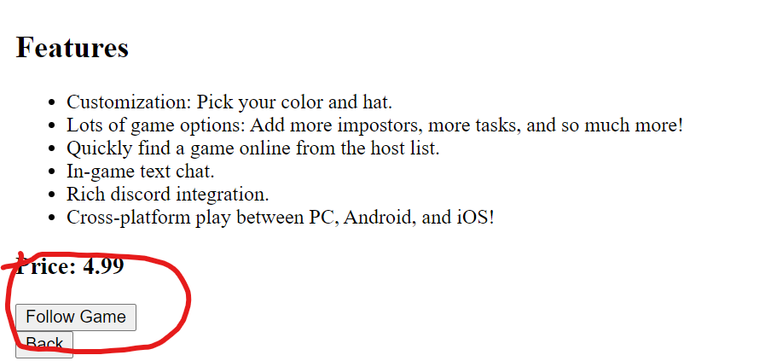

(You must be logged in for this) Hit the “Follow Game” button and you will get a success response.

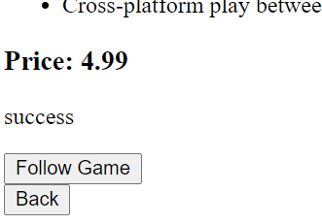

To unfollow a game. Go back to the home page and click on the profile tab.

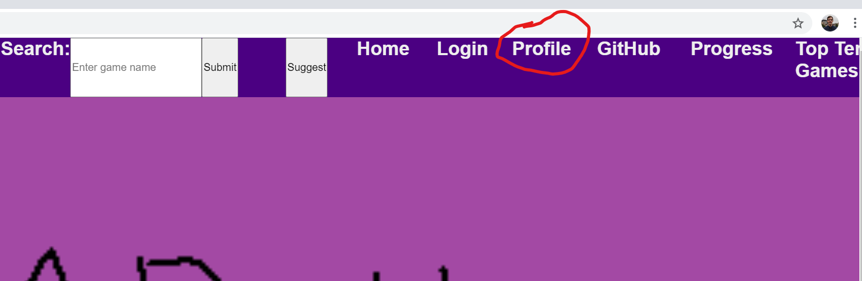

This will take you back to the user page but this time there will be a list of games you followed.

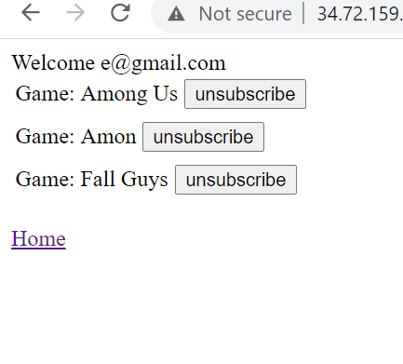

To stop getting emails about a game, just hit Unsubscribe on the game you don’t want anymore. The page will refresh and update. For this I will unfollow Fall guys.

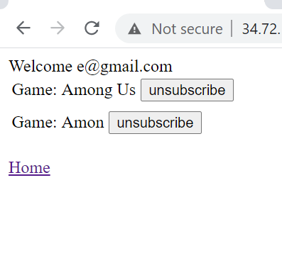

1. **Viewing top ten games**

To view the top ten games, navigate to the home page and click on the “Top Ten Games” tab.

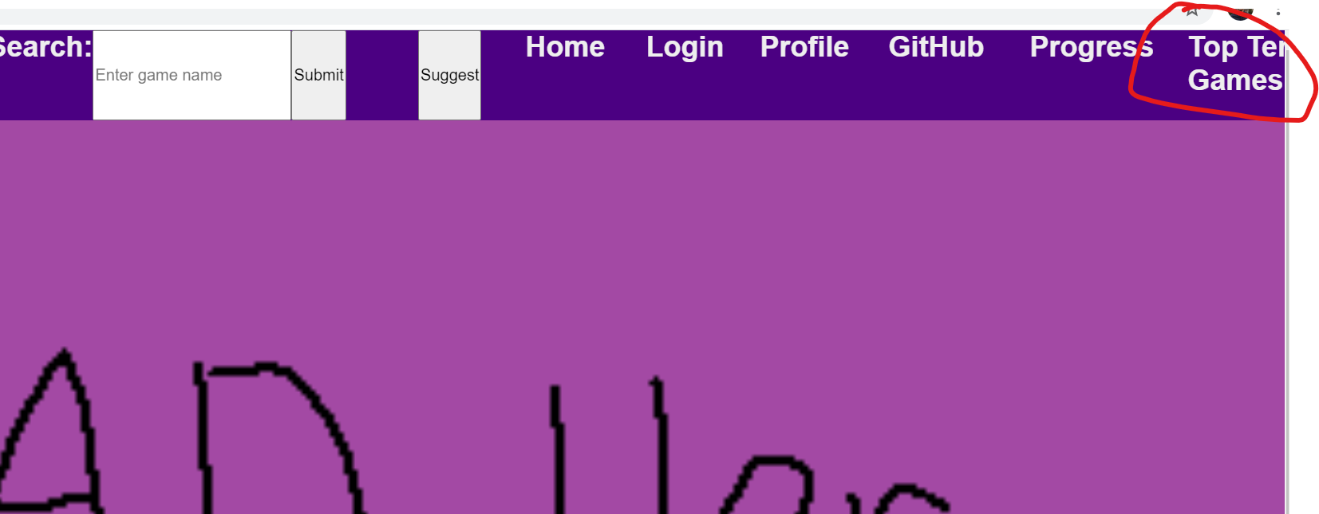

This will you take you to a new page

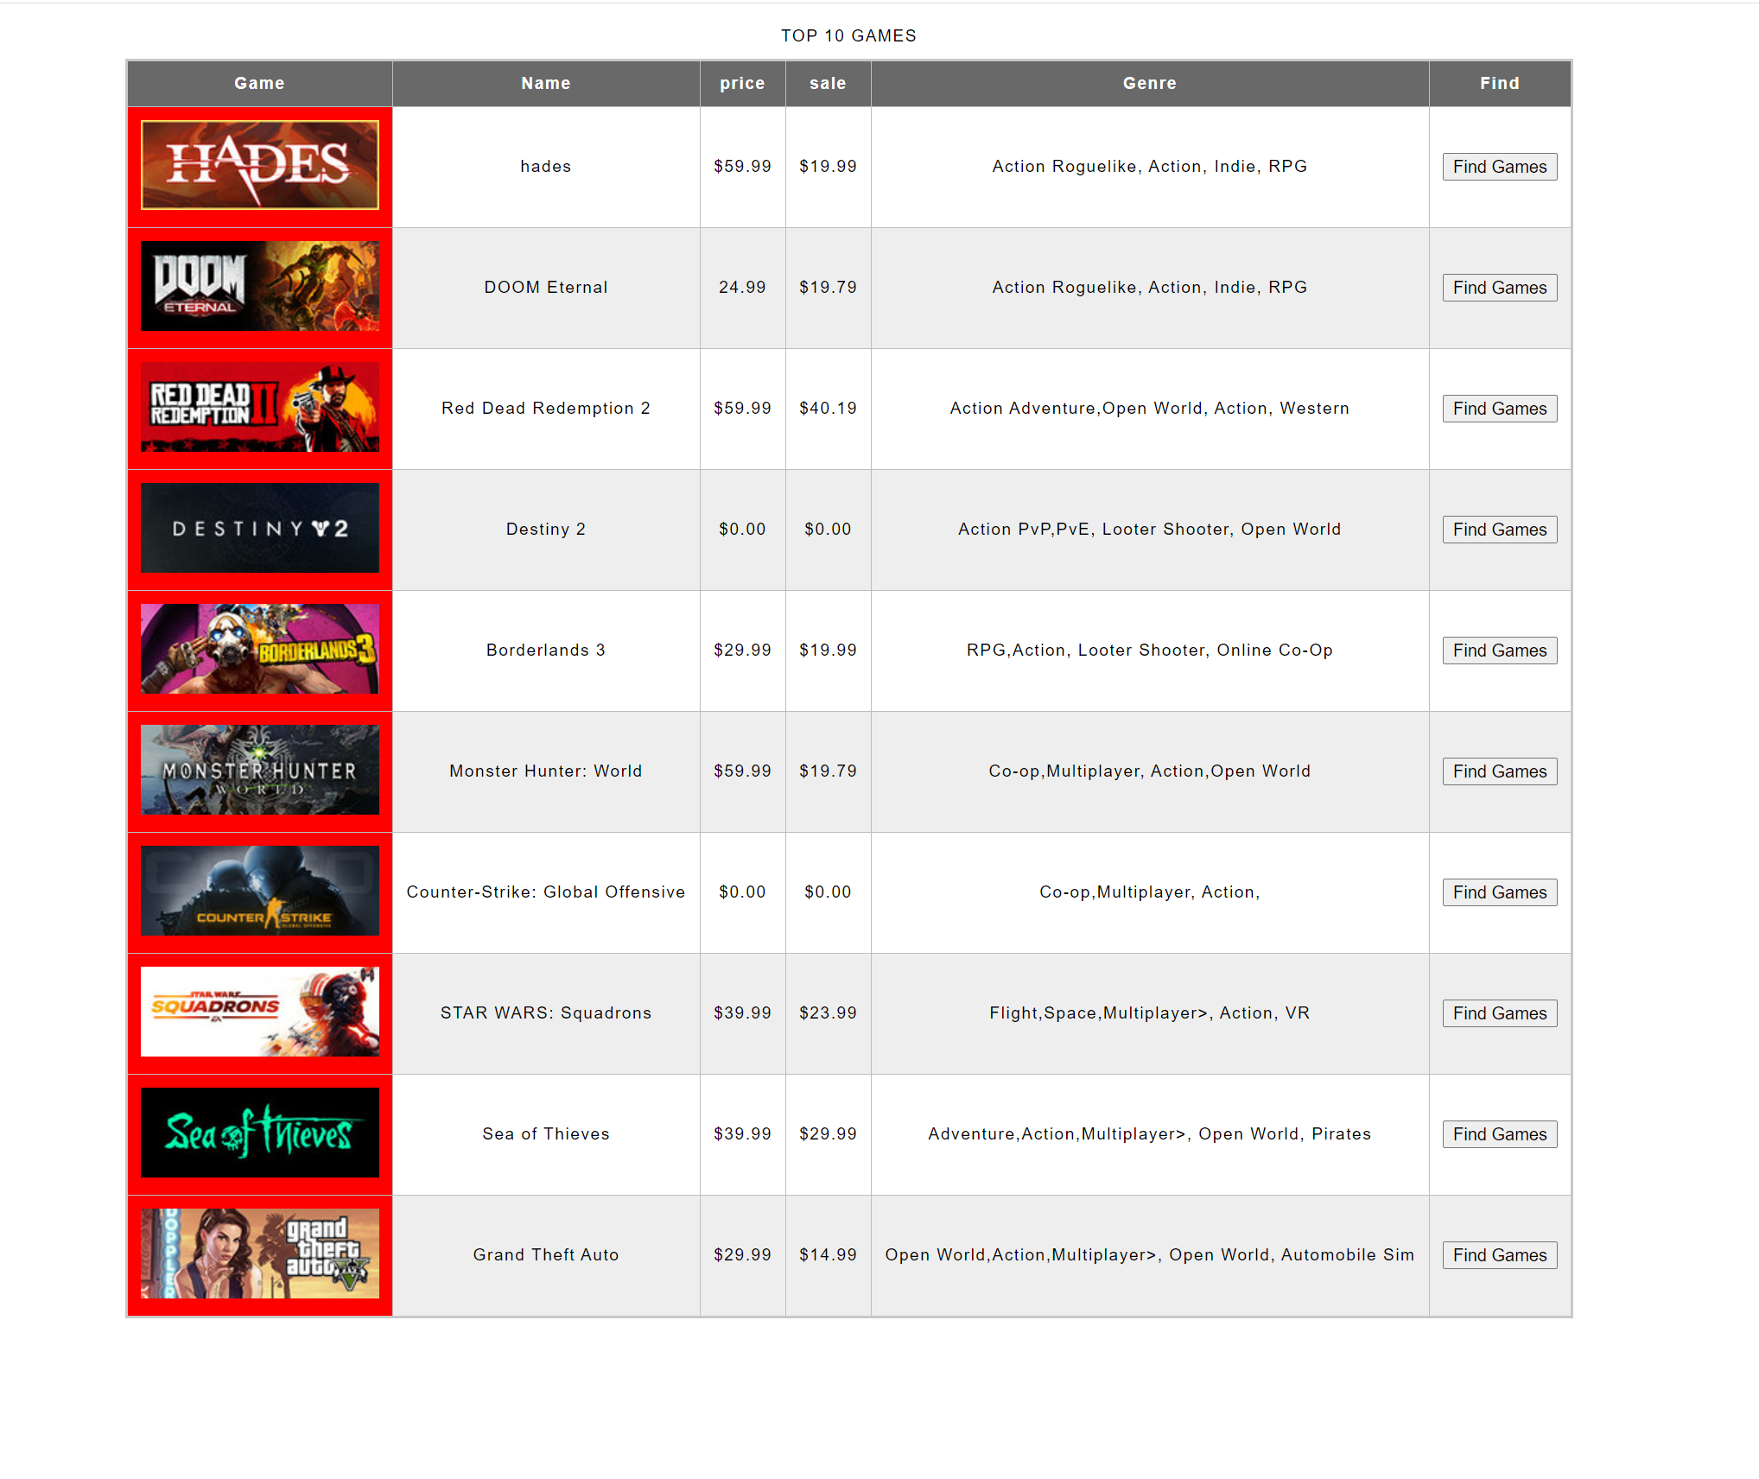

To see more information about the game and to follow it, hit the Find Games button. This will bring you to the game as if you searched it with **C**.

1. **Installation and setting up services**

1. **Initial setup:** The server that is running the website should be a linux server with at least 2 Gb of RAM. We recommend running it on a cloud service provider such as Google Cloud Platform or Amazon Web Service. This section will walk you through the first steps you need to take to get the website working.
2. Run the following commands to get apache2 installed
3. sudo apt update
4. sudo apt install apache2

You will get the following prompt confirm by pressing ‘y’

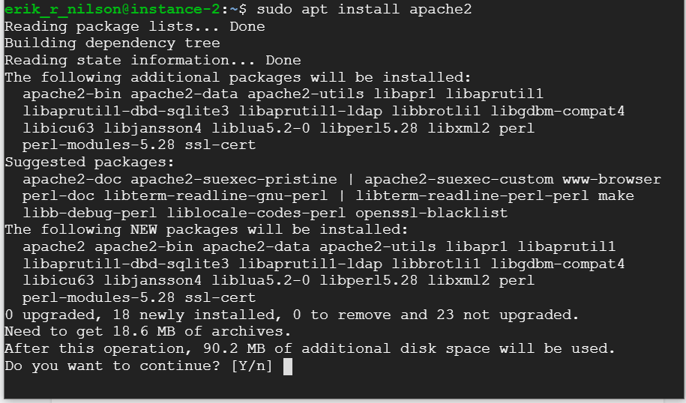

1. Once apache is installed, start it by typing “sudo service apache2 start”
2. You can confirm it is working by typing the servers IP address into a browser. You should see the following screen.

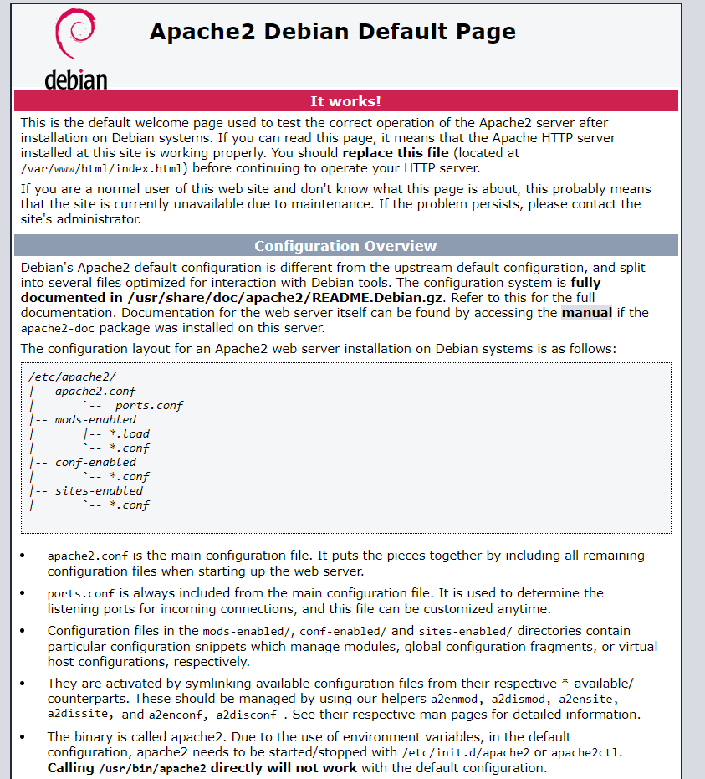

1. We recommend using a cloud mysql database. We will go over database requirements in a later section. But if you do use a cloud sql database, you will need the mysql client. You can get it with the following commands.

Sudo apt-get update

Sudo apt-get install default-mysql-client

Confirm by pressing ‘y’ when prompted.

1. Install php with command

sudo apt install php libapache2-mod-php

B. Setting up the database: The website needs a mysql database. We recommend using a cloud mySQL database but a local one will work. These steps will take you though setting up the database.

1. Connect to the database with the command:

Myssql --host=[ipaddress] --user=root --password

1. Create 2 databases. One called “users” and one called “games with the following 2 commands
   1. CREATE DATABASE games;
   2. CREATE DATABASE users;
2. Navigate to the games database by entering the following:
   1. Use games;
3. Create a table called gameid with the following command:
   1. create table gameid( appid VARCHAR(10) NOT NULL, name VARCHAR(100) NOT NULL);

The table should look like:

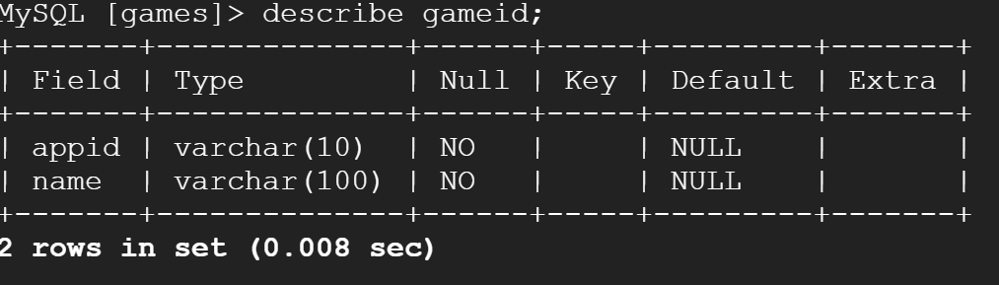

1. Go back and go into the users database
2. Create a table called loginform using the following command
   1. CREATE TABLE loginform( ID INT(11) NOT NULL AUTO_INCREMENT, user VARCHAR(50) NOT NULL, pass VARCHAR(50) NOT NULL, PRIMARY KEY(ID));

Loginform should look like this:

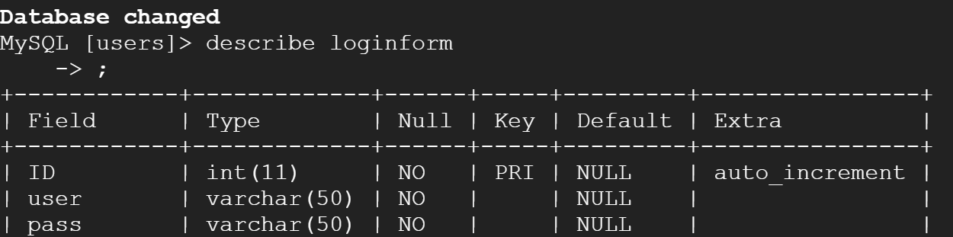

**Uploading files:**

1. Go to the html file. It can be found in /var/www/html
2. Delete the index.html file
3. Upload all the included files in the installation folder onto the html folder on the server. It should look like this:



**Editing files:**

There are several files that will need editing to work with your database. They are:

1. Register.php
2. followGame.php
3. getUserGames.php
4. login.php
5. nameTranslation.php
6. Search.php
7. user.php
8. topten.php
9. Unsubscribe.php

The top of each file will look like this:

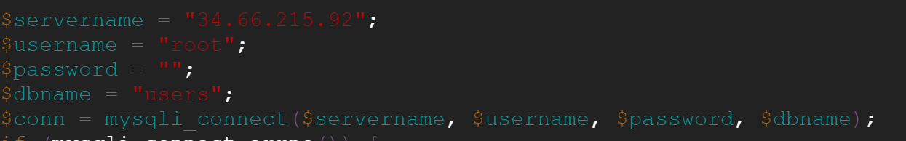

You need to change the servername and password to the server name and password of your mySQL database.

**Populating the gameid table:**

There are two files included called games.php and games.json. Upload them to the server. The top of the file will look like this:

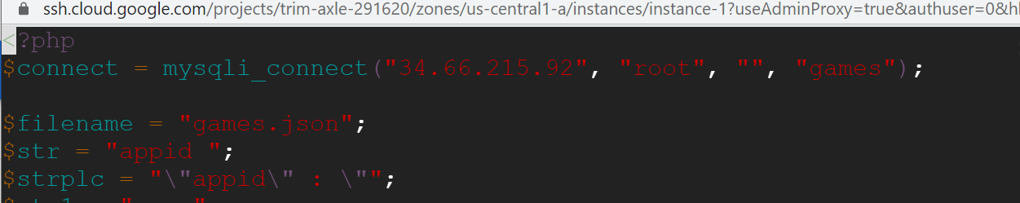

Change the IP address and “” with your mySQL database and password respectively.

Once you have done this, run the games.php file and wait for it to finish. This may take some time.

**Setting up the games prediction:**

The predictive text functionality needs a lot of pip3 installs. You can get it by running the following series of commands.

1. sudo apt install python3-pip
2. sudo pip3 install numpy
3. sudo pip3 install keras
4. sudo pip3 install nltk
5. sudo pip3 install tensorflow
6. pip3 install --upgrade tensorflow-gpu
7. sudo pip3 install --upgrade tensorboard
8. sudo pip3 install keras==2.3.0
9. sudo pip3 install matplotlib
10. pip3 install RMSprop
11. sudo pip3 install 'h5py<3.0.0'
12. sudo pip3 install numpy
13. Sudo pip3 install sendgrid

Once they are installed. Navigate to /usr/local/lib/python3.7/dist-packages.

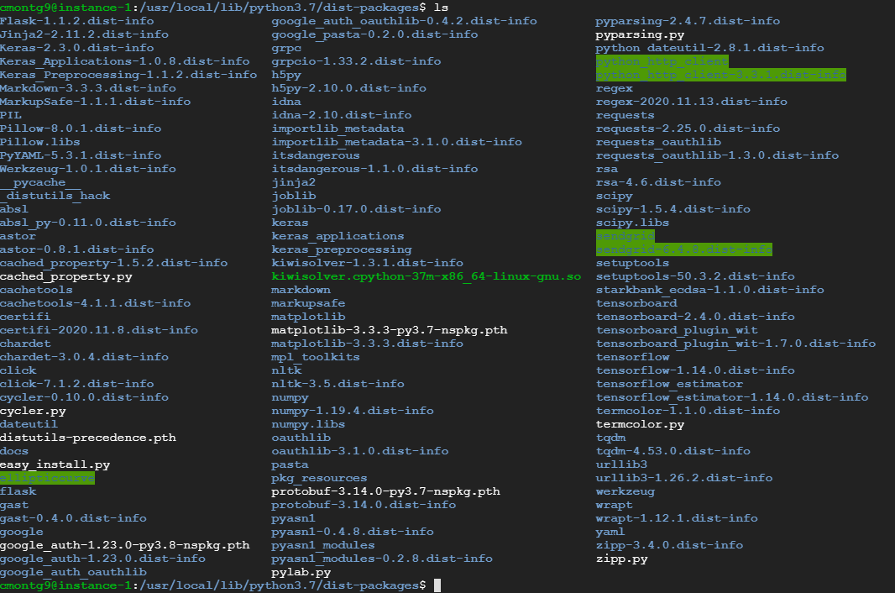

The highlighted directories need their permissions changed. They are

1. So those folders are:
2. sendgrid
3. sendgrid-6.4.8.dist-info
4. python_http_client-3.3.1.dist-info
5. python_http_client
6. ellipticcurve

Change their permissions by running the command sudo chmod -R 777 [directoryName]

**Setting up email service:**

Our website uses a third party API called sendGrid to send emails. You will need to navigate to their website to create an account and get an API key. <https://sendgrid.com/>

Once that is done, go to the /var/www/http folder and open the testEmail.py file. It will look like this.

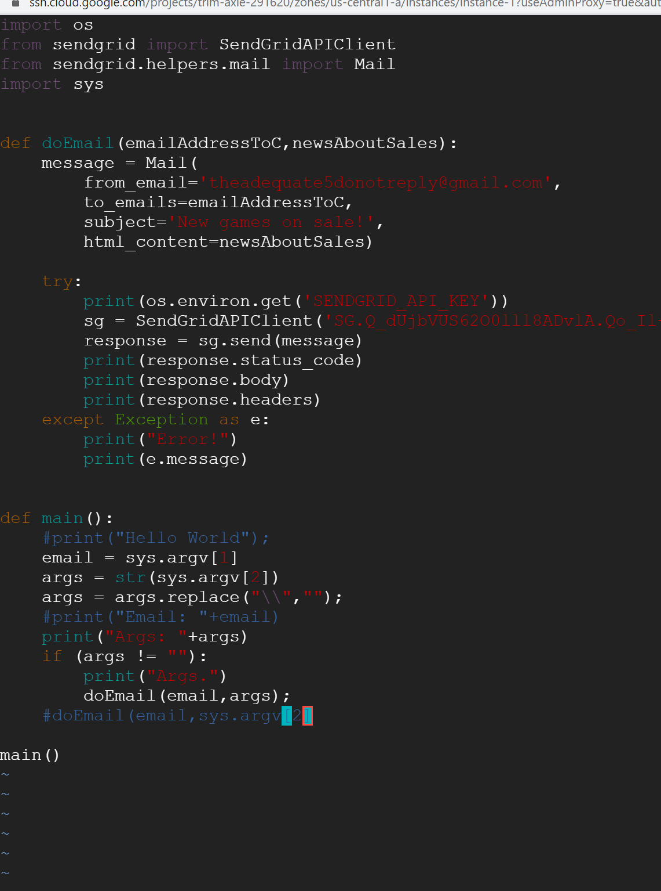

Substitute the sg variable with your own API key. It will look like:

sg = SendGridAPIClient(‘YOURAPIKEY’);

Next, in the terminal type “sudo crontab -e”

Here is where you set up the frequency of the emails being sent. The format is:

minute hour dayOfMonth month dayOfWeek /var/www/html/testEmail.sh

Example:

31 17 * * * /var/www/html/testEmail.sh to send the email out at 12:31

Here is what the file should look like:

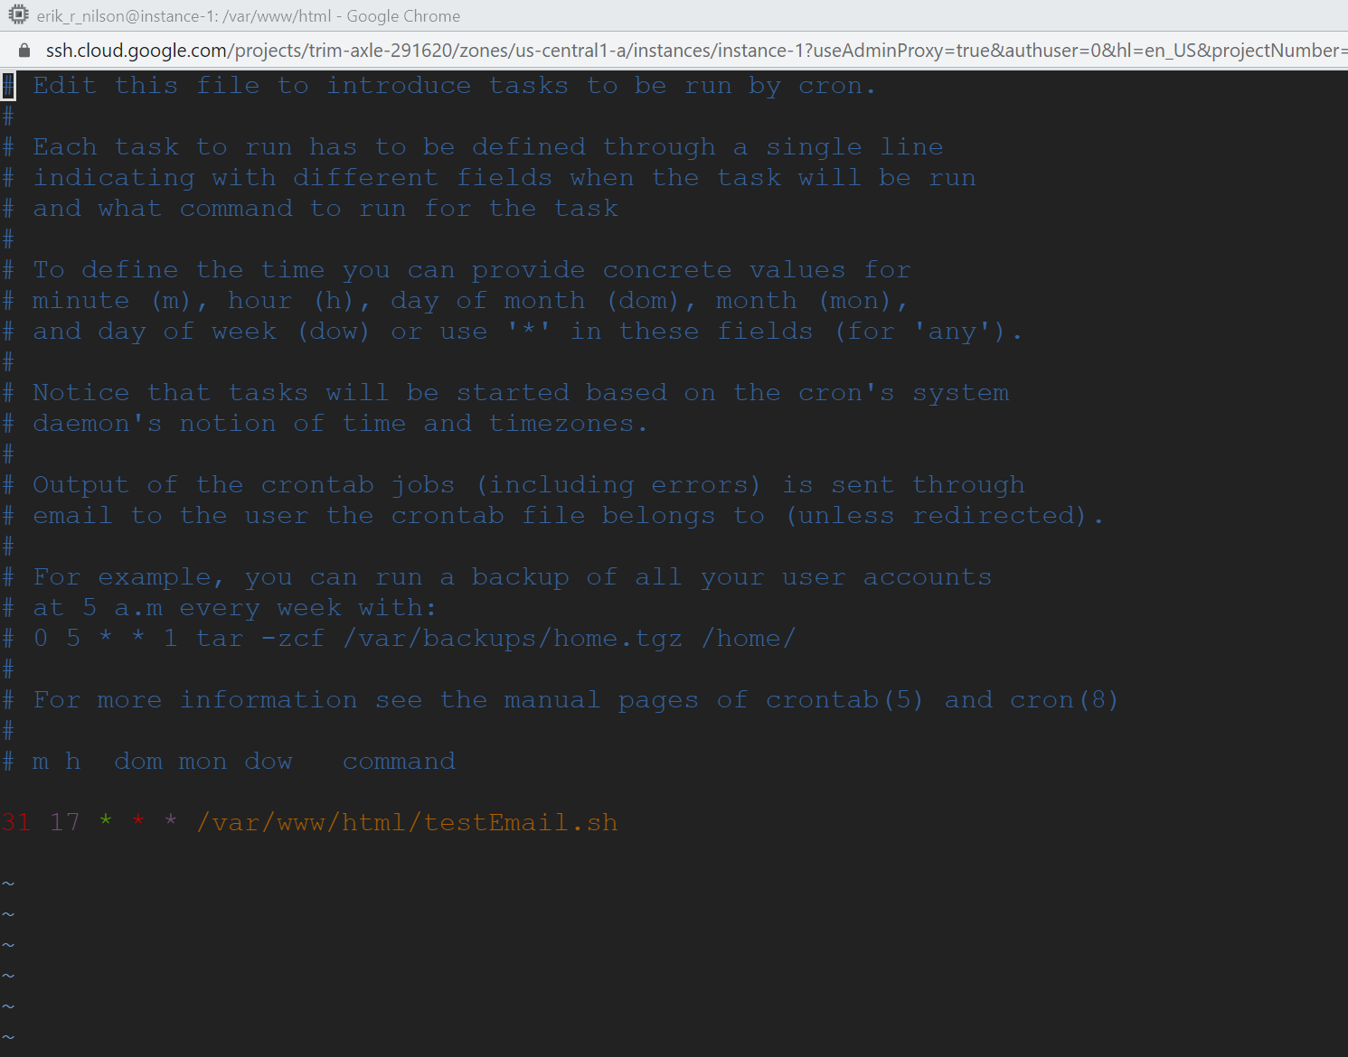

Now you are set up to send emails!