SECURE HEALTH GENERAL HOSPITAL
PERFORMANCE DASHBOARD
A Microsoft Excel Data Analytics Project | By Namuya Daniel Talamoe


1. Introduction
Hospitals generate a large amount of data every day: who is admitted, which department treats them, how long they stay and how much they pay. When this data is not analysed, it is hard for management to see what is working and what needs improvement.
This project analyses 1,000 patient records from Secure Health General Hospital, covering 1 January 2024 to 28 December 2025, using Microsoft Excel. The results are presented in an interactive dashboard that gives management a clear picture of admissions, department workload, patient profile (age and gender), length of stay, billing, payment performance and insurance coverage.
The goal is to turn raw hospital records into insights that support better decisions on staffing, resource planning and revenue collection.

2. About the Dataset
The dataset contains 1,000 patient records, one row per admission, with 17 columns and no missing values. Patient IDs run from PAT-3001 onward and every ID is unique. Patient ages range from 1 to 85 years (average 46.1).
Column | What it means
Patient ID | Unique code for each patient (e.g. PAT-3001)
Patient Name | Name of the patient
Age | Age of the patient in years
Gender | Female or Male
Admission Date | Date the patient was admitted
Discharge Date | Date the patient left the hospital
Department | General, Emergency, Orthopedics, Pediatrics, Cardiology or Neurology
Diagnosis | Medical condition treated (38 different diagnoses)
Total Bill Amount | Total amount charged to the patient ($)
Insurance Coverage % | Share of the bill covered by insurance (0% to 100%)
Payment Status | Paid, Partially Paid or Pending
Length of Stay (days) | Number of days between admission and discharge
Age Group | Under 19, 19-35, 36-50, 51-65, 66-80 or 81 & above
Admission Year | 2024 or 2025
Quarter | Quarter of admission (Q1 to Q4)
Month | Month of admission (Jan to Dec)
Paid Amount | Amount already paid by the patient ($)

Data preparation: The data was checked in Excel for missing values, duplicate rows and inconsistent entries. None were found, and the length of stay matched the admission and discharge dates for every record. Helper columns (Age Group, Admission Year, Quarter, Month and Paid Amount) were used to summarise the data in PivotTable-style summaries, which feed the dashboard charts.

3. Problem Statement
The management of Secure Health General Hospital wants to understand how the hospital is performing, but the information sits in a large table that is difficult to read. Management needs clear answers to the following questions:
- How many patients were admitted, and how did admissions change over time (by year, quarter and month)?
- Which departments receive the most patients, and which have the longest stays and highest bills?
- What is the age and gender profile of the patients?
- What is the average length of stay?
- How much has been billed, how much has been paid, and what is the payment status of patients?
- How much of the billing is covered by insurance?
- Which diagnoses are the most common and the most costly?
This dashboard was built to answer these questions in one place.

4. Visualization
The dashboard was built in Microsoft Excel. A row of KPI cards sits at the top, followed by charts that are linked to summary tables calculated from the Data sheet, so they update when the data changes.
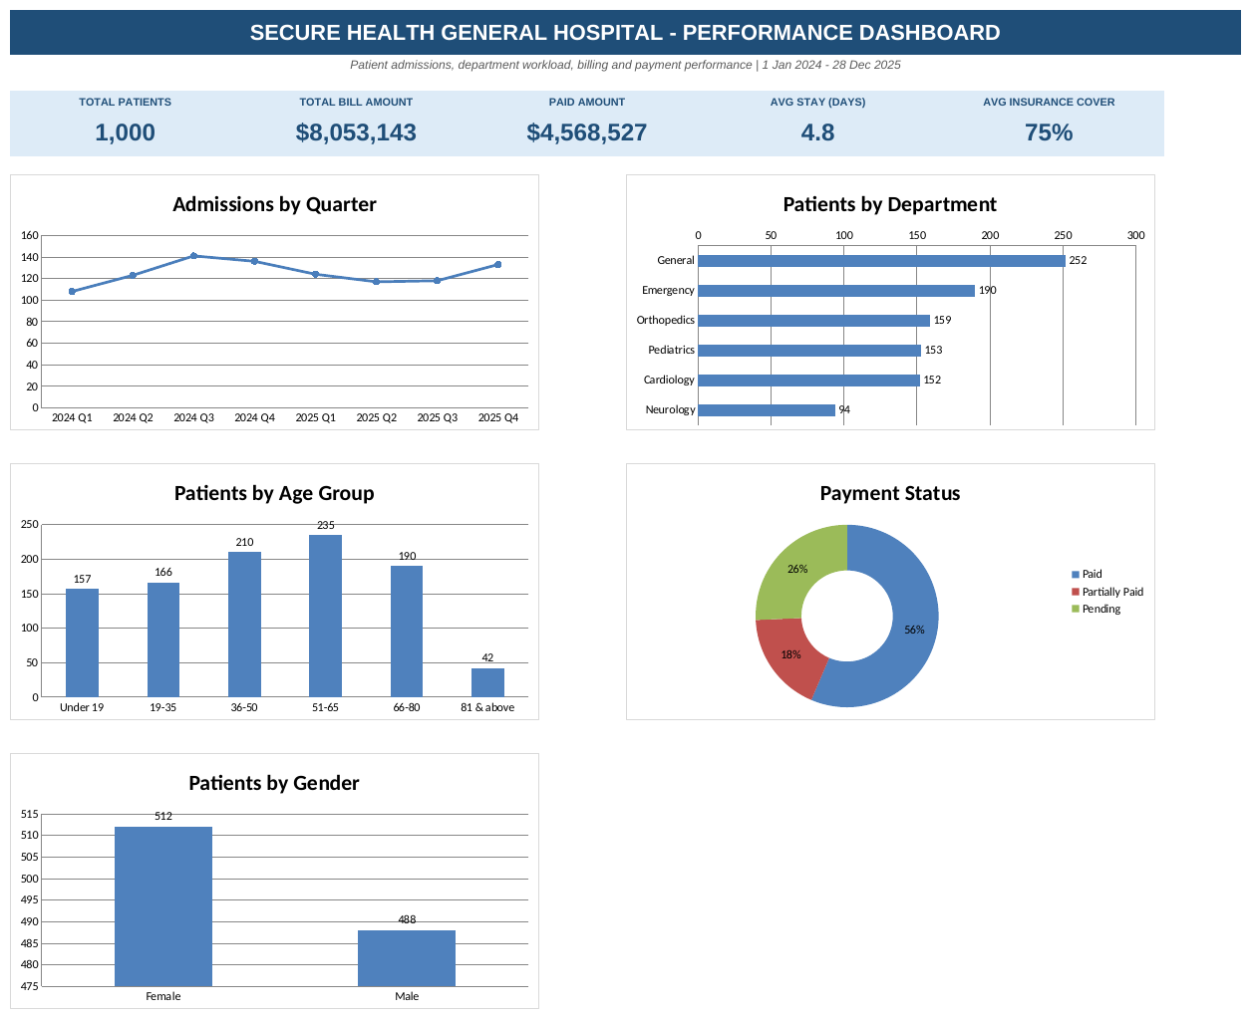
The dashboard contains:
- KPI cards: total patients (1,000), total bill amount ($8,053,143), paid amount ($4,568,527), average stay (4.8 days) and average insurance cover (75%).
- Admissions by quarter (line chart) from 2024 Q1 to 2025 Q4.
- Number of patients by department (bar chart).
- Number of patients by age group (column chart).
- Payment status (doughnut chart): Paid, Partially Paid and Pending.
- Number of patients by gender (column chart).

5. Insights
The findings below answer the management questions, using the numbers in the dashboard and the analysis sheet.

Admissions over time
- Volume: The hospital admitted 1,000 patients: 508 in 2024 and 492 in 2025, so admissions were fairly steady year to year.
- Quarters: Admissions peaked in 2024 Q3 (141 patients) and were lowest in 2024 Q1 (108). They stayed between 117 and 136 per quarter after that.
- Months: Combining both years, November (100), July (96) and April (94) were the busiest months, while February (66) and June (69) were the quietest.

Departments
Department | Patients | % of total | Avg stay (days) | Total bill ($) | Avg bill ($)
General | 252 | 25.2% | 3.9 | 993,027 | 3,941
Emergency | 190 | 19.0% | 2.0 | 622,525 | 3,276
Orthopedics | 159 | 15.9% | 8.4 | 2,553,862 | 16,062
Pediatrics | 153 | 15.3% | 3.0 | 572,988 | 3,745
Cardiology | 152 | 15.2% | 6.5 | 2,095,438 | 13,786
Neurology | 94 | 9.4% | 6.9 | 1,215,303 | 12,929

- Workload: General has the most patients (252, 25.2%), followed by Emergency (190). Neurology has the fewest (94, 9.4%).
- Revenue: Orthopedics brings in the most money ($2.55 million, about 32% of all billing) even though it ranks third for patient numbers, because its patients stay longest (8.4 days) and pay the highest average bill ($16,062). Cardiology is second with $2.10 million (26%).

Age and gender
- Age: The largest group is 51-65 years (235 patients, 23.5%), followed by 36-50 (210) and 66-80 (190). The smallest group is 81 & above (42 patients, 4.2%).
- Cost by age: The 51-65 group also has the highest total billing ($2.36 million, 29% of the total). Patients under 19 stay shortest (3.0 days on average) and have the lowest average bill (about $3,716).
- Gender: Female patients made up 51.2% of admissions (512) and male patients 48.8% (488). Average bills are almost the same: about $7,996 for females and $8,113 for males.

Length of stay
- Average: Patients stay 4.8 days on average (range 1 to 14 days).
- By department: Orthopedics (8.4 days), Neurology (6.9) and Cardiology (6.5) have the longest stays. Emergency has the shortest (2.0 days).

Billing and payment status
- Billing: The total bill was $8,053,143. Of this, $4,568,527 (56.7%) has been paid, leaving $3,484,616 (43.3%) not yet paid. This is the billing for Partially Paid ($1,401,830) and Pending ($2,082,786) patients.
- Status: 564 patients (56.4%) have fully paid, 179 (17.9%) are partially paid and 257 (25.7%) are pending.
- Departments: Pediatrics has the highest share of pending patients (28.8%), followed by General (27.0%). Orthopedics ($1.10 million) and Cardiology ($0.90 million) have the largest unpaid amounts in dollars.
Note: in the dataset, the Paid Amount column is filled only for fully paid patients, so partially paid patients show no recorded payment.

Insurance
- Average cover: Insurance covered 74.9% (about 75%) of patient bills on average.
- Spread: The most common cover level is 80% (302 patients, 30.2%). 111 patients (11.1%) were fully covered, while 44 (4.4%) had no insurance.
- Effect on payment: Among patients with 80% cover or more, 68% have fully paid. Among those with less than 80% cover, only 39% have fully paid. Higher insurance cover goes with better payment.

Diagnoses
- Most common: Pneumonia (43 patients), Gastritis (39) and Dehydration (38) are the three most frequent diagnoses out of 38.
- Most costly: Knee Replacement (average bill $18,319, 9.7 days), Hip Fracture ($17,109) and Spinal Disc Herniation ($16,616) are the most expensive per patient. Carpal Tunnel brings in the most total billing ($589,740).

6. Recommendations
- Strengthen the busiest areas. Add staff and resources in General and Emergency, which together handle 44% of patients, and plan for busier periods such as Q3 and November.
- Follow up on unpaid bills. Use reminders, payment plans and a billing follow-up team to recover the $3.48 million outstanding, starting with Orthopedics, Cardiology and the high-pending Pediatrics and General departments.
- Promote insurance use. Help patients with low or no cover to enrol or check eligibility before admission, since higher insurance cover is linked to more bills being fully paid.
- Protect high-value services. Orthopedics and Cardiology earn the most revenue. Keep their capacity, theatre and bed availability strong, and review long stays to shorten them without reducing quality of care.
- Plan for age and diagnosis needs. Patients aged 36-65 are the biggest group, so plan services such as chronic care and cardiac screening for them, and prepare for common conditions like pneumonia and gastritis.
- Fix payment records. Record the amount paid by partially paid patients so the hospital can see exactly what remains owing.
- Keep the dashboard updated. Refresh it regularly so management can track performance over time.

7. Conclusion
This project shows how Microsoft Excel can turn raw hospital records into a clear, interactive dashboard. The analysis gives management of Secure Health General Hospital answers on admissions, department workload, patient profile, length of stay, billing and insurance.
The key messages are that General and Emergency carry the heaviest patient load, Orthopedics and Cardiology generate the most revenue, and 43% of the total bill is still unpaid. With these insights, the hospital can make better decisions on staffing, resources and revenue collection. In future, the analysis could be extended with more years of data and measures such as readmission rates and patient satisfaction.
Tools used: Microsoft Excel (formulas, summary tables, charts), GitHub.
Author: Namuya Daniel Talamoe

