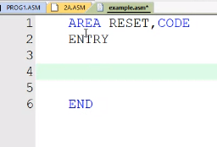

ARM HAS A BARREL SHIFTER, SUPPORTS LEFT AND RIGHT SHIFT

**FASTEST WAY TO MULTIPLY BY 2, IT IS BY LEFT SHIFT**

ASSEMBLY IS A LOW-LEVEL LANGUAGE

THIS HIGH LEVEL OR LOW LEVEL MUST BE CONVERTED TO BINARY, THE BINARY CODE IS FETCHED AND EXECUTED

Instruction to the assembler (above is an instruction to assembler only)

* They are called **assembler directives**
* They do not have binary equivalents, i.e not converted to binary
* No memory is NEEDED
* Simply to be followed by the assembler
* Helps convert the code in assembly to the binary code
* Is not a part of the code, just aids in the process
* Has significance during the time of writing the program and conversion

Instruction to arm core

* Have an equivalent binary code represented in the memory
* Hex code will be generated
* Need memory

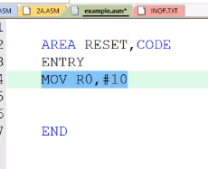

This has 3 instructions to the assembler - AREA RESET, CODE, ENTRY, END

One to the arm core - MOV, ADD

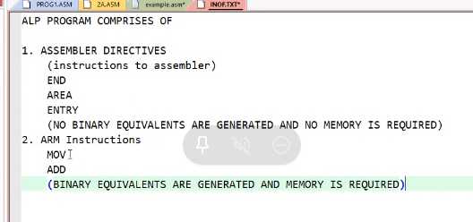

THE HEX EQUIVALENT IS USED INSTEAD OF ALL THE 1S AND 0S

THIS IS WHAT IS ACTUALLY PRESENT

0000 0000 0000 0000 0000 0000 0000 0000

EACH BLOCK CAN TAKE VALUES FROM 0 TO FOR 0 TO 15

0 0000

1 0001

2 0010

3 0011

4 0100

5 0101

6 0110

7 0111

8 1000

9 1001

A 1010

B 1011

C 1100

D 1101

E 1110

F 1111

DISASSEMBLY

IDENTIFYING THE HEX/BINARY CODE OF EVERY INSTRUCTION

4 MEMORY LOCATIONS TO REPRESENT 1 INSTRUCTION -> AS EACH IS 32 BITS

EACH BYTE HAS 8 BITS

E3A0 000A

1110 0011 1010 0000 0000 0000 0000 1010

E 3 A 0 0 0 0 A

ASSEMBLER TAKES EVERY INSTRUCTION AND MAKES IT INTO THIS FORMAT

EVERY INSTRUCTION IS CONVERTED TO A SINGLE BINARY PATTERN

**ONE TO ONE CORRESPONDENCE** TO THE INSTRUCTION

AS EACH INSTRUCTION IS BROKEN DOWN AND REPRESENTED

HOWEVER IN A HIGH-LEVEL LANGUAGE,

Int a = b + c;

Gives a set of add and move instructions

**HIGH-LEVEL -> ASSEMBLY INSTRUCTIONS -> MACHINE LANGUAGE**

**So** no one to one correspondence exists in a high-level language

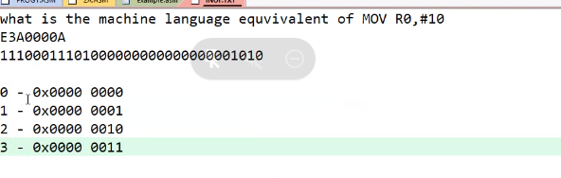

These 32 bits or 4 bytes is used to represent the instruction

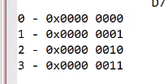

Loc 3 - > 1110 0011 EA

Loc 2 - > 1010 0000 A0

Loc 1 -> 0000 0000 00

Loc 0 - > 0000 1010 0A

**REPRESENTED AS**

**IN THE ACTUAL MEMORY**

**0A 00 A0 EA**

This follows **little-endian**, as the LSB bits come before the MSB bits

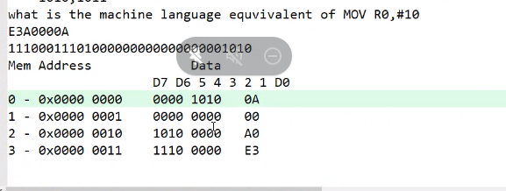

MEMORY

TOTAL 2**32 -> 4 GB , FOR ALL PURPOSES

THOUGH THERE IS SUPPORT FOR 4GB ONLY 512 KB OF FLASH, 32 KB OF SRAM

FLASH IS PUT FOR THE FIRST 512 KB, AS OUT ADDRESSES START FROM

0X00000000 TO 0X8000

IN LPC 2148

512 KB -> FLASH

32 KB -> RAM

FROM 0 ONWARDS, THE FLASH STARTS AND HAS A SIZE OF 512 KILO BYTES

FROM 1 GB ONWARD THE SRAM STARTS HAS A SIZE OF 32 KILOBYTES

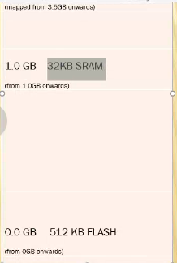

**INSTRUCTIONS**

* Types

**Data manipulation - 3 ADDRESS FORMAT**

Data transfer

Arithmetic operations

Logical

Shift

rotate

**Branching**

B (stop B stop)

**Load and store**

These are the only instruction can access memory or SRAM

ONLY LOAD AND STORE USES OR CAN ACCESS MAIN MEMORY, THE REST CAN ACCESS ONLY REGISTERS, THIS IS WHY IT IS CALLED LOAD AND STORE ARCHITECTURE

VARIABLES

* STORE VARIABLES EITHER IN REGISTERS
* STORE IN SRAM

FIRSTLY TRY TO LOOK AT WHETHER UR REGISTER IS USABLE